**Ability to create effective reports in Power BI, create Dashboards in Power BI and deploy and publish Power BI reports**

KO 1: Able to Create Reports to Show Relationships, Handling Unusual Data

Visualizations

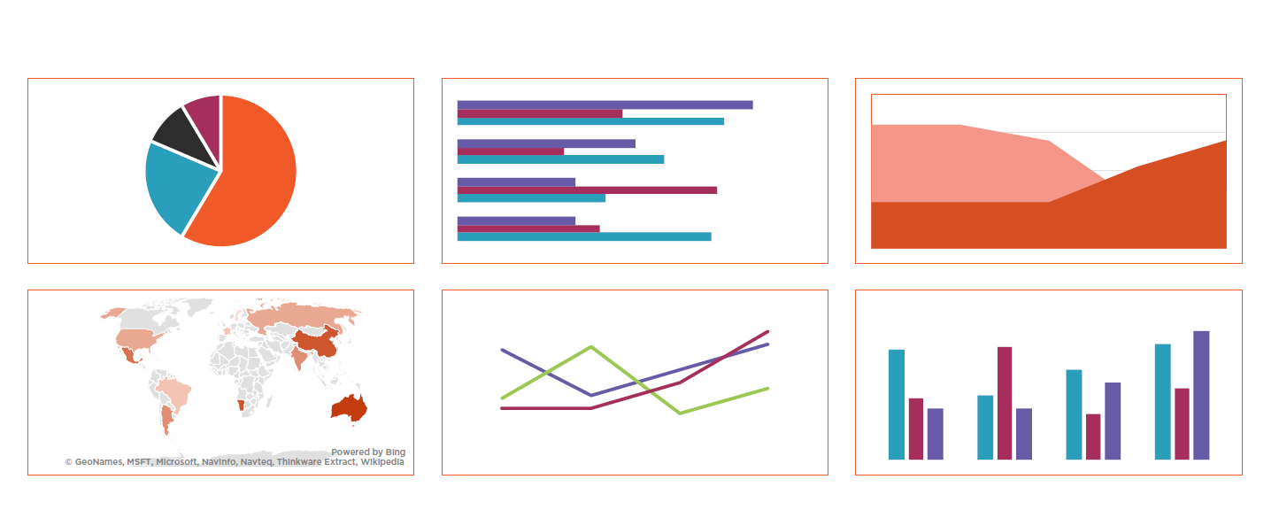

Creating Reports to Show Relationships

Here We have Selected 100% Stacked Column Chart under the Visualization

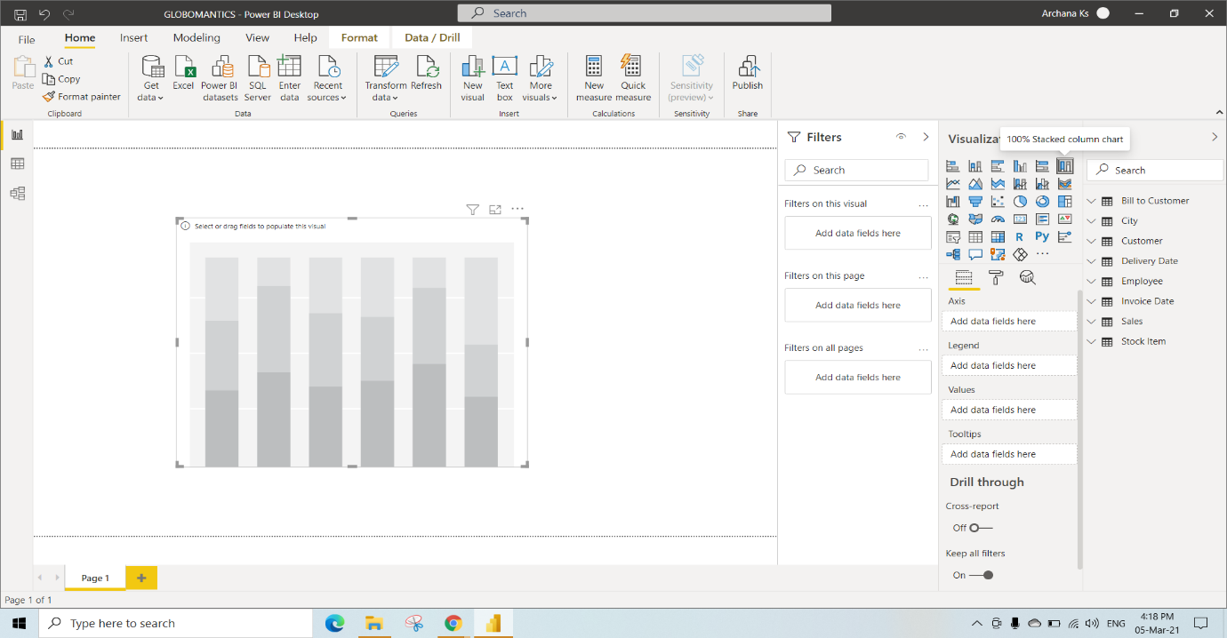

In this, we have Selected Short month and Total excluding Tax columns from tables and Applied Basic Filtering on Fiscal Year by Selecting the Year 2018

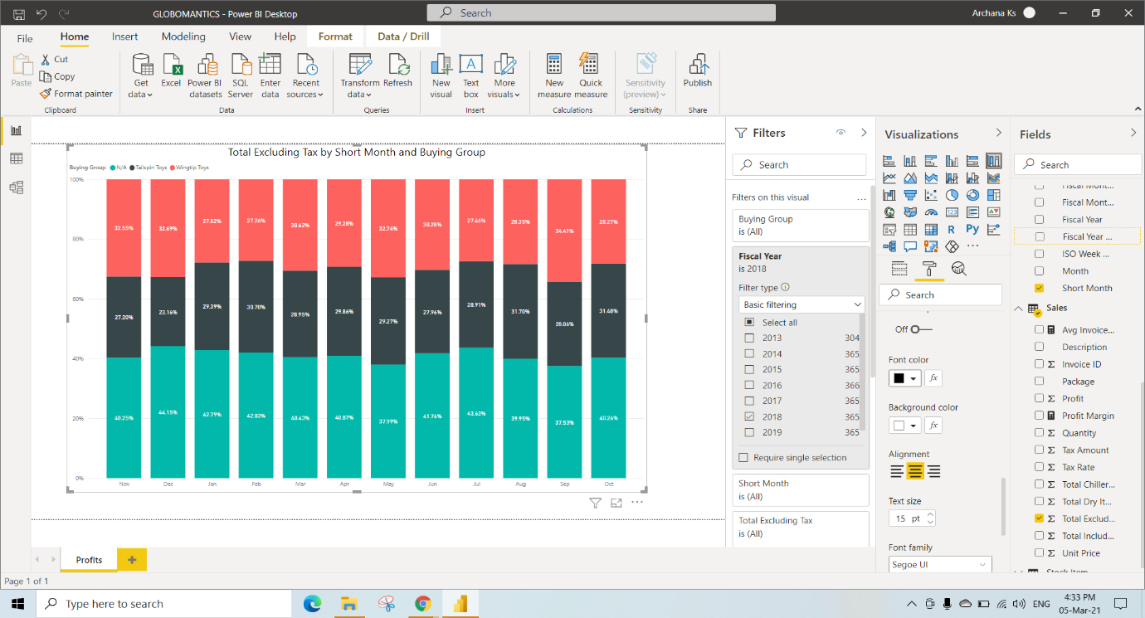

Here We have selected Pie Chart under the Visualization

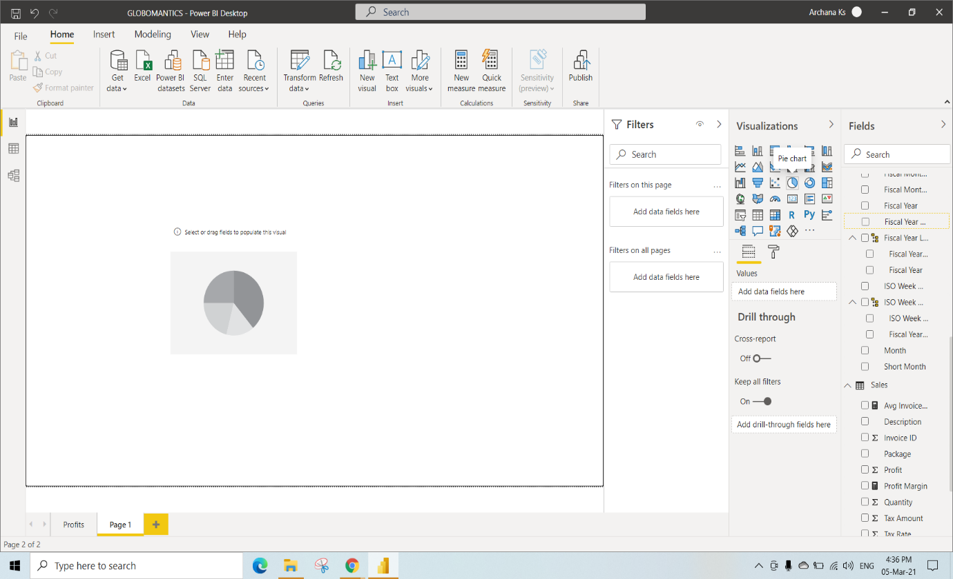

In this, we have Selected Colours and Invoice ID from Tables

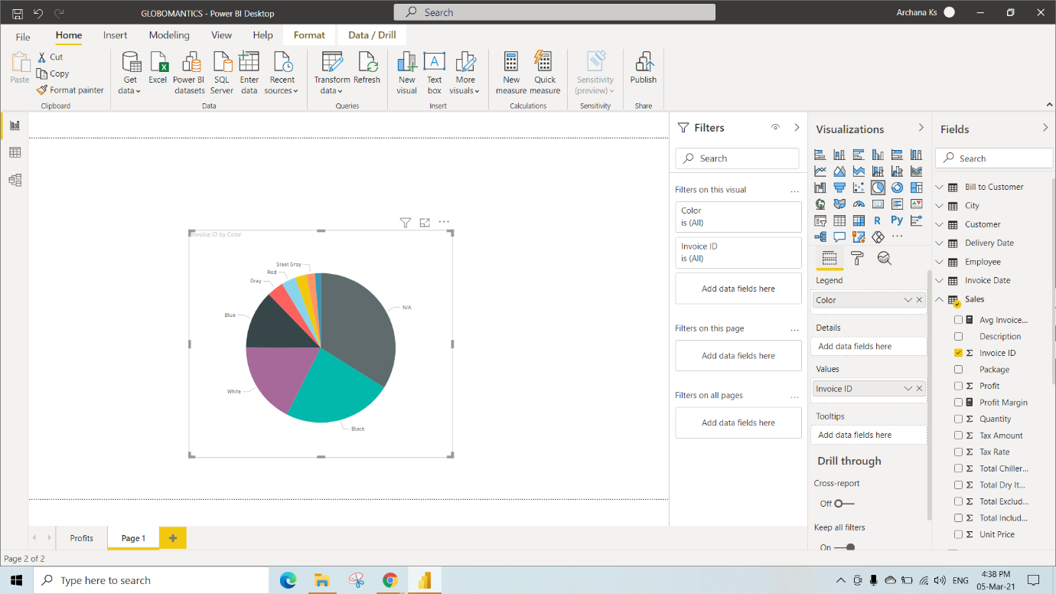

In this Pie Chart, We have Switched on the Legend option in the Formatting under the Visualization. So that we are able to see the color names on the top of the Visuals

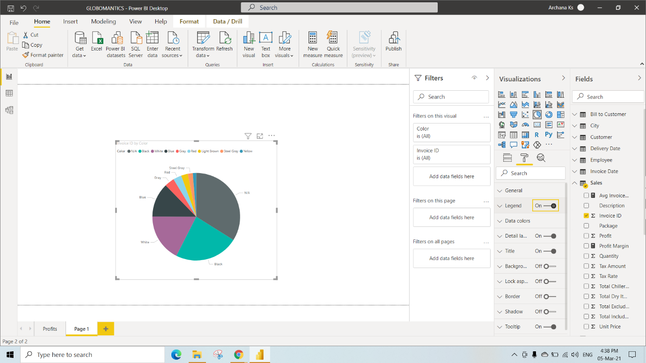

After Switching off the Detail Label Option, The labels for the Pie chart got Disabled

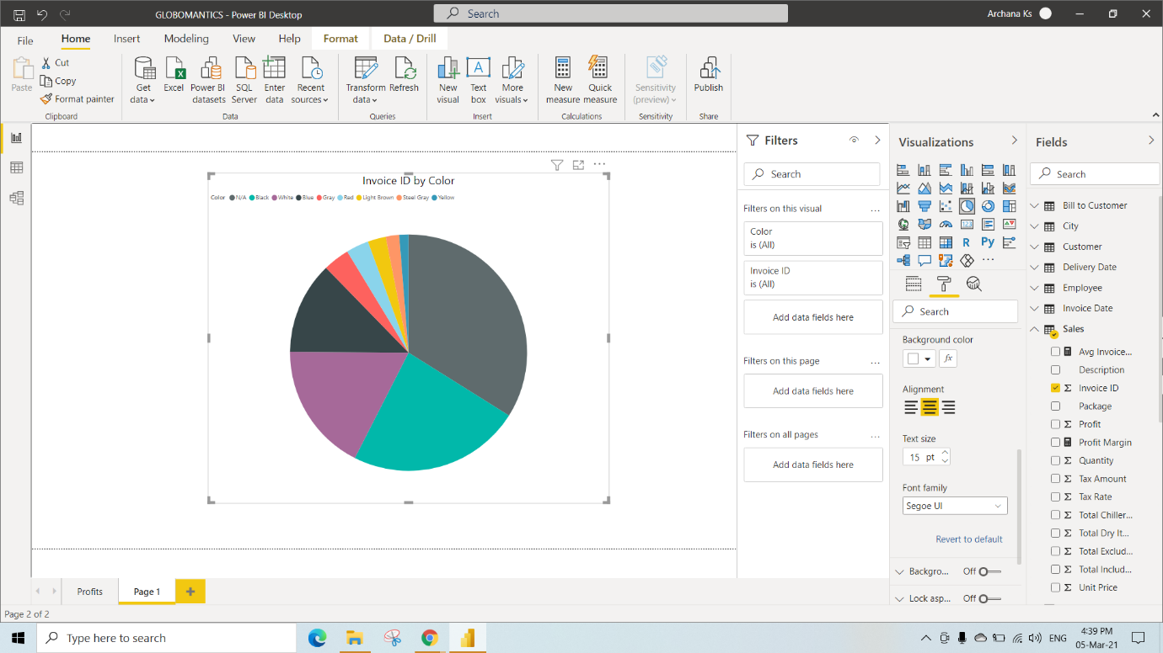

Step 1. From Pie Chart Visual, In the Home Tab click on Copy

Step 2. Select New Page in the Bottom(Click on + Sign) and Paste it

By selecting the Pie Chart, Click on Donut Chart under the visualization

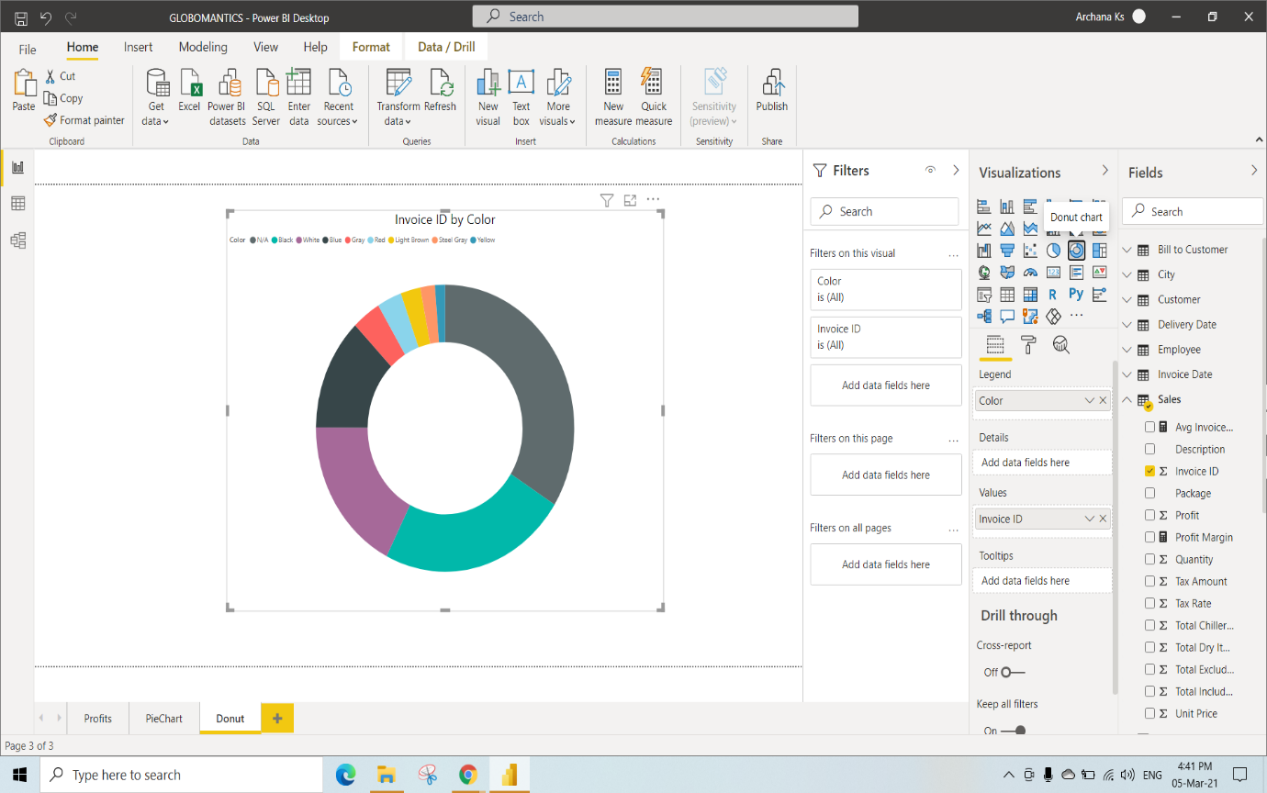

Select that Donut Chart and Select Format , In the Format You can resizre the radius of the Donut(50radius)

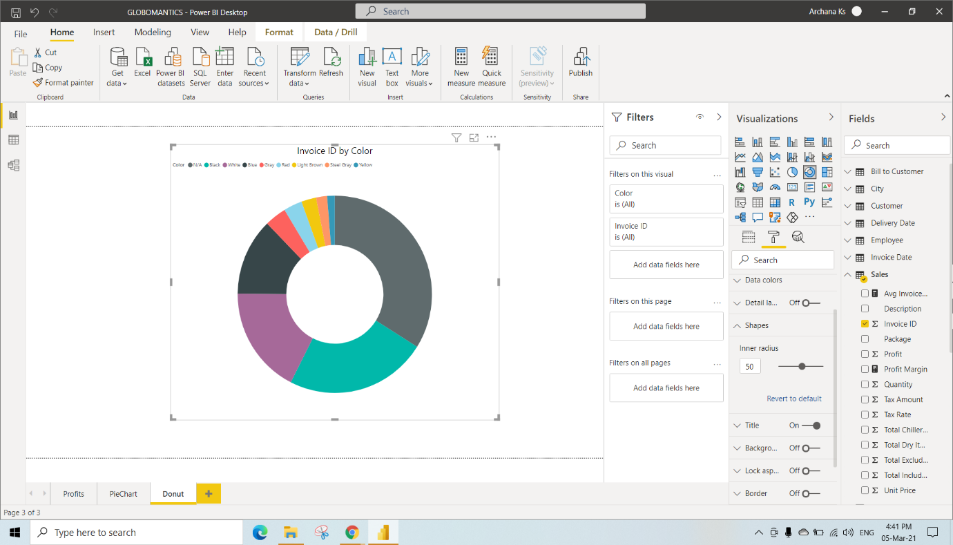

Here We have selected Funnel Chart under the Visualization

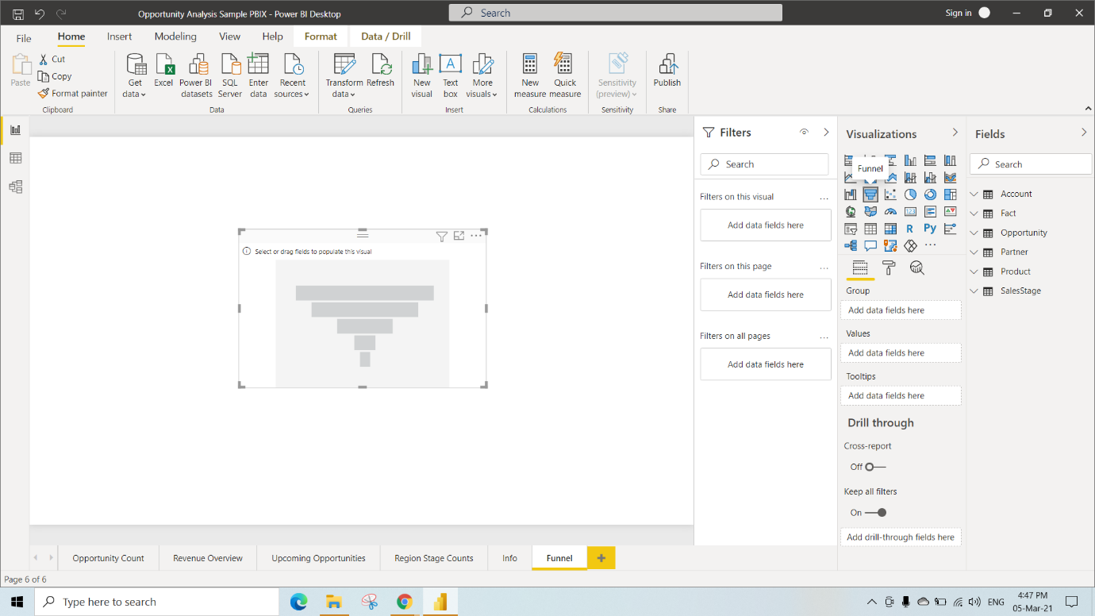

Now We have Selected Opportunity count and sales Stage columns from the tables and Alligned Text to Middle under Format

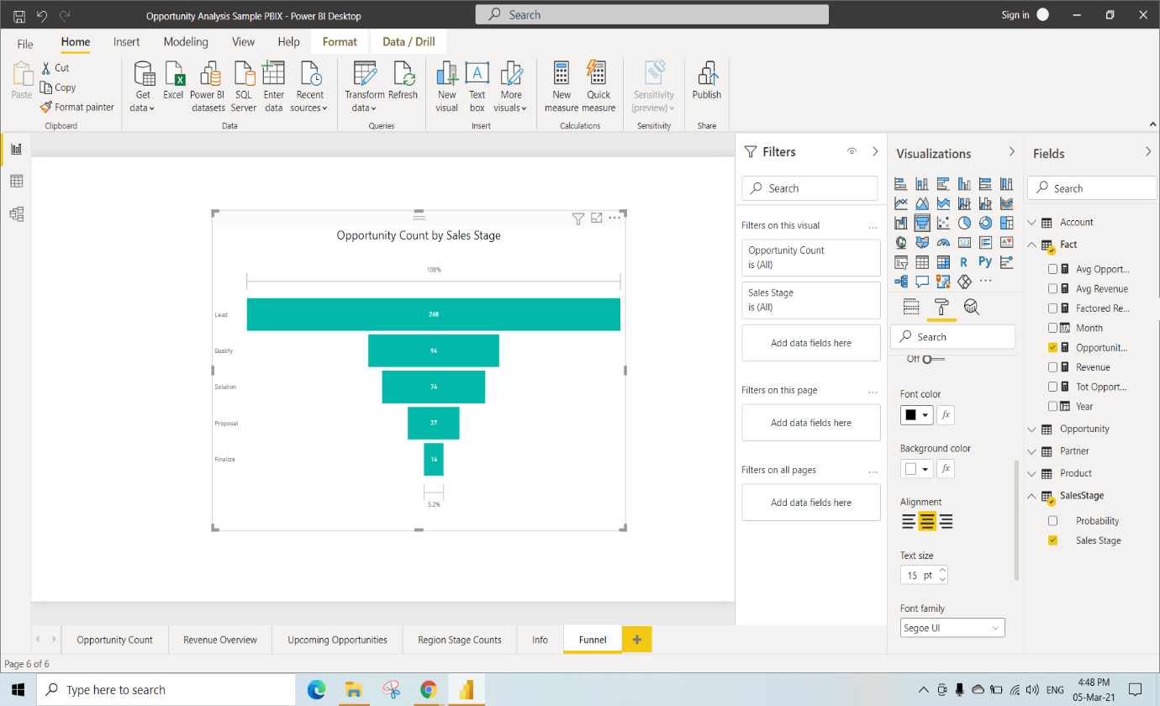

Here We have selected Waterfall Chart under the Visualization

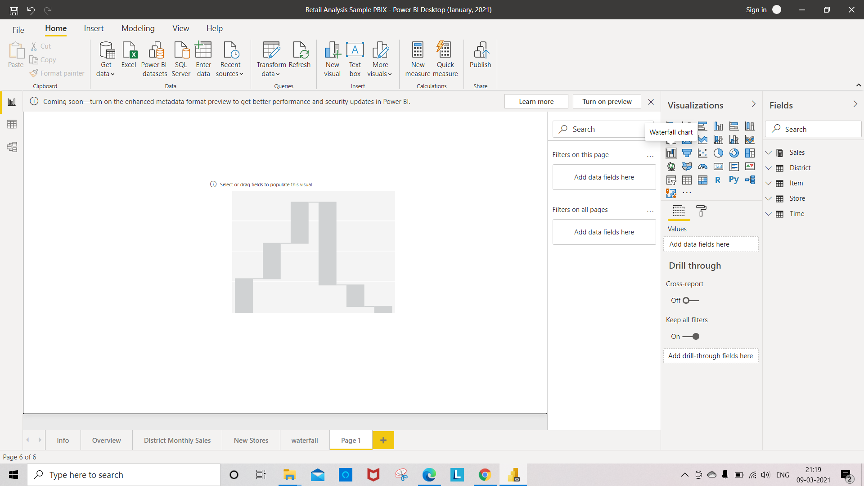

In this, We have Selected Fiscal month and Total Sales variance columns from the Tables and turned off the Data Lable in Format

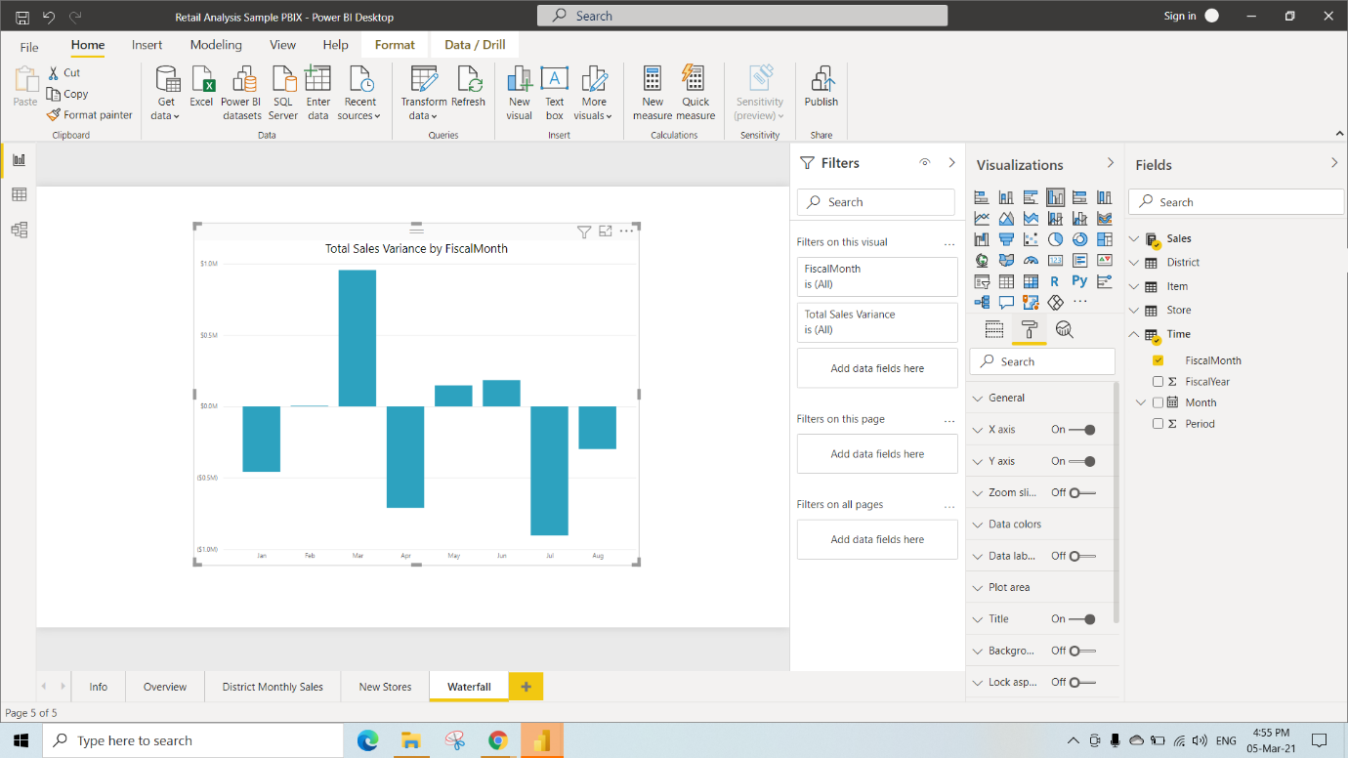

Here We have Selected the TreeMap under the Visualization

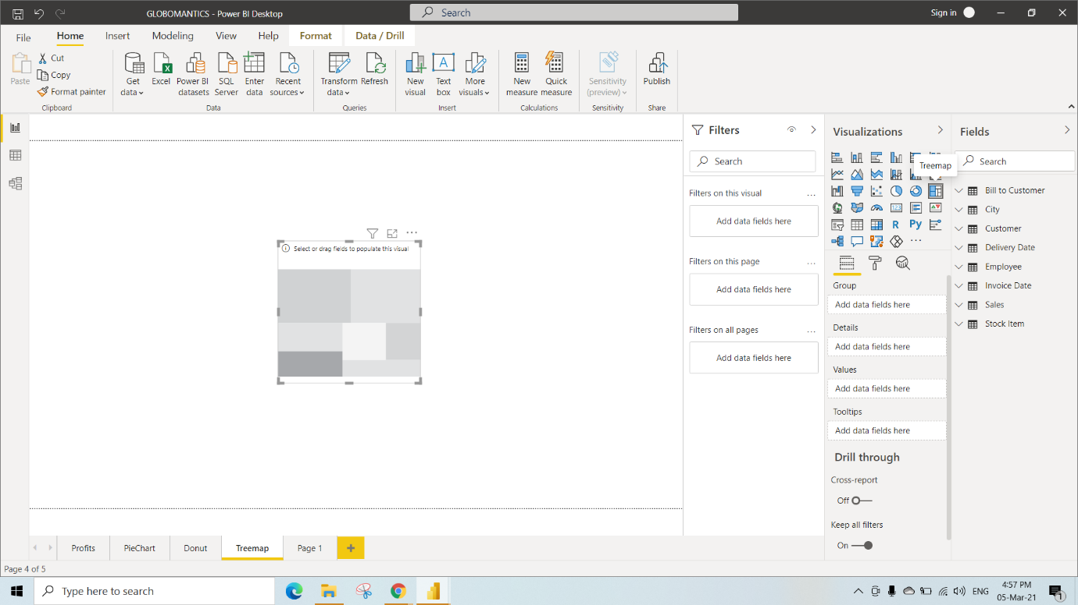

In this We have Selected Sales Territory and State Province Columns in Tables and also aligned text to middle

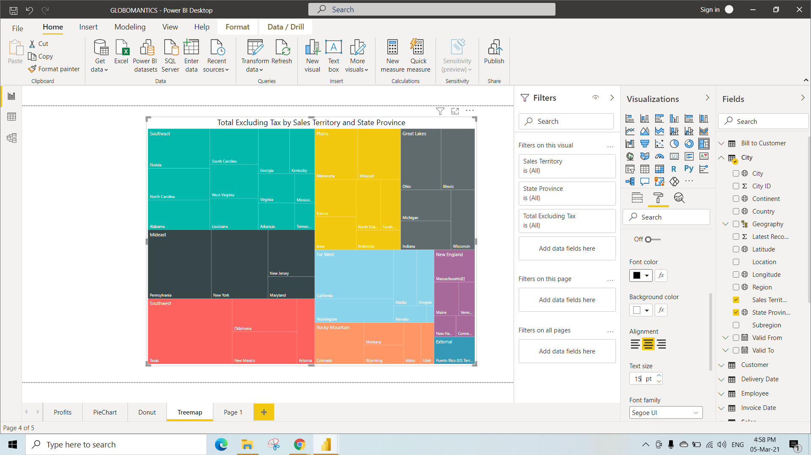

Handling Unusual Data

Here We have Selected the Map under the Visualization

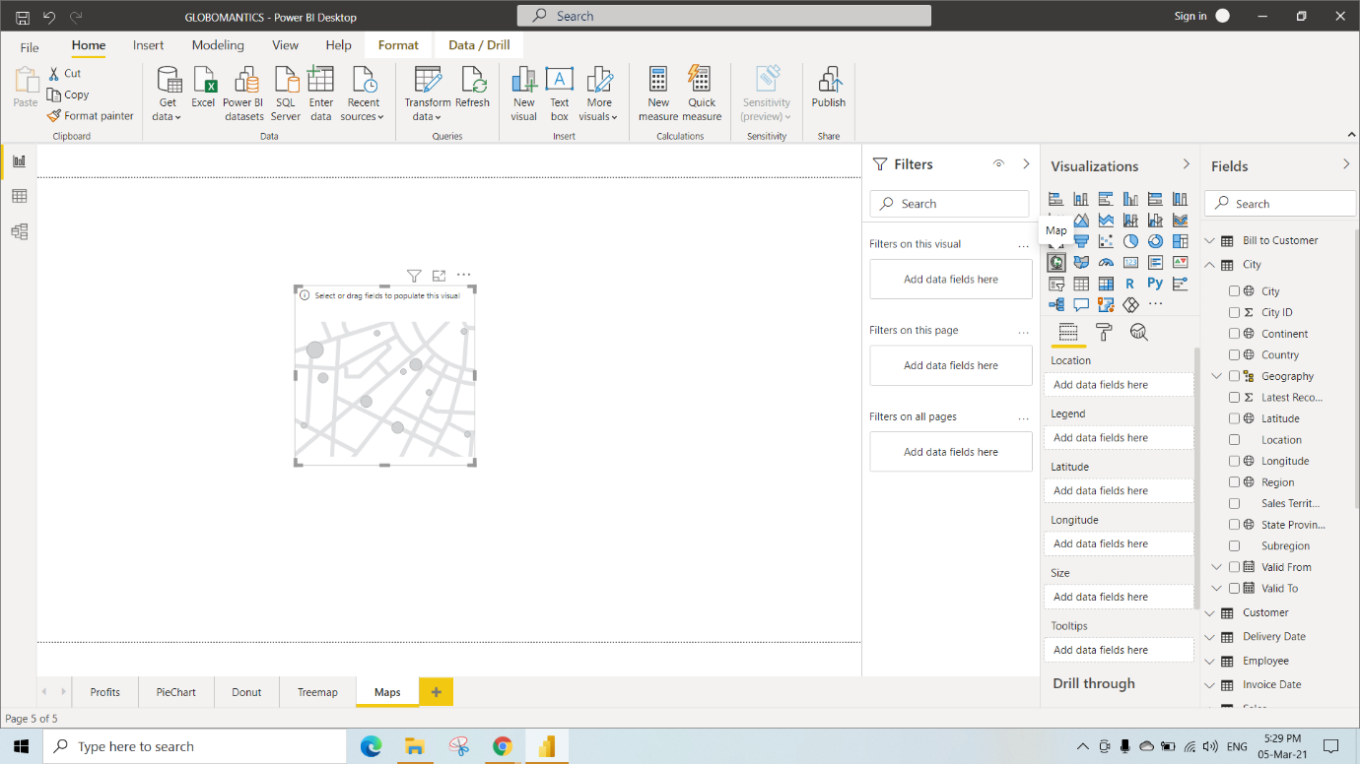

In this We have Selected Sales Territory, State Province, Average of Longitude and Average of Latitude to their corresponding fields from Tables

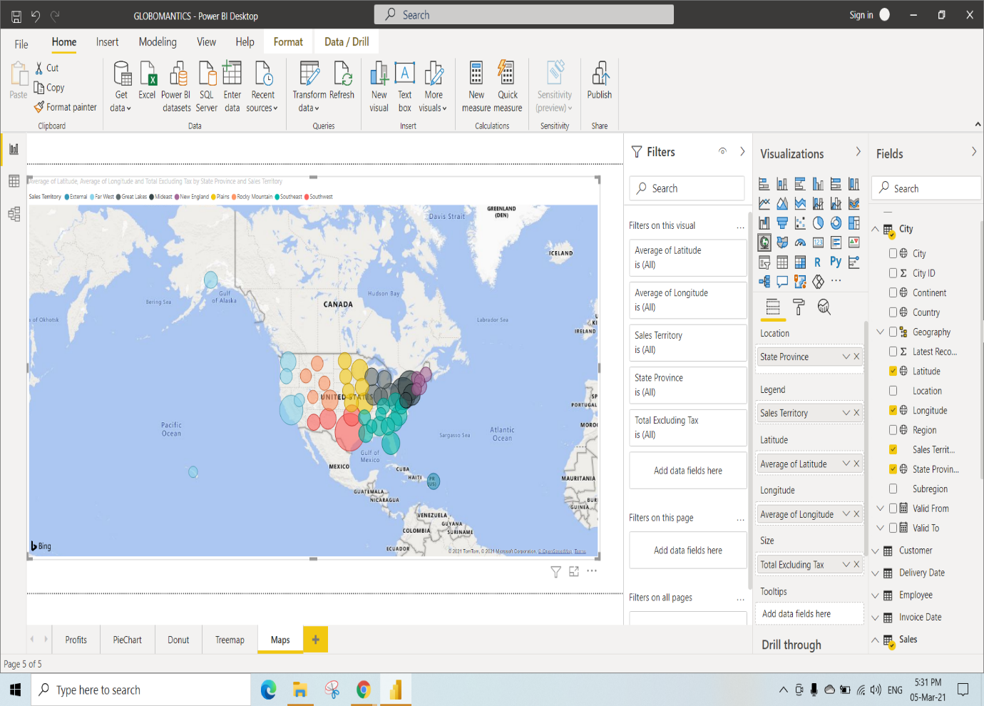

For the above Visualization we have added city to the location field and moved Sales territory from legend to location.

To Expand all down one level in the hierarchy we have selected 4th icon under the used visualization

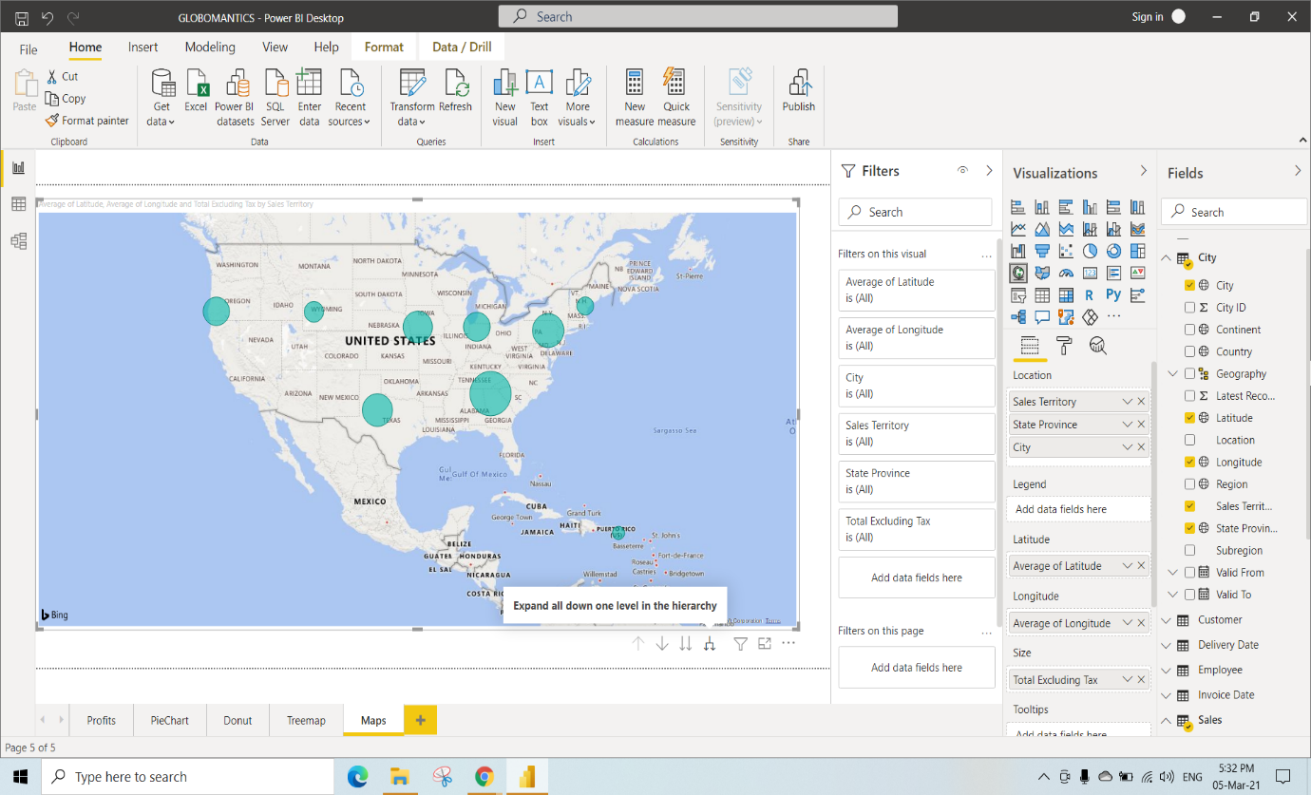

To get back previous hierarchy use drill up icon under the used visualization

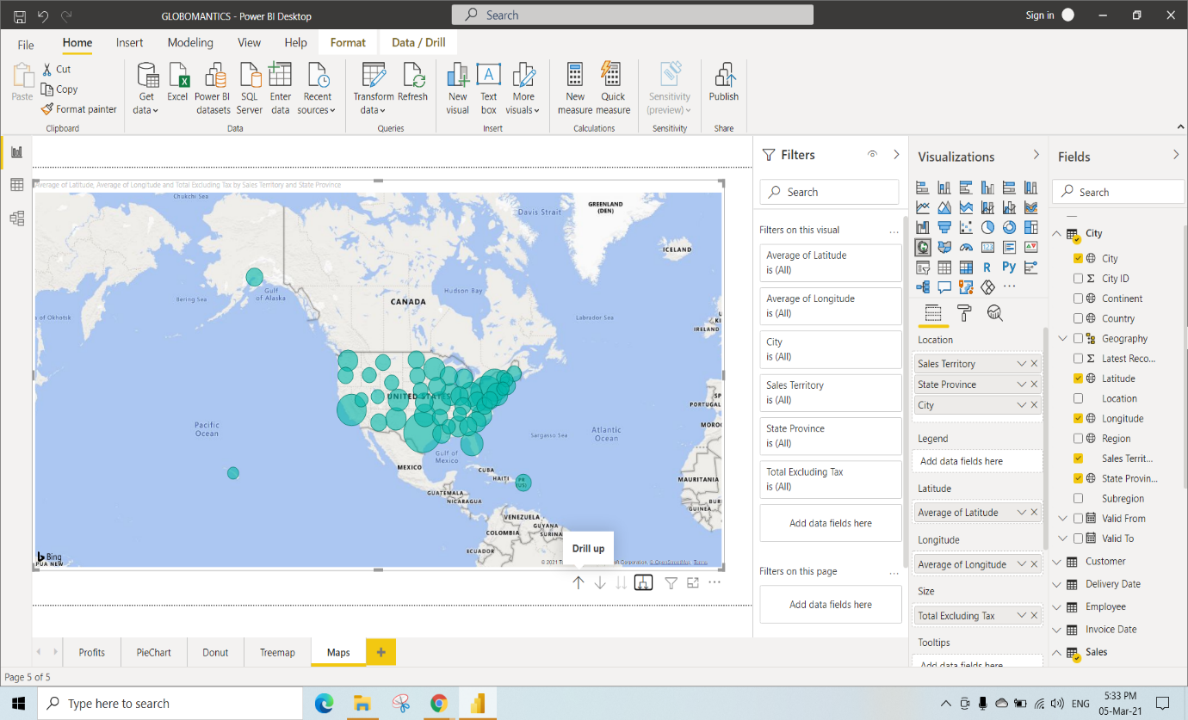

Here For the above visualization just click on that map and select filled map under visualization

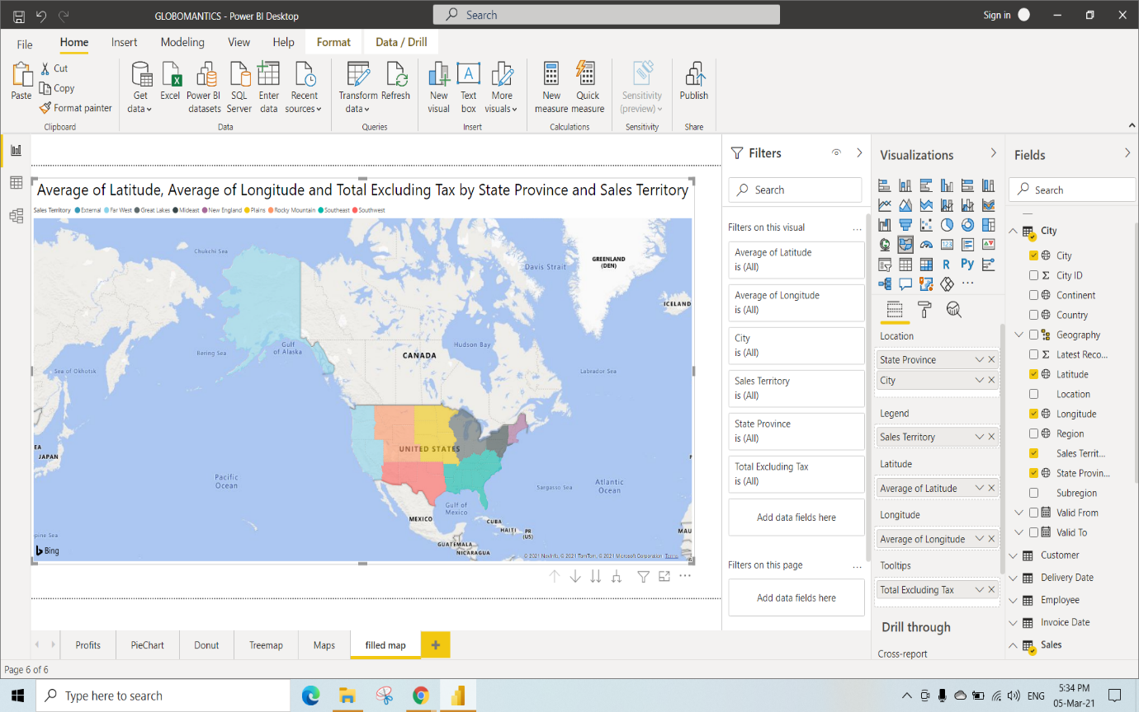

To get new Visualizations

Step 1: Go to File

Step 2: Select options and settings

Step 3: Click on options

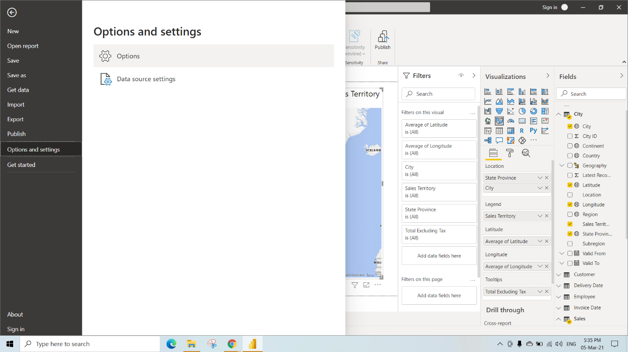

Step 4: Select Shape map visual and click on OK

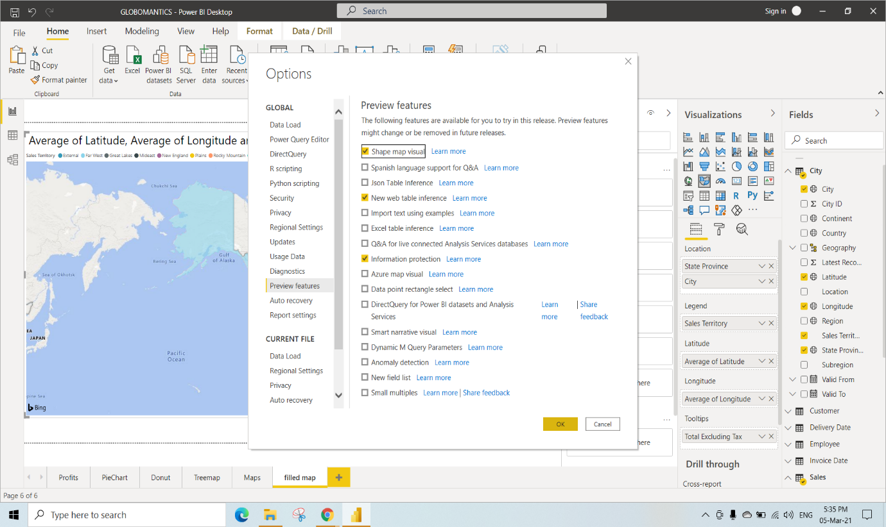

This selection process requires Restart of PowerBI Desktop App Once after you restarting your application you will get that shape map visual under the Visualizations

Step 5: Click on OK

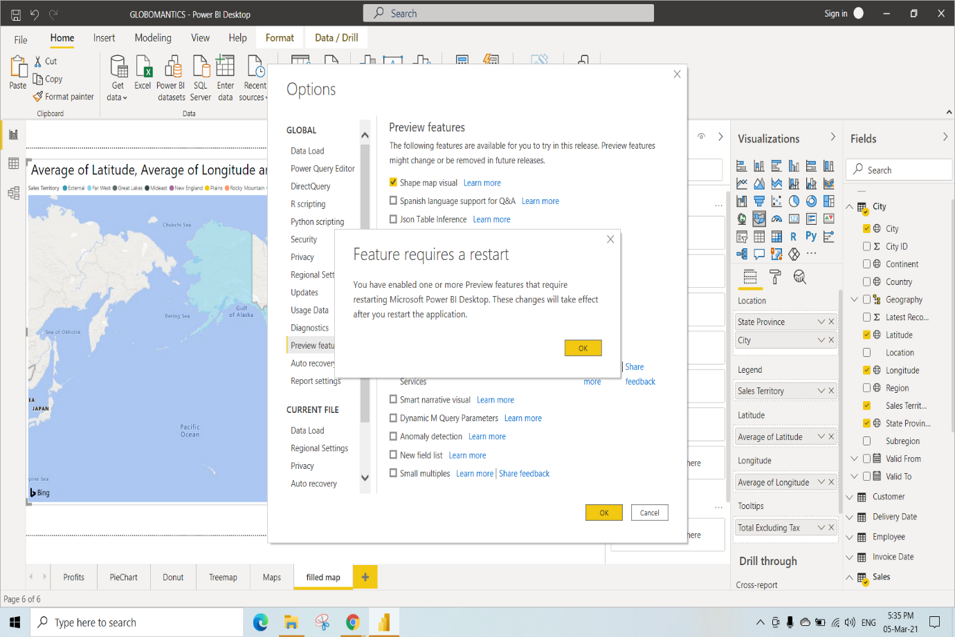

Here For the above visualization just click on that map and select shape map under visualization

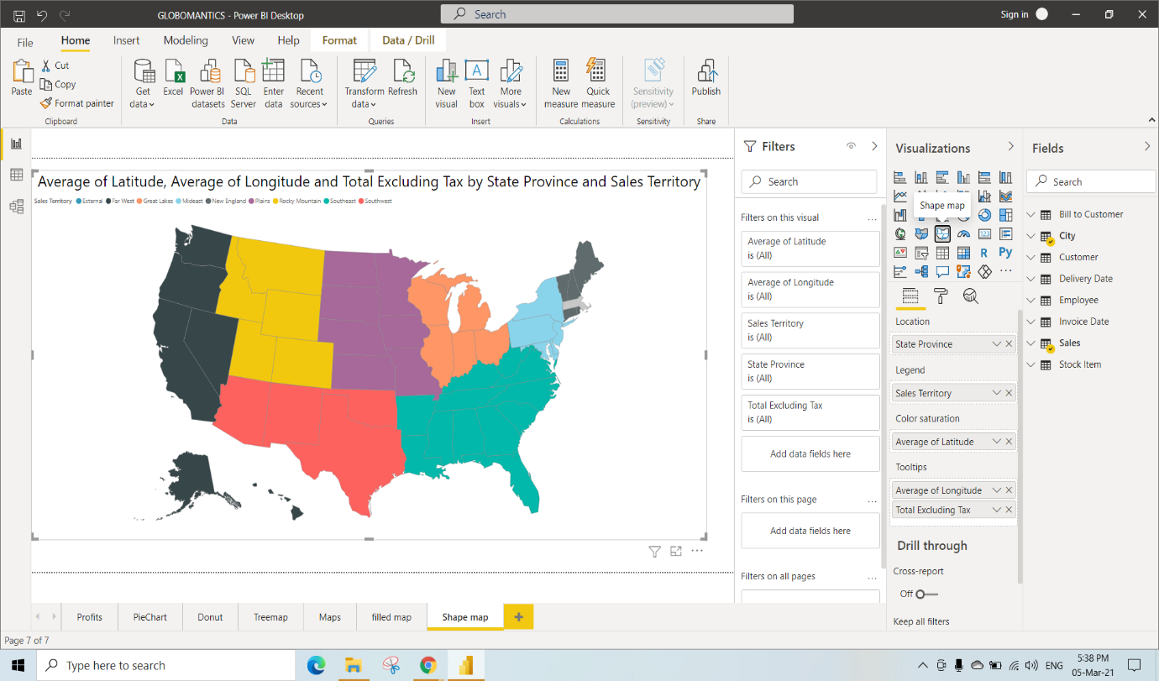

Under the format options we have selected Projection as Orthographic(You can Select anyone)

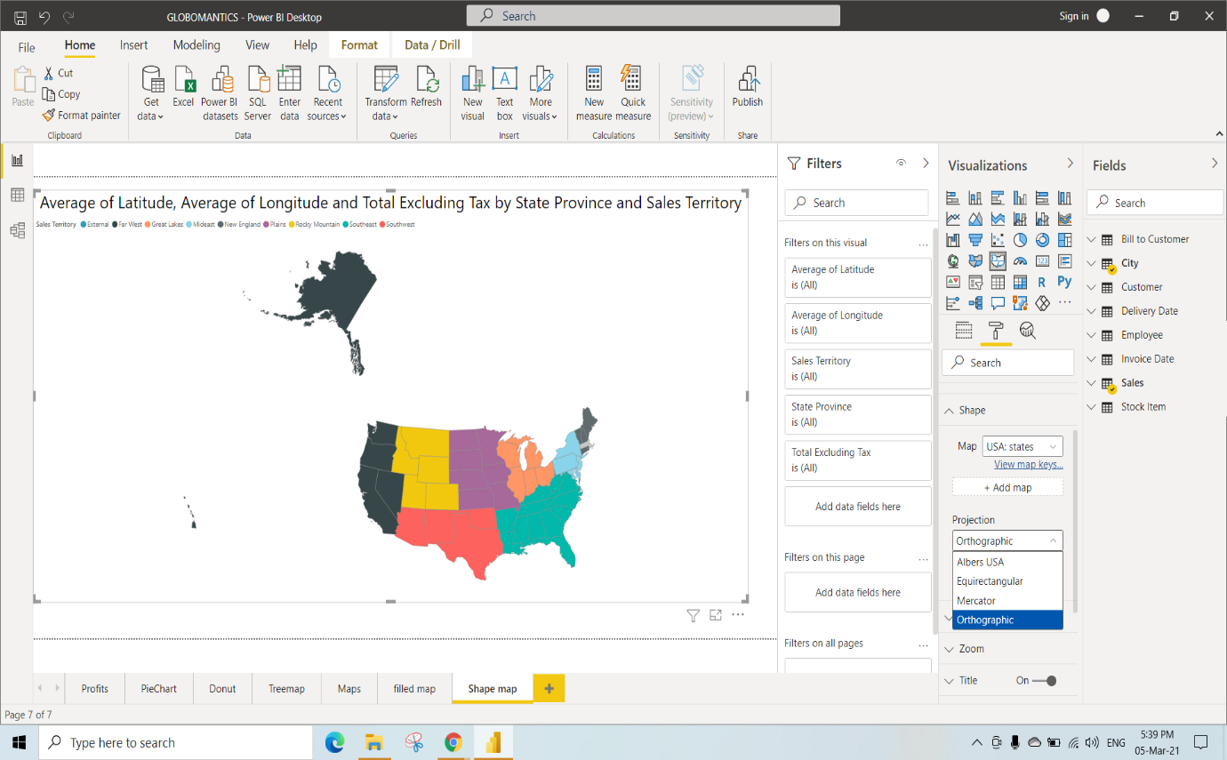

KO 2: Able to Leverage Interactivity in Reports

Slicing and What if Parameter

Here we have selected slicer under the Visualization

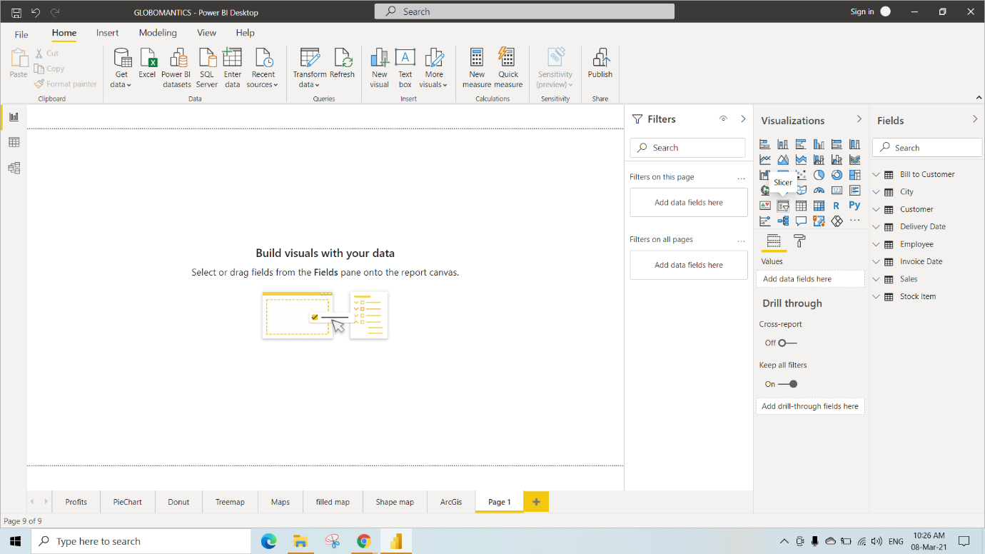

Here we have selected Sales Territory column from City table into the Slicer

In Slicer, We can select List or Dropdown as shown Below

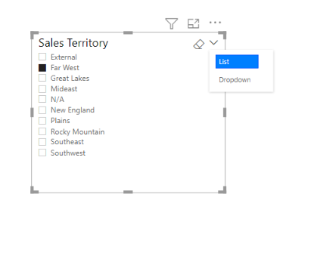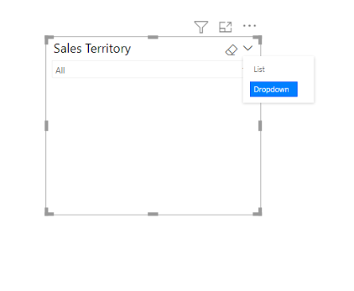

Here We have selected table under Visualization and added Employee, City, Sales Territory and Fiscal Year to the table visual.

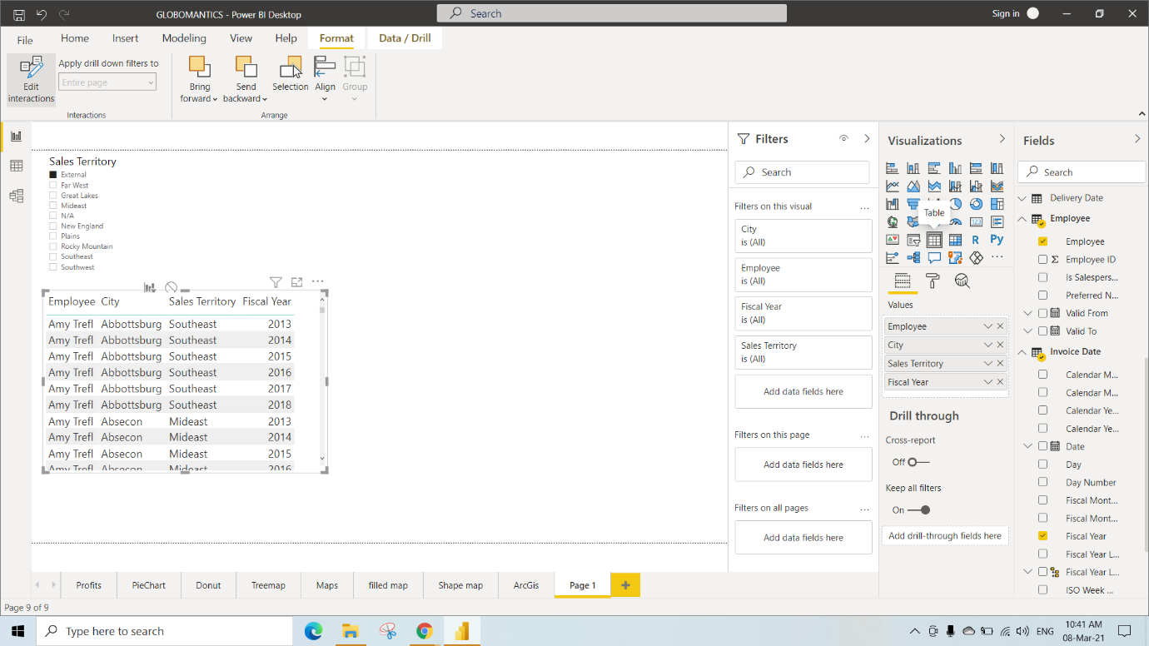

If we select any particular Sales Territory from Slicer visual we can

also see the changes in the table Visual

Here We have selected Greatlakes hence we can see all the datas related to Greatlakes

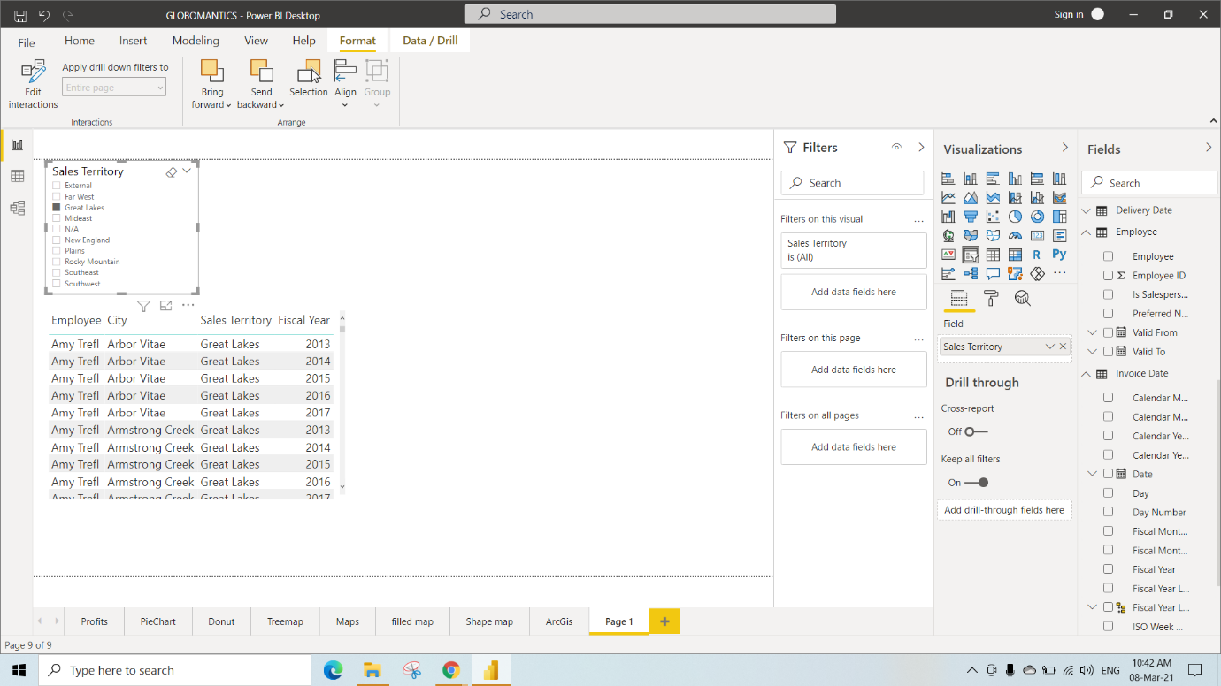

Here we have used Fiscal Year in Slicer

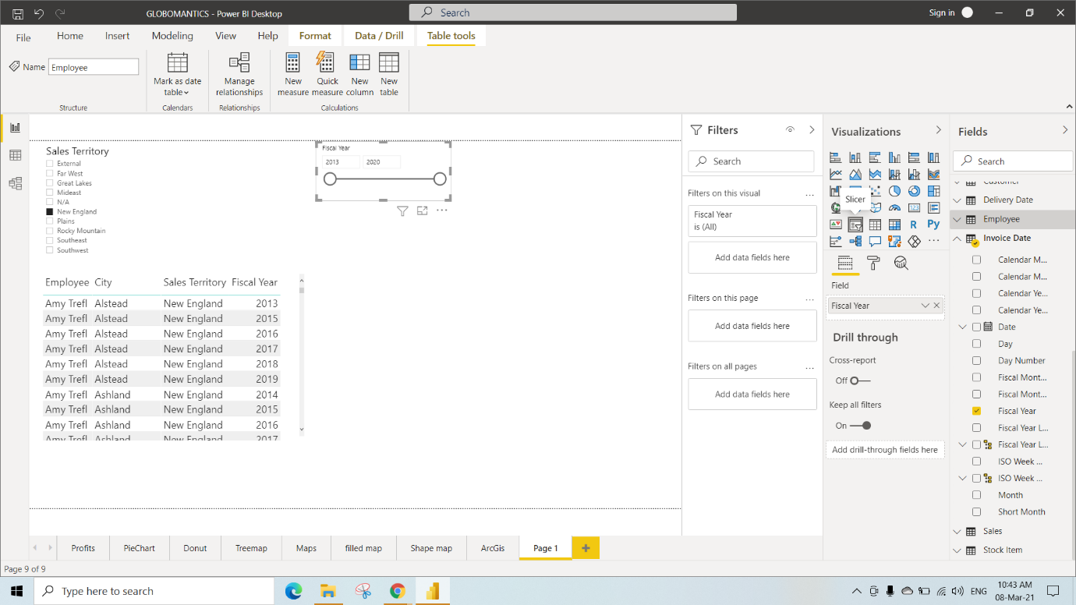

Here we have given the limit from 2015 to 2019 in the Fiscal Year Slicer so we can see the data’s from 15 to 16 in the Table visual

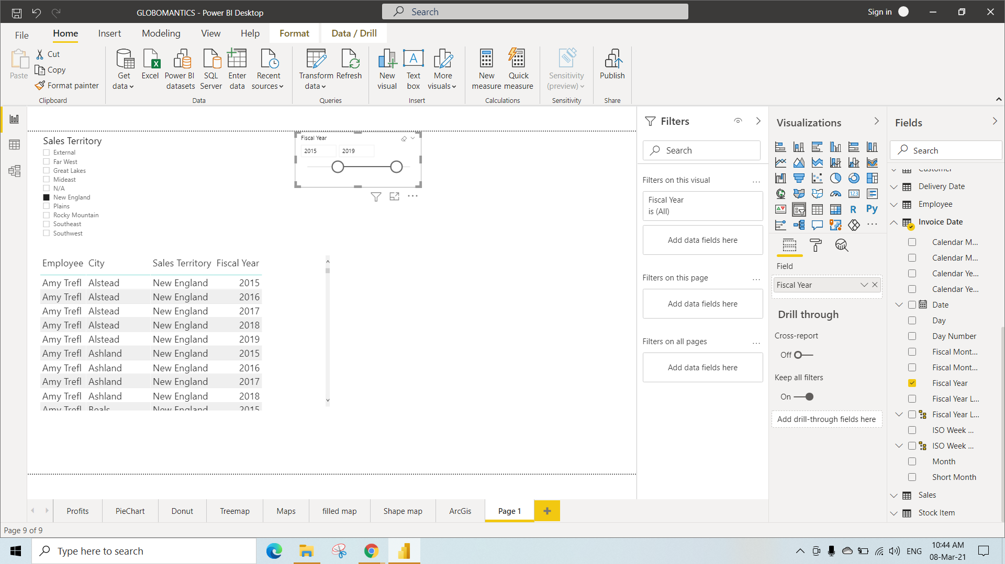

Here we have used Employee in Slicer

And also performed filter on Is Sales Person (Set the filter to select All)

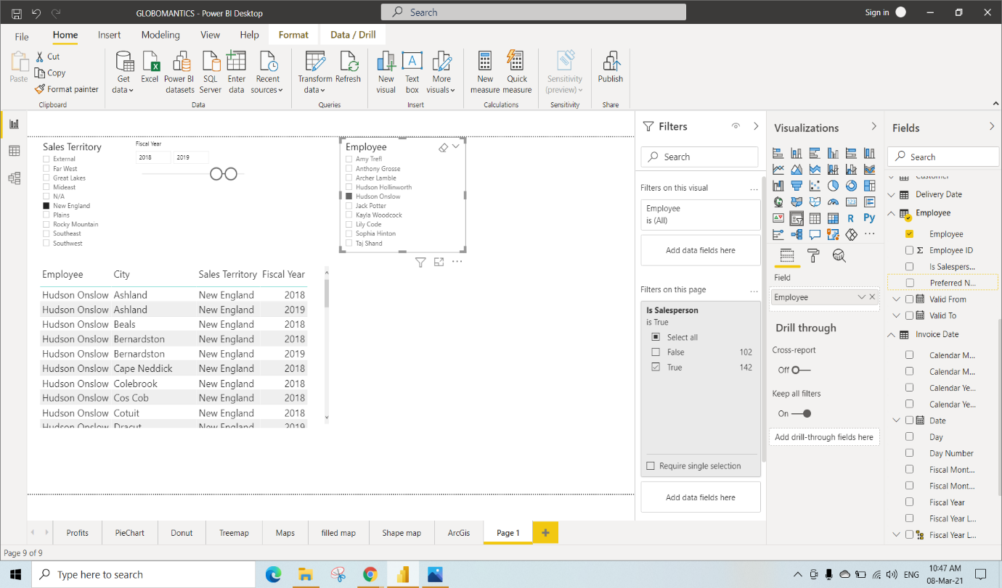

Step 1: Go to Modeling

Step 2: Select New Parameter(what if)

Give any name(we have given Percentage price increase as name and set minimum to 0 maximum to 1 and also set increment as 0.05)

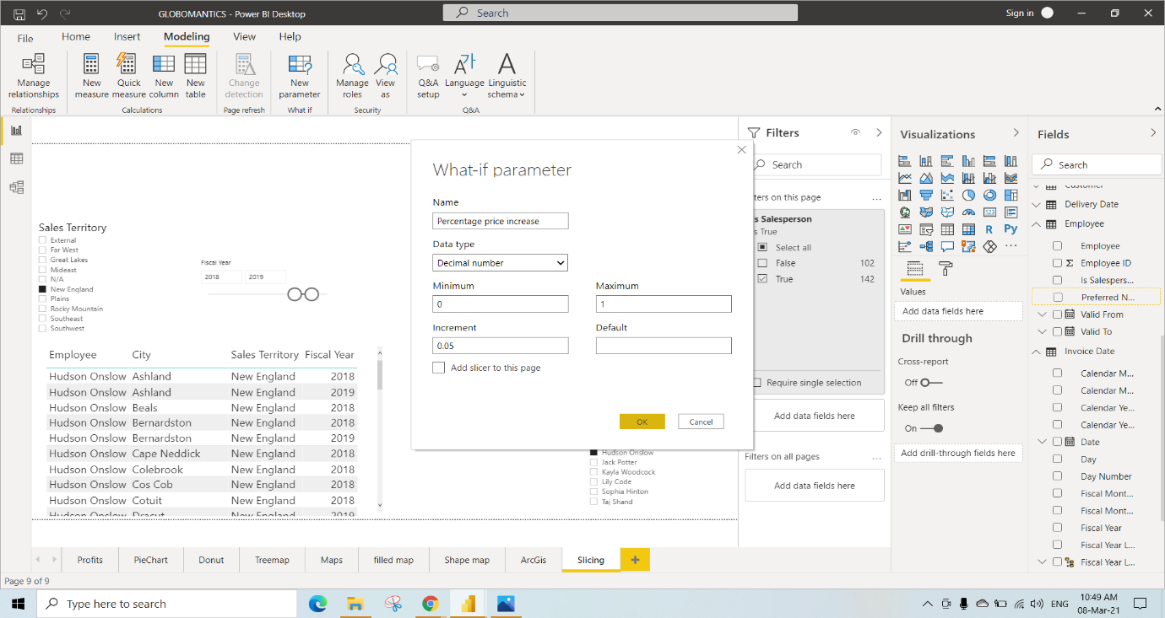

Create a new Measure named as AITPI

“AITPI=’Sales’[Average Invoice total]+ ’Sales’[Average Invoice total]*’Percentage Price increase’[Percentage price increase Value]”

And also add Avg Invoice total and Employee to table Visual

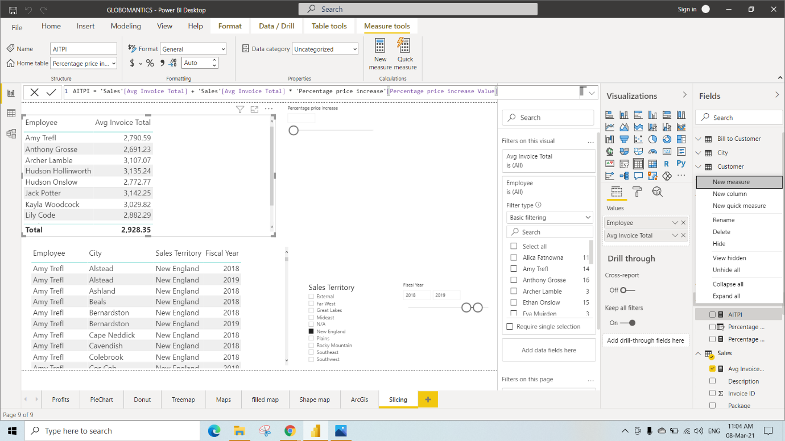

We have added the AITPI to the table visual

If we change the percentage price Increase parameter value then it will be reflected in the AITPI column in the table visual (the AIPTI value will be based on the created measure)

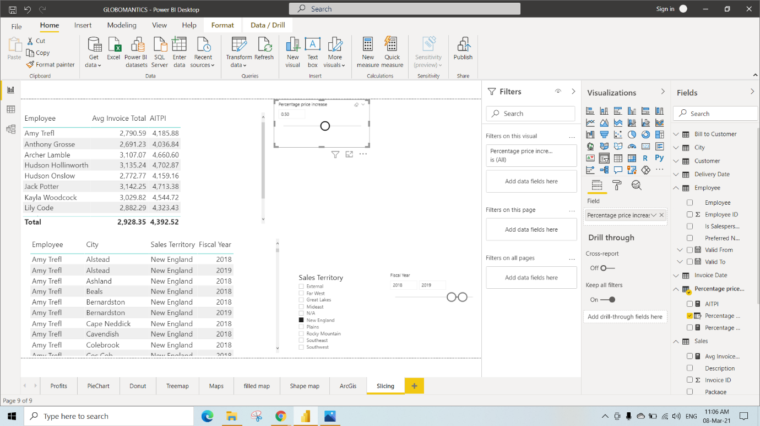

Grouping, Binning and Edit Relationship

Here we have selected Clustered Column Chart

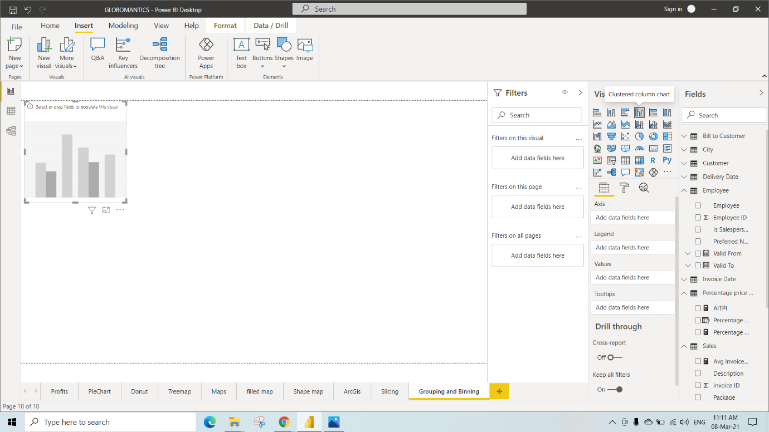

In this we have selected Short month and Total Chiller Items columns from the table

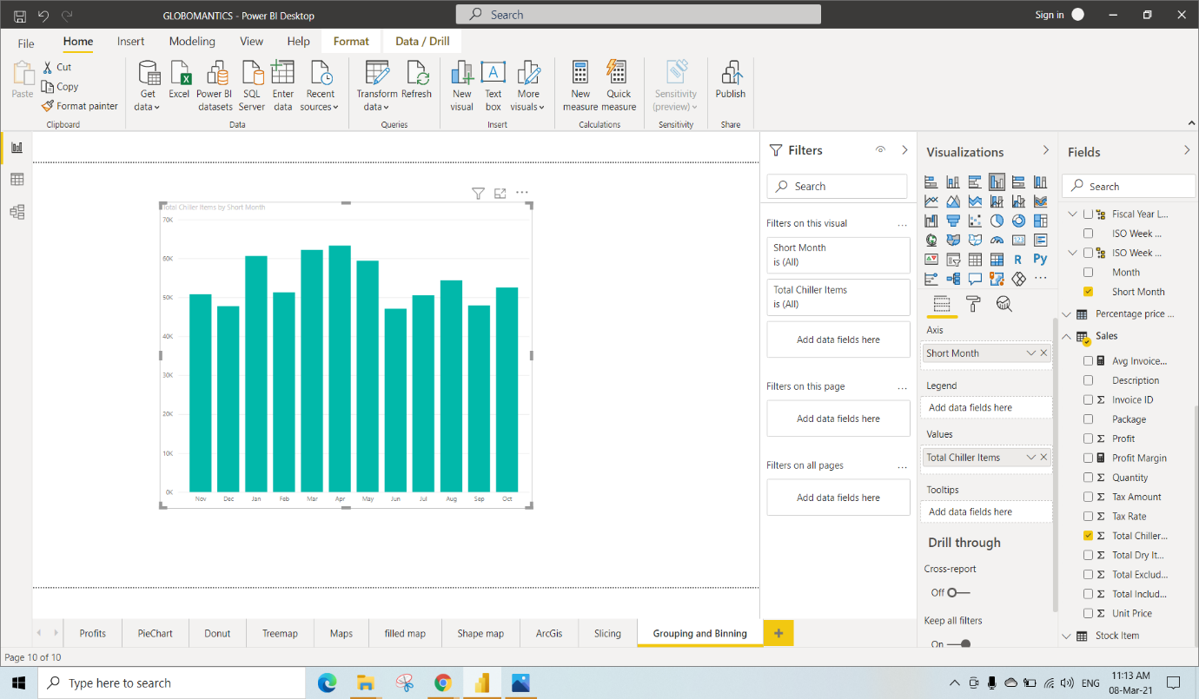

Here we are Grouping Nov, Dec and Jan as one group

Step 1: Select Nov, Dec, Jan and Right Click

Step 2: Click on group Data

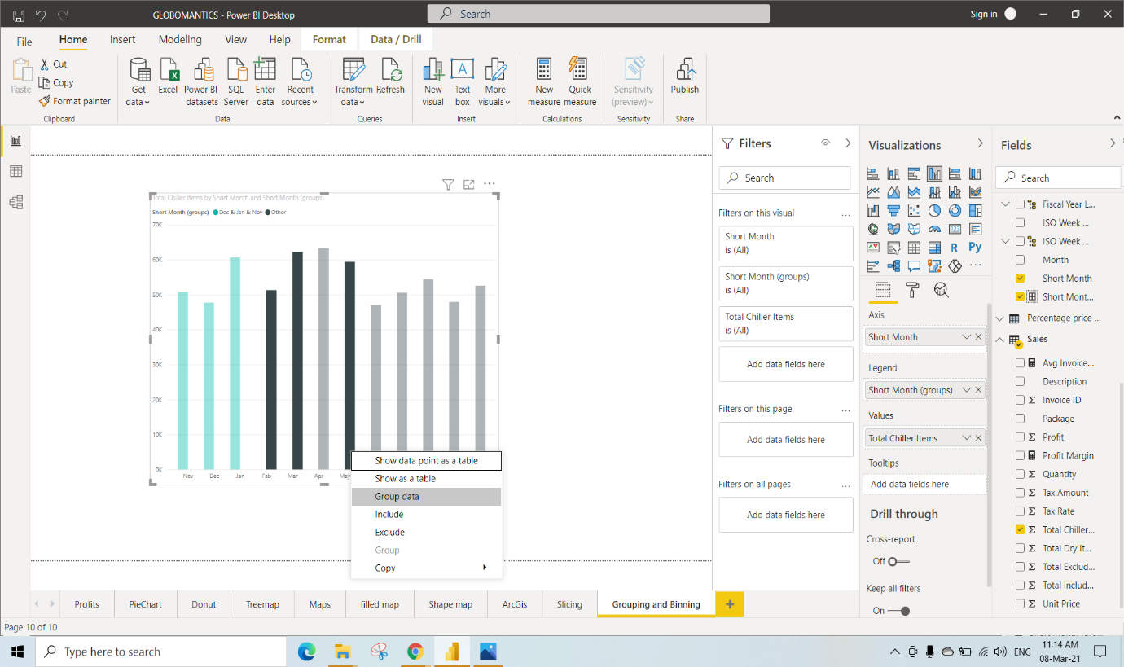

Similarly We have grouped (Feb, Mar and May) (Aug, Sep and Oct) as another groups

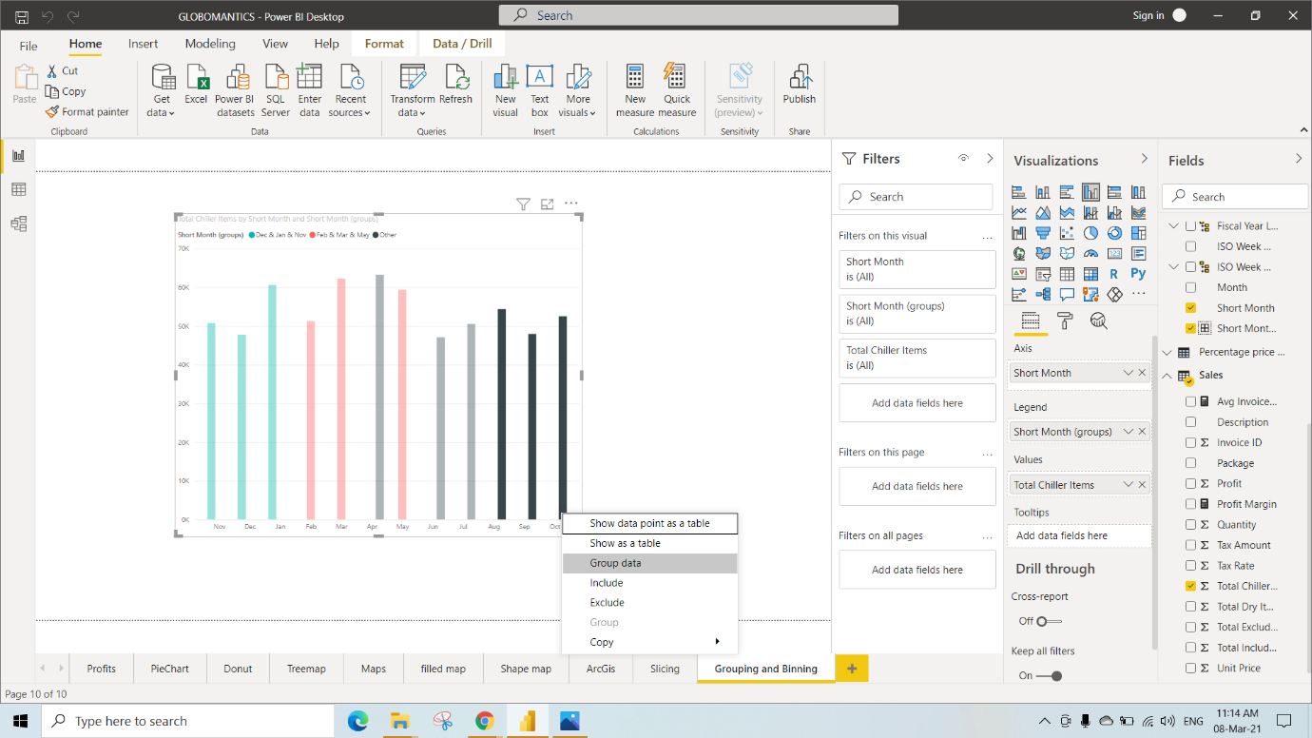

We can also edit the created groups by right clicking on Short Month Group under legend field and click on edit groups

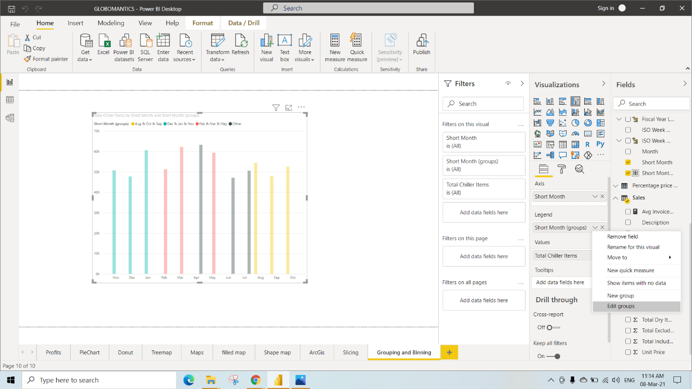

Here we have selected may from groups and members and click on Ungroup (so that it will come out of the previous group)

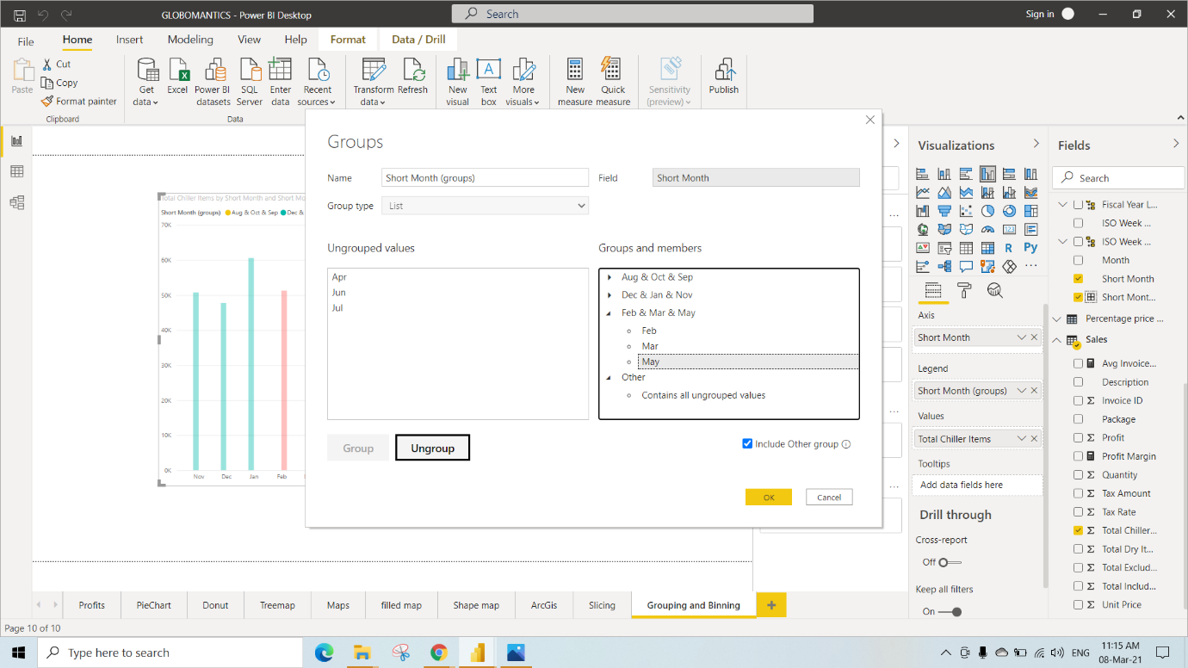

Similarly select Apr from Ungrouped data and also select groups from the “group and members” to which Apr to be grouped and click on Group

Here we have also grouped May, Jun and Jul as another group

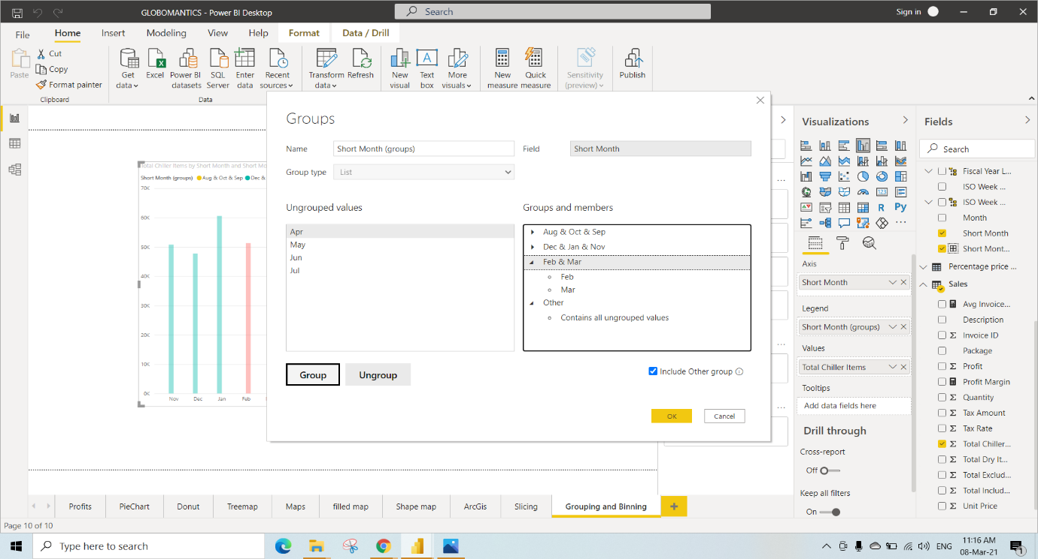

We have Renamed Nov & Dec & Jan 🡪 1st Quarter

Feb & Mar & Apr🡪 2nd Quarter

May & Jun & Jul🡪3rd Quarter

Aug & Oct & Sep 🡪4th quarter

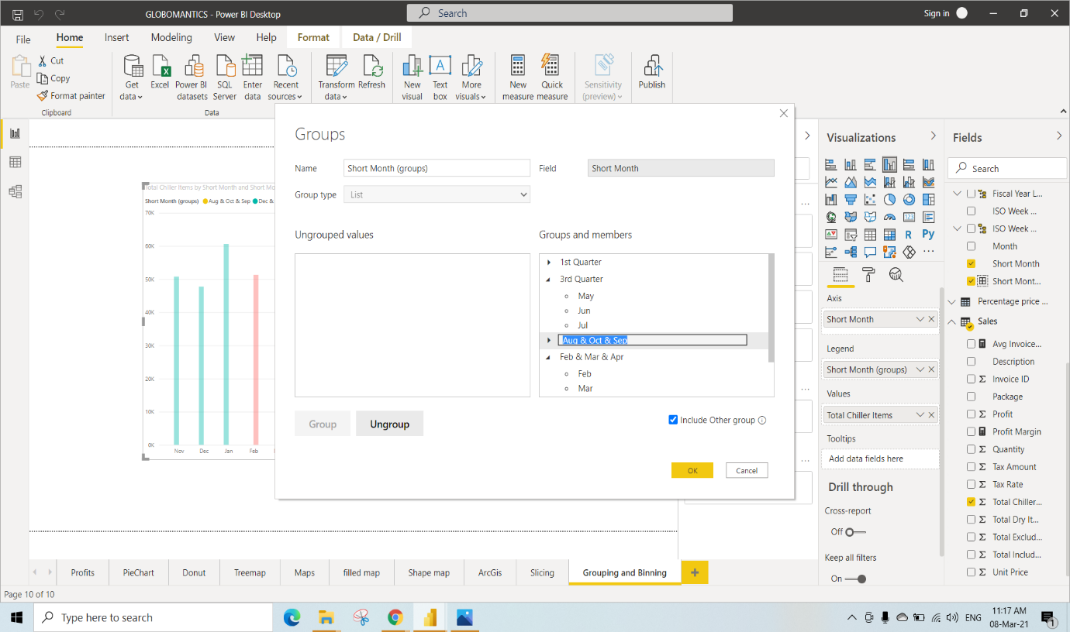

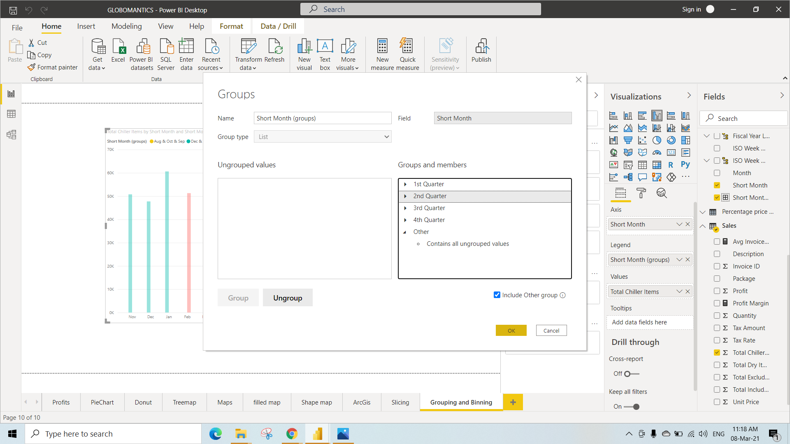

After Grouping Everything We can see the visual like this

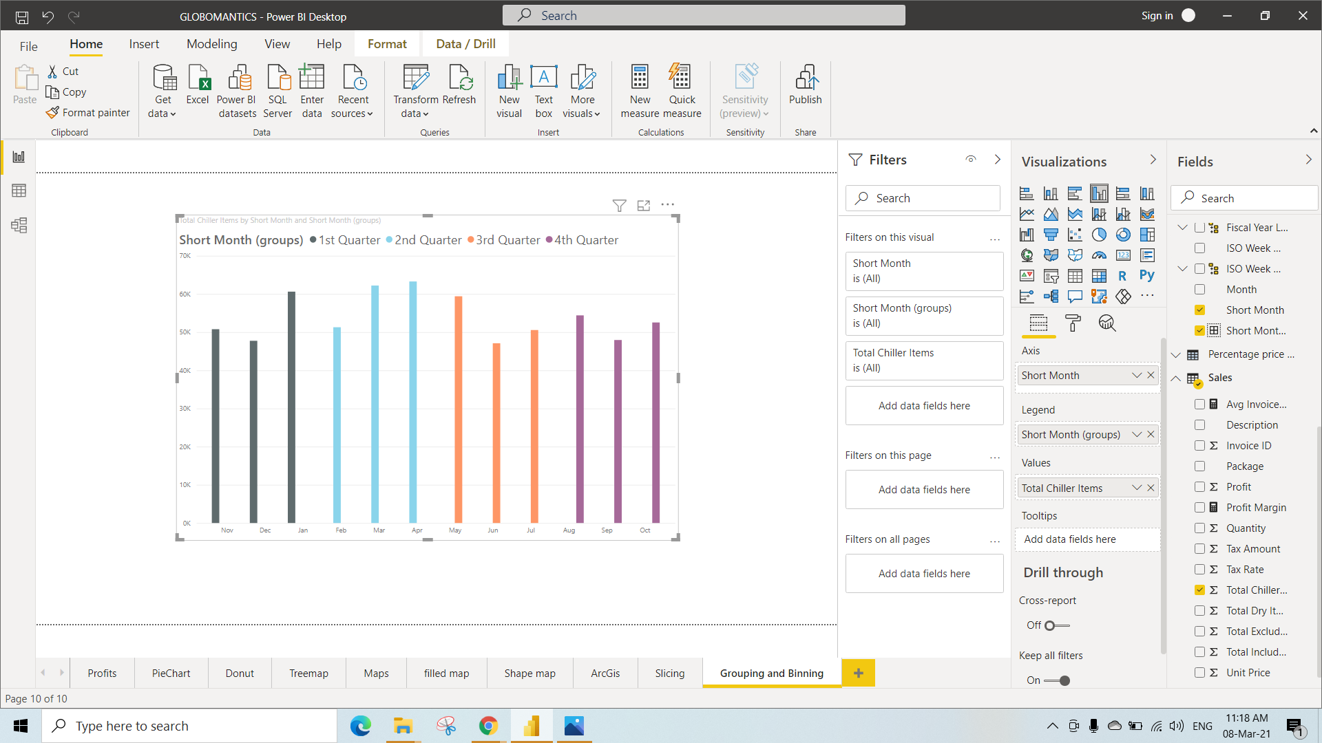

Click on the empty space in the page and Select Clustered Column Chart and We have selected Short Month and Invoice ID columns from the tables so that we can see the grouped data’s in the visualization

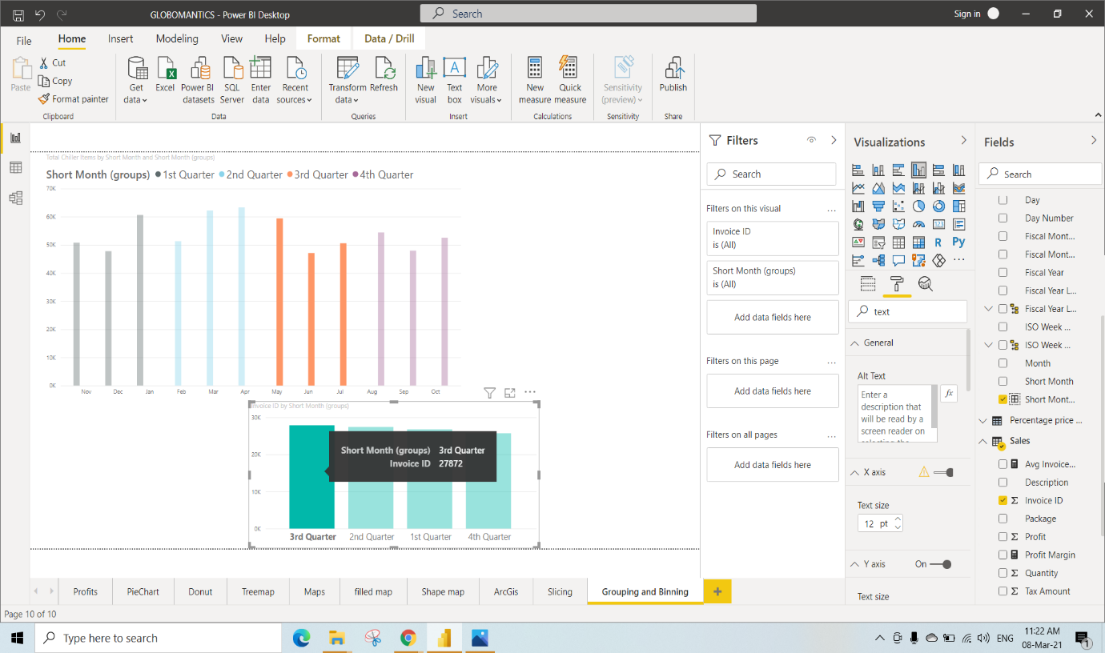

Here we have selected Clustered column Chart and also selected Invoice ID and Profit column from the Table

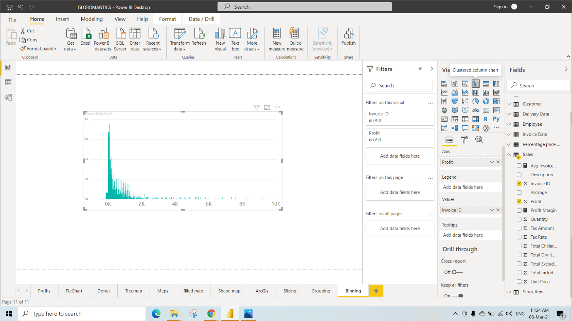

Click on Profit dropdown under fields and select New group

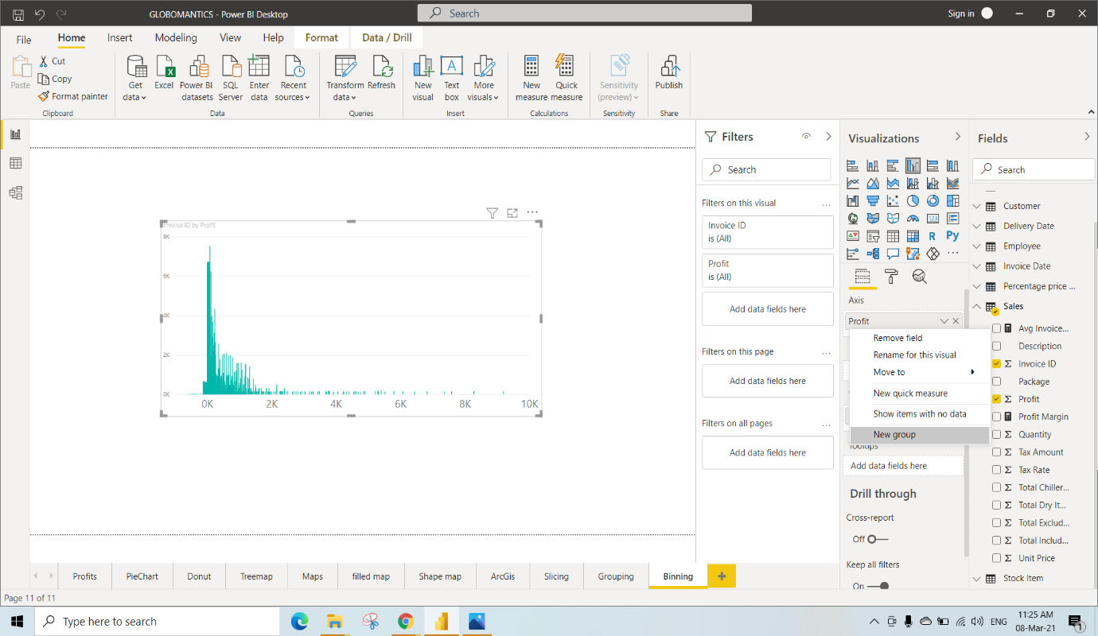

Set Group Type 🡪 Bin

Bin Type 🡪 Number of bins

Bint count 🡪 25 and

Click on OK

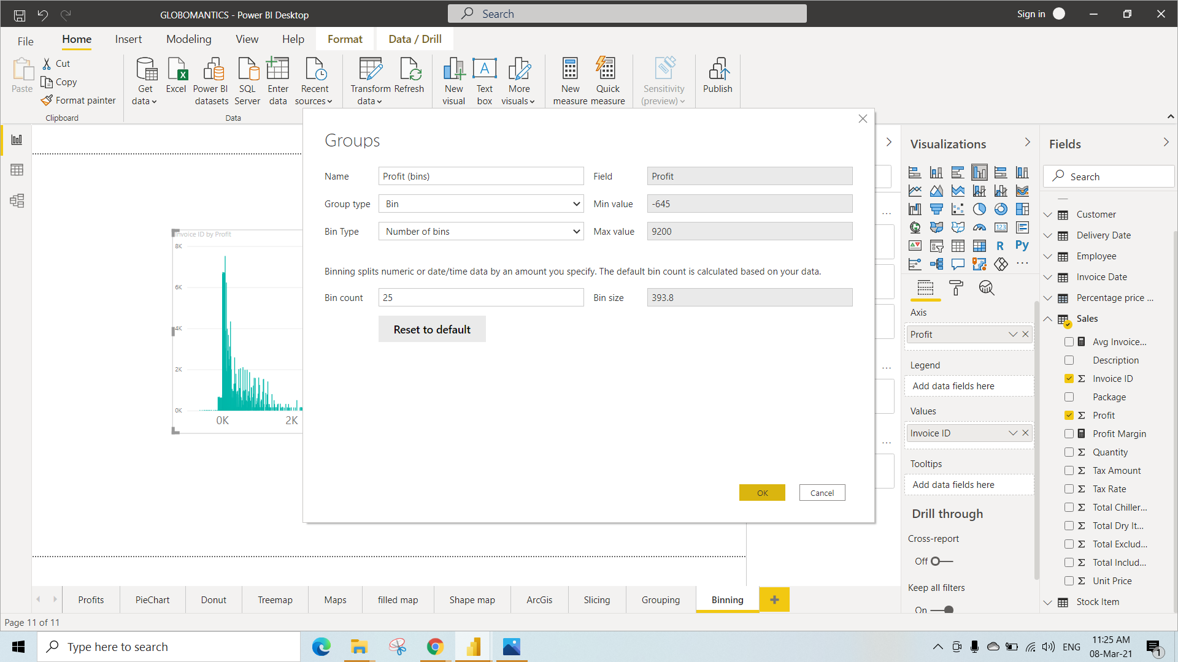

After performing Binning we are able to see this visualization

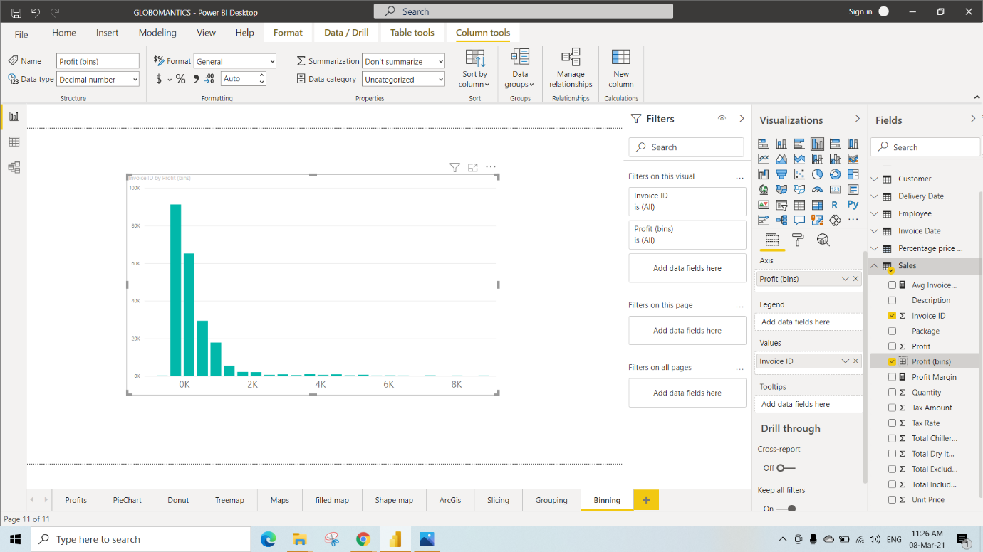

In the Slicing page

Go to Format🡪 Select Edit Interactions so that we are able to see 2options on every visualization one is “Filter” and the other is “None”

In this we have selected None option so that there is no changes in the Table though we have selected employee “Hudson Onslow” In the other table

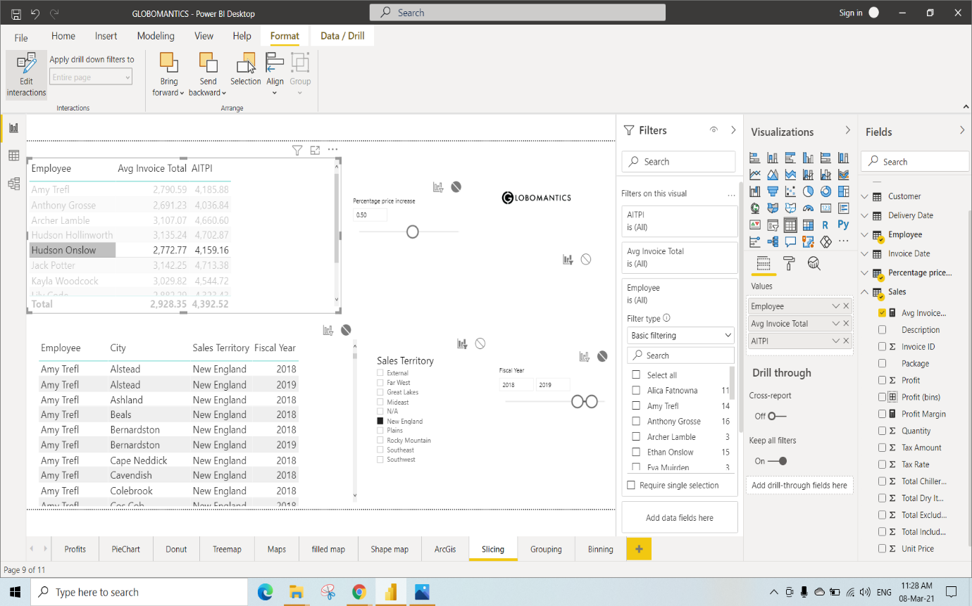

In this we have selected Filter option so that there is changes in the Table.

We have selected employee “Hudson Onslow” so we can only see the data’s related to that Employee named Hudson Onslow

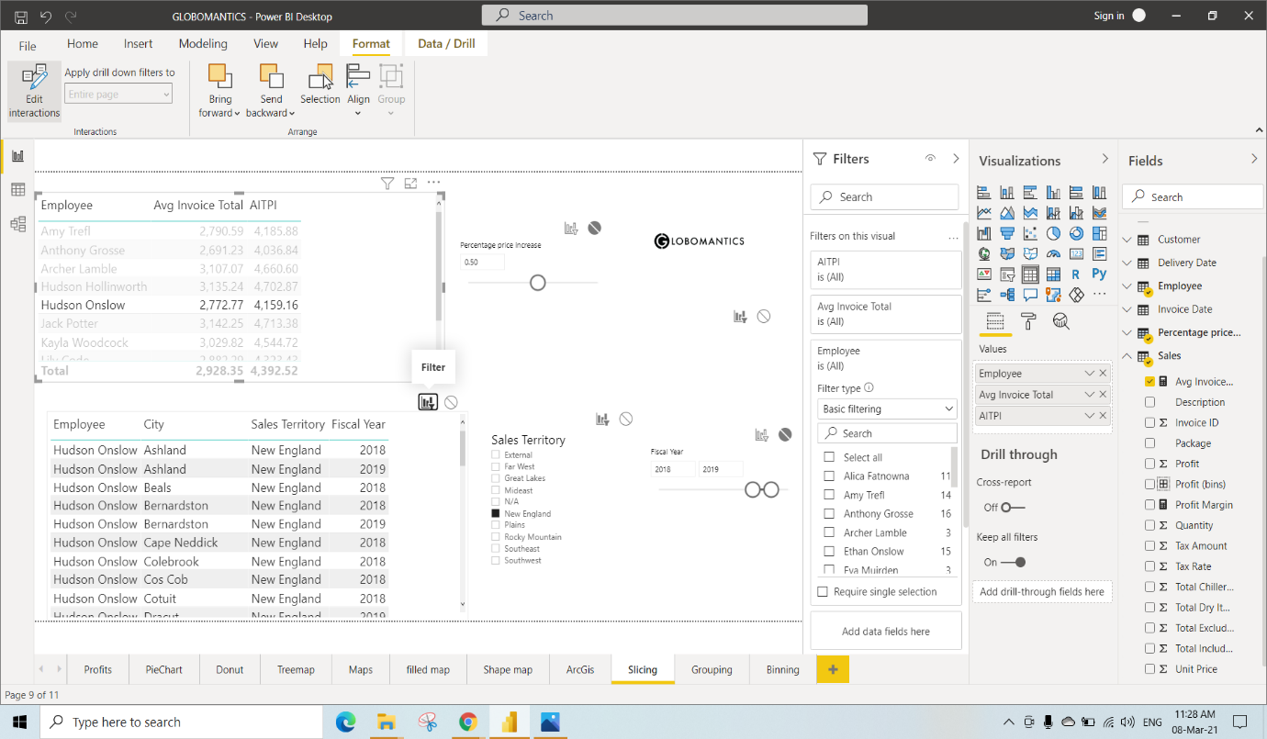

Creating a Dashboard

Step 1: Open Power BI Workspace

Step 2: Click on Get data

Step 3: Click on get under Files

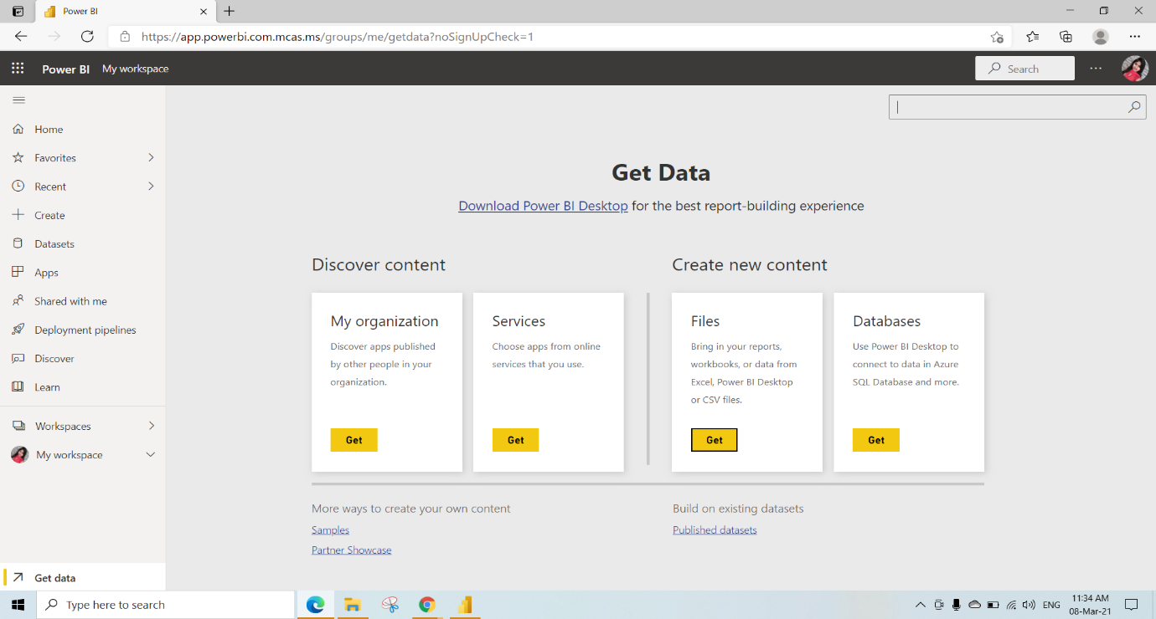

Step 4: Click on Files

Step 5: Select Local File

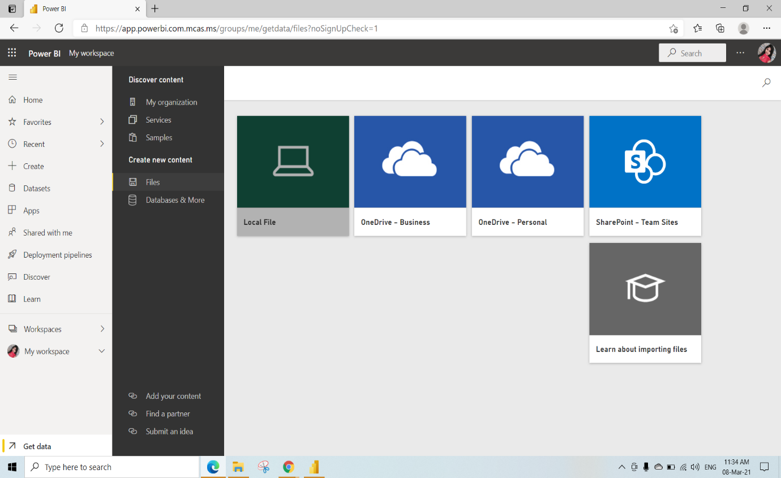

Step 6: Select the pbix File

Step 7: Click on open

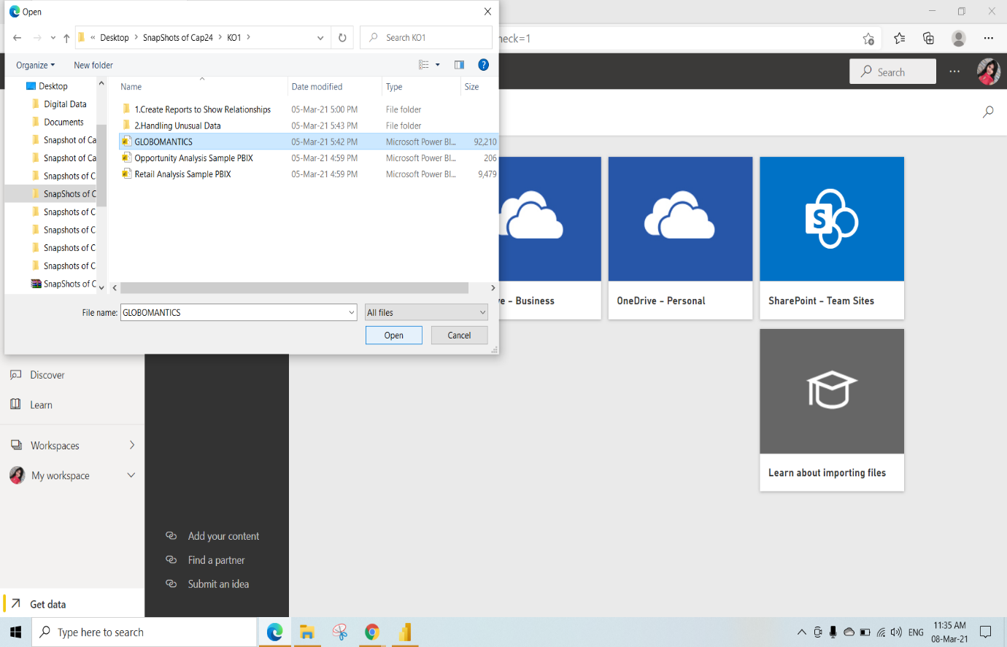

Here we are Importing GLOBOMANTICS.pbix File

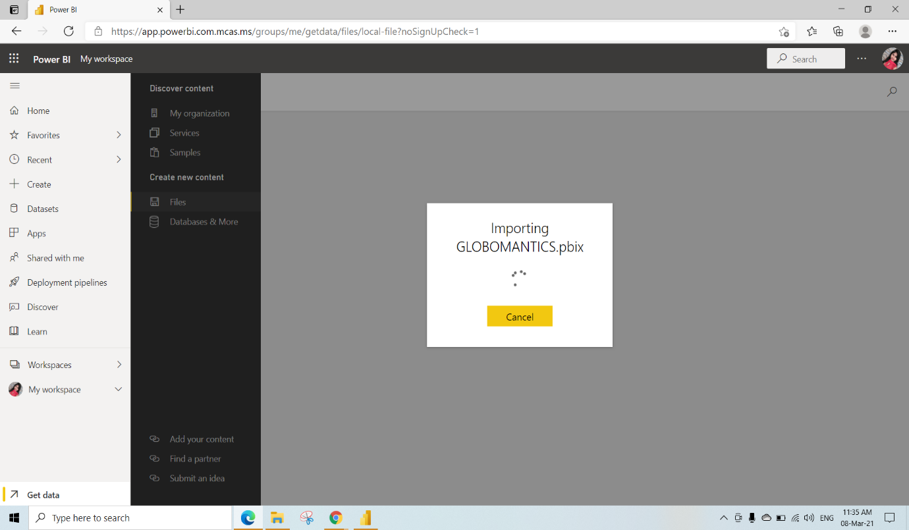

We can see the Imported Globomantics file report

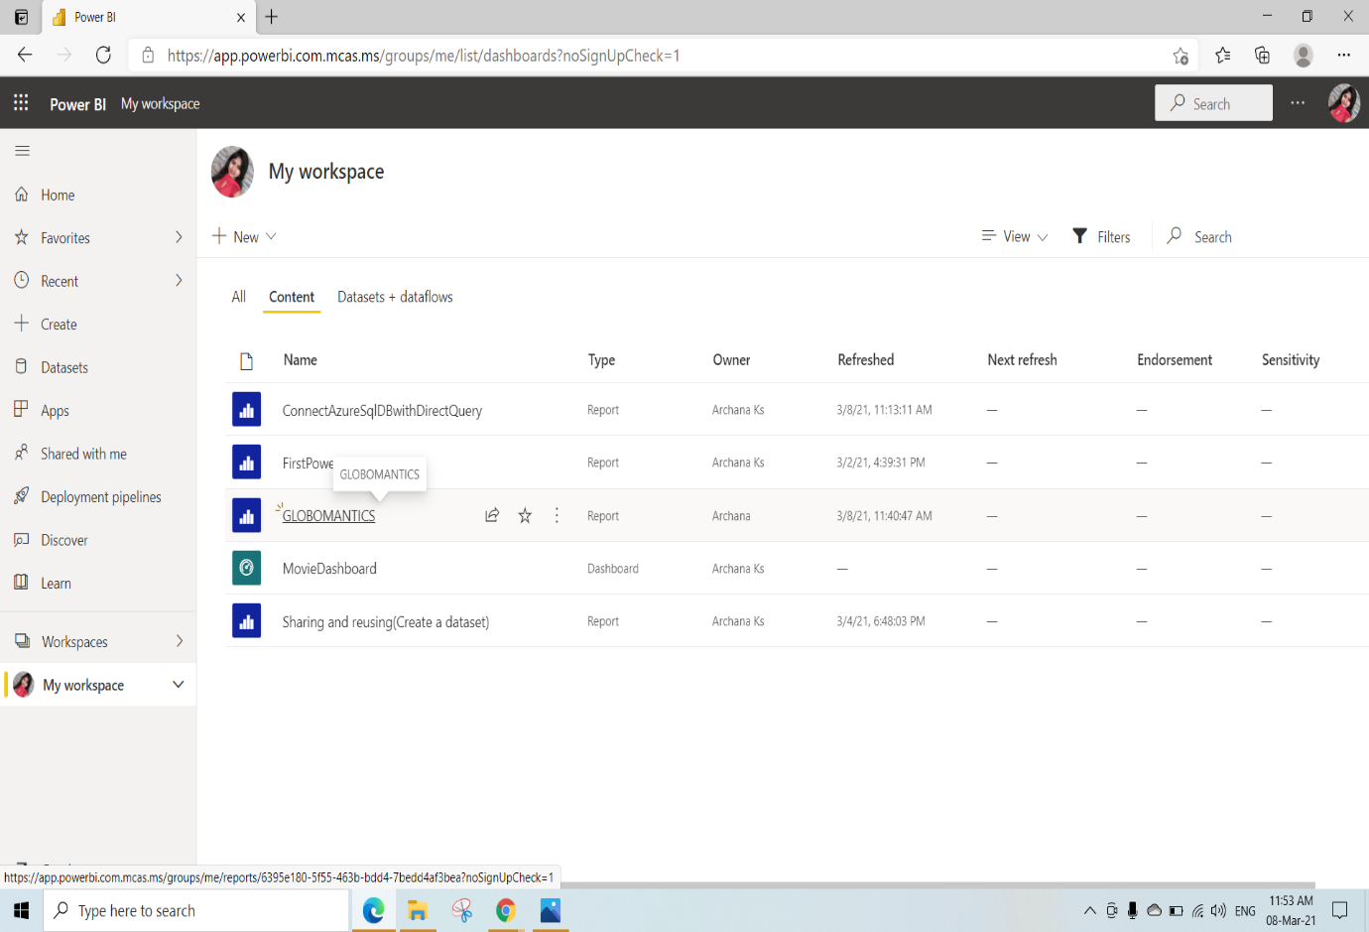

We can see all the Pages which have created in PowerBI Desktop and it can be edited here

We have set

Percentage Price Increase Parameter as 0.60

Sales territory Slicer as Great Lakes

And Fiscal year Slicer in the range as 2018 and 2019

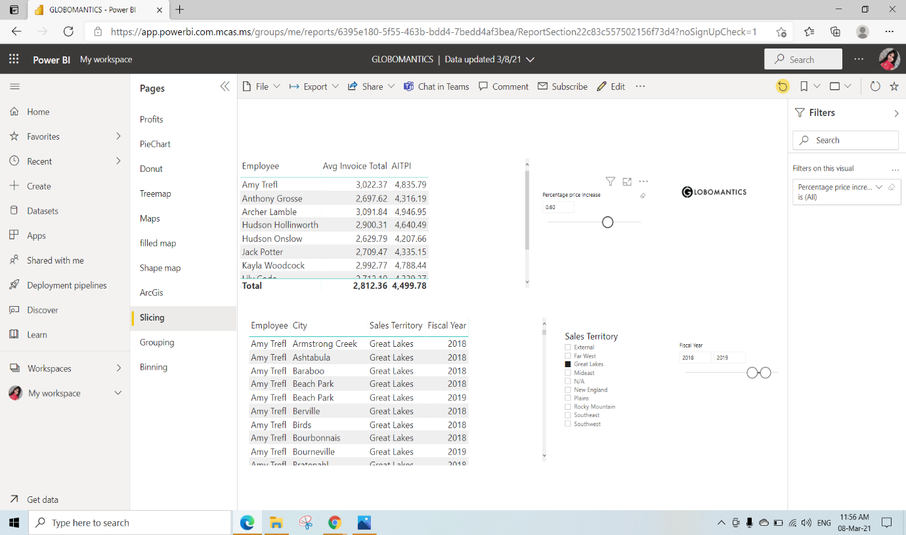

We can also get the Quick Insights of the Reports by clicking on 3dots on the report and by selecting Quick insights

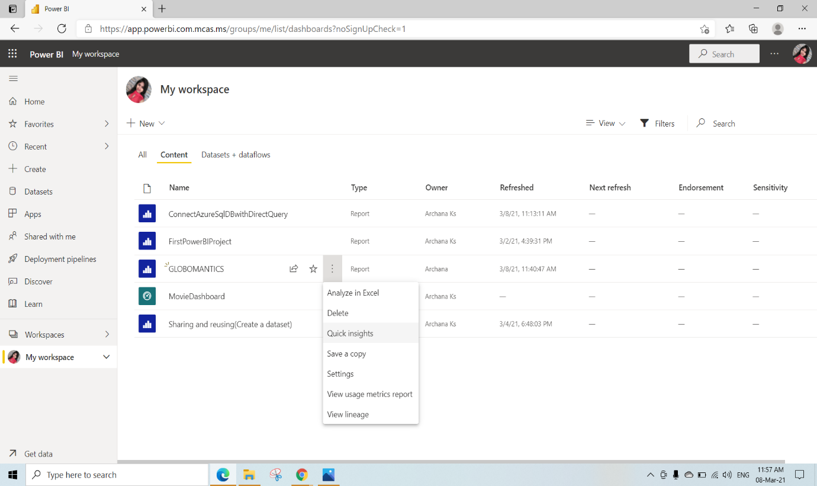

Quick Insights for Globomantics

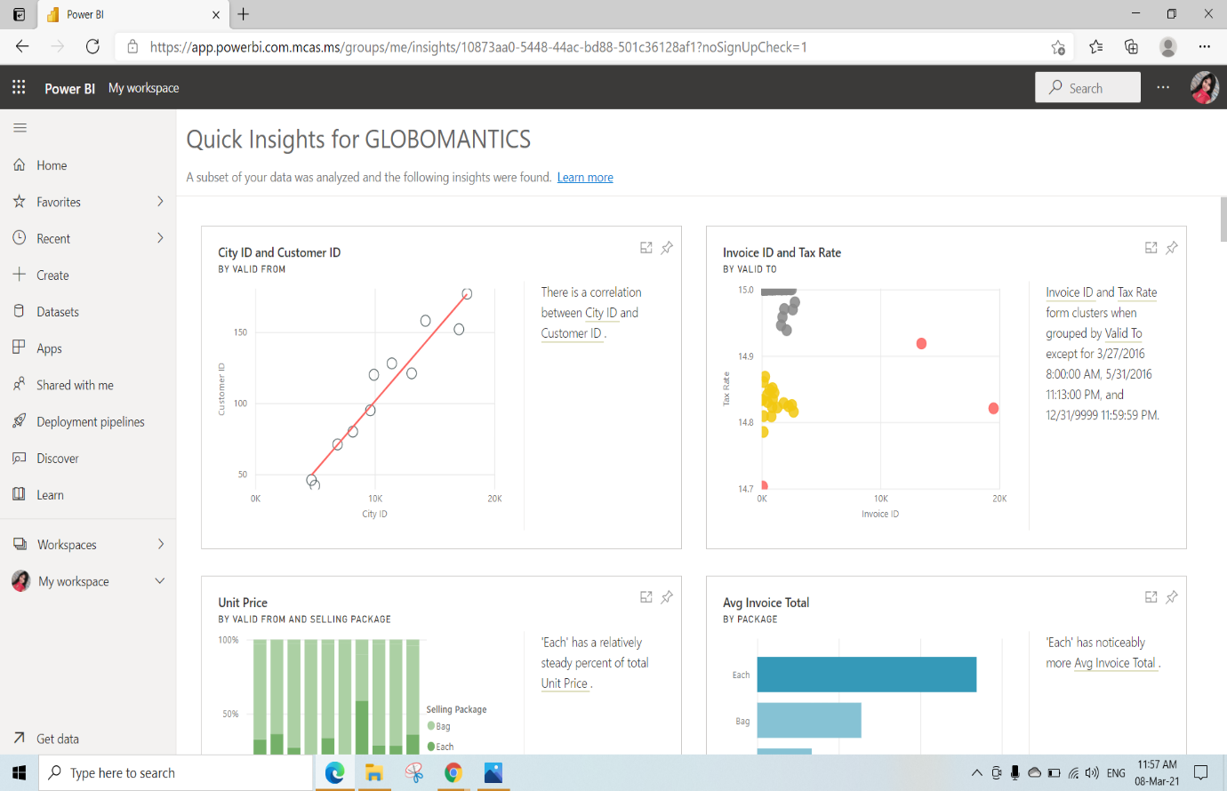

KO3: Able to Design Dashboards for Users, Able to build Dashboard Content, Add Media to Dashboards, Apply Themes and Styles and Manage Dashboards

Difference between Reports and Dashboards

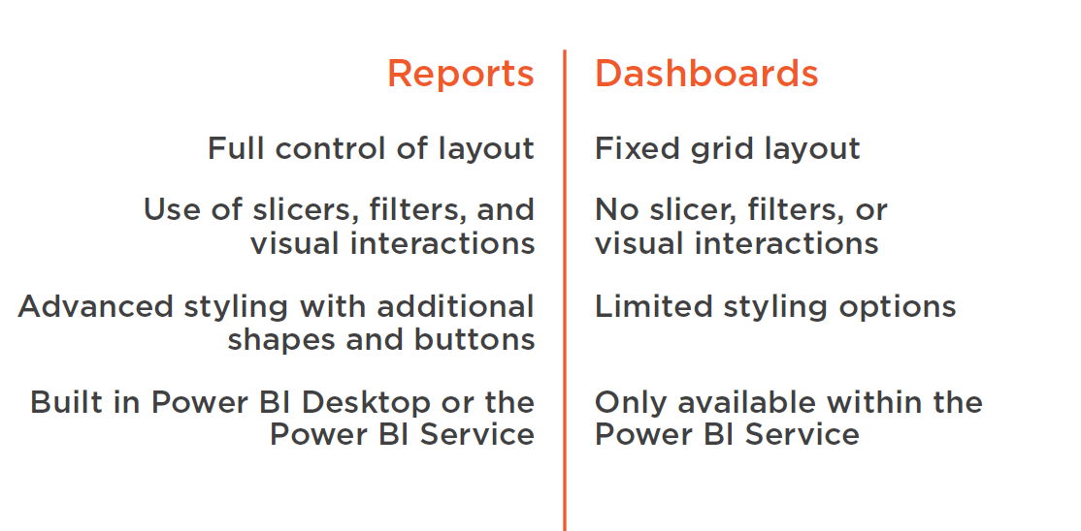

Designing Dashboards for users

Click on “Create a Workspace” to create a new Workspace

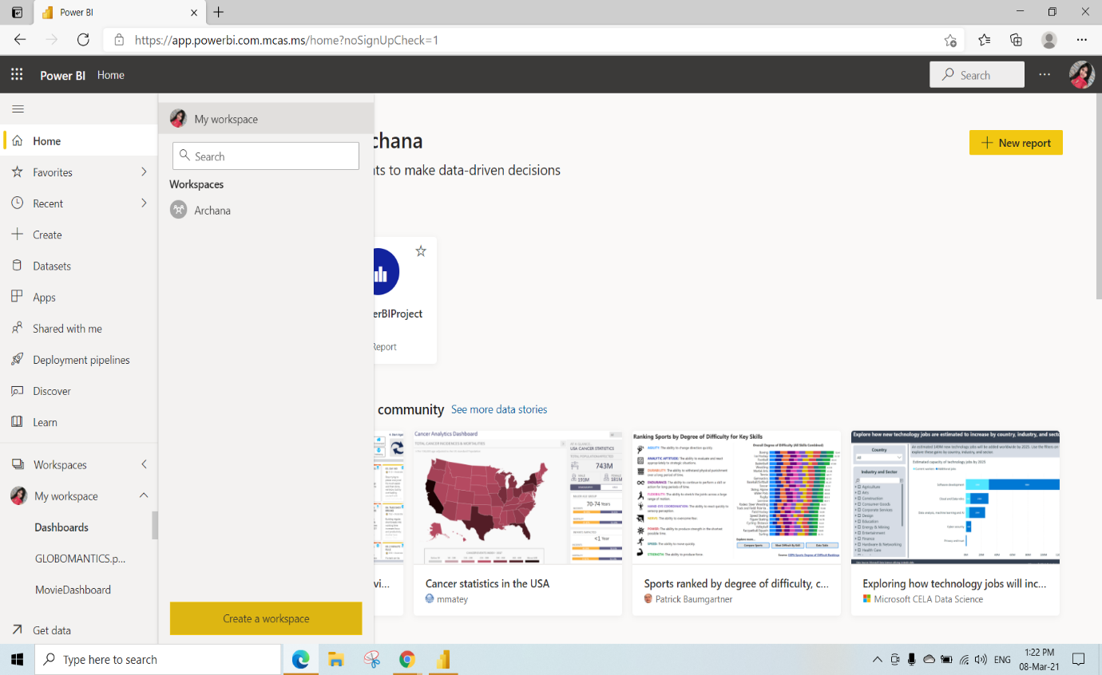

Here we are giving the workspace name as “Sales&Marketing”

Click on Save

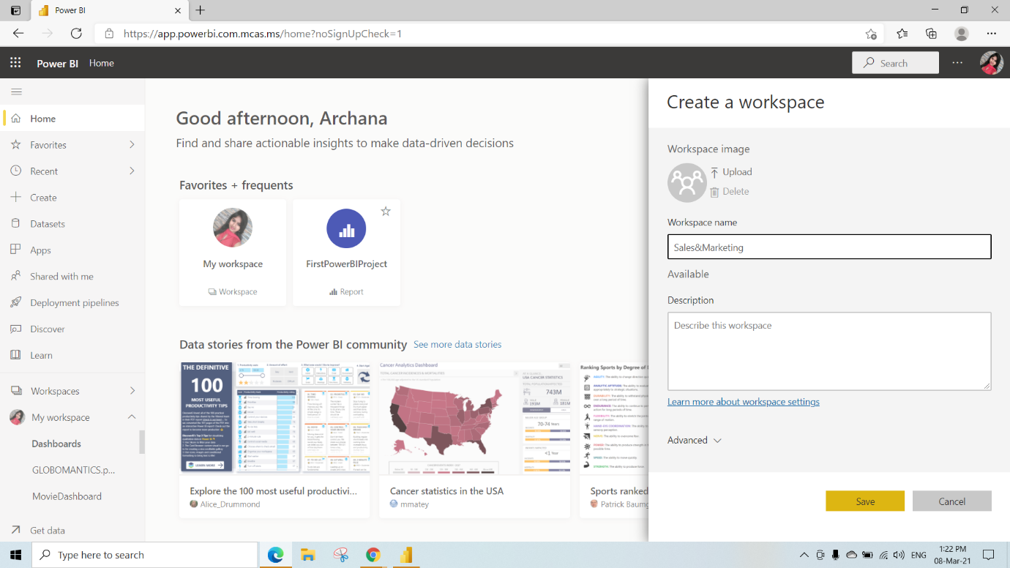

Here we are publishing DesigningDashboardforUsers Files to Sales&Marketing Workspace

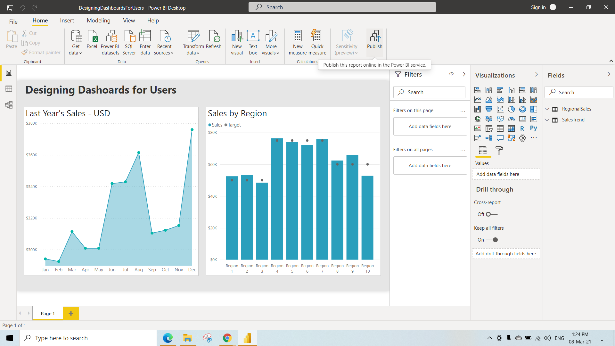

We have Selected Sales&Marketing Workspace and Click on Select

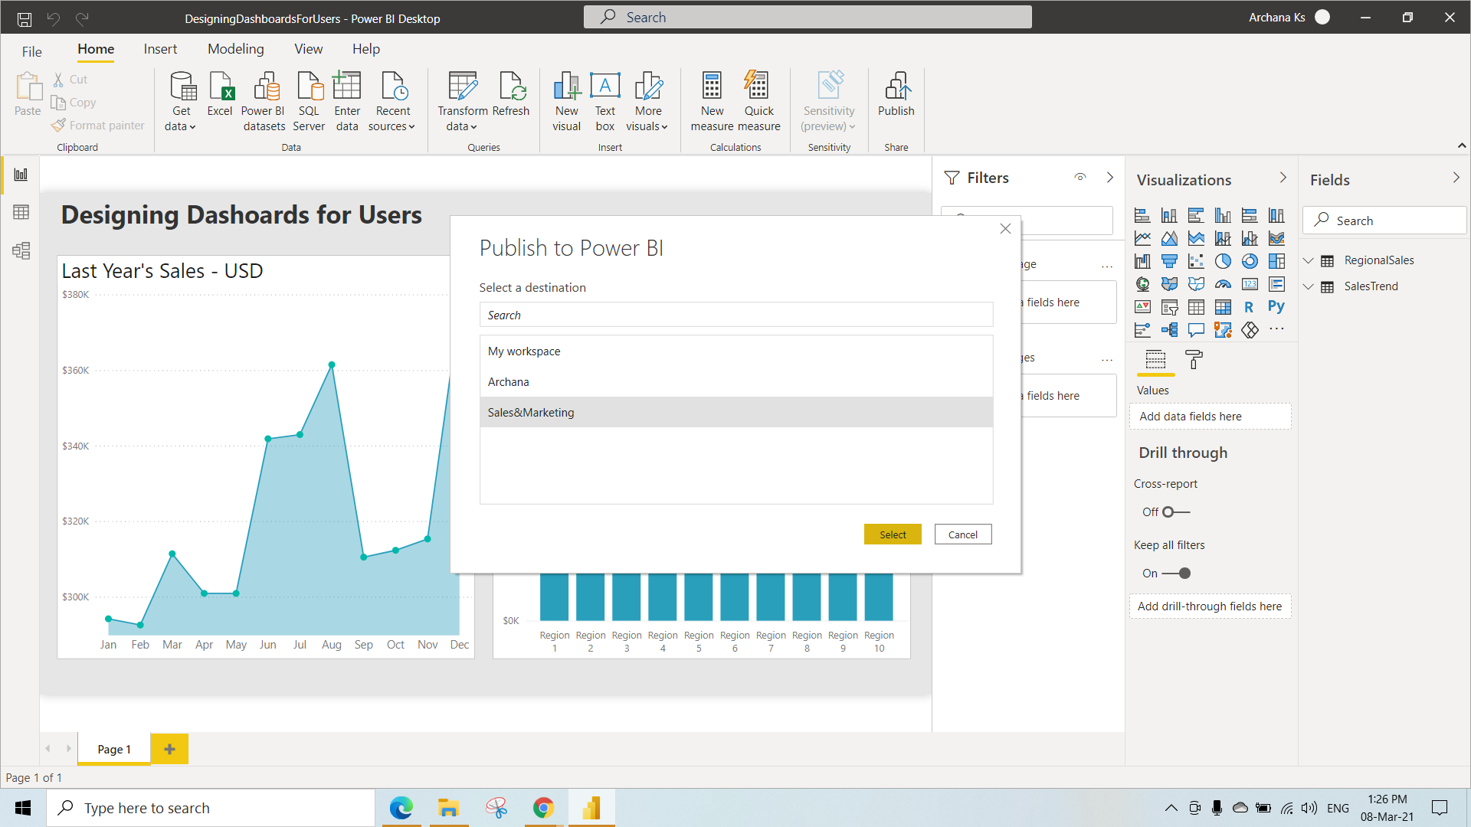

After Publishing the File Just Click on “Open ‘DesigningDashboardForUsers.pbix’ in PowerBI” File Then it will redirected to the Workspace

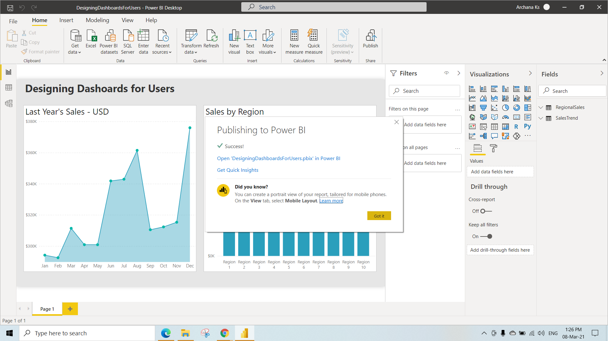

Here we have switched off the legend so we cannot see the labels of Sales&Target in the Sales by Region visualization

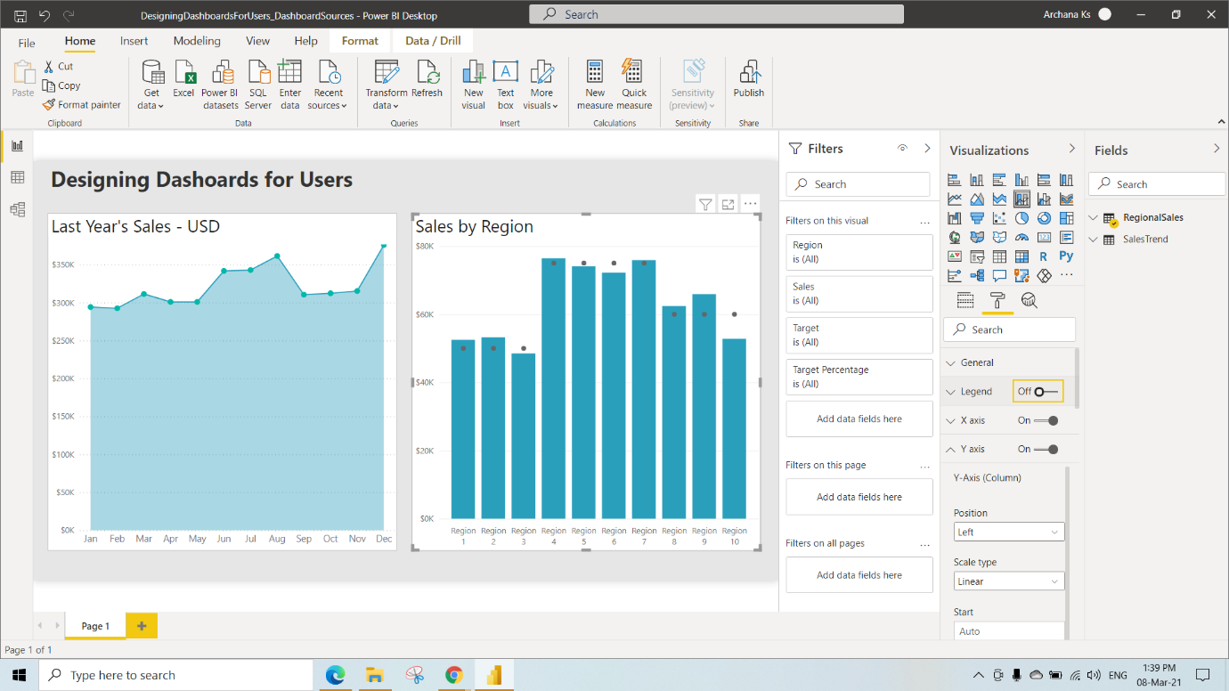

We can change the data colours of the visualization by clicking on Data Colours under the Format and click on fx as shown(We can select any Data Colours) We have selected Based on field as TargetMet and Click on OK

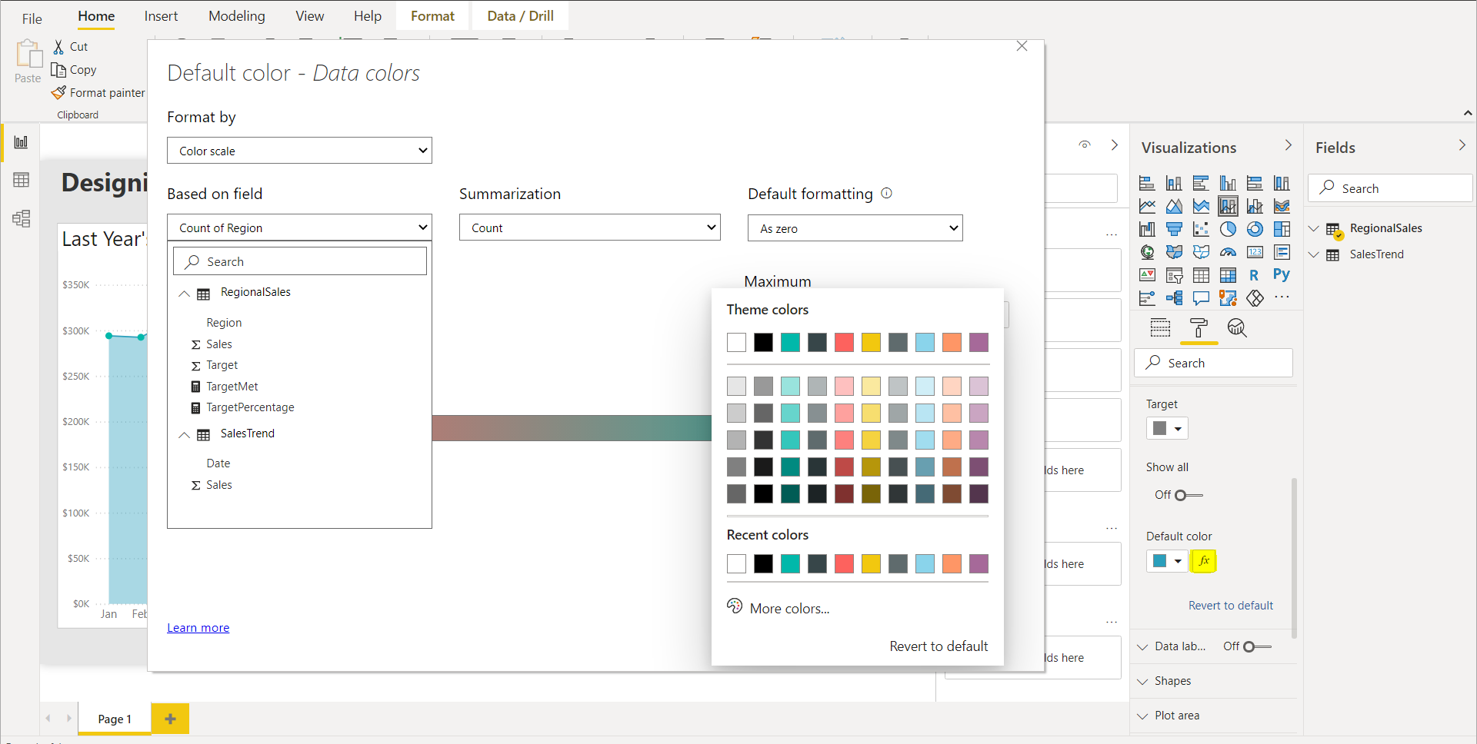

After Changing the Data Colour we can see this Visual

Here we have performed filtering on Regions by selecting dropdown near Region under the filter type as TopN and show Items as Bottom 5 and Filtered based on target Percentage column so that we can see the 5 least sales Region

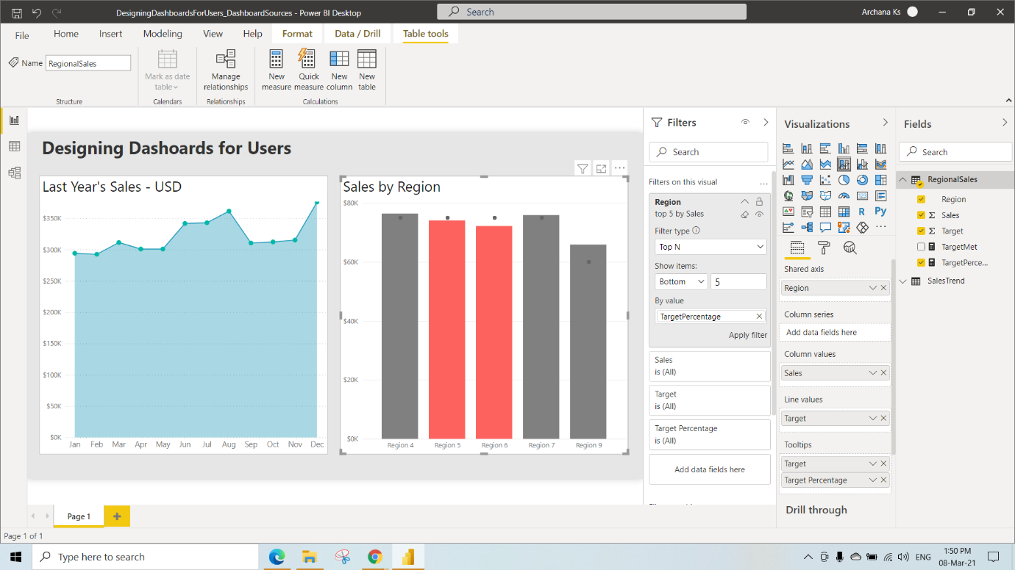

We can sort the Regions by Sales under this Visualization by Clicking 3dots 🡪 Sort By 🡪 Sales

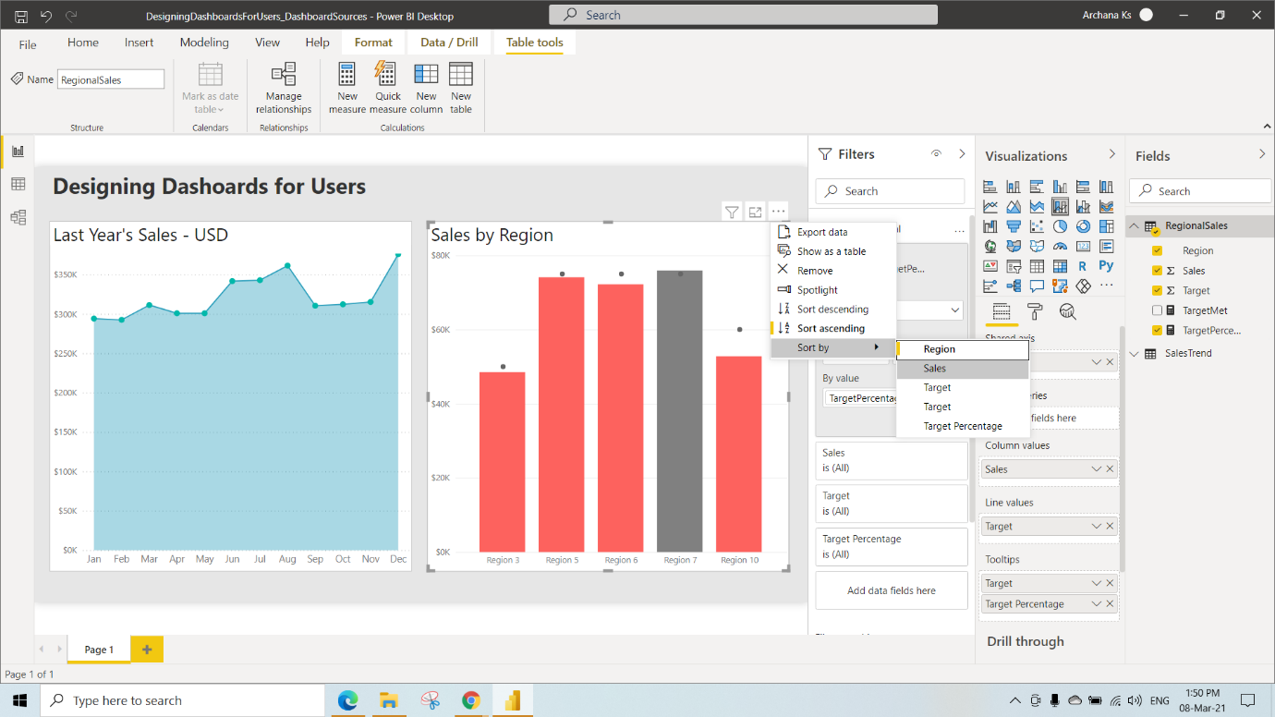

Here we have renamed the visual as Lowest Performing Regions under the Format in Title Text

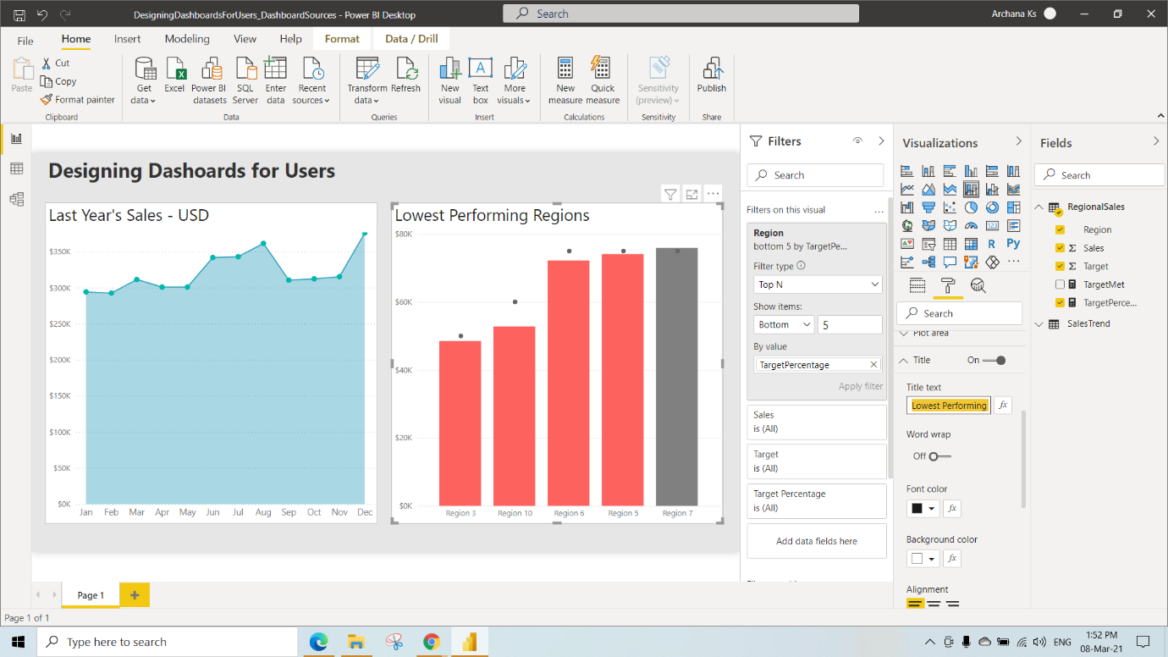

We have Created a Sales Dashboard and pinned both the Visuals to that dashboard after Publishing the report

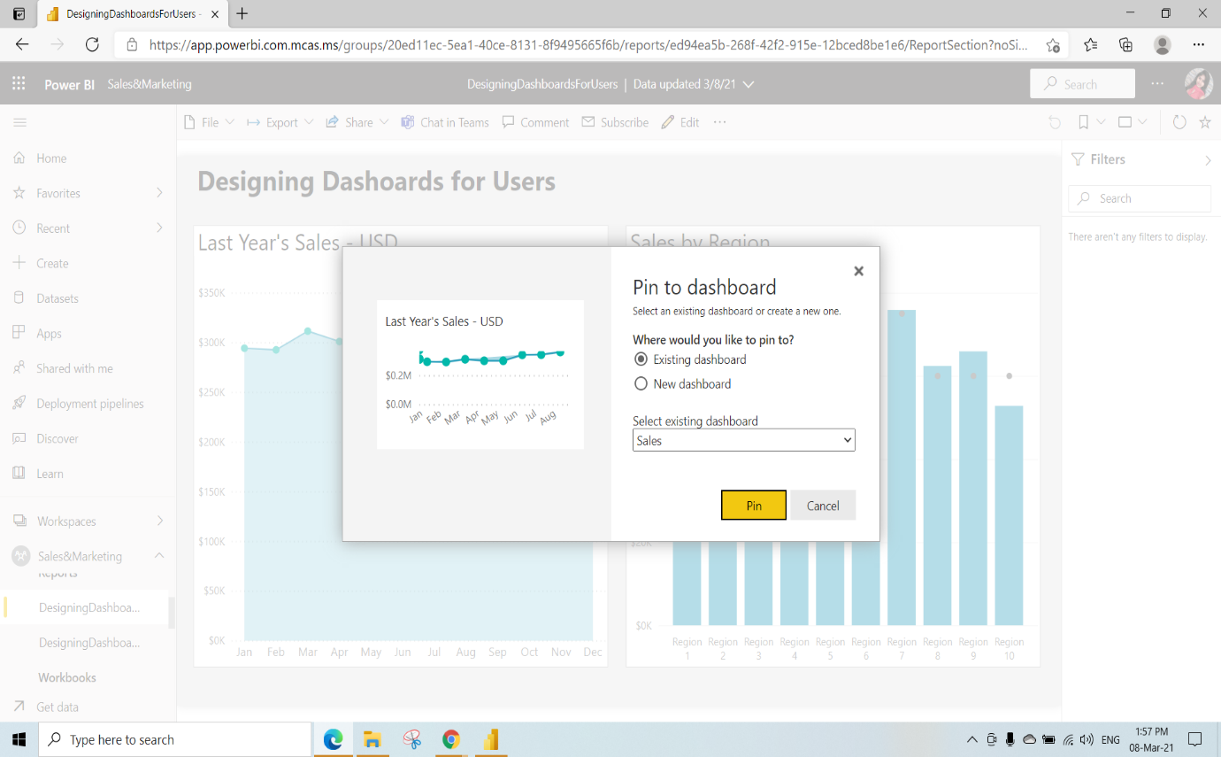

Click on Go to dashboard

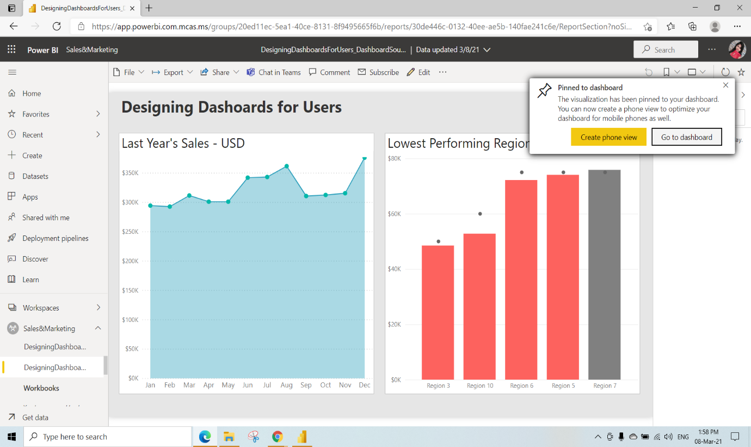

This is the Dashboard View

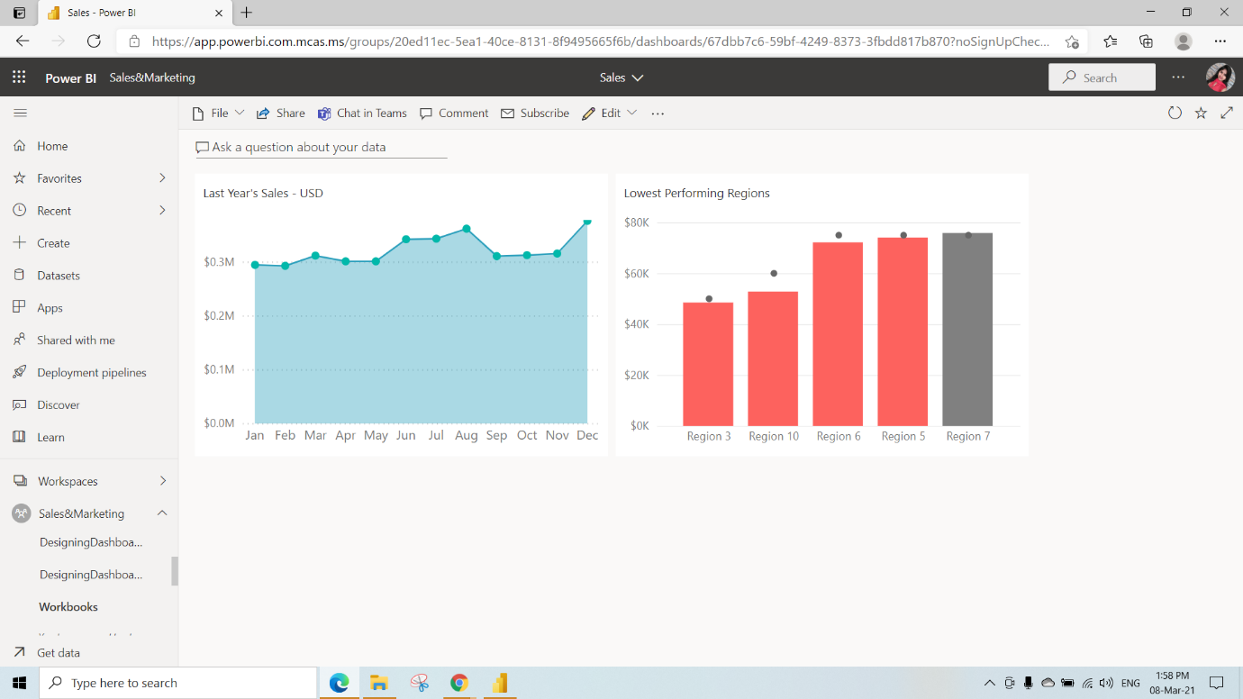

We can edit the details in the Dashboard

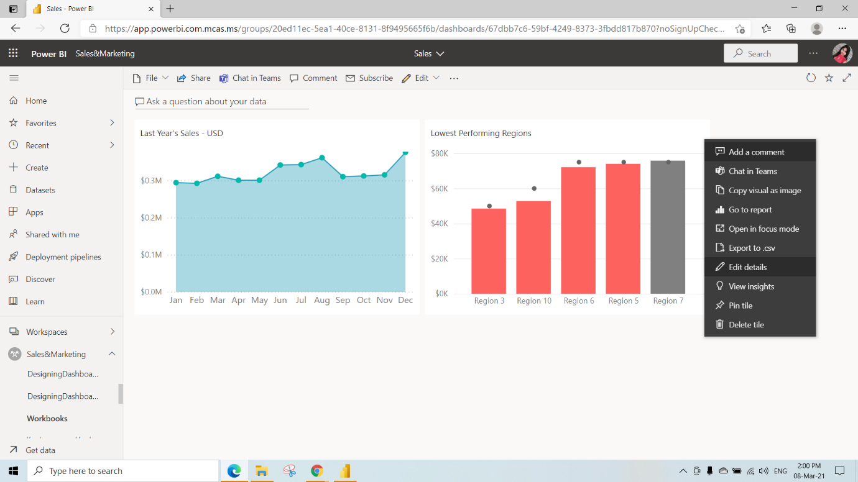

We can set the Custom link(when we click on that visual where we need to go)Select the link type as Link to Dashboard or report in the current Workspace and Click on Apply

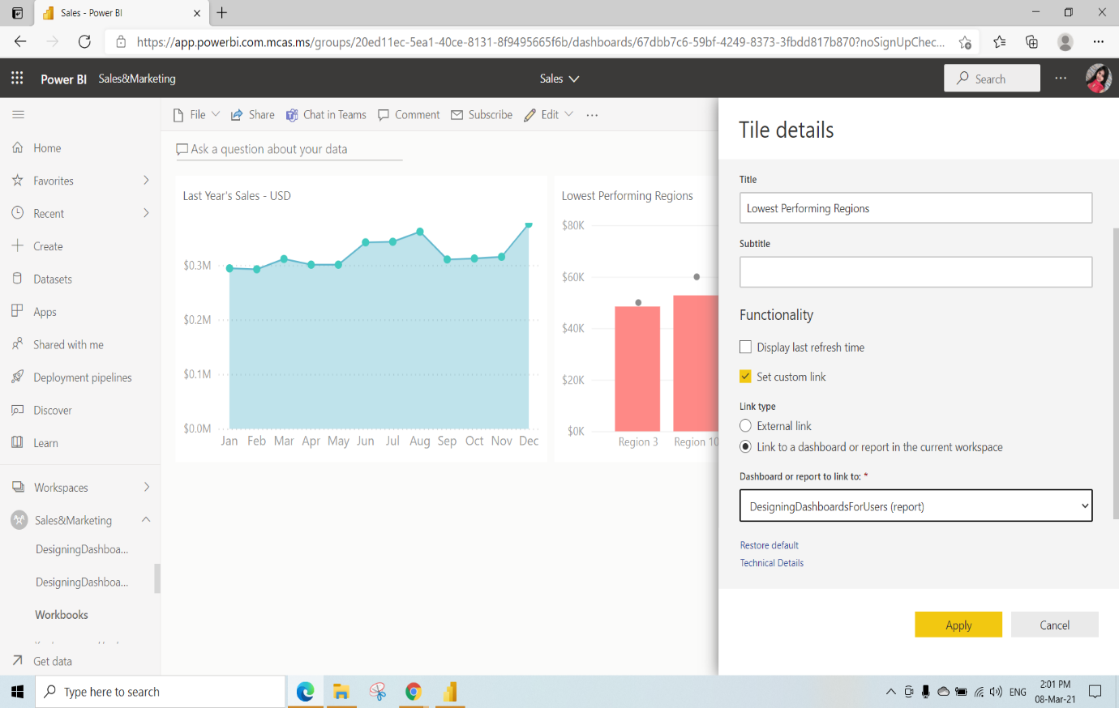

Here we have removed the last year’s Sales – USD Visual

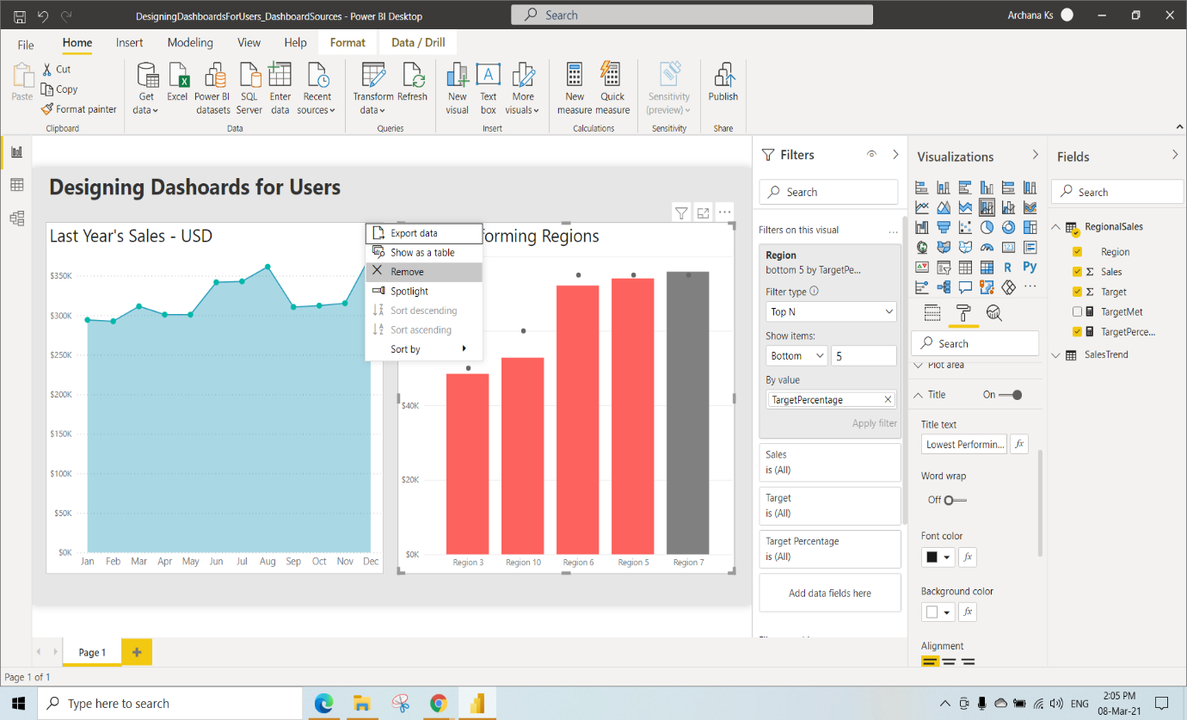

And Copy the Lowest Performing Regions Visual and Paste it beside this

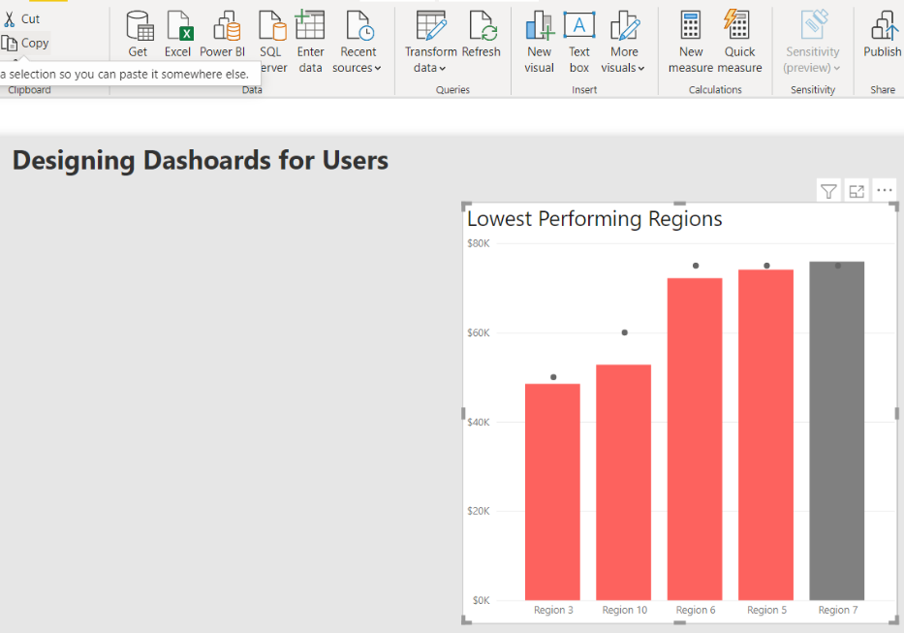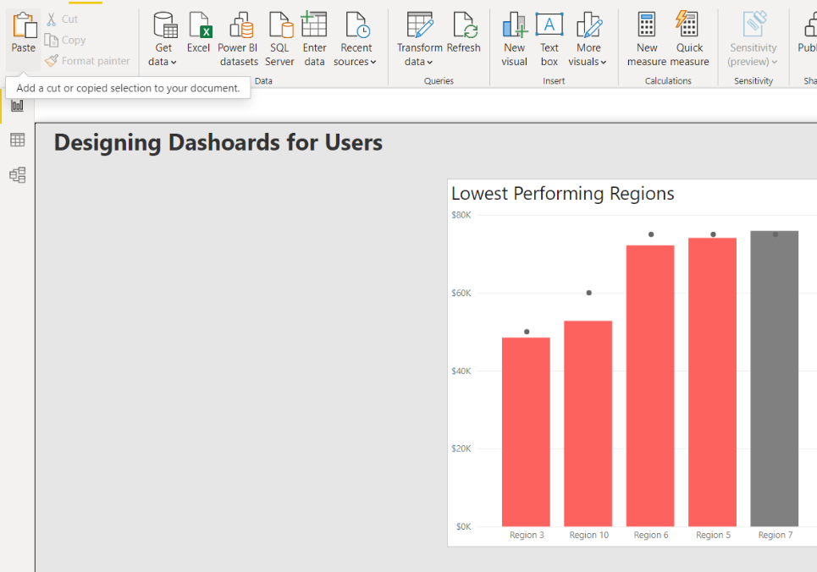

After pasting

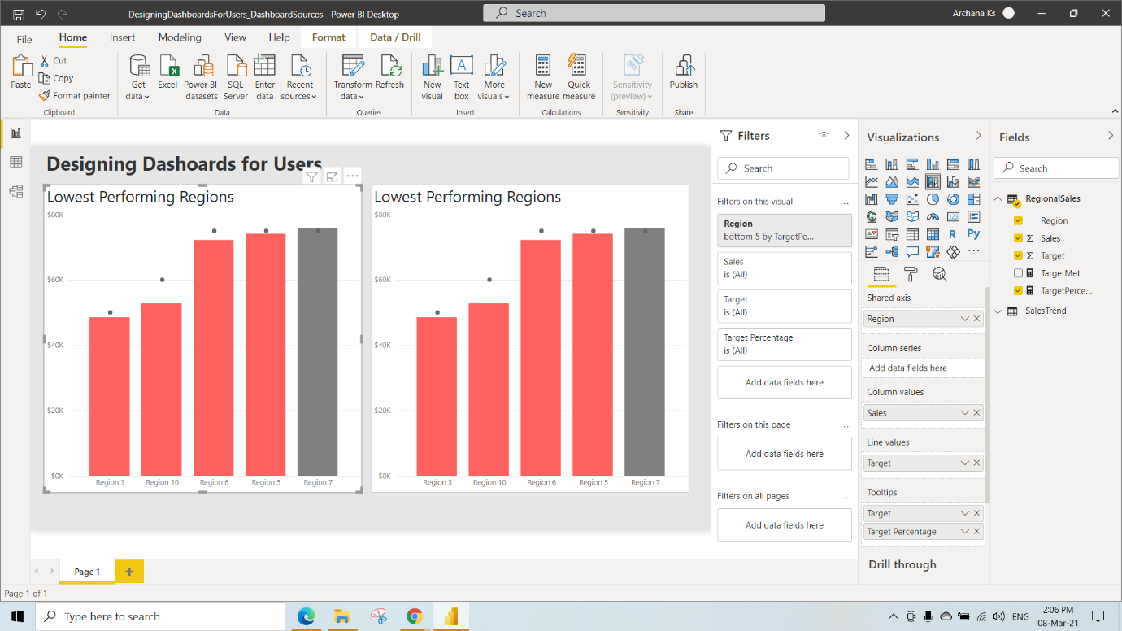

Rename the pasted visual as Best Performing Regions

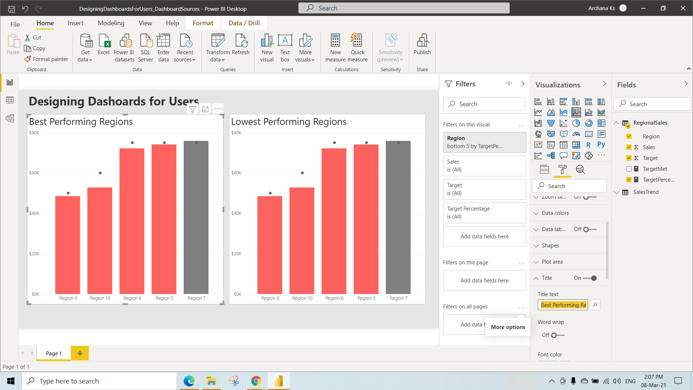

Here we have performed filtering on Regions by selecting dropdown near Region under the filter type as TopN and show Items as Top 3 and Filtered based on target Percentage column so that we can see the 3 Top sales Region

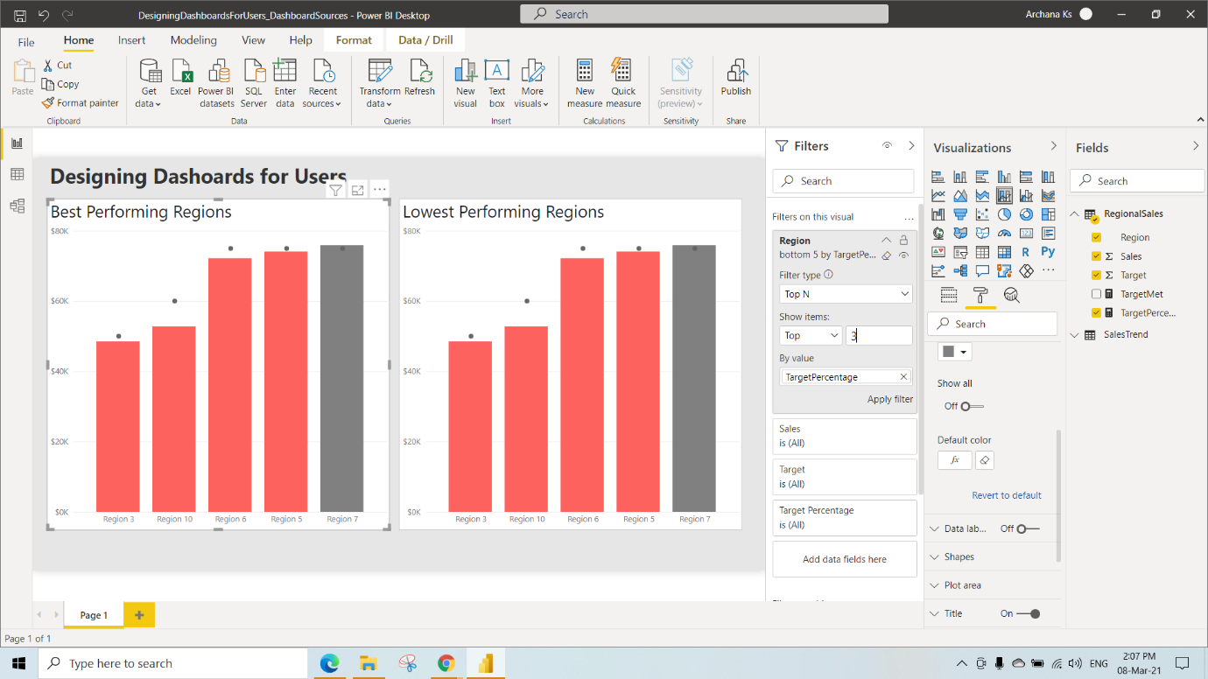

Change the Data Colours

After Changing the Data Colour we can see this Visual

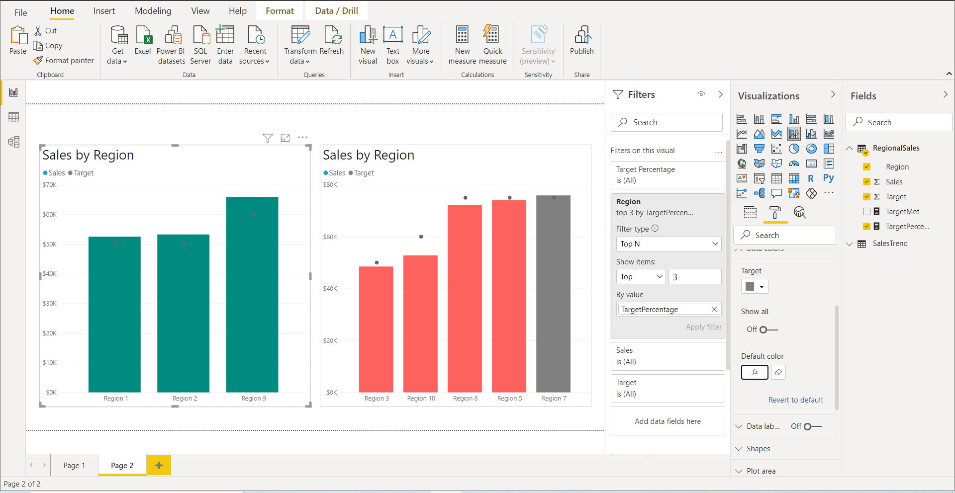

We have pinned this Best Performing Regions to New dashboard named as Sales Legend

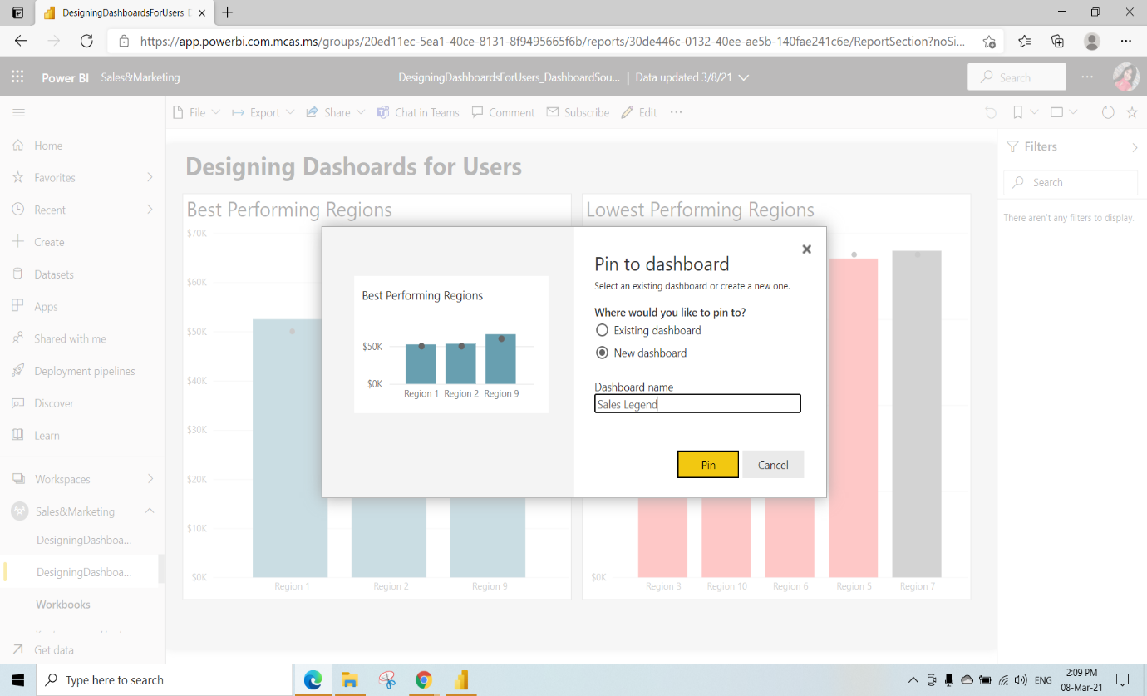

Click on Go to dashboard

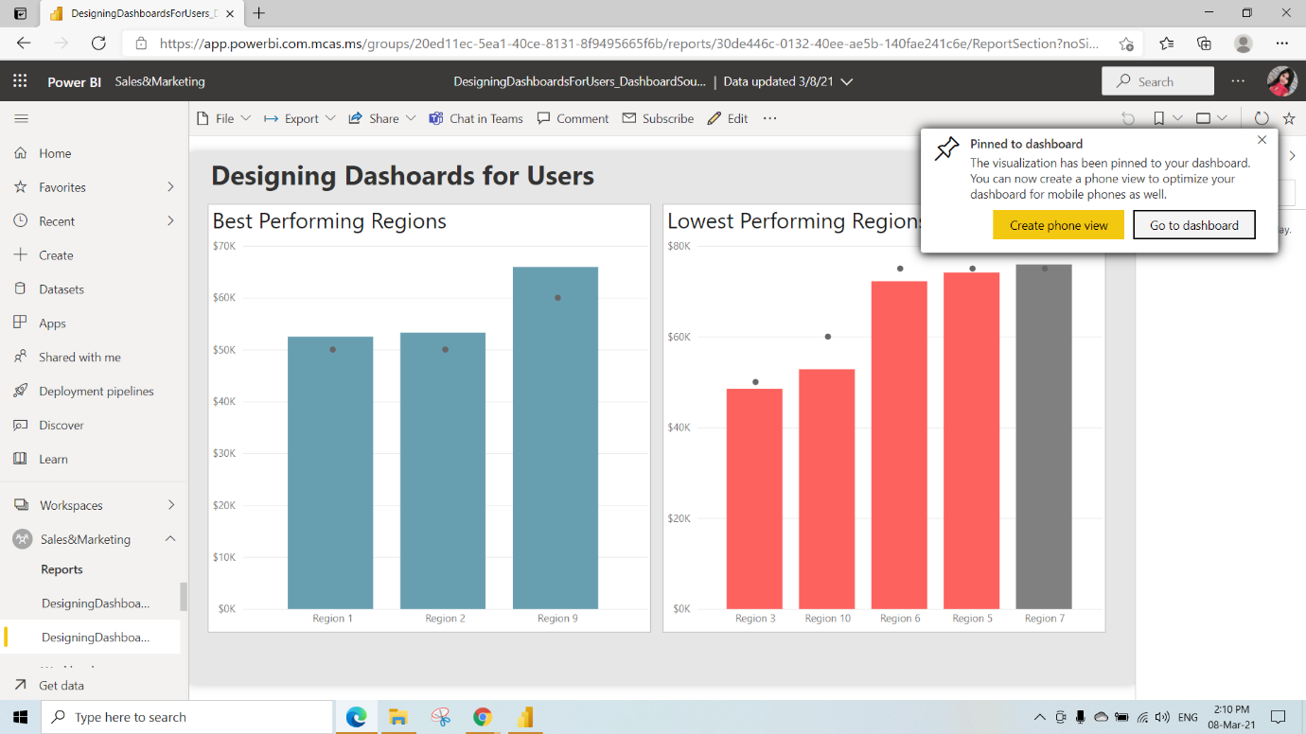

We can set the Custom link(when we click on that visual where we need to go)Select the link type as Link to Dashboard or report in the current Workspace and Click on Apply

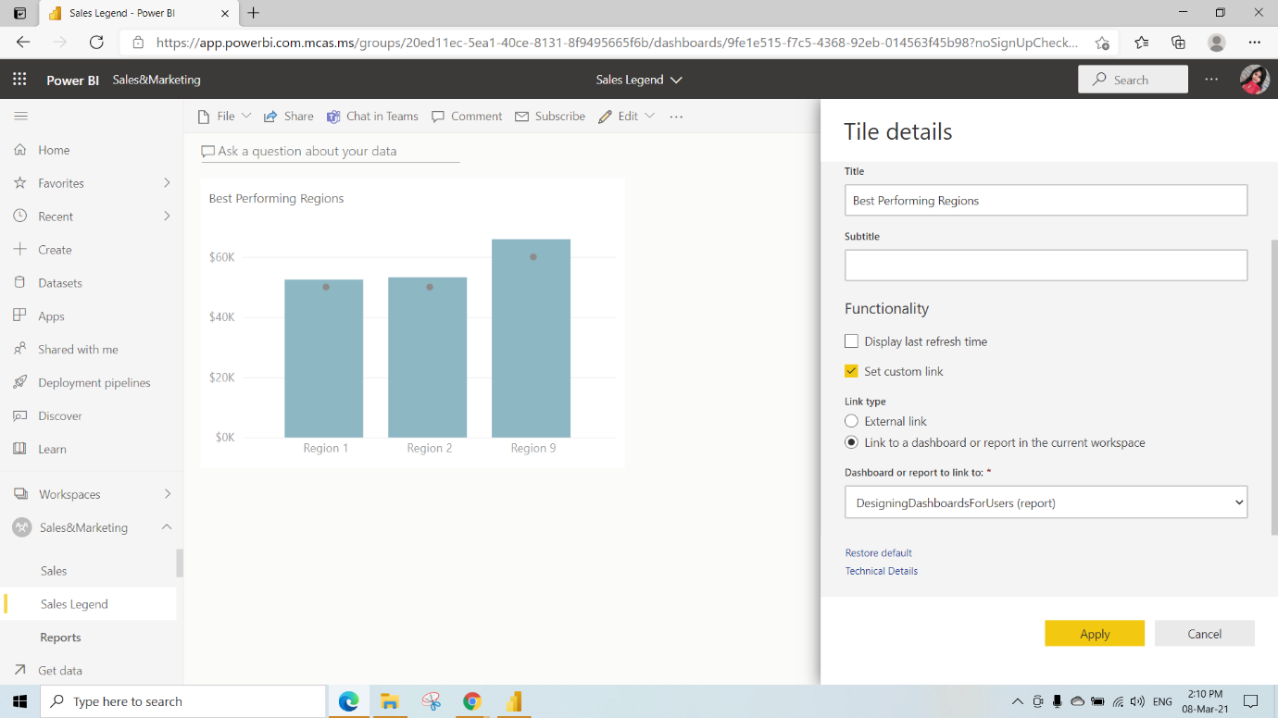

Build Dashboard Content

Click on Create a Workspace

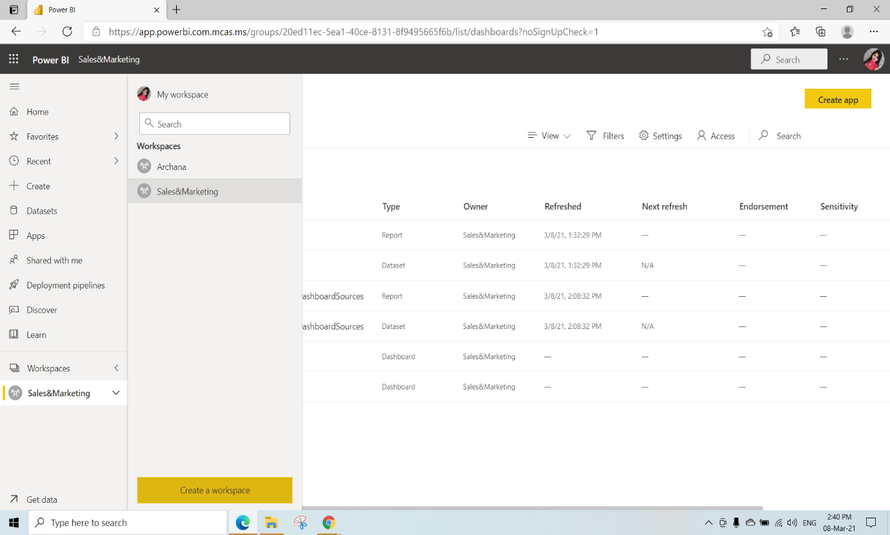

Here we have given the workspace name as globomantics and click on Save

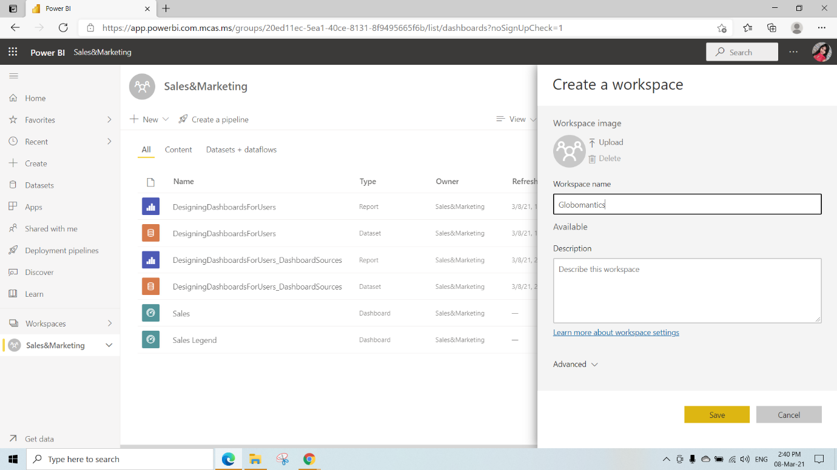

Here we are publishing the SalesDashboardSources File to the Globomantics workspace

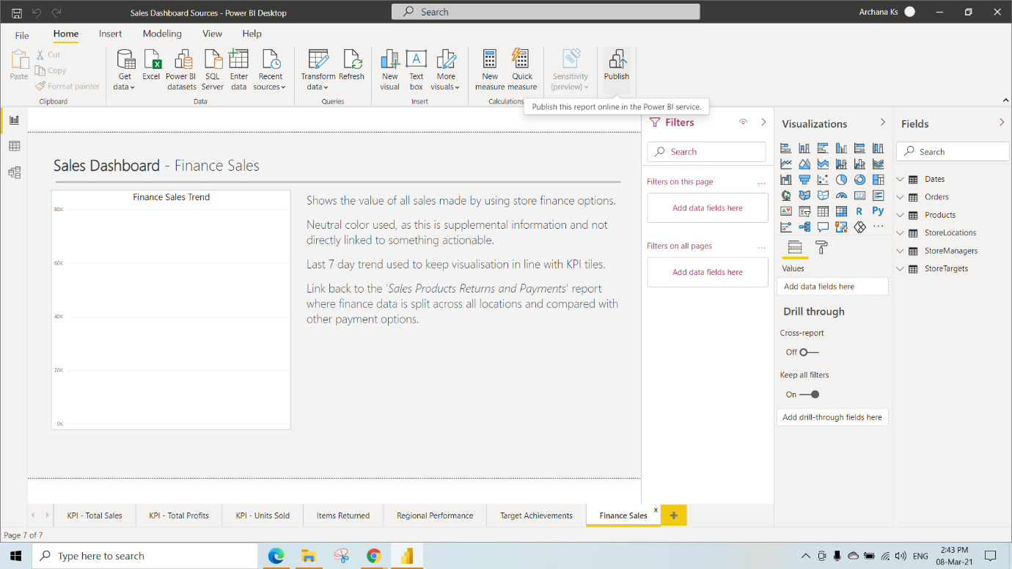

Have to Select Globomantics and click on Select

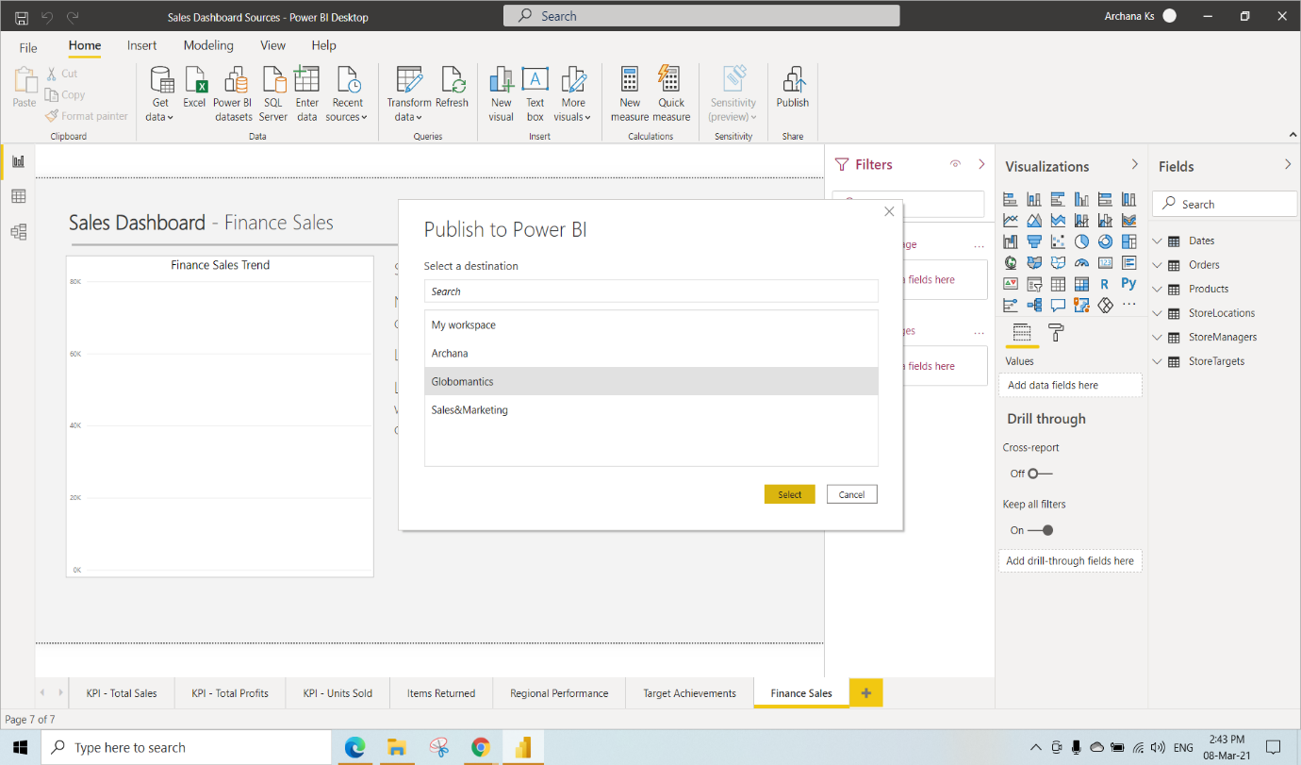

After Publishing click on that “open’ Sales Dashboard Sources.pbix’ in Power BI” link

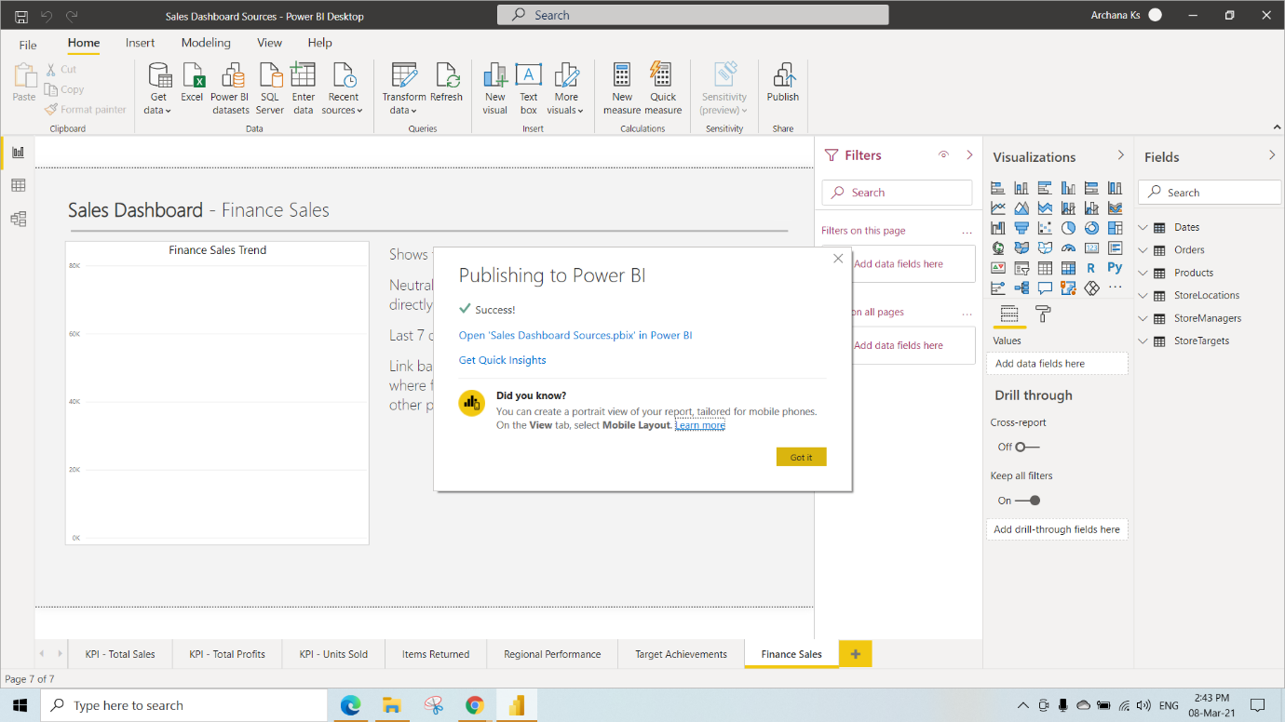

We can see the published report click on that report

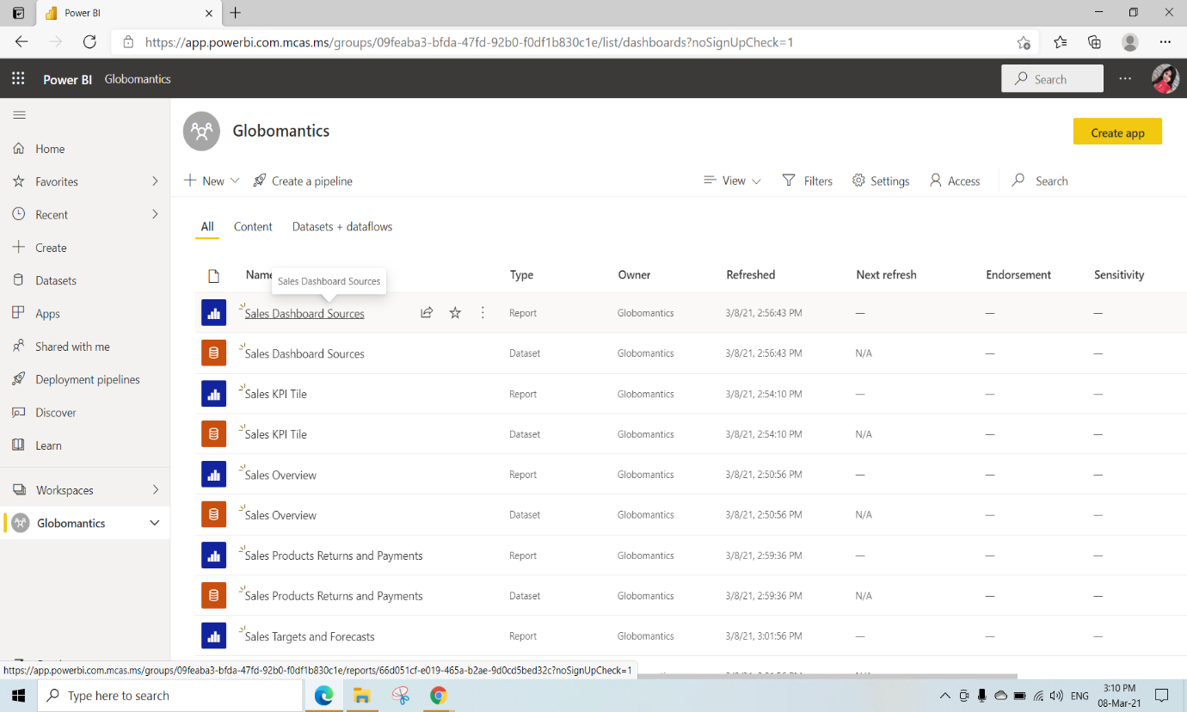

Here we need to pin that Total Sales KPI to a new Dashboard named as Sales overview

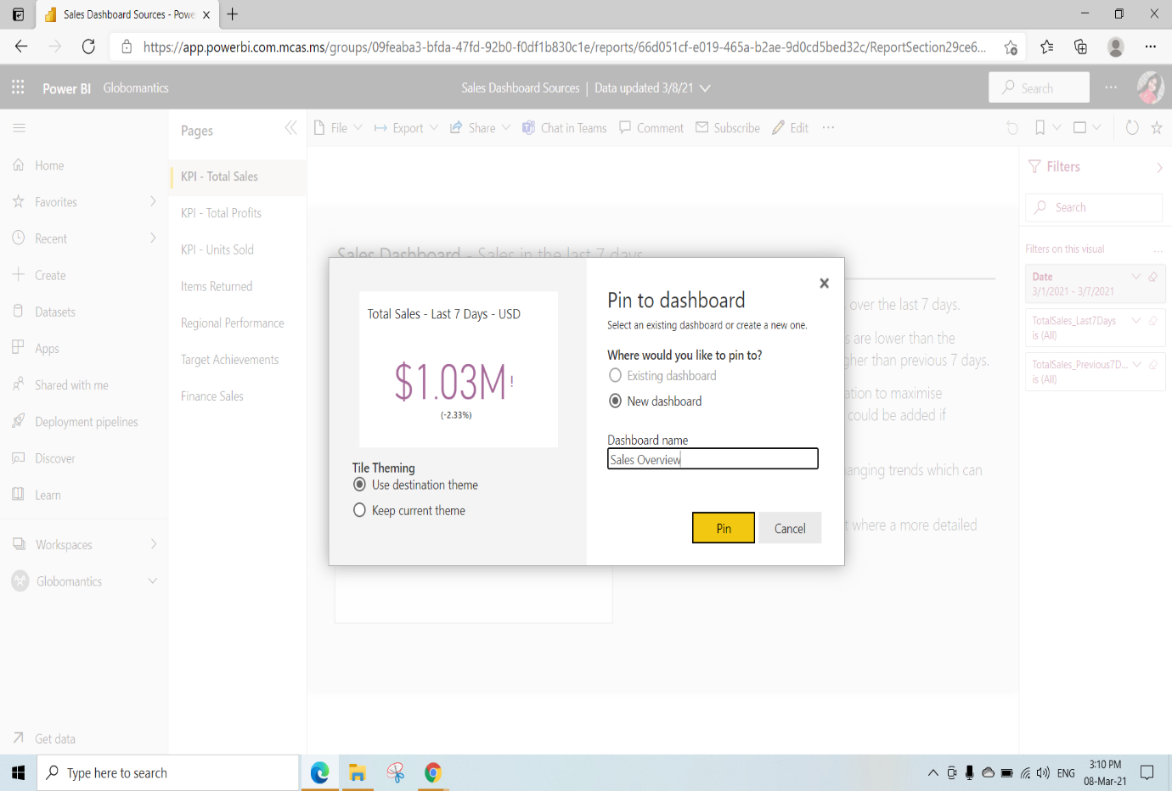

Pin all pages which are there in Sales dashboard Sources report to the Sales overview Dashboard

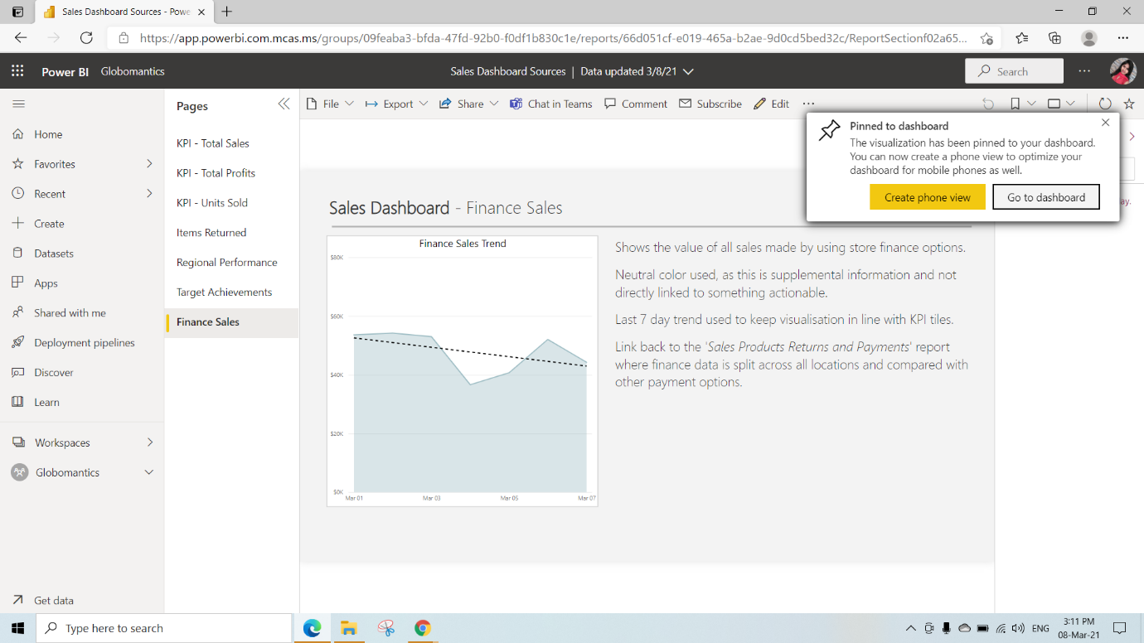

This is the Sales overview Dashboard View

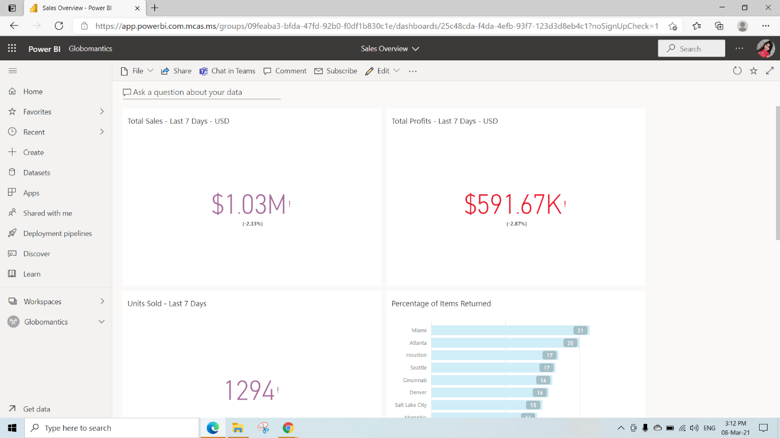

Rearrange those tiles however you want

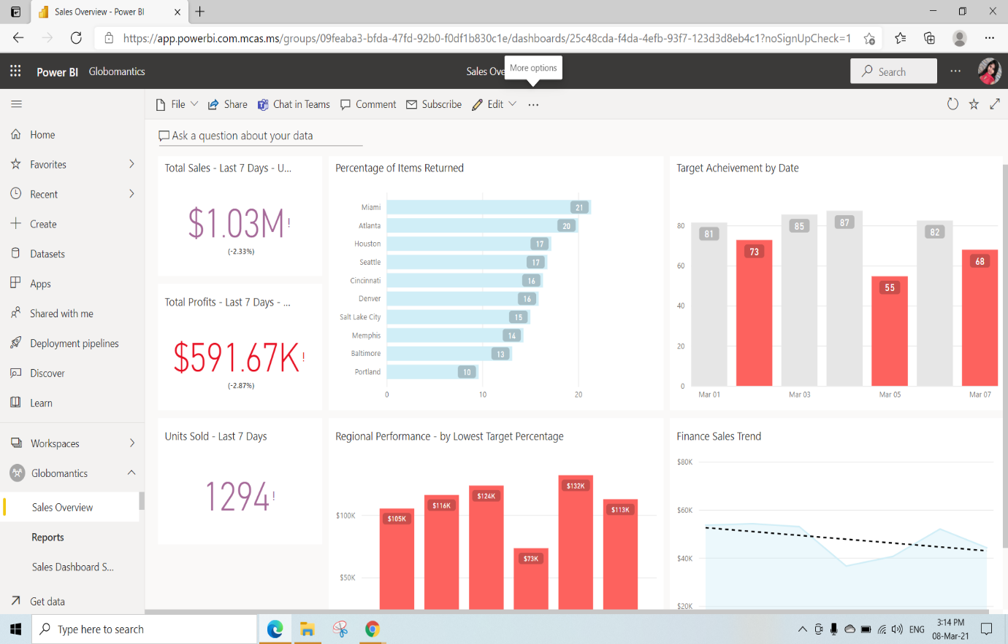We can edit the Tiles by clicking on 3dots and selecting edit Details

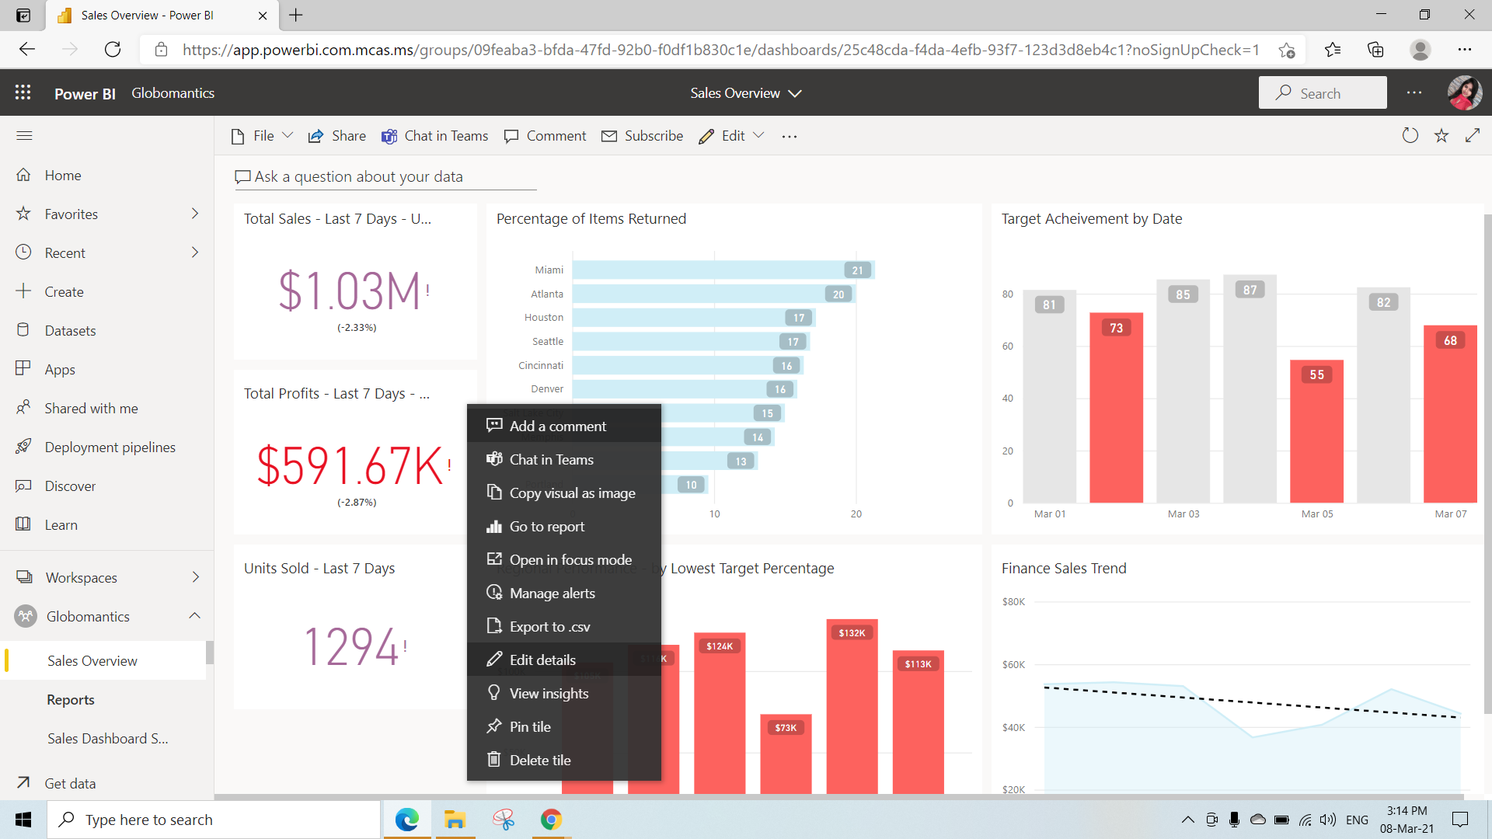

Here we have selected Display title and subtitle for Total profits Tile

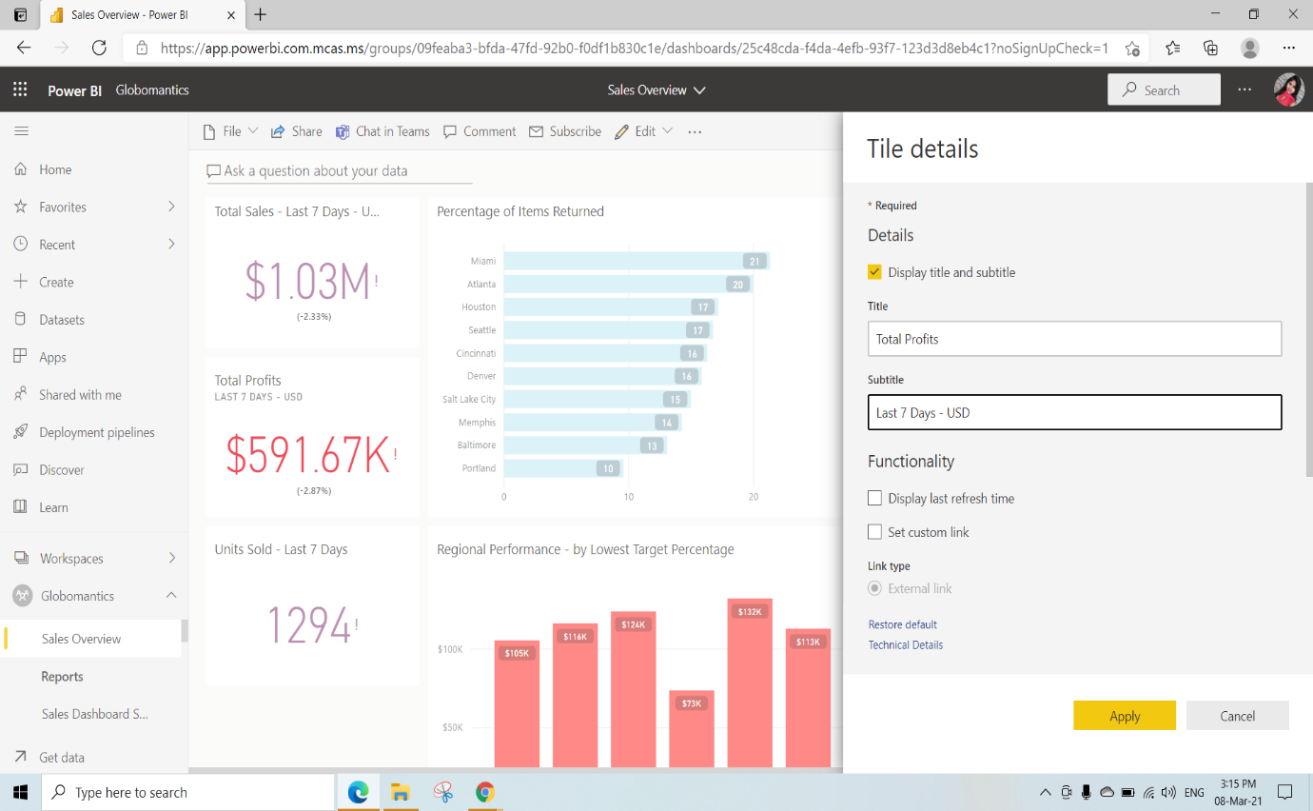

Here we are opening the Sales KPI Tile report to edit the visuals

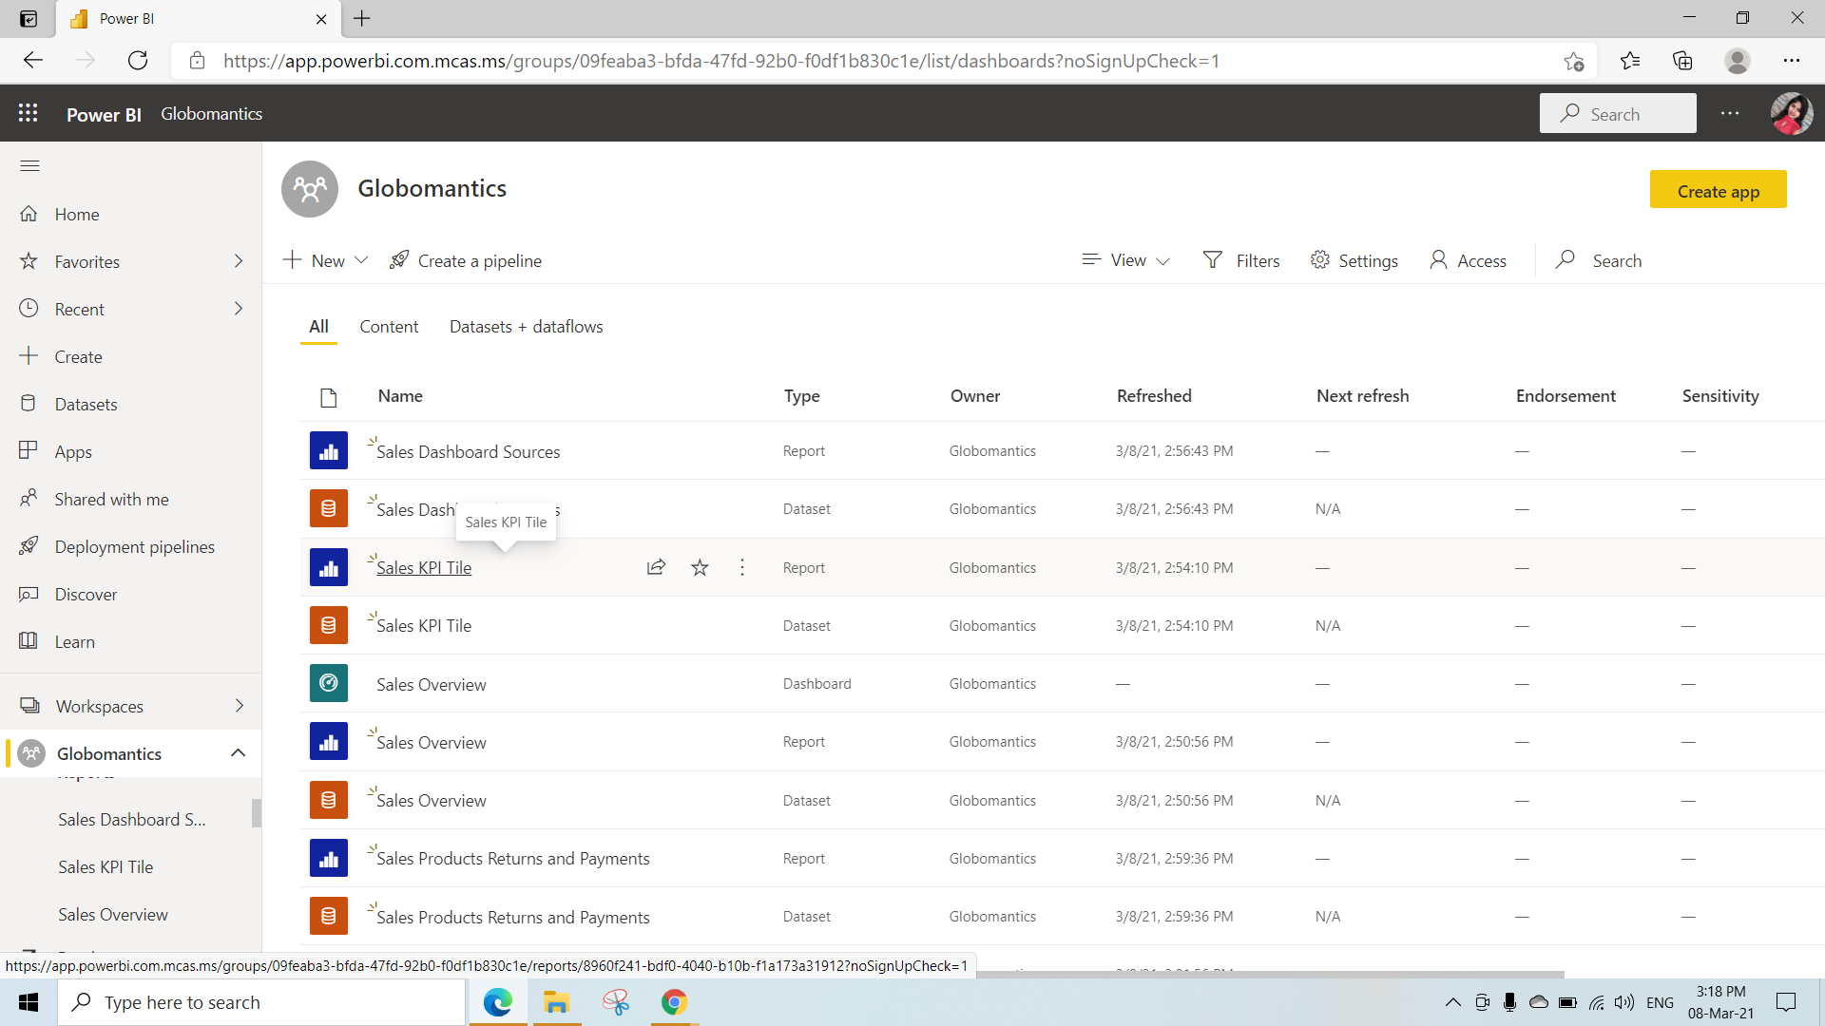

Here under the format we have alligned the text title to middle and click on Reading view to go back to the Tiles View

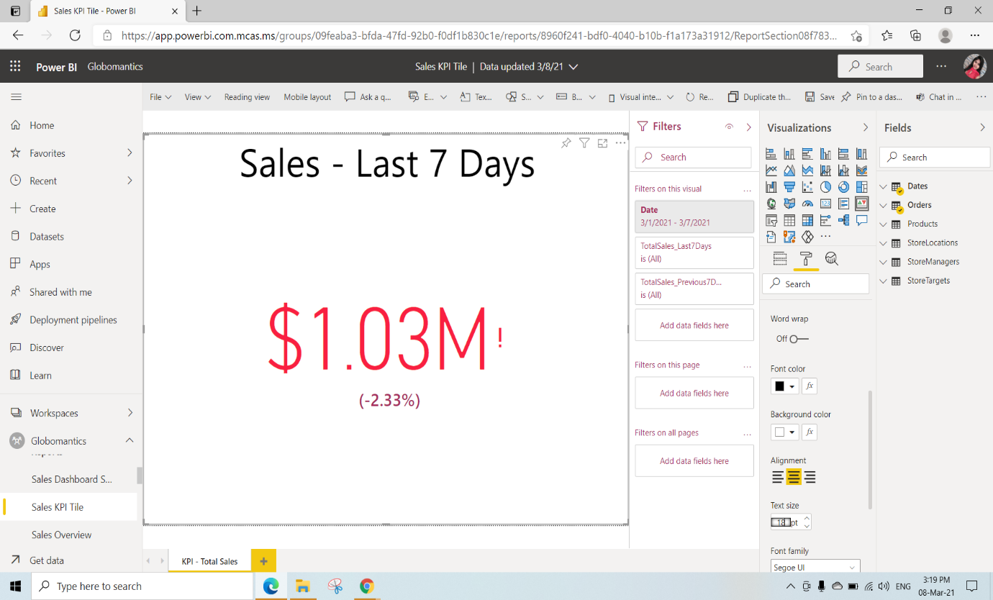

Click on Save to save this report

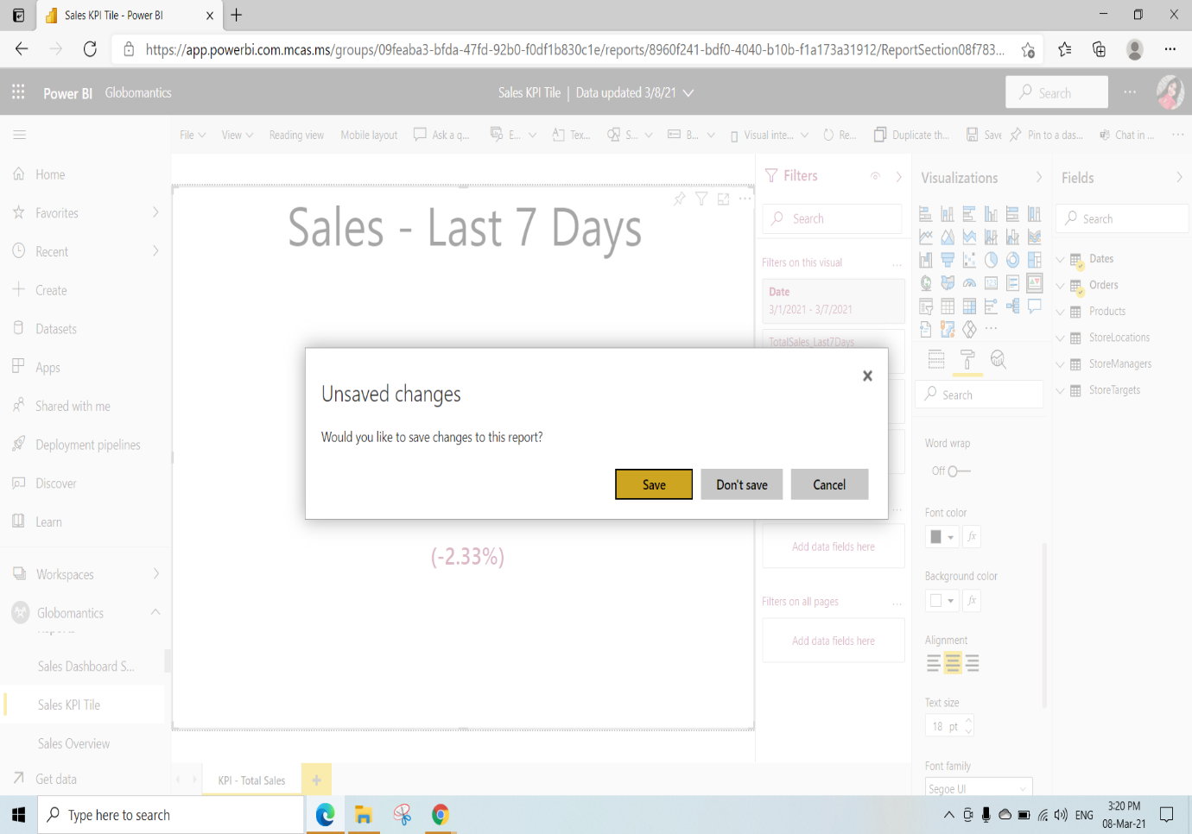

Here we can pin to Dashboard directly from the reports

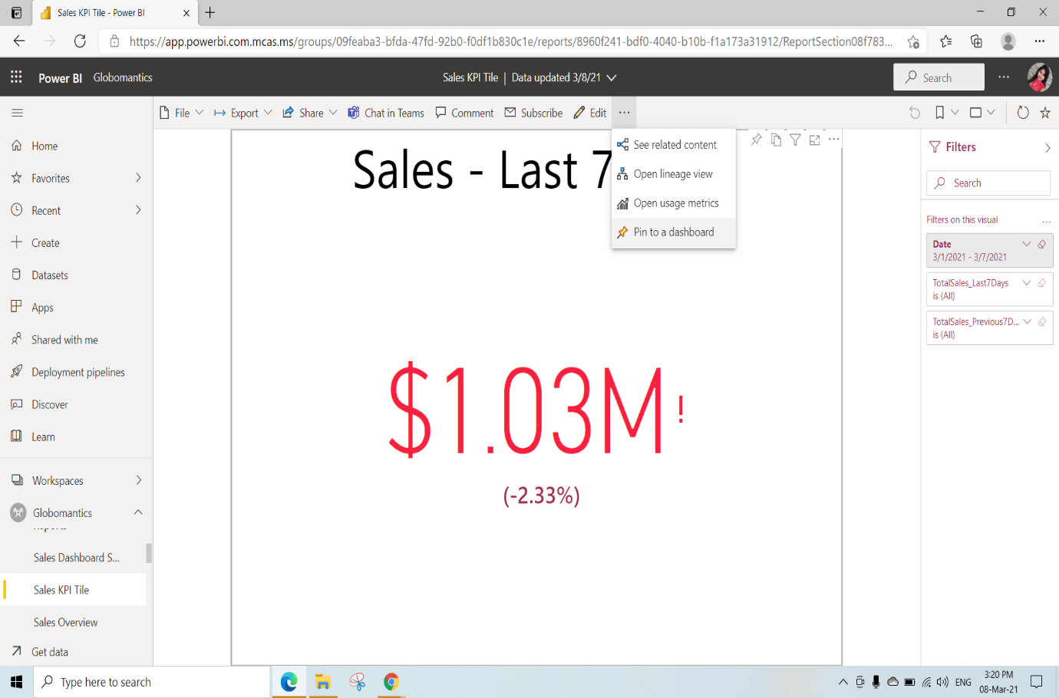

We have edited the tiles and visuals in the report itself and can pin directly to the Dashboard by clicking on pin live

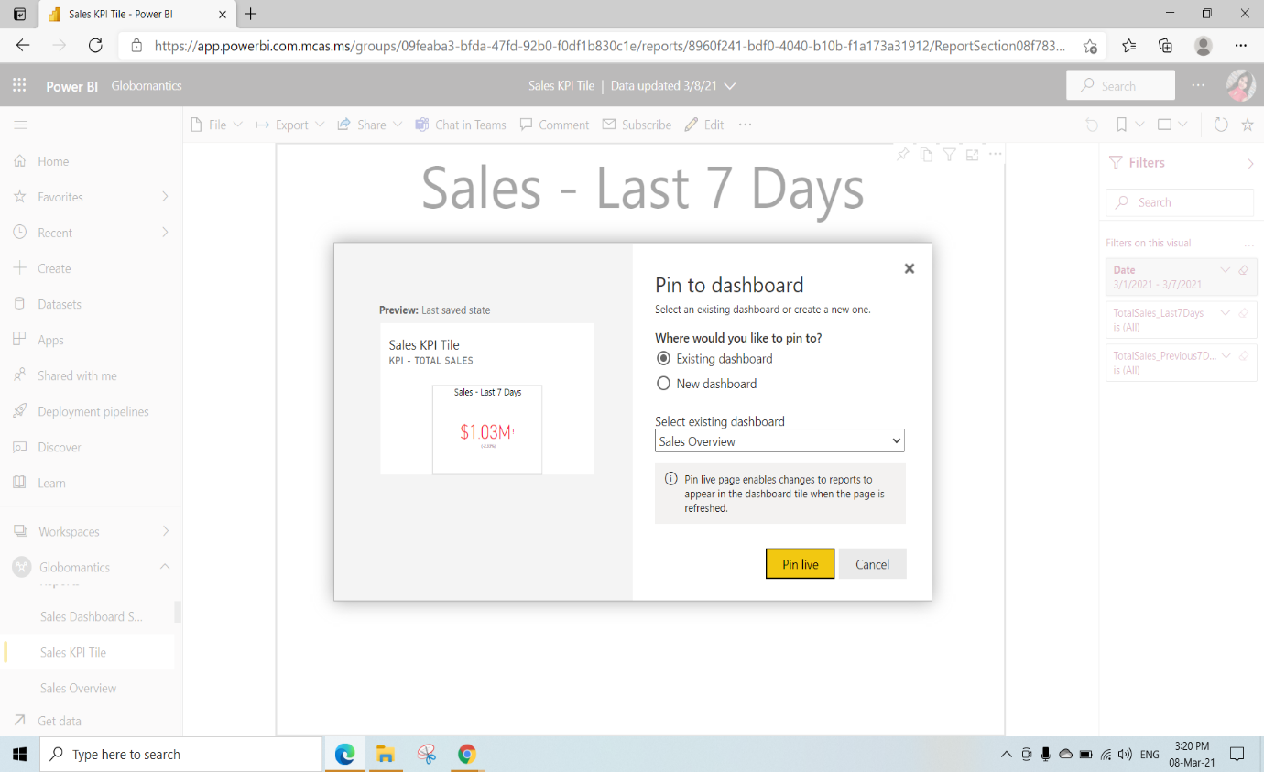

By clicking on 3 dots We are editing Details

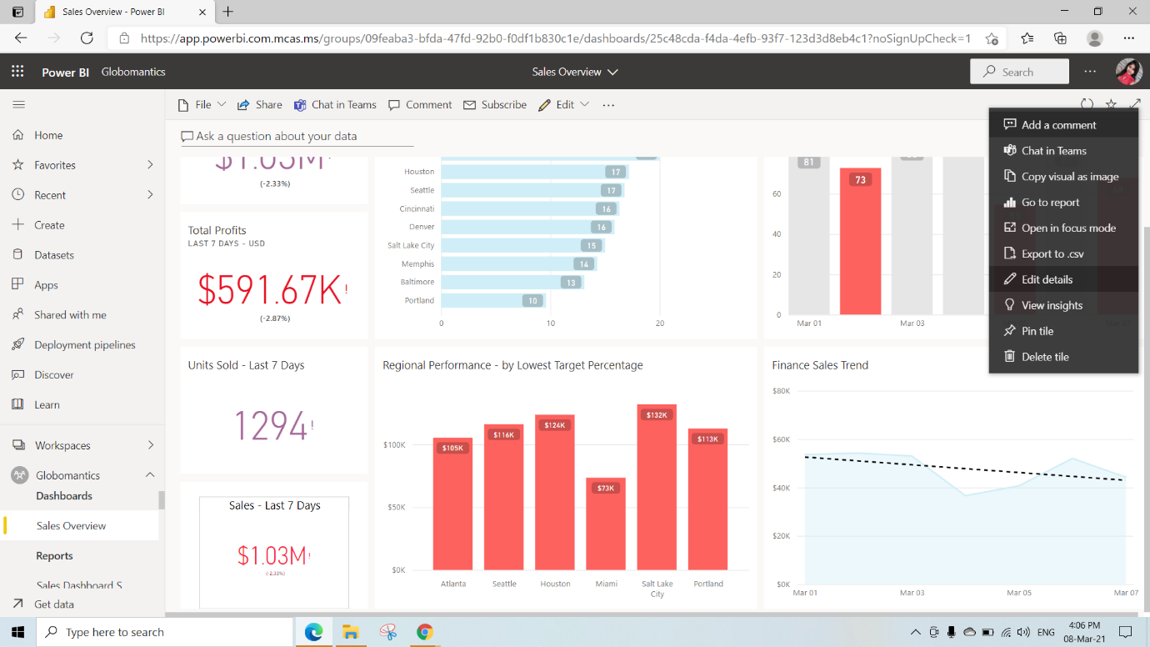

We can set the Custom link(when we click on that visual where we need to go)Select the link type as External Link and Set the URL with any link(we have given github link as <https://github.com/Cianan/globomantics>) and Click on Apply

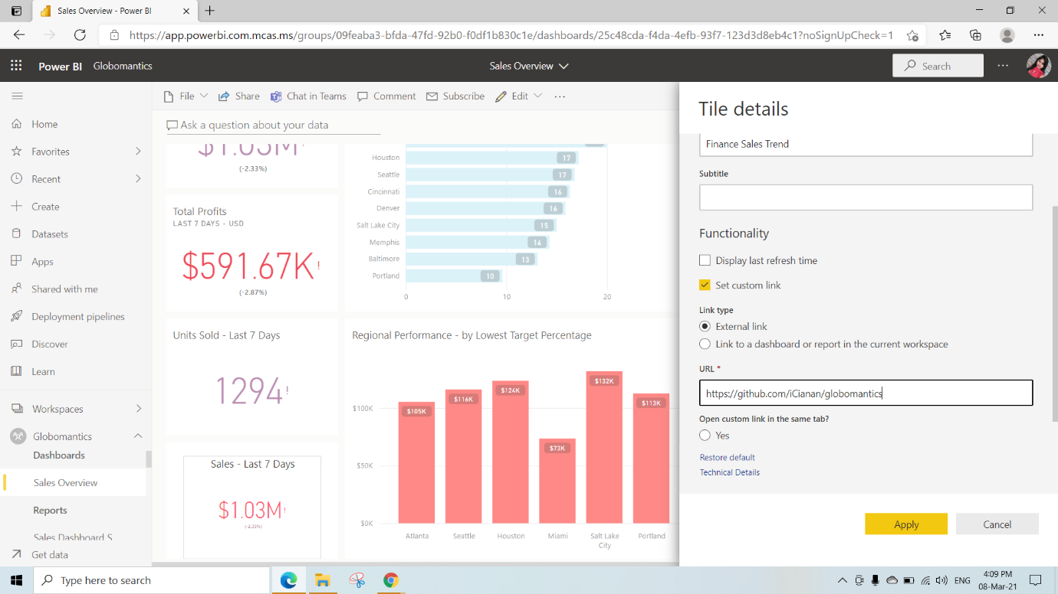

When we click on that Finance sales Trend we will be able to go to that github site which we have mentioned in the URL

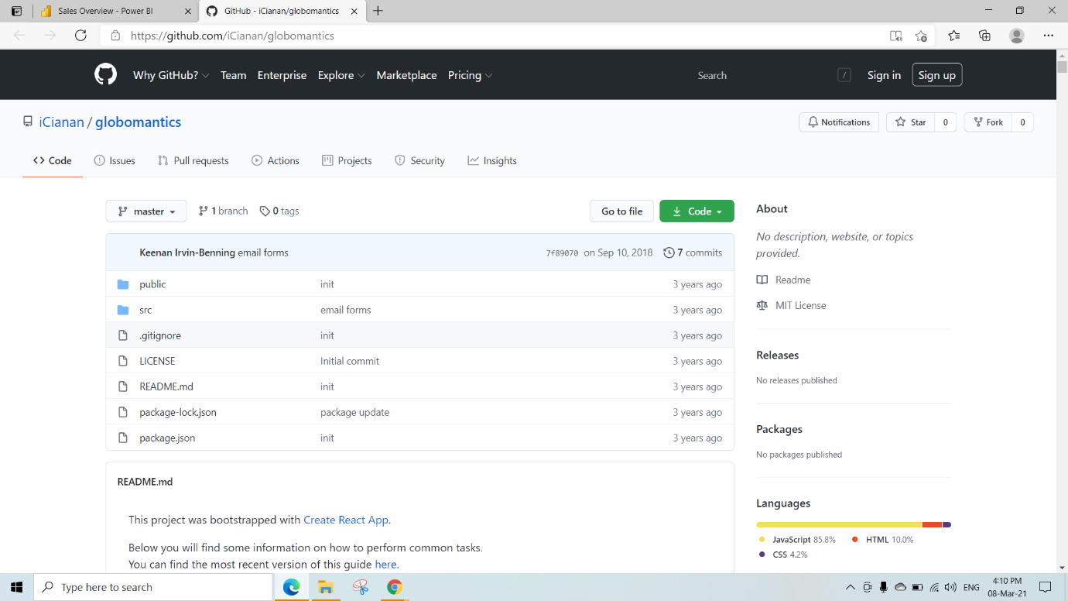

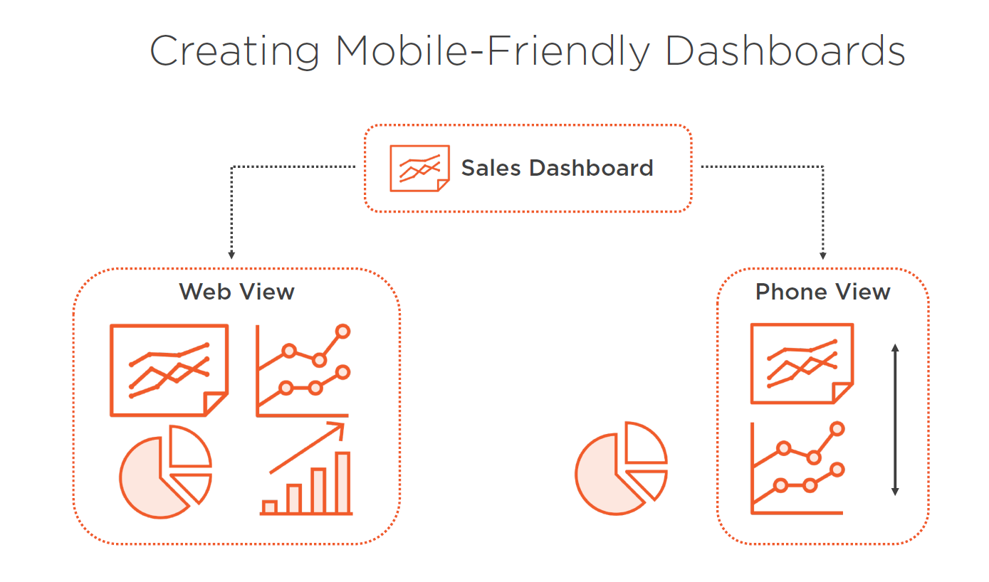

To get the Mobile View click on edit and select Mobile View

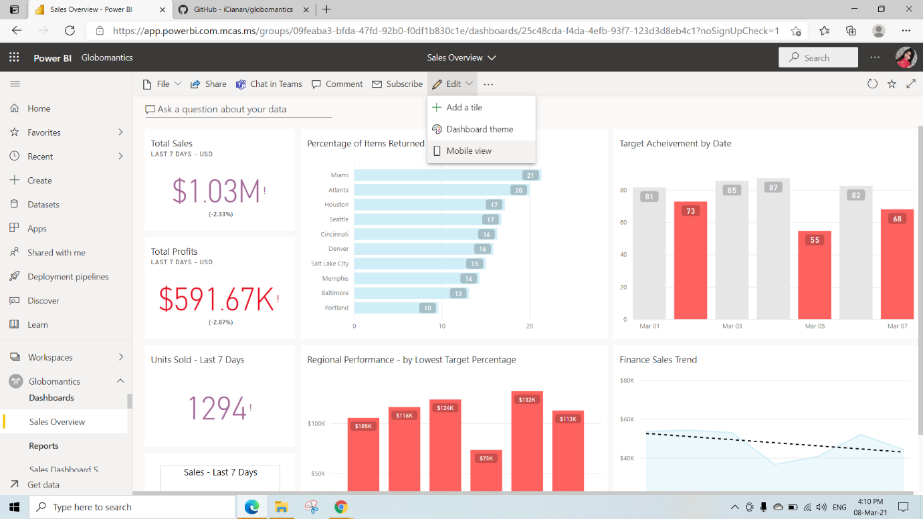

This is the Mobile View(We can select any visuals or tiles inside this mobile view and also can rearrange)

And also we have Web view

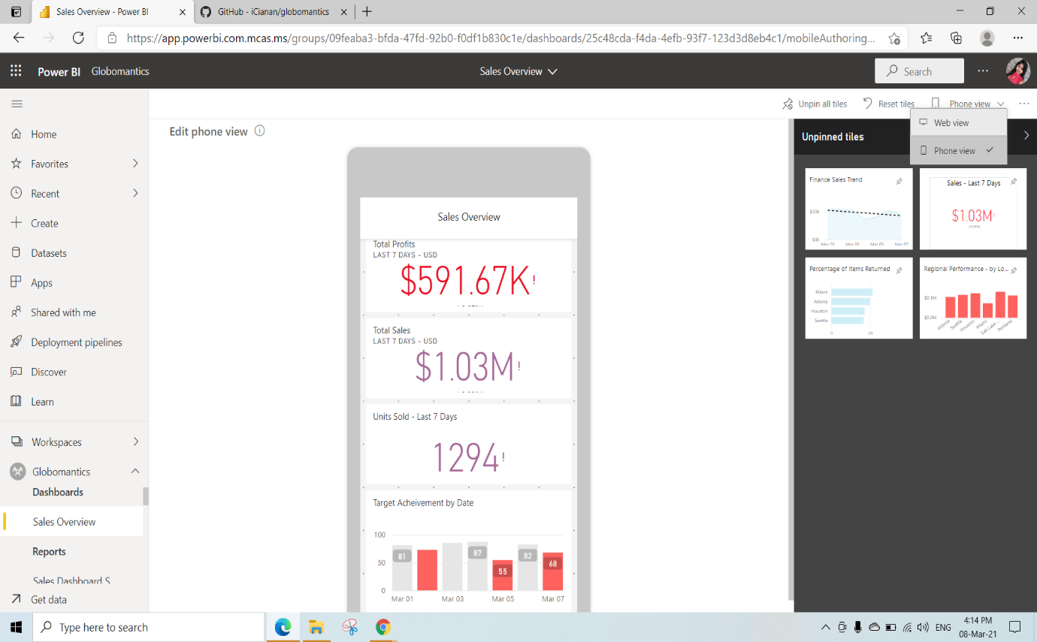

Adding Media to Dashboards

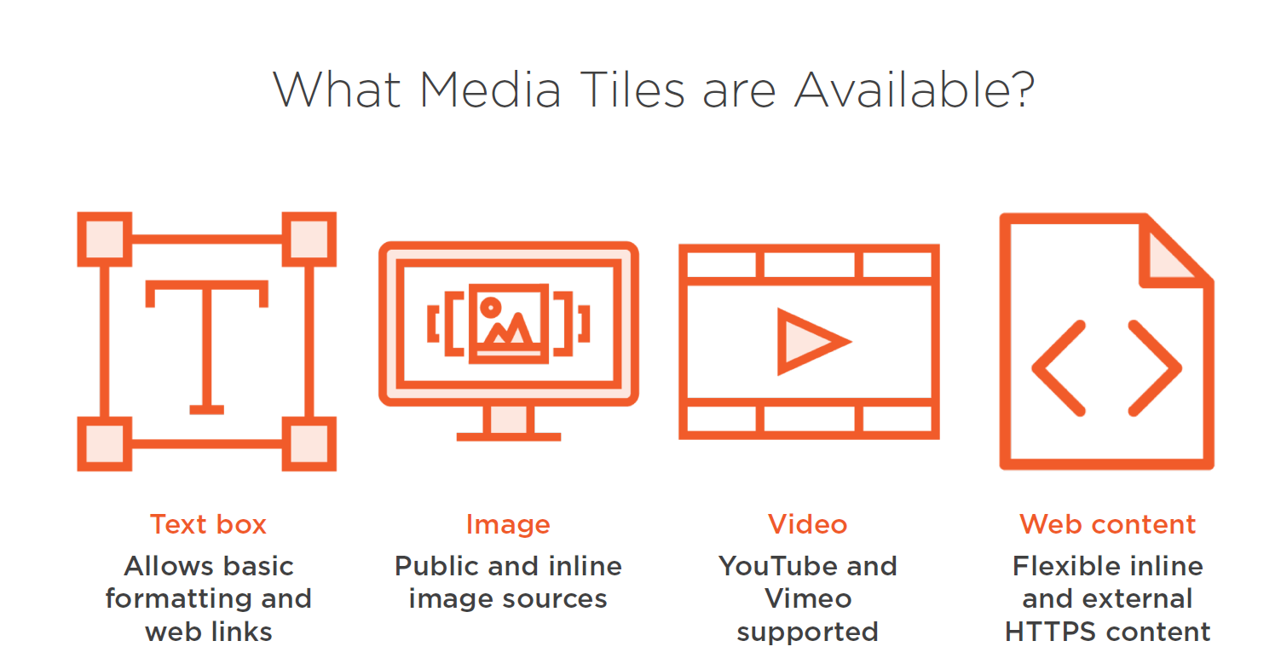

Create a new Dashboard by Clicking on New🡪 Dashboard

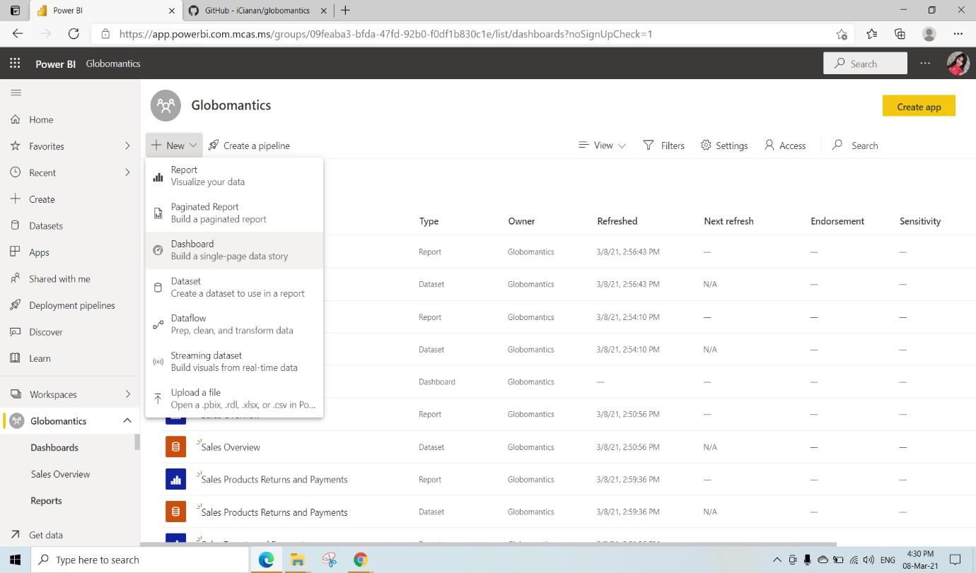

Give any name to the Dashboard(we have given Media Dashboard)

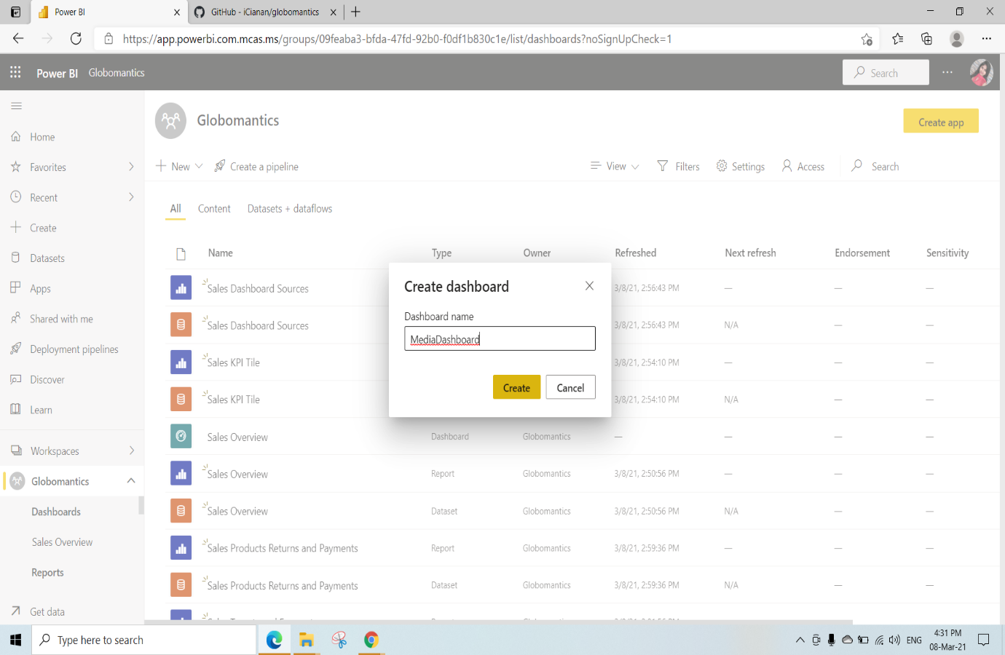

Click on edit and Select Add a Tile

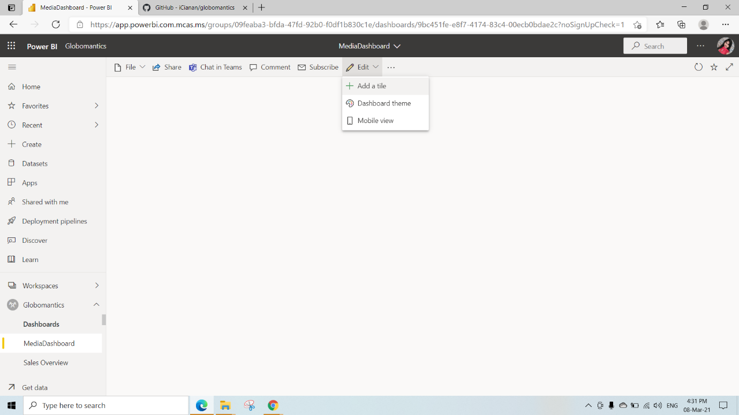

Here we have selected the Text box tile to Enter some Text and click on Next

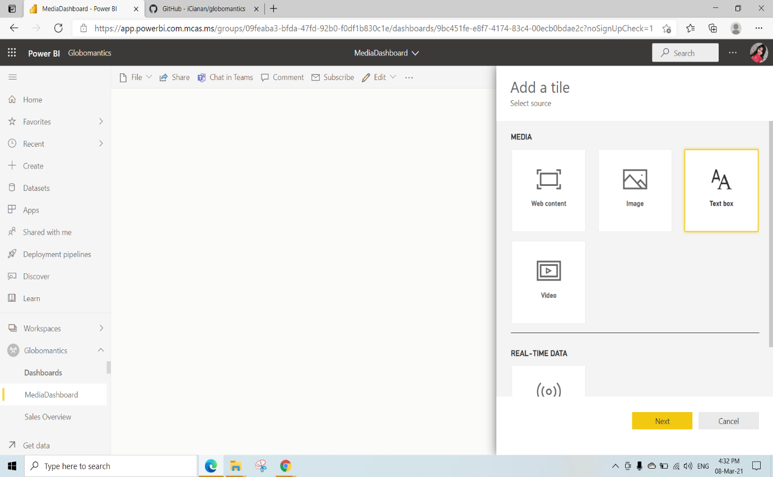

Just write the Text whatever you wanted to display in the Dashboard

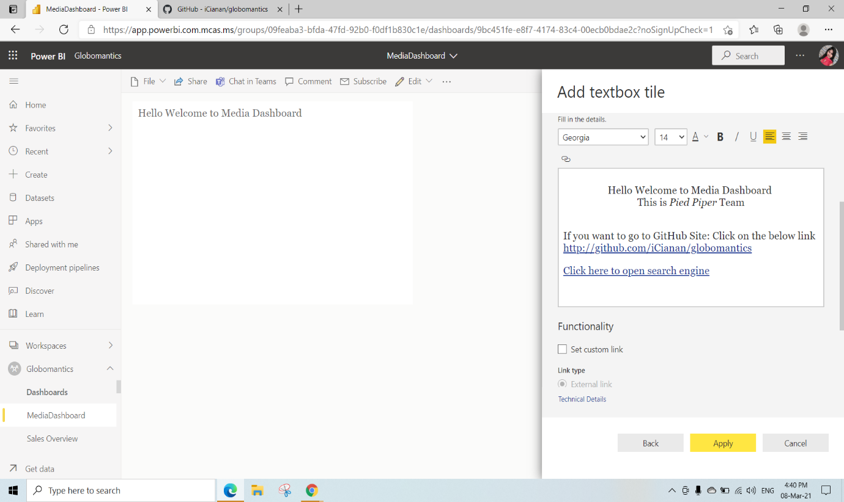

After adding the Text Box tile it will appear like this

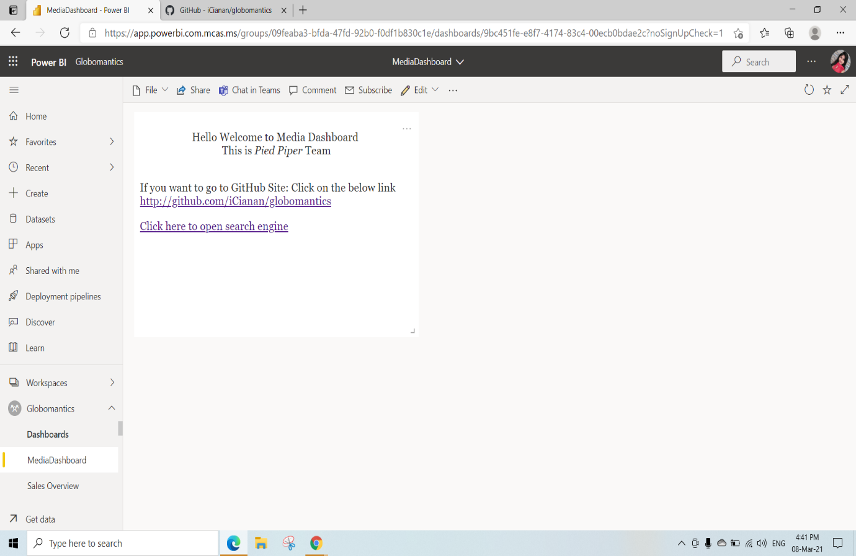

When you click on that 2nd Link You will be redirected to this page

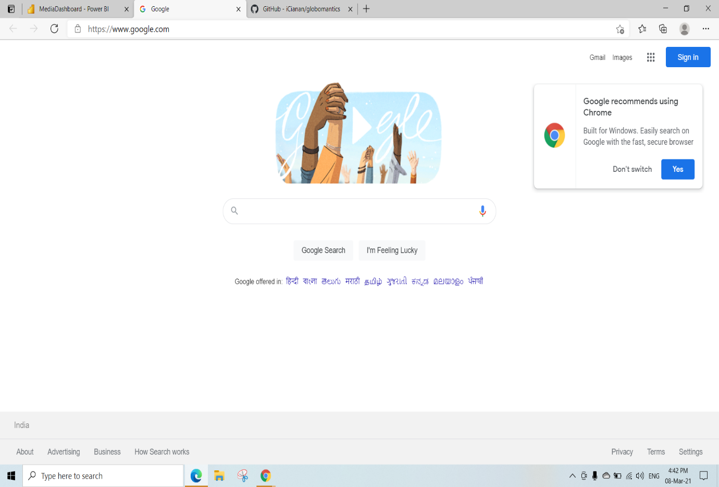

When you click on that 1st GitHub Link You will be redirected to this page

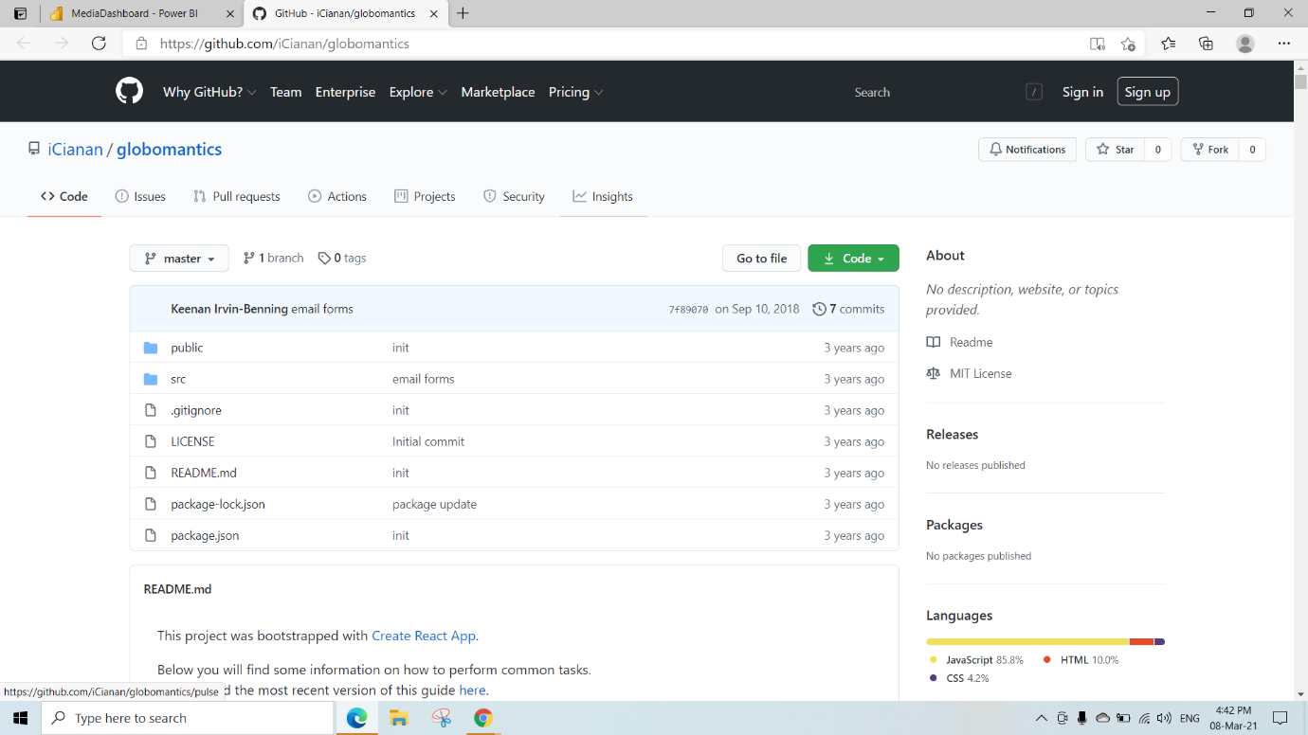

Here we have selected the Image tile and click on Next

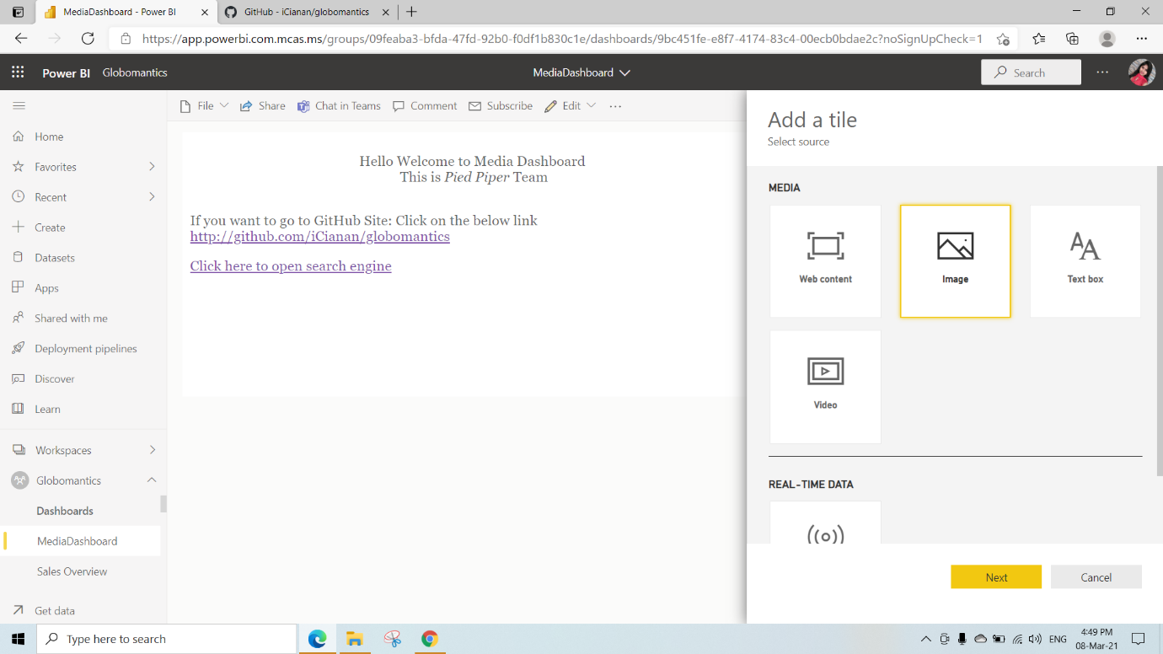

Here we need to give the image link that we wanted to see on dashboard under the URL we have given and click on Apply

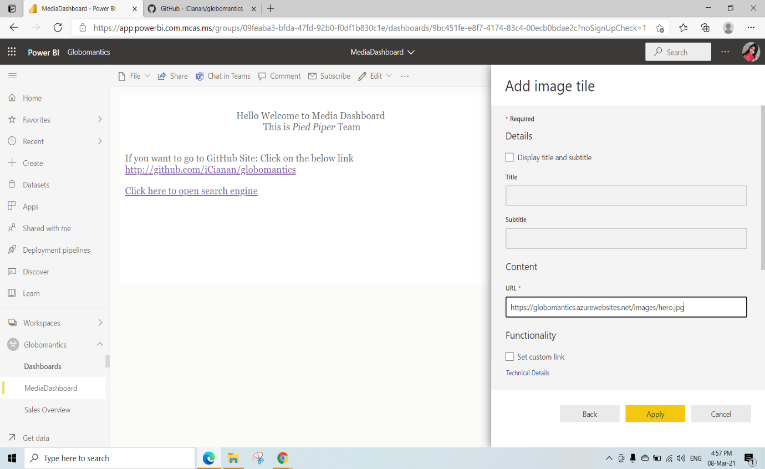

After adding image we can see the below page

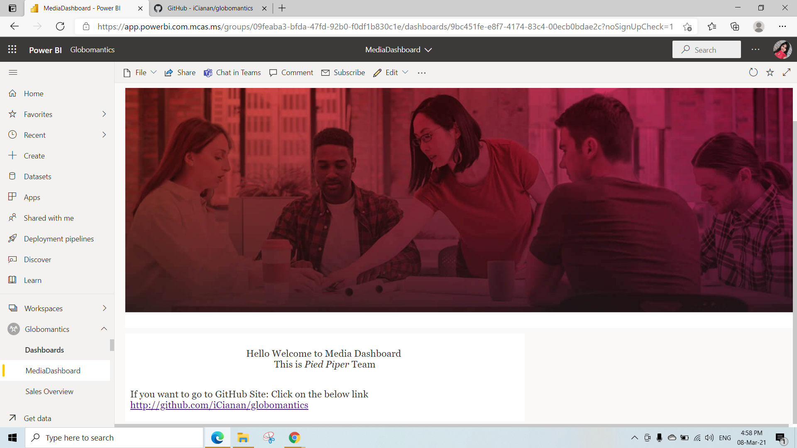

Here we have selected the Video tile and click on Next

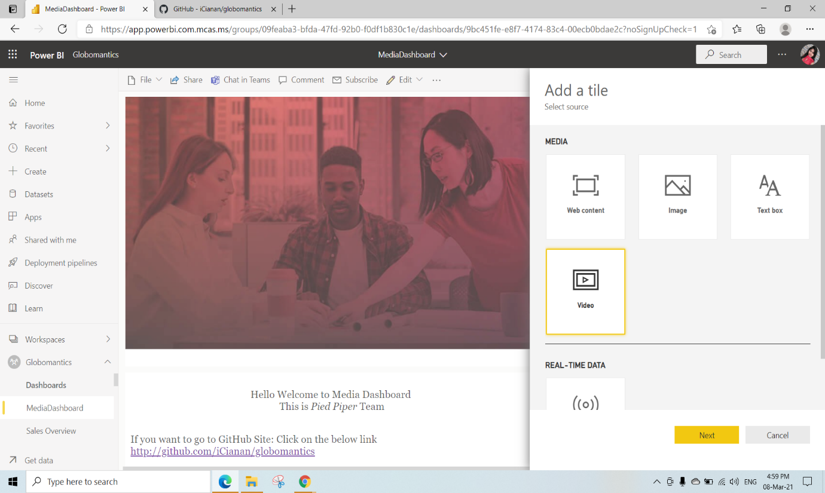

We can add any video link from any website and Click on Apply

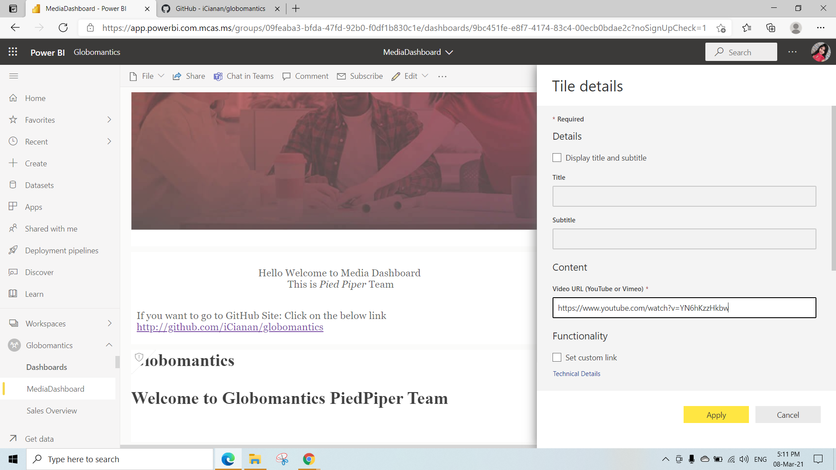

After adding Video link In the dashboard we can play that video

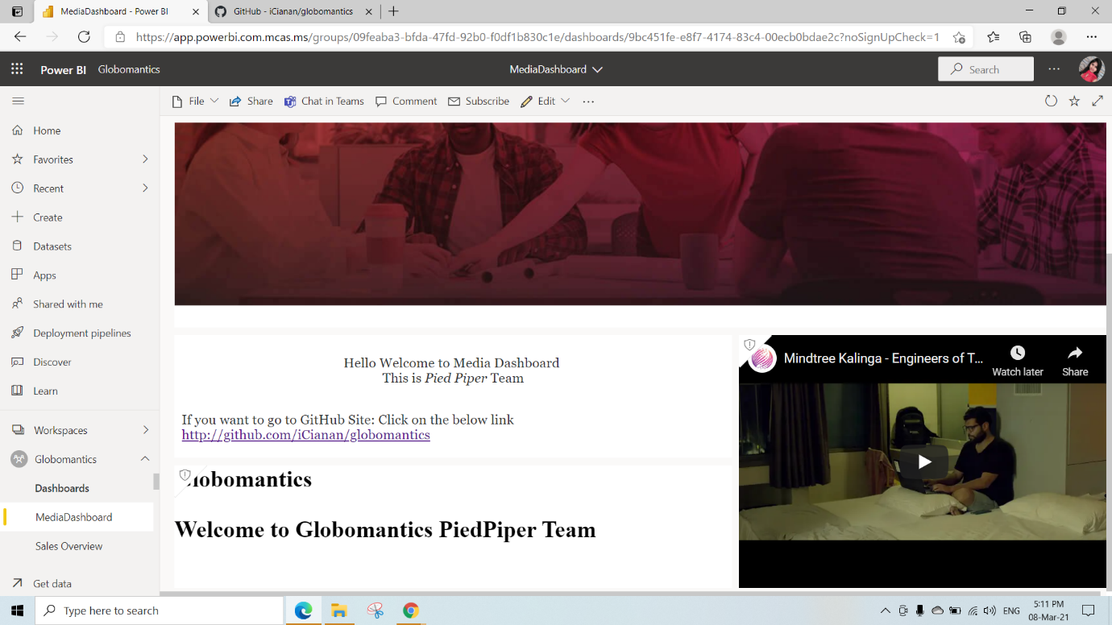

Here we have selected the Web Context and click on Next

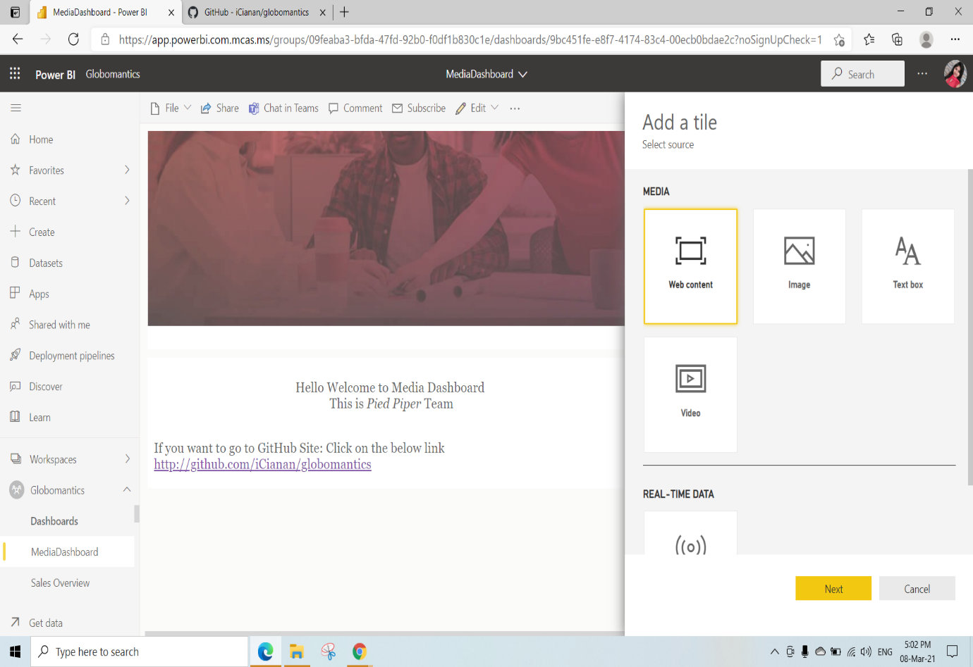

Write any embedded code and click on Apply

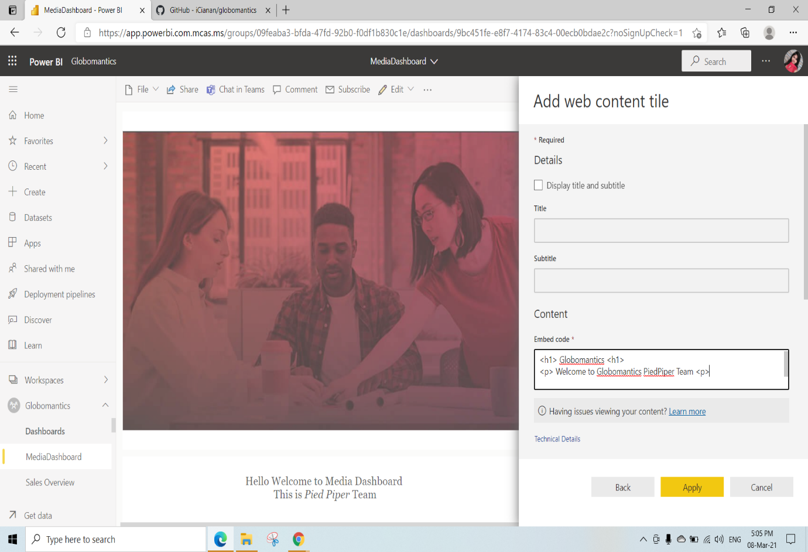

After adding Web Content

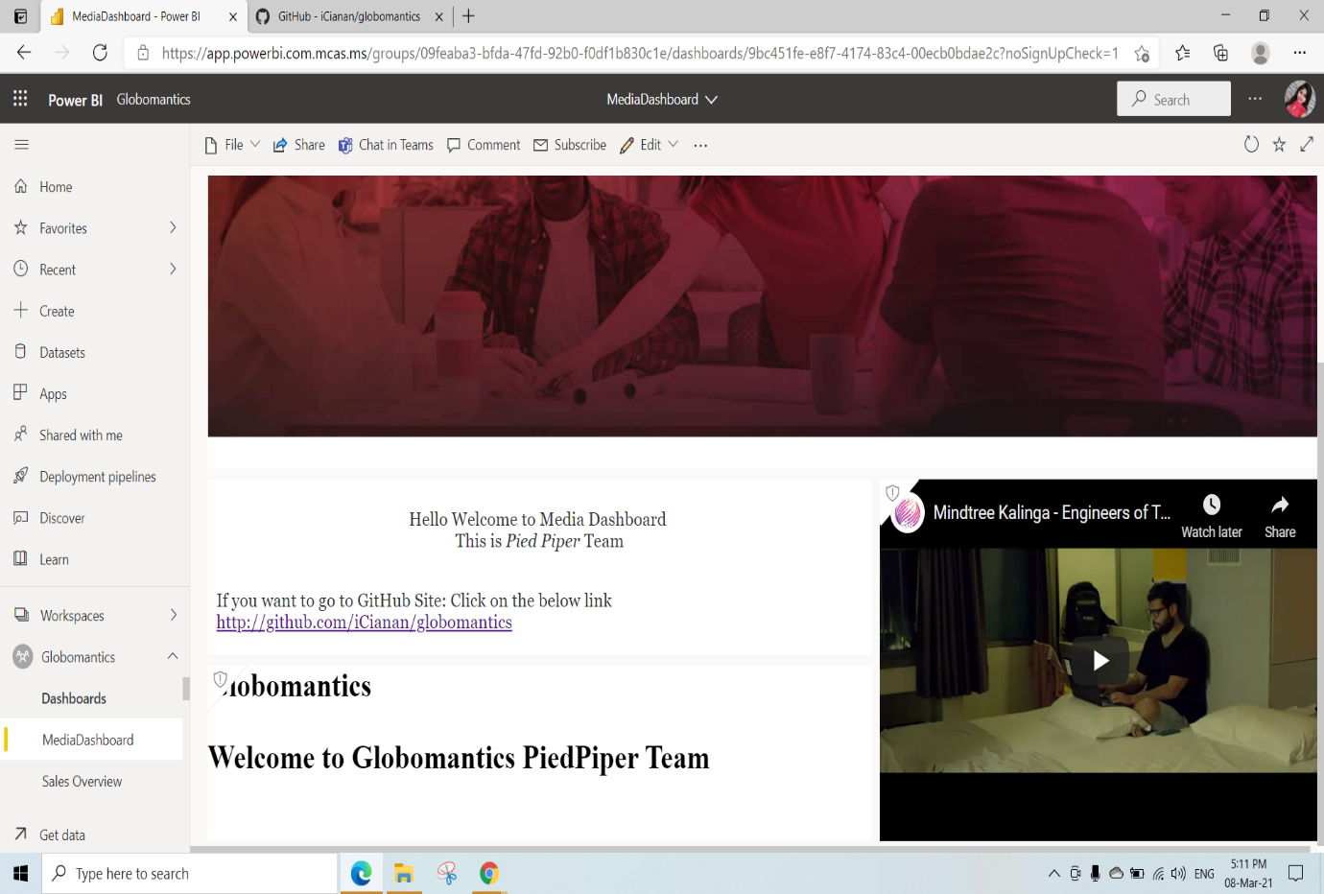

Here we have created New Dashboard named as HomePage

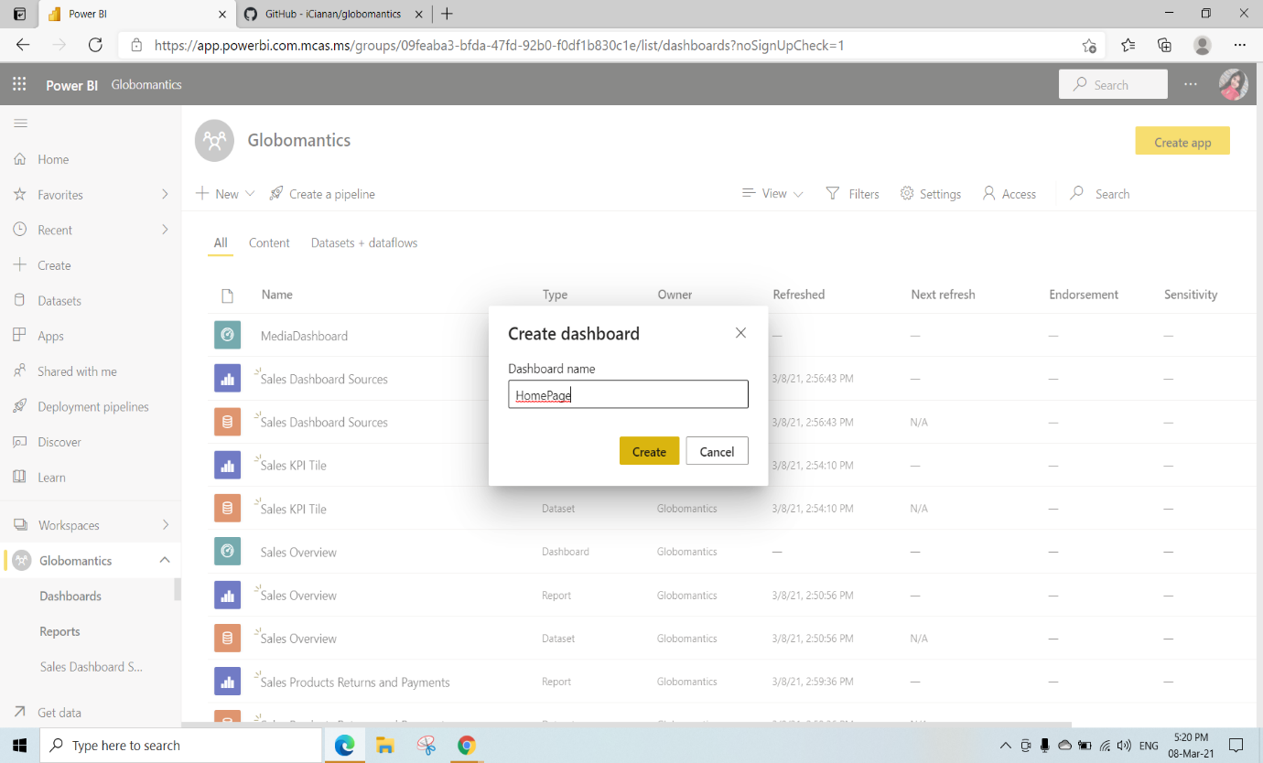

Here we have added All the tiles explained above

This is Home Page of Globomantics

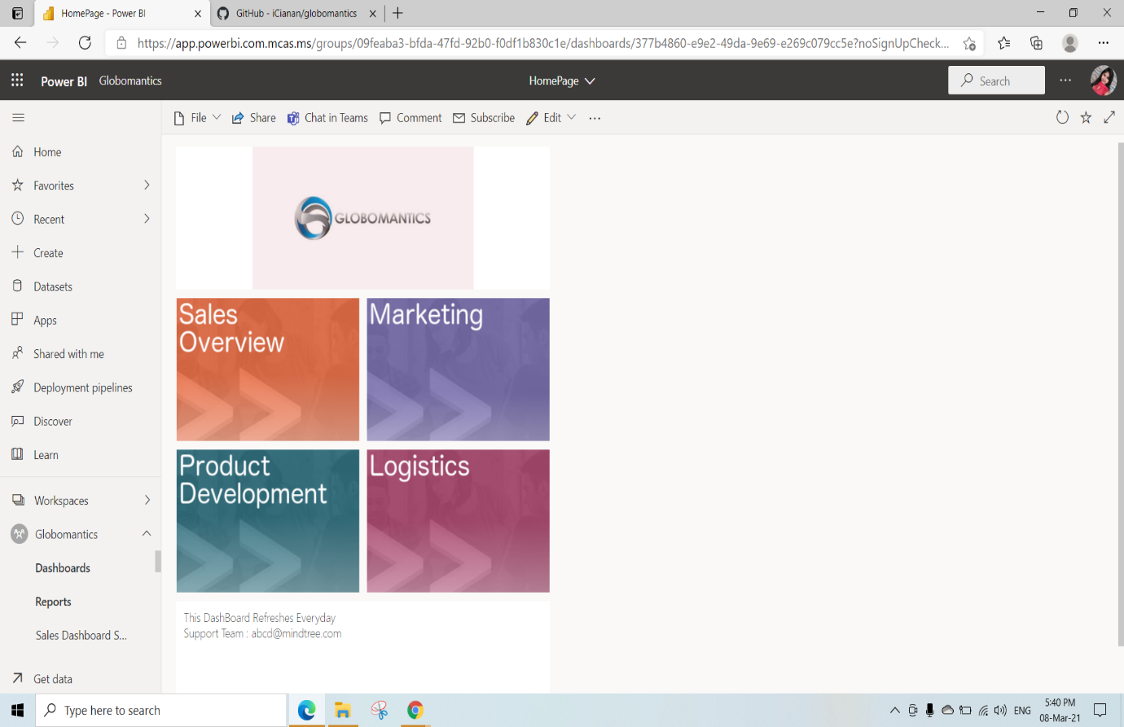

Adding Themes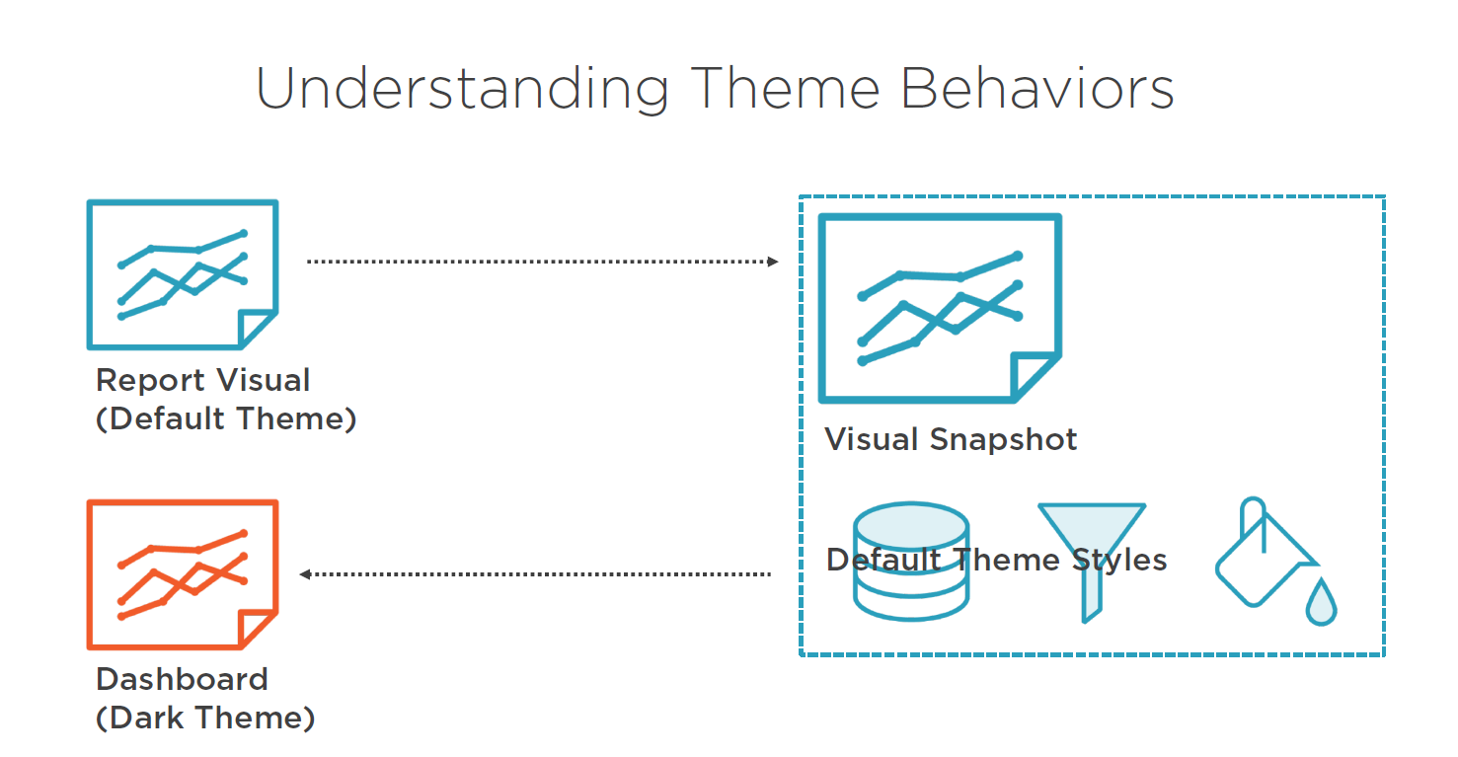

We have created new Dashboard named as Themes

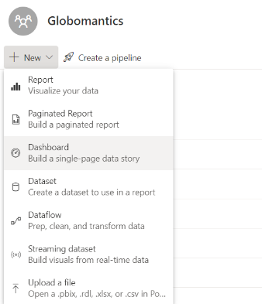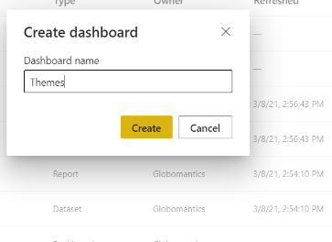

From the Sales Dashboard Sources Pin the Finance Sales Trend Visual to the Themes Dashboard

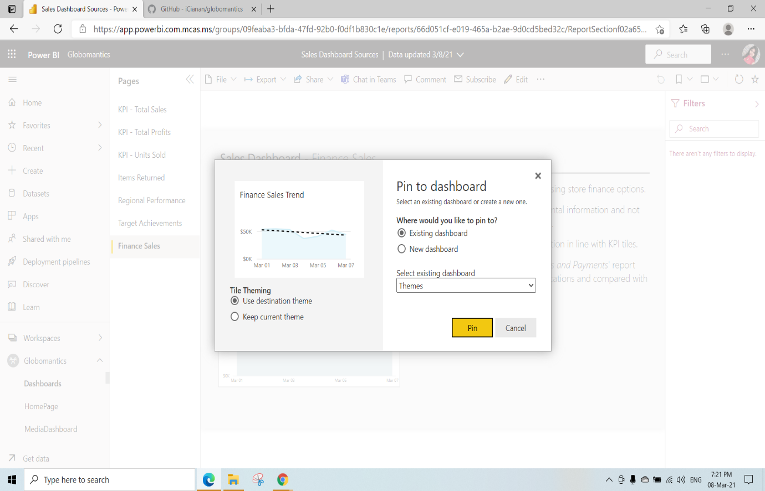

From the Sales Dashboard Sources Pin the Regional Performance Visual to the Themes Dashboard

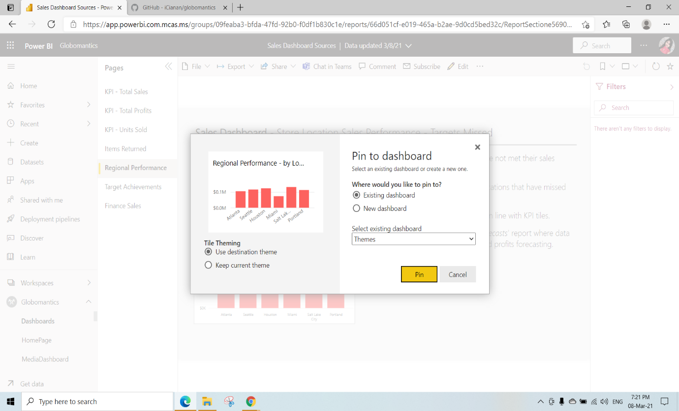

Click on Go To Dashboard

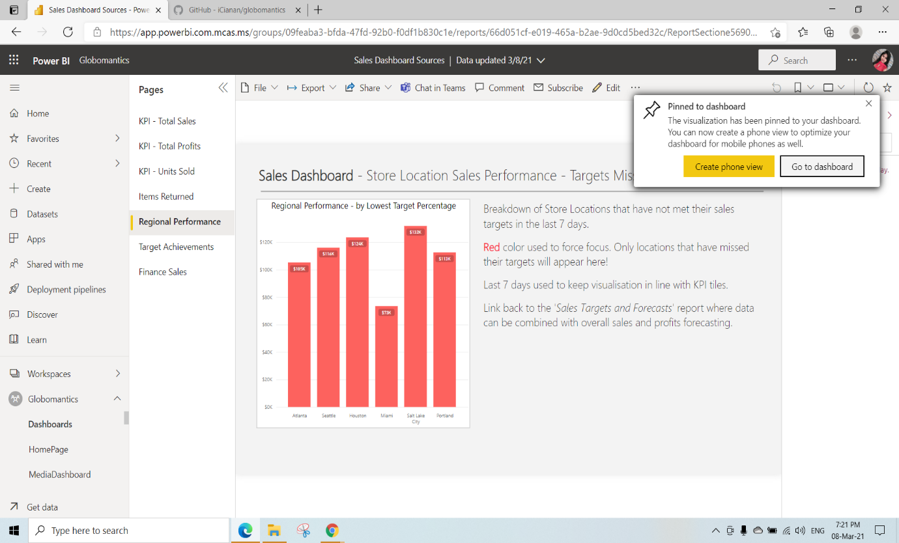

This is the Theme Dashboard view

Click on Edit 🡪 Dashboard theme to change the Dashboard themes

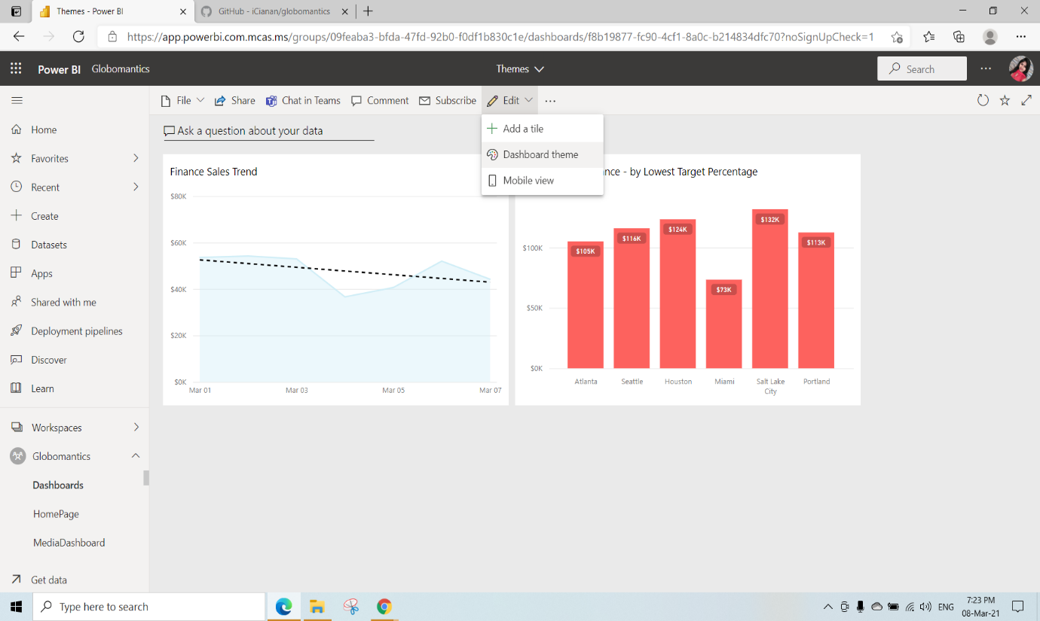

We have selected Dark theme and click on Save

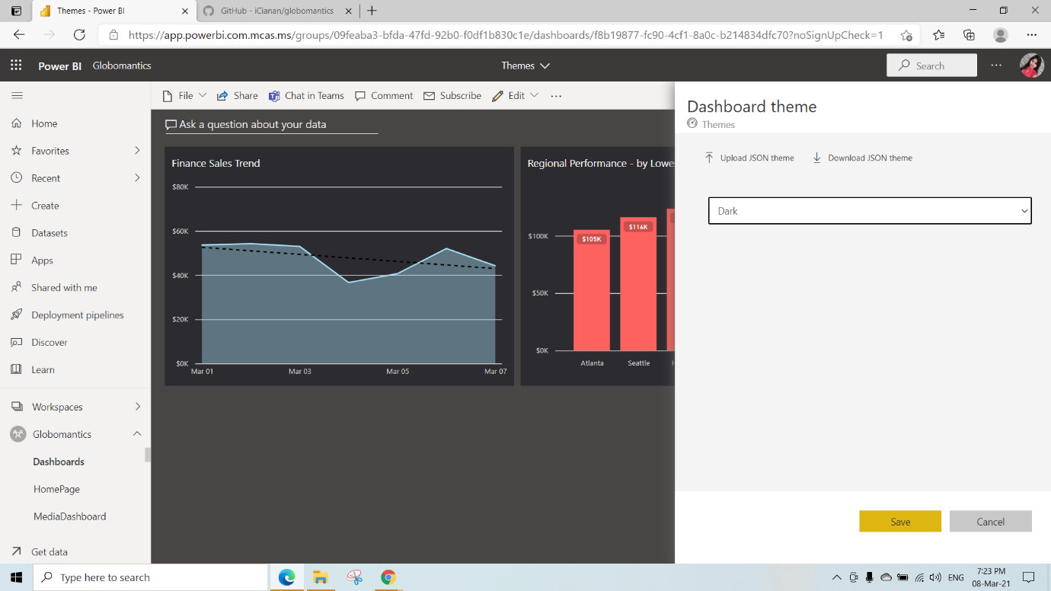

Here we have selected light theme and uploaded some json file with code

{

"name": "Pluralsight",

"dataColors": ["#F15B2A", "#2A9FBC", "#A62E5C", "#9BC850", "#675BA7", "#0E5C6F", "#23C98E", "#F91F41"],

"background":"#eaeaea",

"foreground": "#A62E5C",

"tableAccent": "#A62E5C"

} click on Open and Save

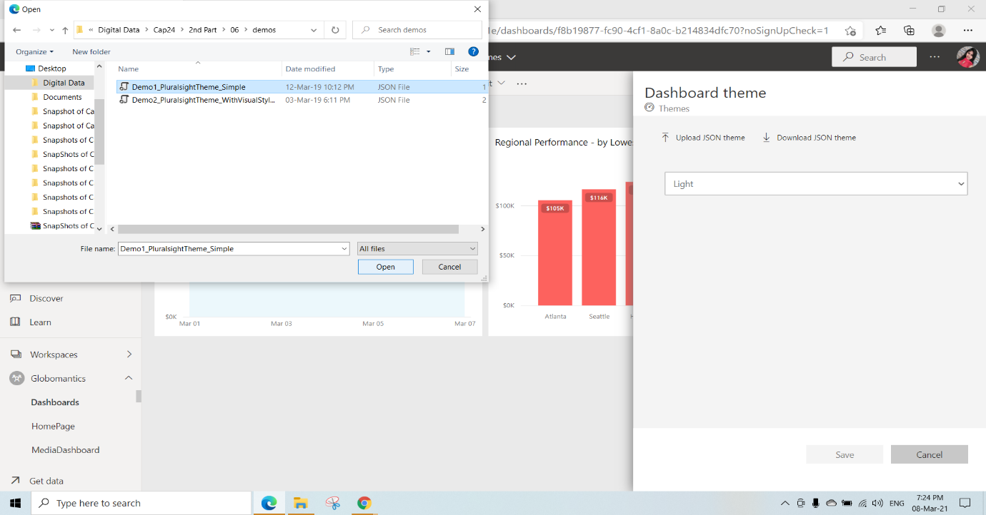

This is light theme with Jsonfile Properties

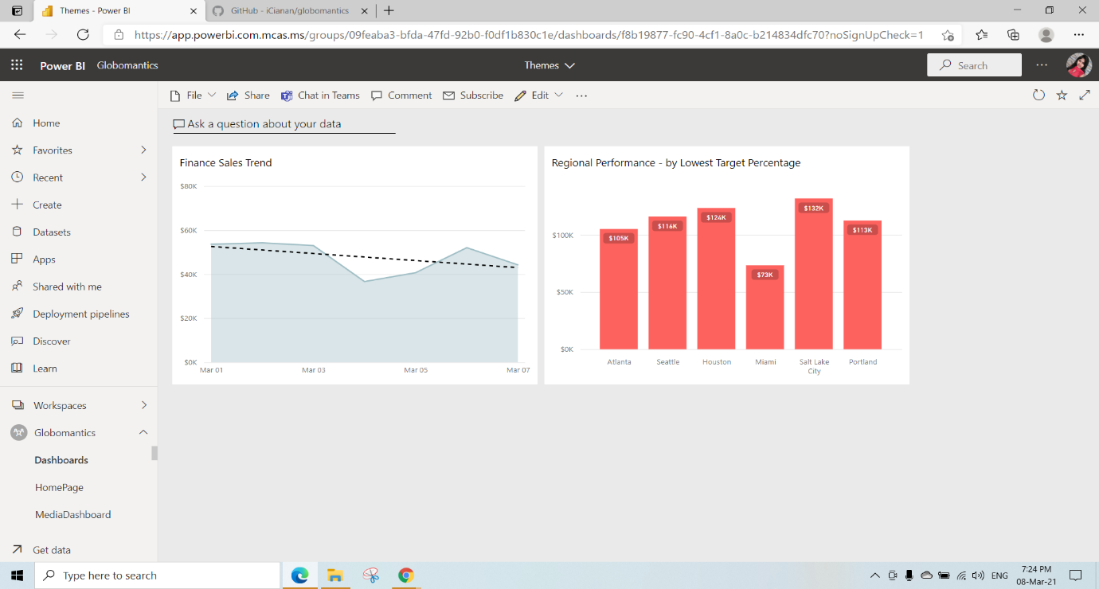

Here we have selected custom theme and uploaded some json file with code

{

"name": "Pluralsight",

"dataColors": ["#F15B2A", "#2A9FBC", "#A62E5C", "#9BC850", "#675BA7", "#0E5C6F", "#23C98E", "#F91F41"],

"background":"#FFFFFF",

"foreground": "#A62E5C",

"tableAccent": "#A62E5C",

"tiles": {

"background": "#ffffff",

"color": "#000000"

},

"visualStyles": {

"*": {

"*": {

"valueAxis": [

{

"labelColor": { "solid": { "color": "#000000"}},

"fontSize": 30,

"fontFamily": "Courier New"

}

],

"categoryAxis":[

{

"labelColor": { "solid": { "color": "#000000"}},

"fontSize": 30,

"fontFamily": "Courier New"

}

]

}

},

"areaChart":{

"*":{

"valueAxis": [

{

"labelColor": { "solid": { "color": "#F15B2A"}},

"fontSize": 10,

"fontFamily": "Arial"

}

]

}

}

}

}

Click on open and save

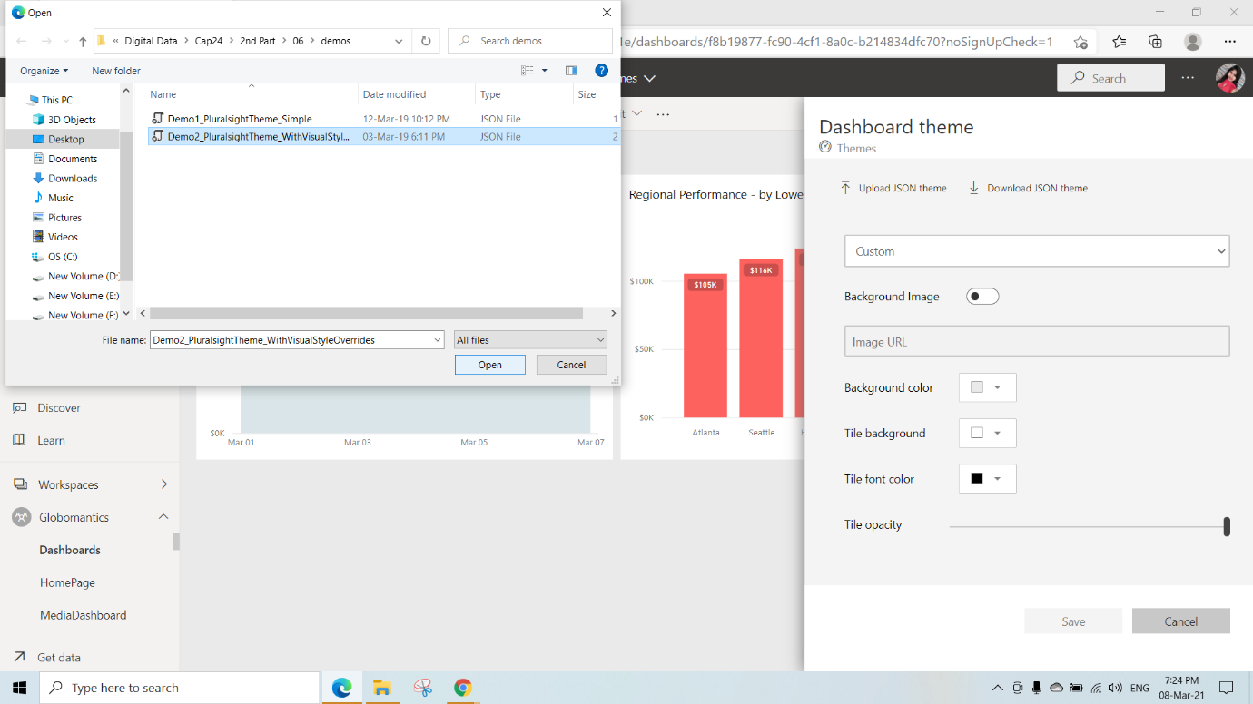

After the Custom theme with JsonFile Properties

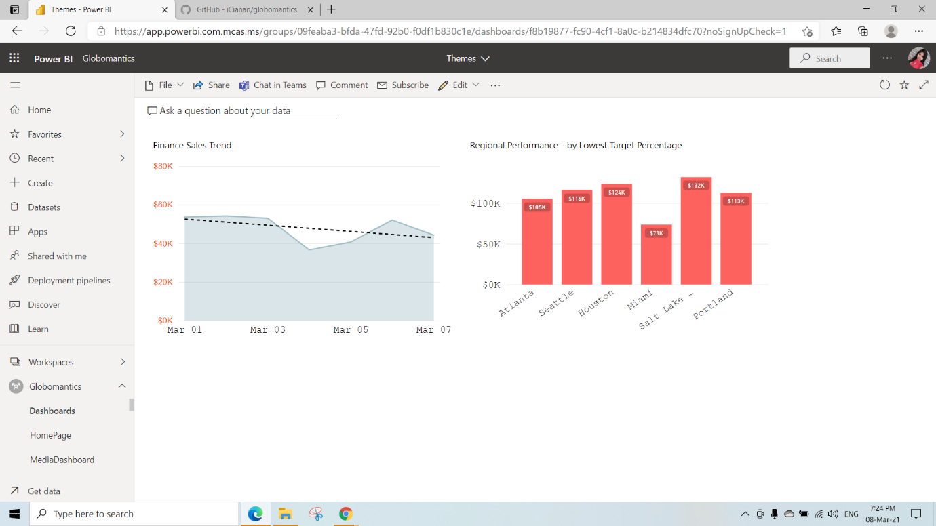

Here we can also add Background Image (We must switch on that icon) give any image link and Click on Save

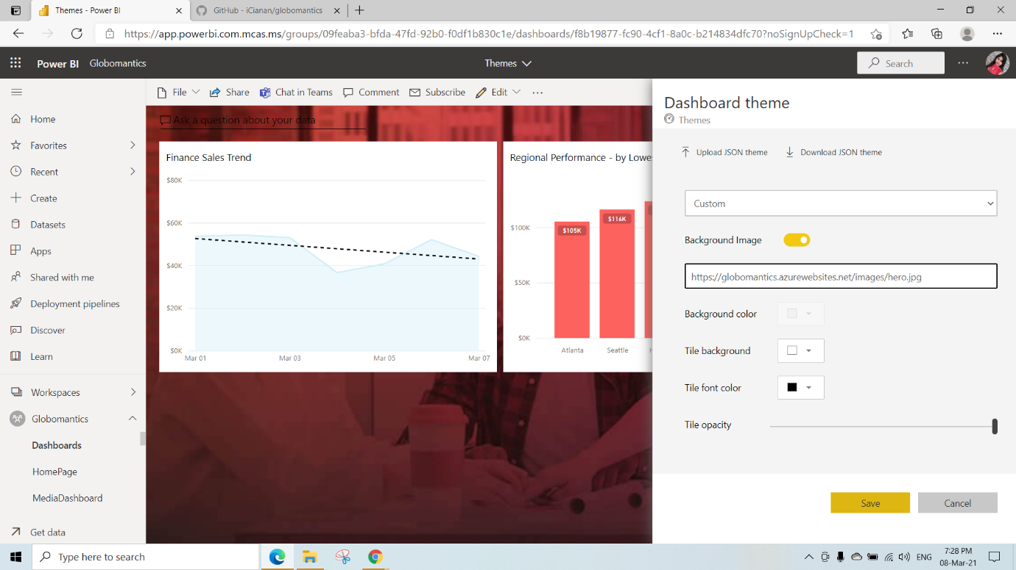

Here we can adjuzt the Tile Capacity of Background Image and have to save it to see the Changes

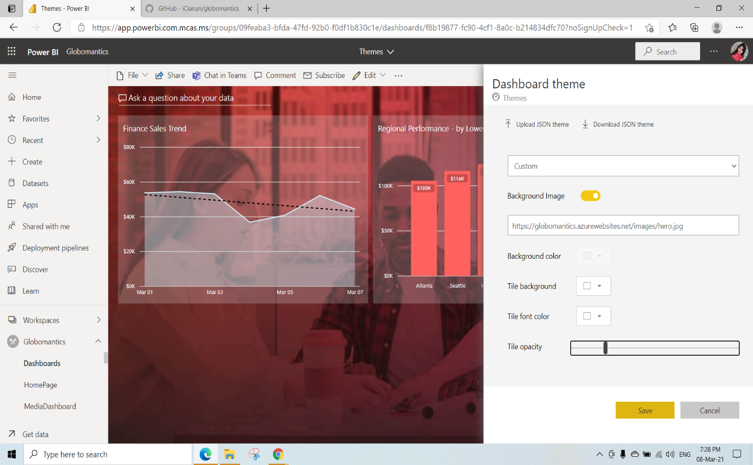

After adding background image and adjusting tile Capacity

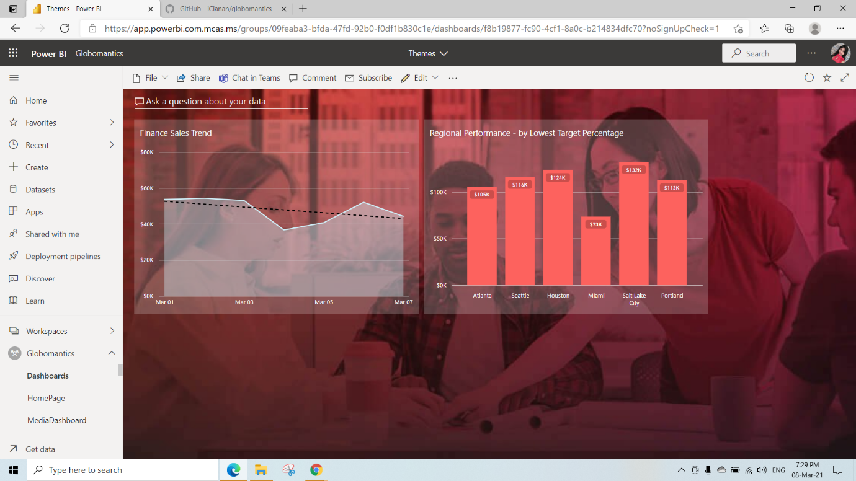

Managing Dashboards

Here we have created new Dashboard named as Managing Dashboards

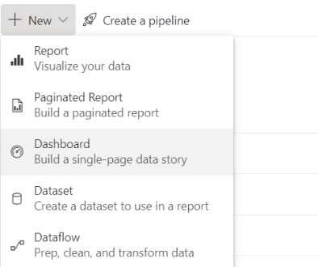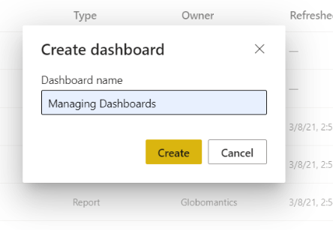

Publish Managing Dashboards to Globomantics Workspace

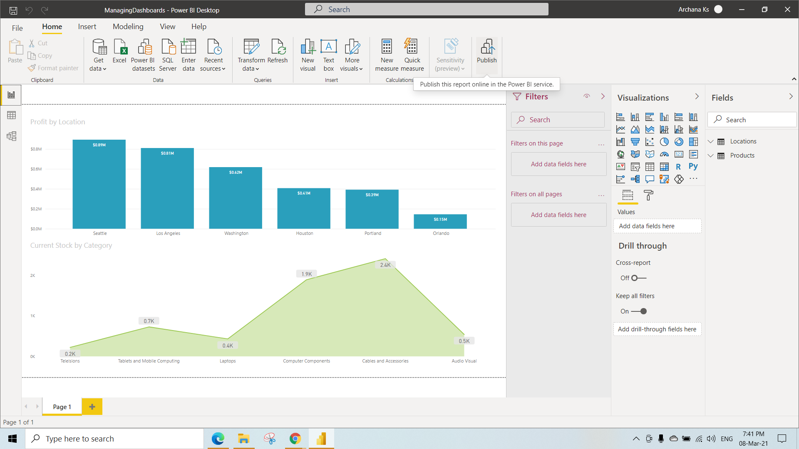

After Publishing click on that open link

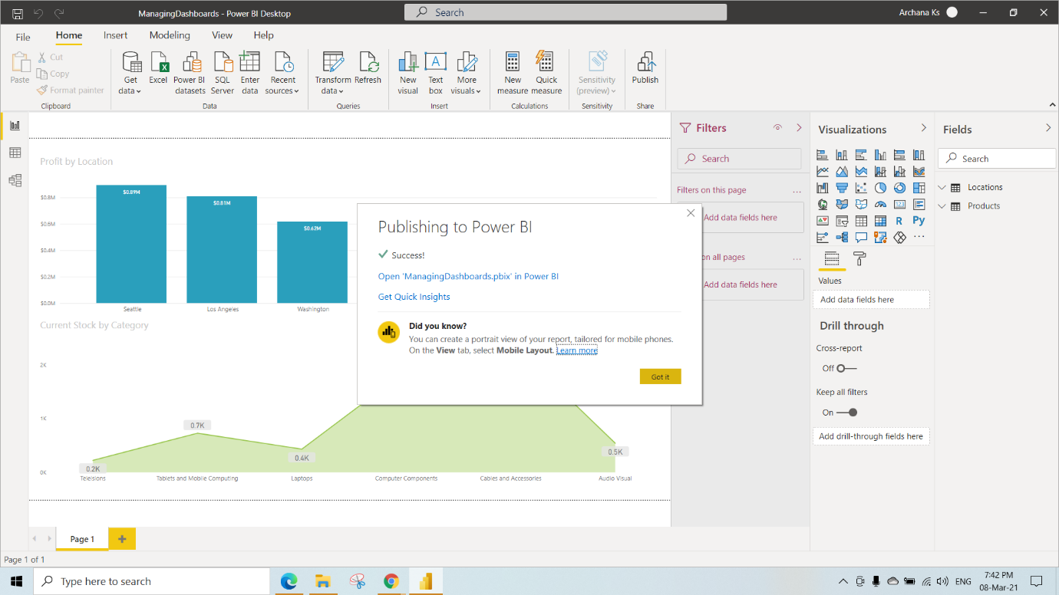

Pin all the Visuals which are there in the Managing Dashboards PBIX File to the ManagingDashboards

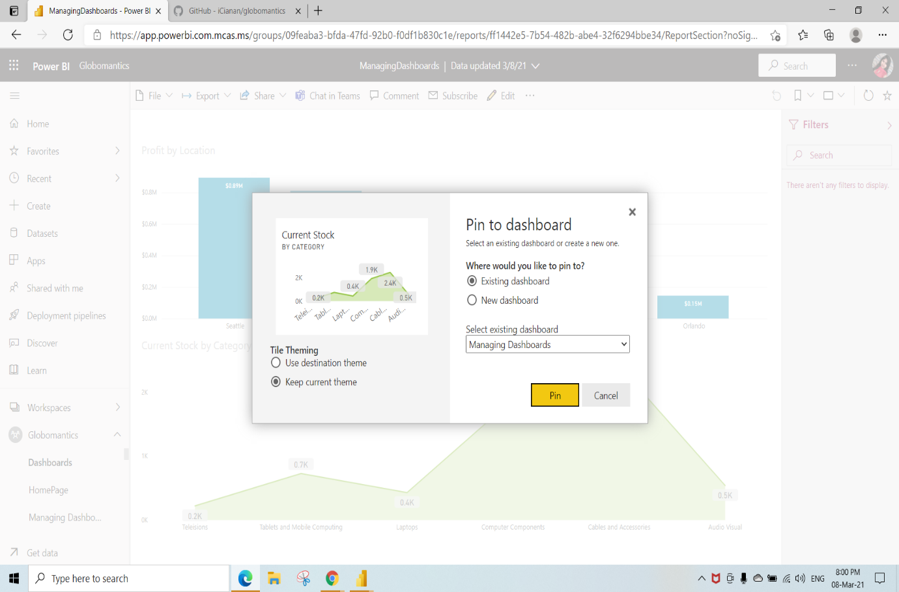

In the Globomantics Workspace Click on the Managing Dashboards1 Report

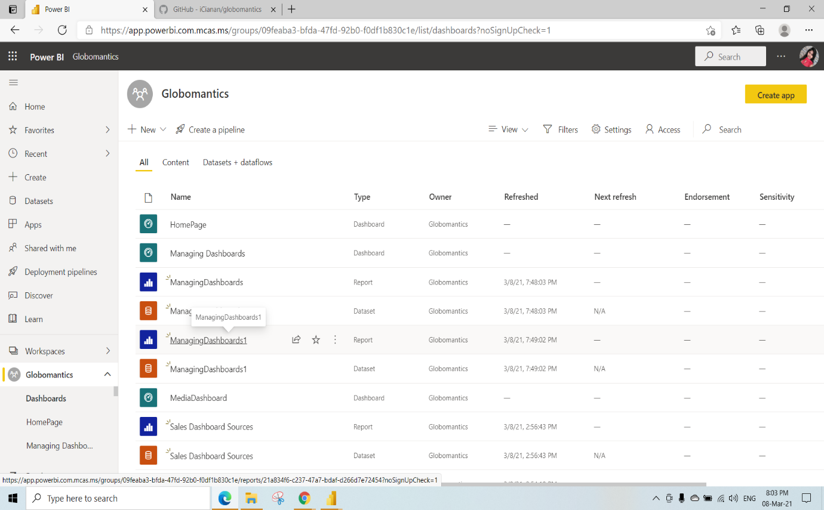

Go to File🡪 Save a Copy to create a Duplicate copy of this Dashboard

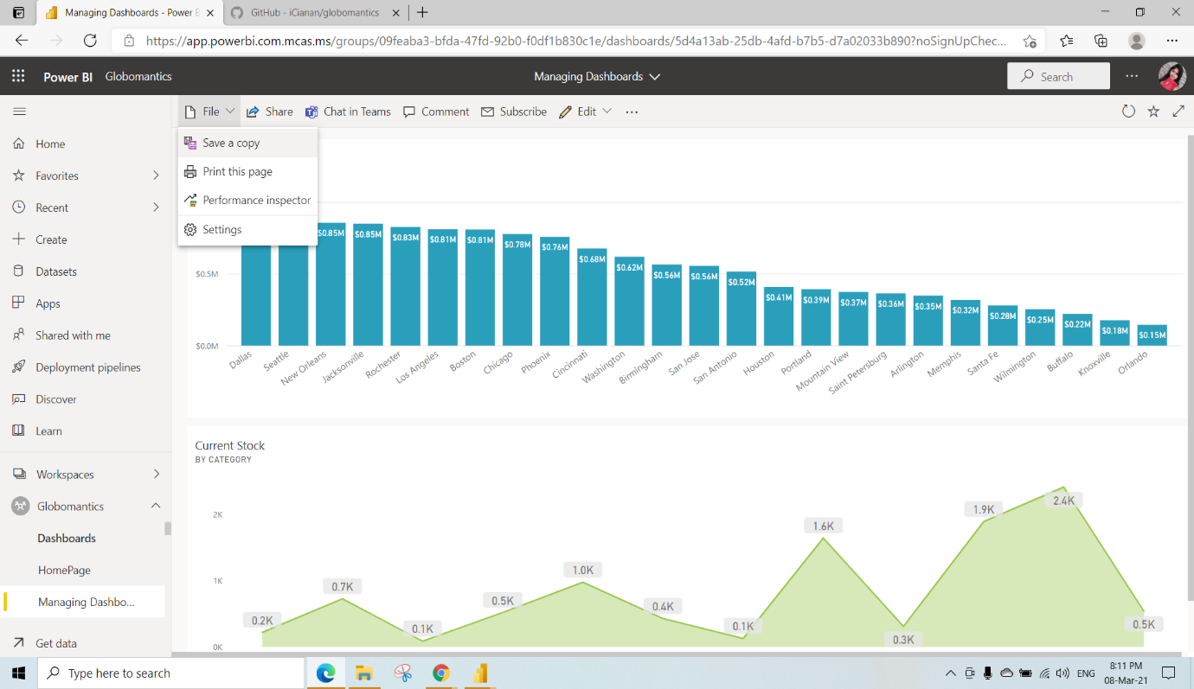

Give a name to the Duplicate dashboard and click on Duplicate(We have given name as Managing dashboard_V2 for duplicate dashboard)

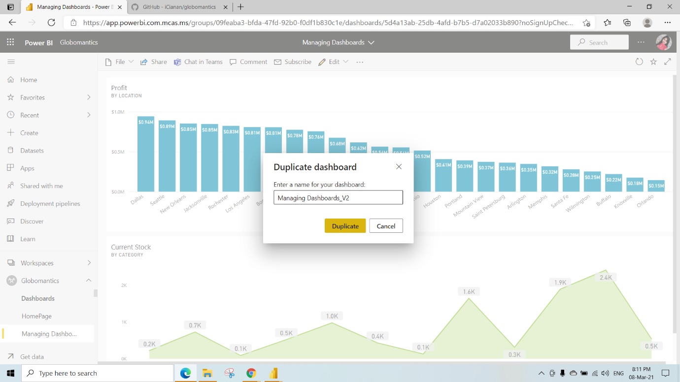

Go to the Duplicated dashboard and remove the Profit Tile by clicking Delete tile

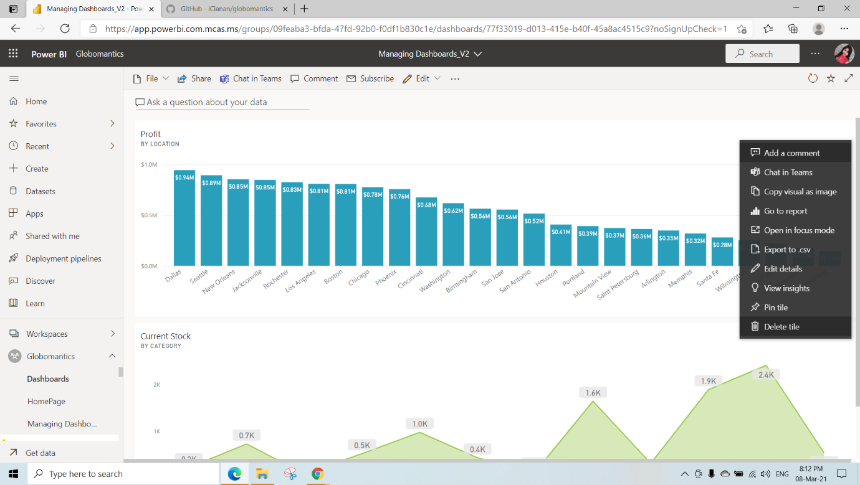

Go to the Managing dashboards1 and Click on edit

Here we have performed filter on location by clicking dropdown and selecting TopN and show Top 5 Items By Value Profit and click on Apply Filter (you are able to see top 5 locations)

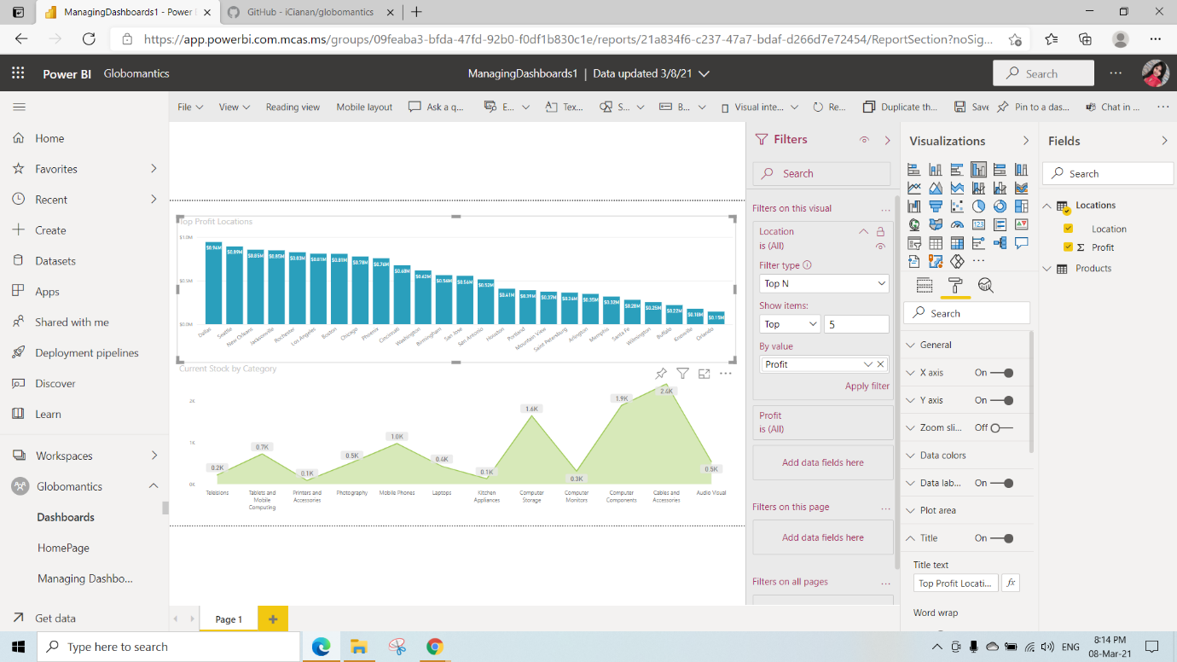

After applying Filter we will get this Visual

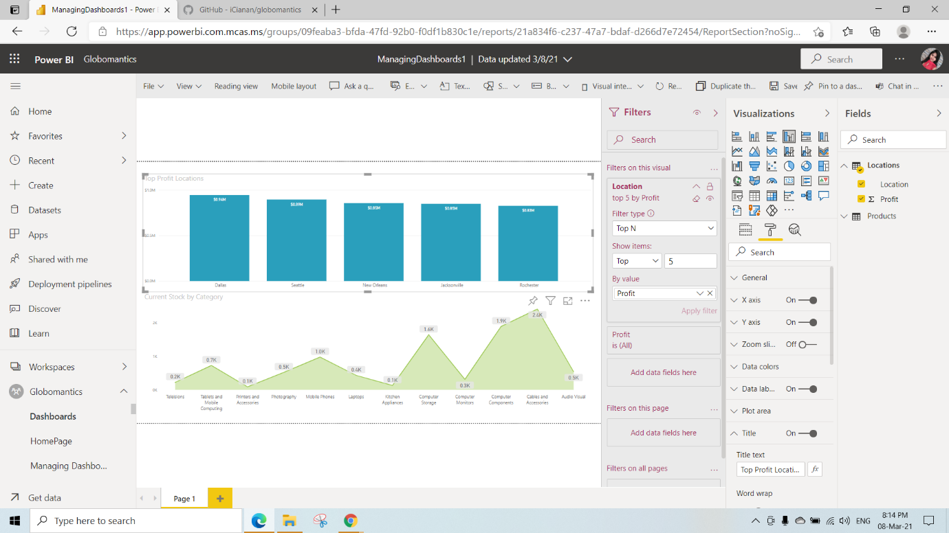

And pin that Top 5 Visual to the Duplicated Dashboard named as managing dashboard_V2

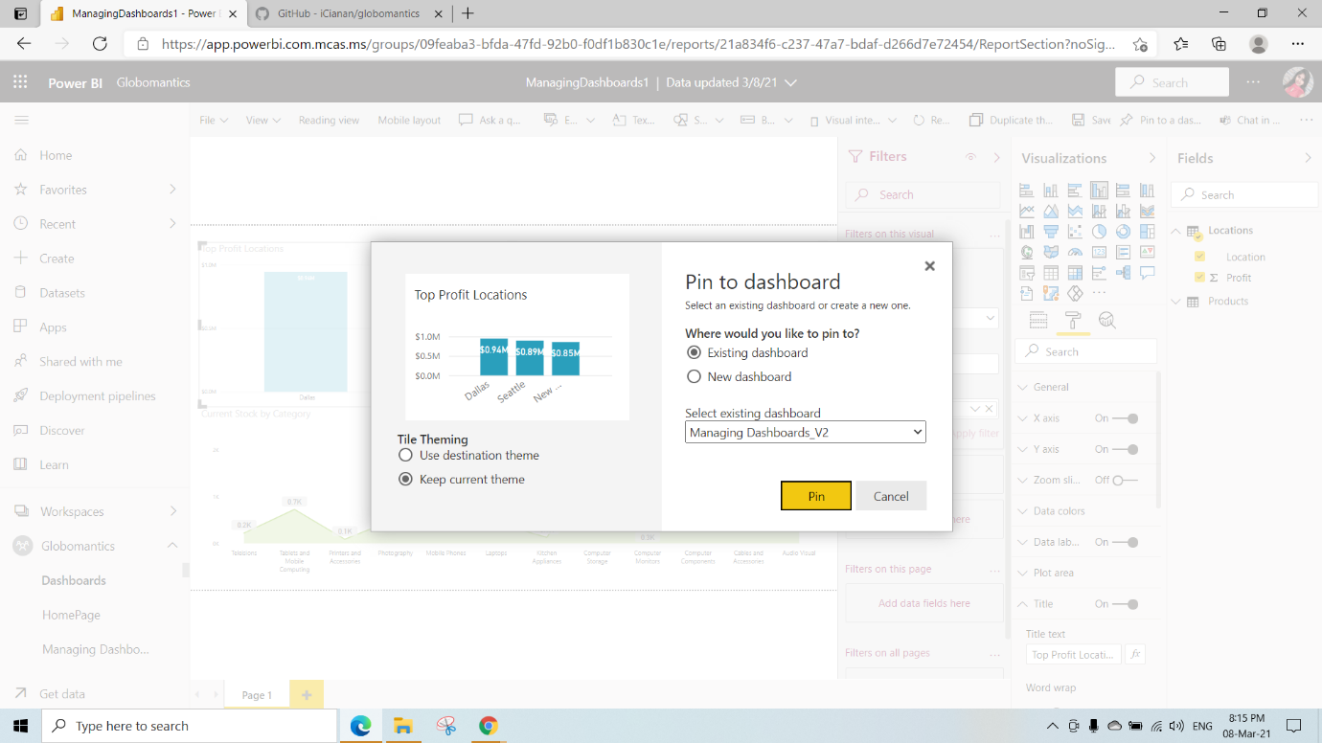

This is the Managing Dashboard_V2 View

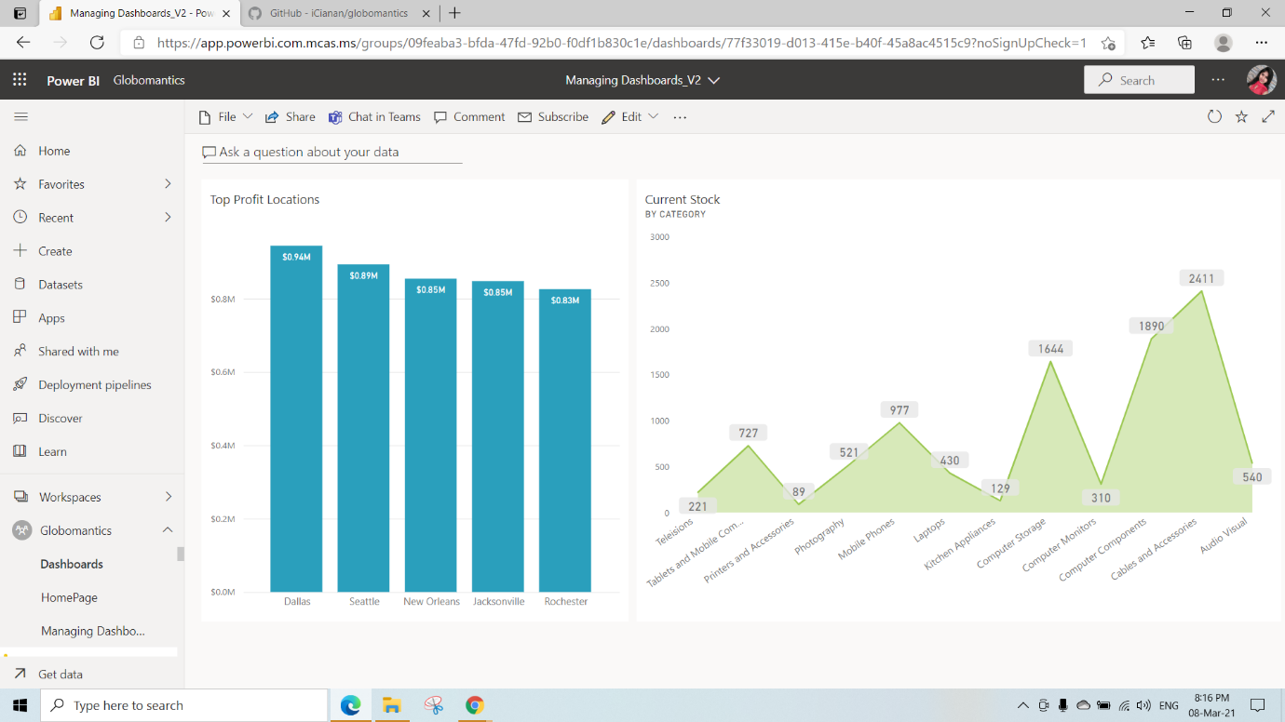

Click on Home Page dashboard under the Globomantics workspace

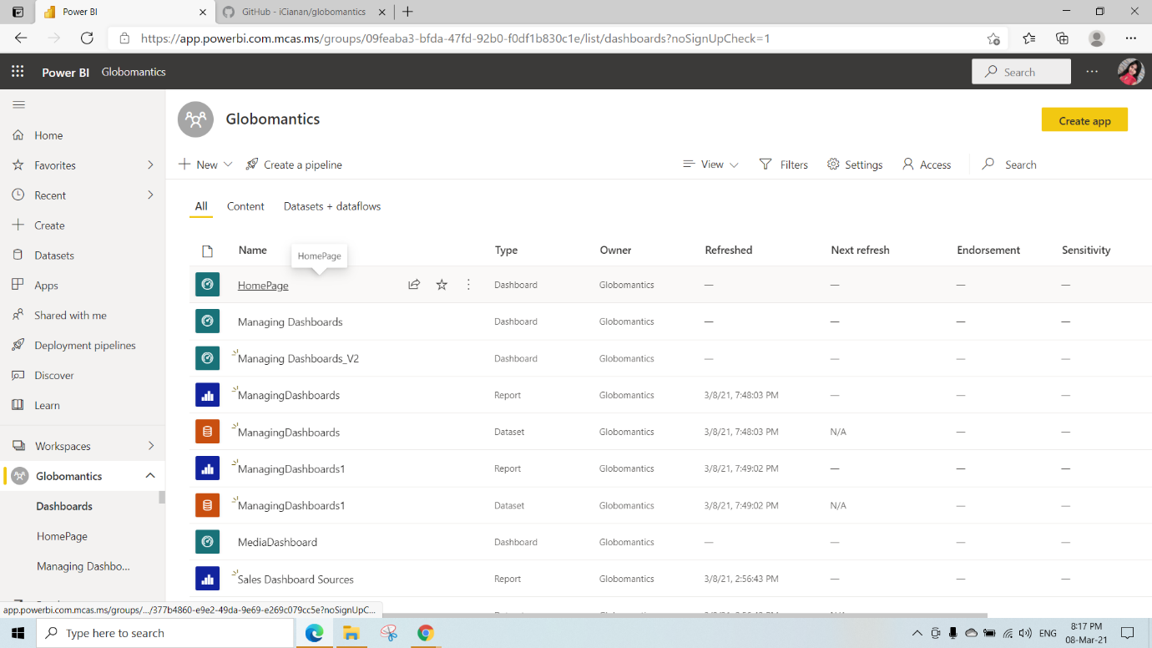

By clicking on 3dots in the Marketing Image Tile Select edit details

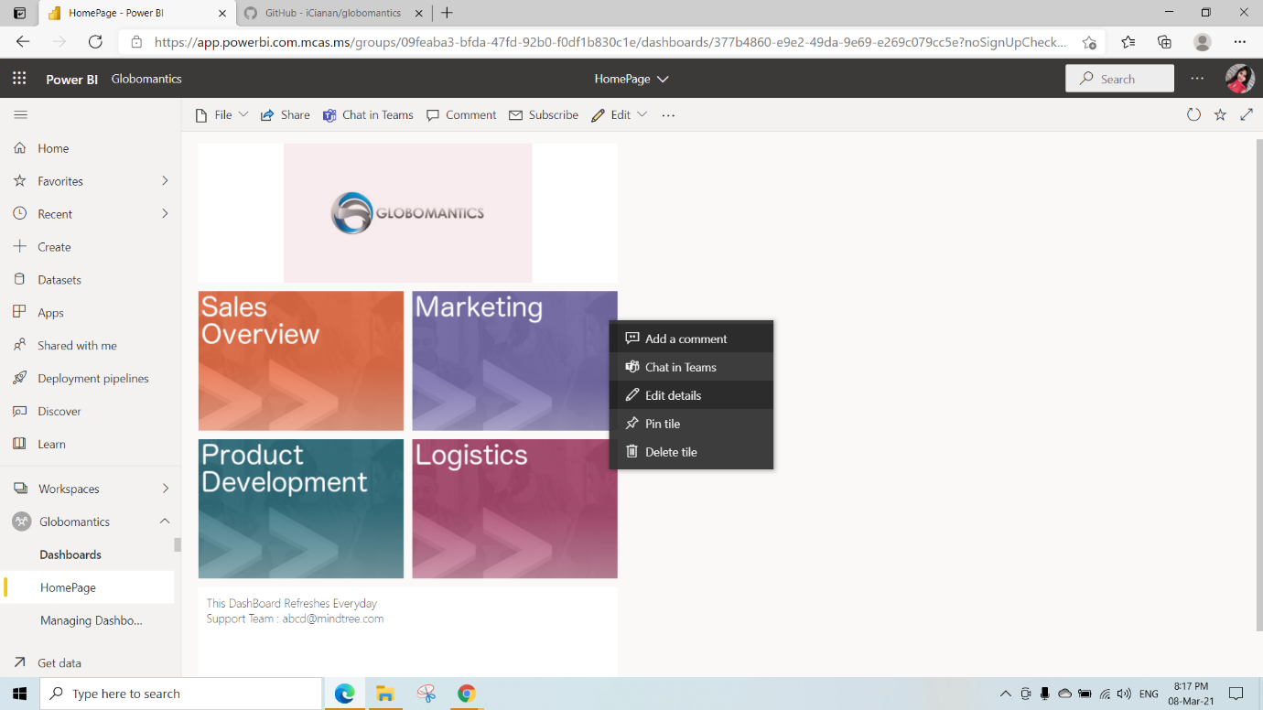

We can set the Custom link(when we click on that visual where we need to go)Select the link type as Link to Dashboard or report in the current Workspace and Click on Apply(Here we have selected managing dashboard_V2 (dashboard))

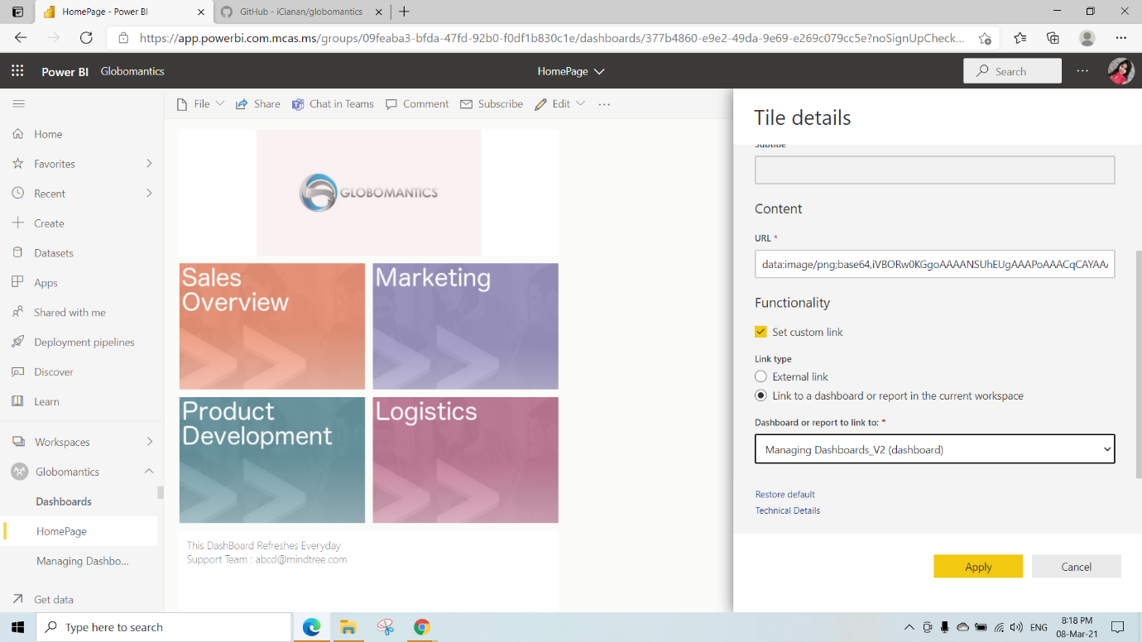

After clicking on Marketing Tile We will be redirected to this Managing Dashboard)V2

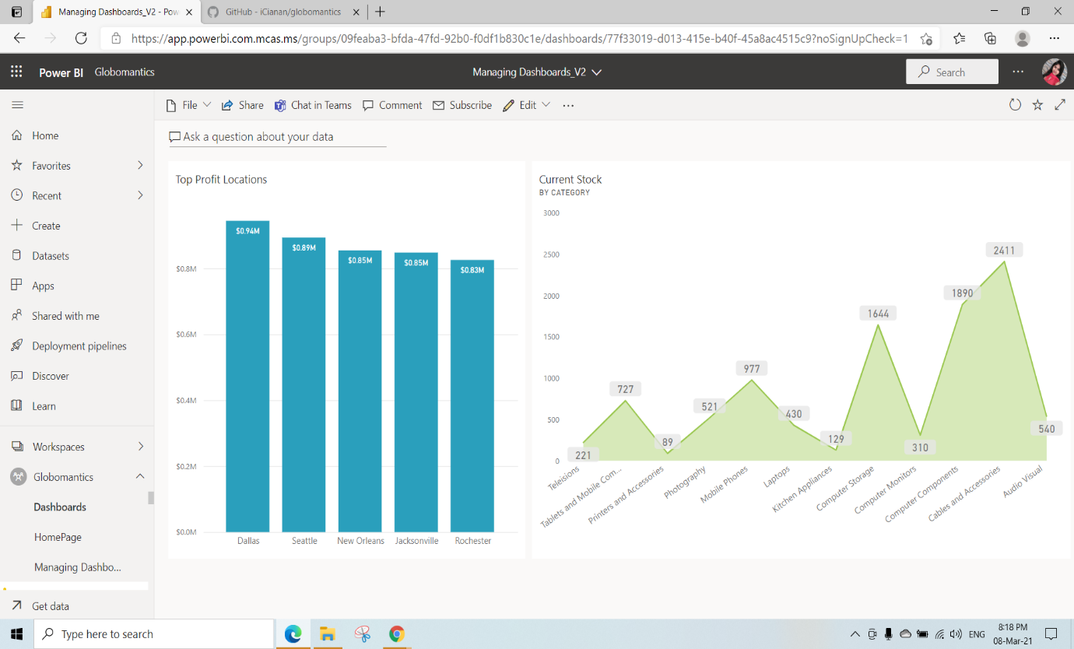

Here we have added a Text box Tile and write the text whatever you want and click on Apply

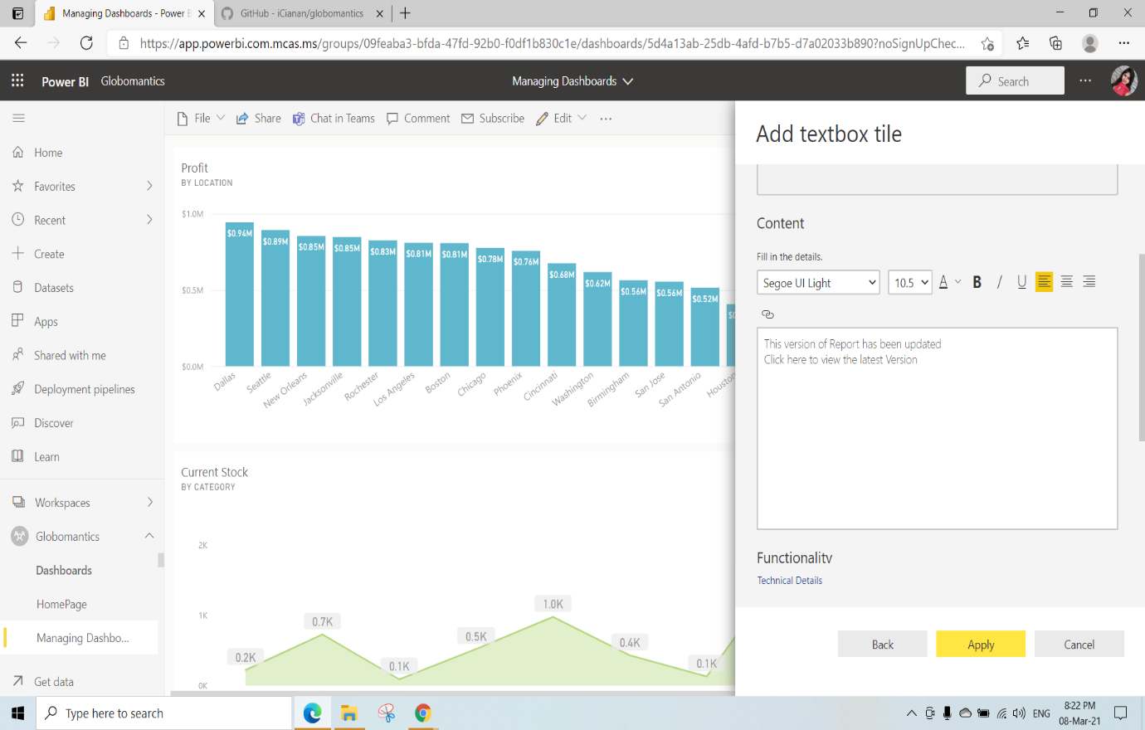

We have edited the Text Box tile

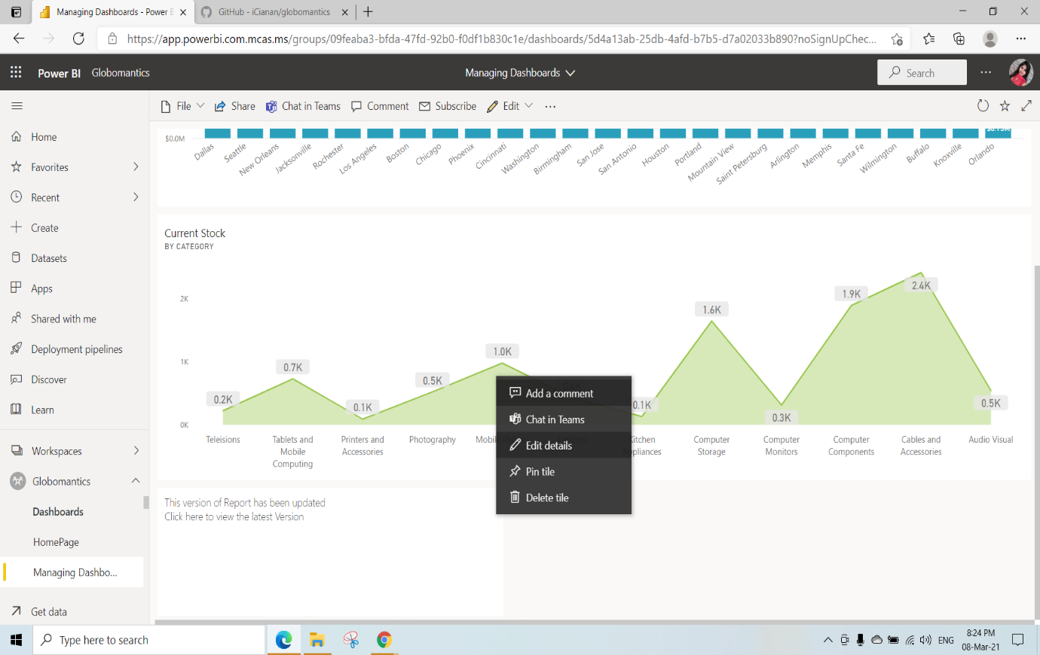

We can set the Custom link(when we click on that visual where we need to go)Select the link type as Link to Dashboard or report in the current Workspace and Click on Apply(here we have linked Managing dashboard_V2(dashboard) to the text Tile)

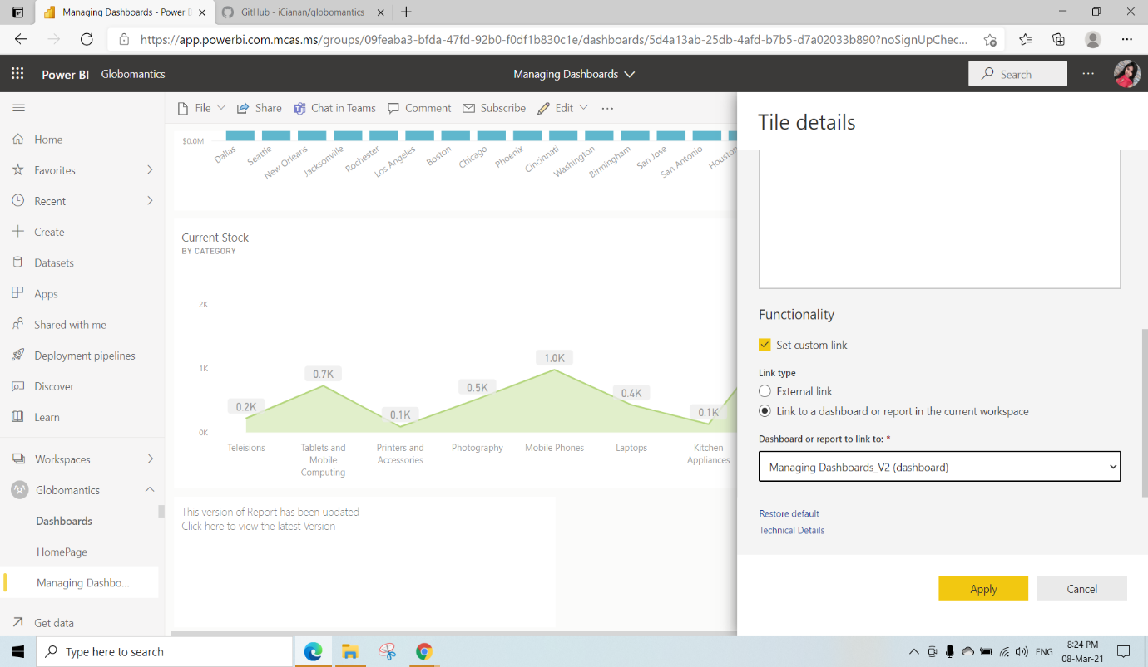

After Clicking on that Text Box Tile We will be redirected to the Managing dashboard_V2 Dashboard

KO 4: Able to Understand Data Security Behaviours in Dashboards

We have Created a new measure named as CurrentUser

CurrentUser = USERPRINCIPALNAME( )

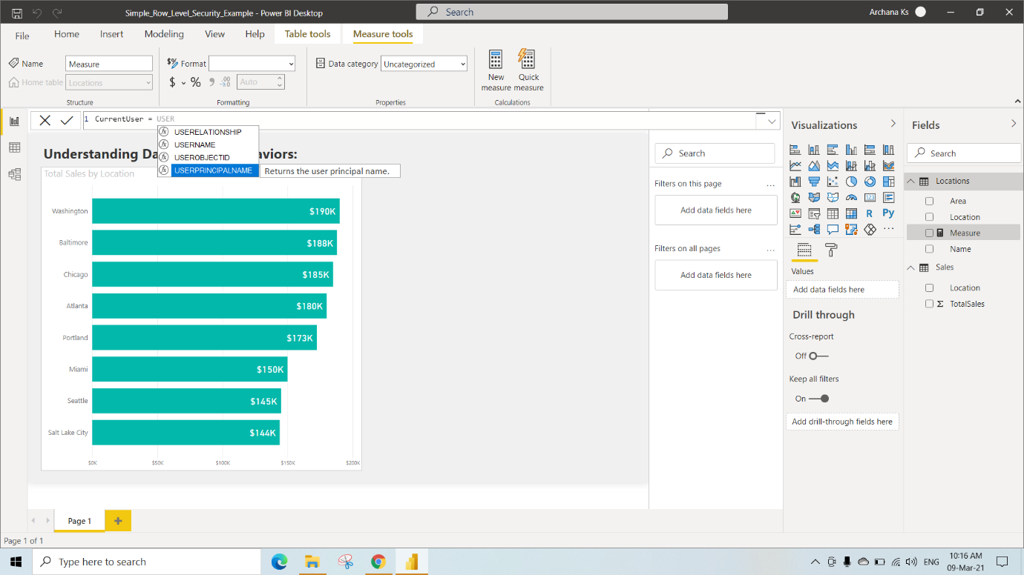

And also another measure as CurrentTime

CurrentTime = FORMAT(UTCNOW( ),"HH:MM:ss")

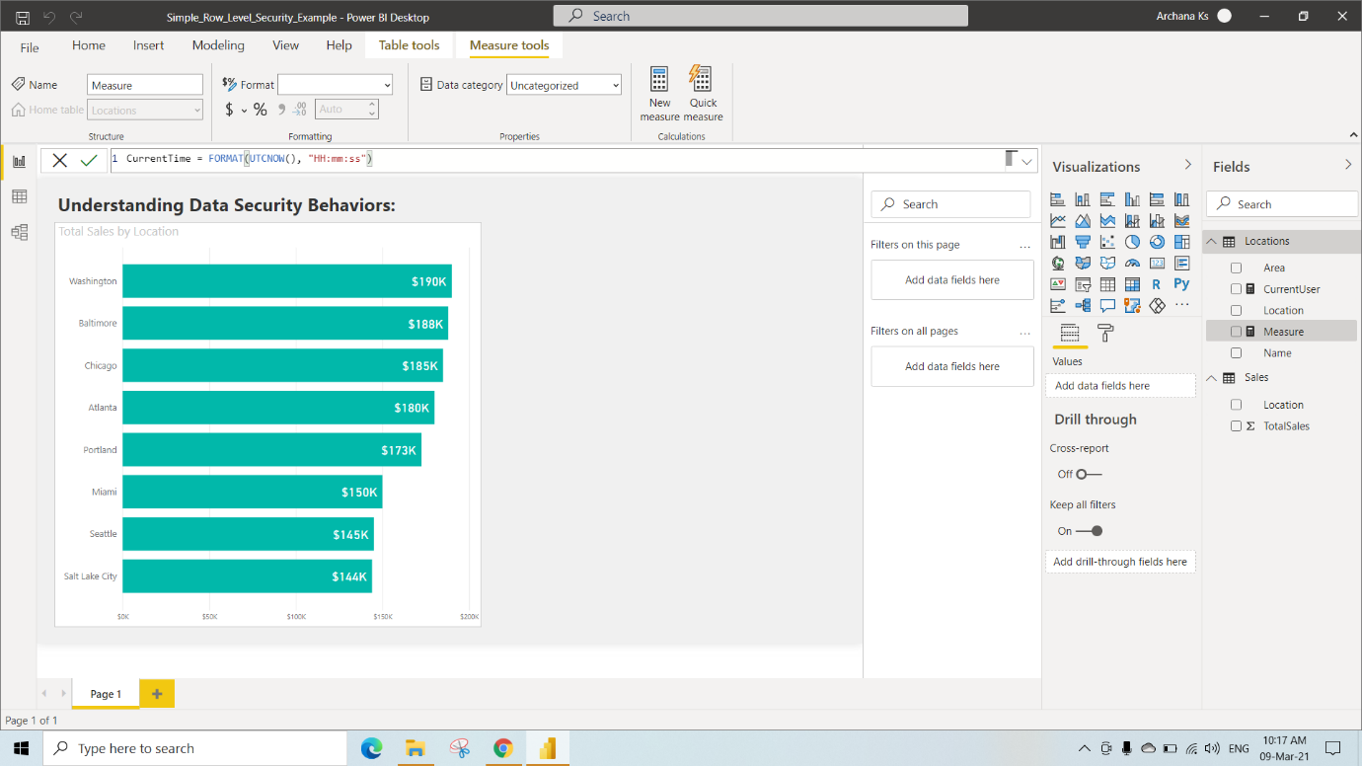

Here Under Modeling Select Manage Roles

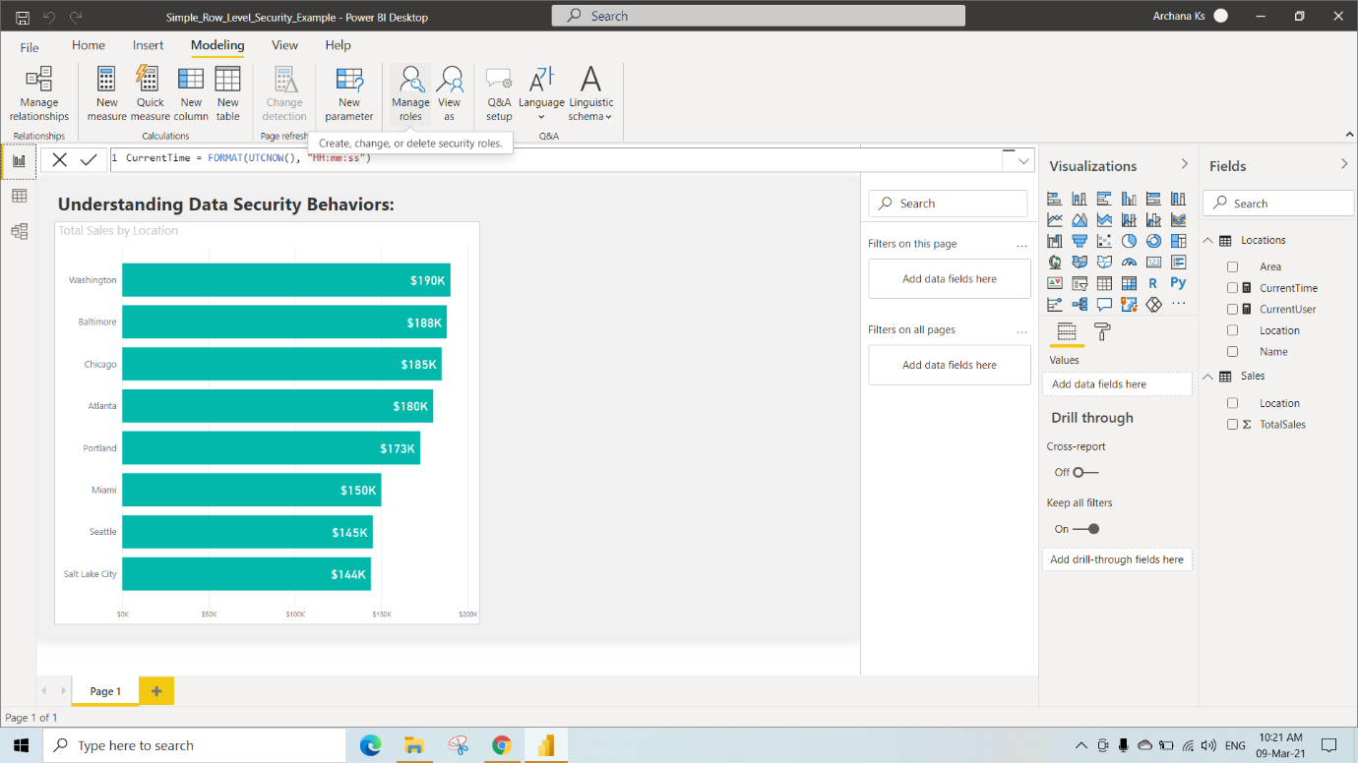

We have Created North Role for Location by clicking on create and selecting Location under the tables and writing DAX Expression as [Area] = “North” and click on that (right mark)

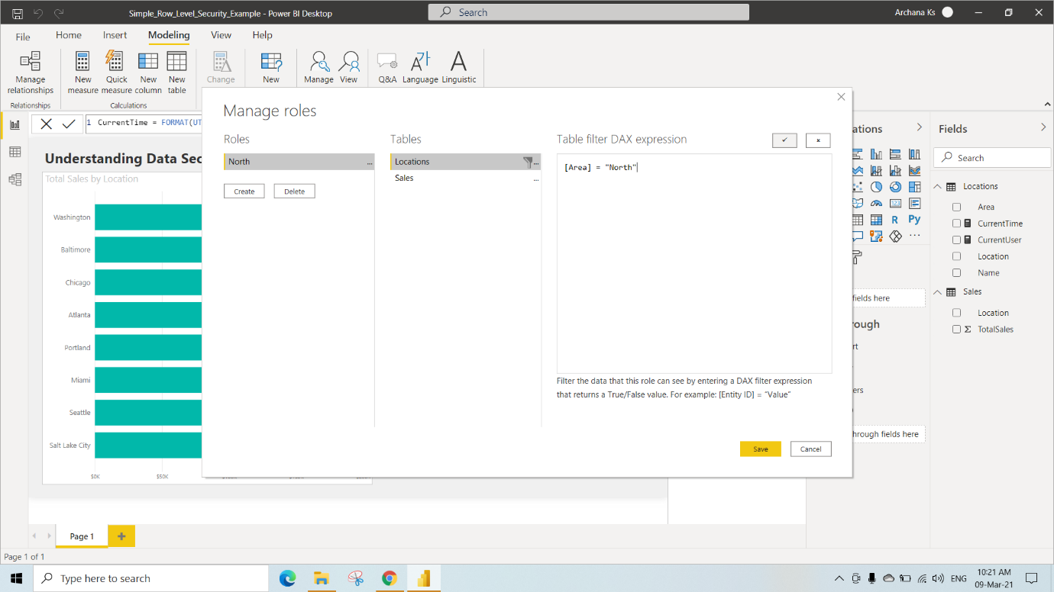

Same as above create 3 roles for Location as North, East and West and Click on Save

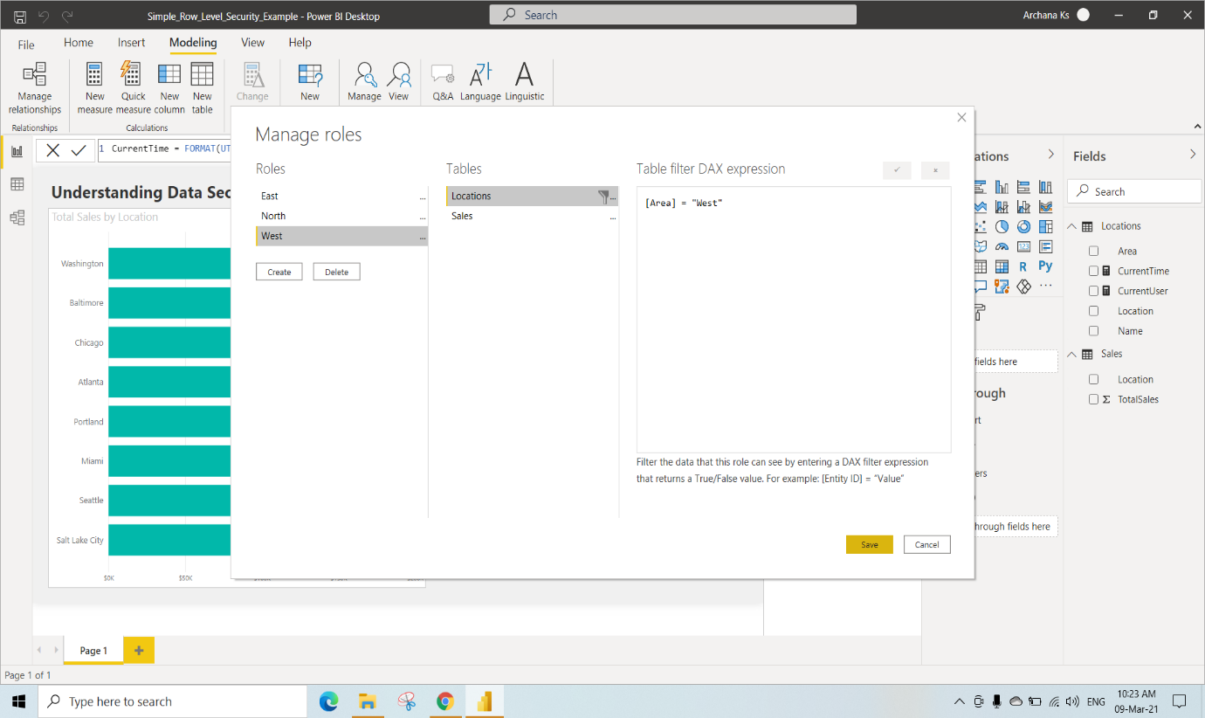

Select View as under Modeling and Select north and Click on OK

You can See the data only related to North Location(can see Changes in the Visual)

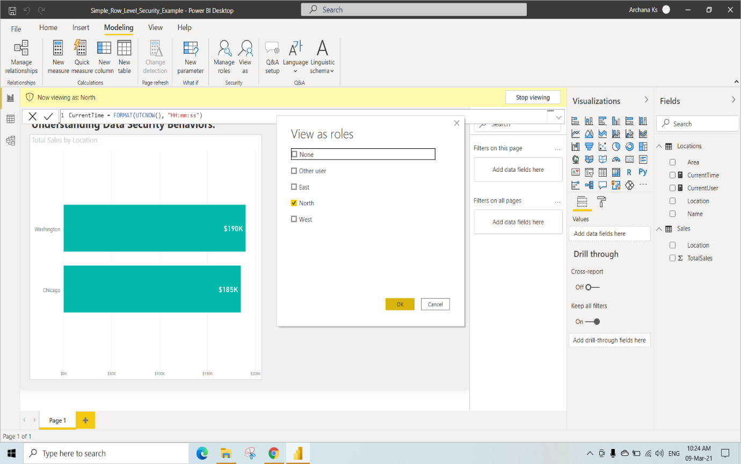

If we click on Stop viewing we will get the original visual as next Image

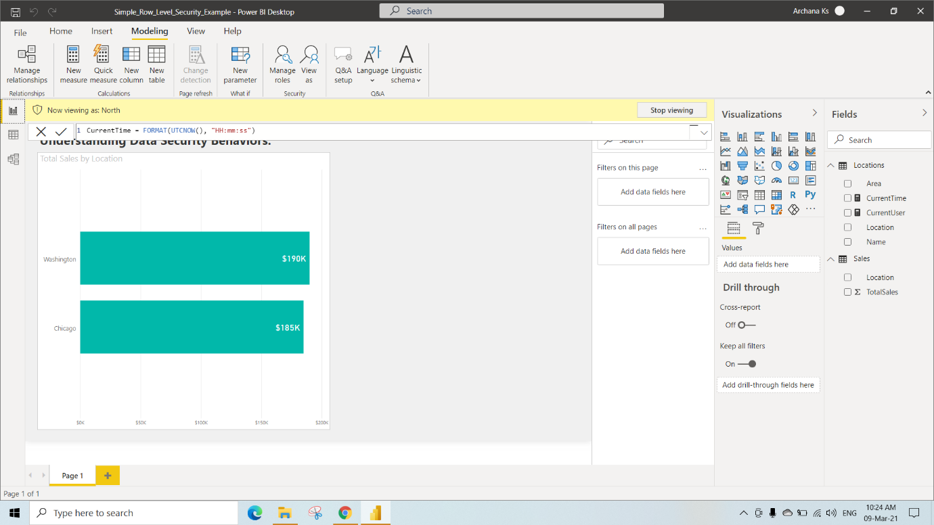

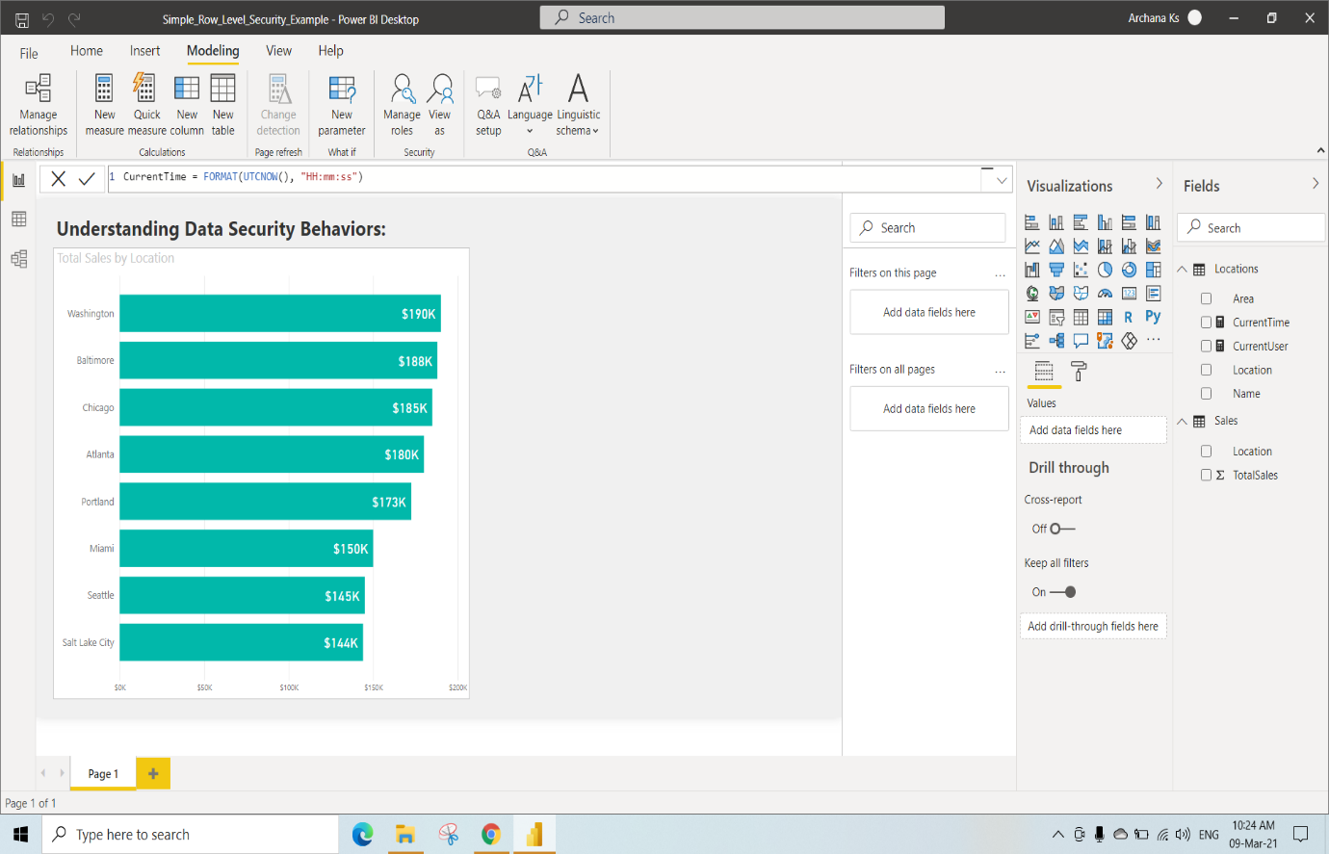

Here we have selected New table under modeling and add Current User and Current Time measures from the location table

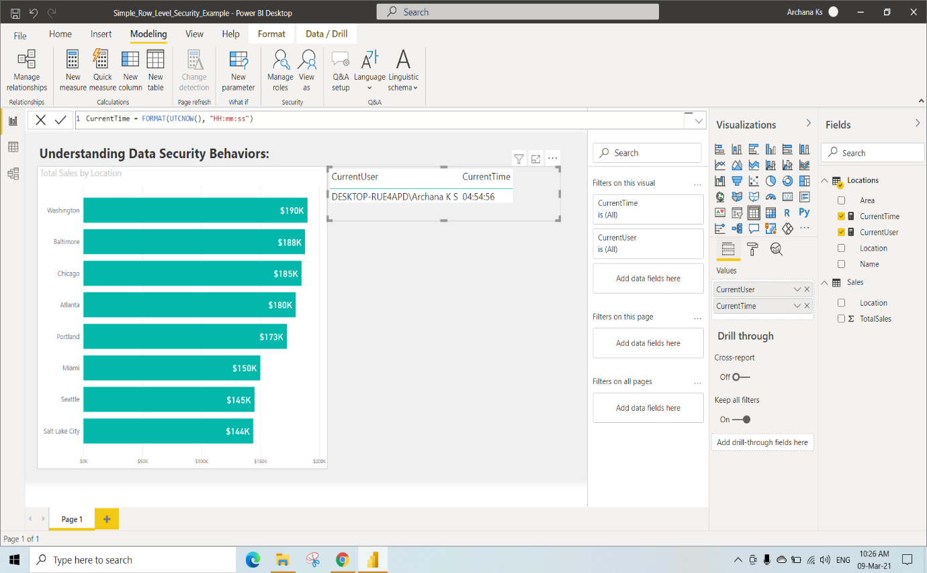

Create a new Workspace named as DataSecurity and in that Create a new Dashboard named as SecurityDashboard and click on create

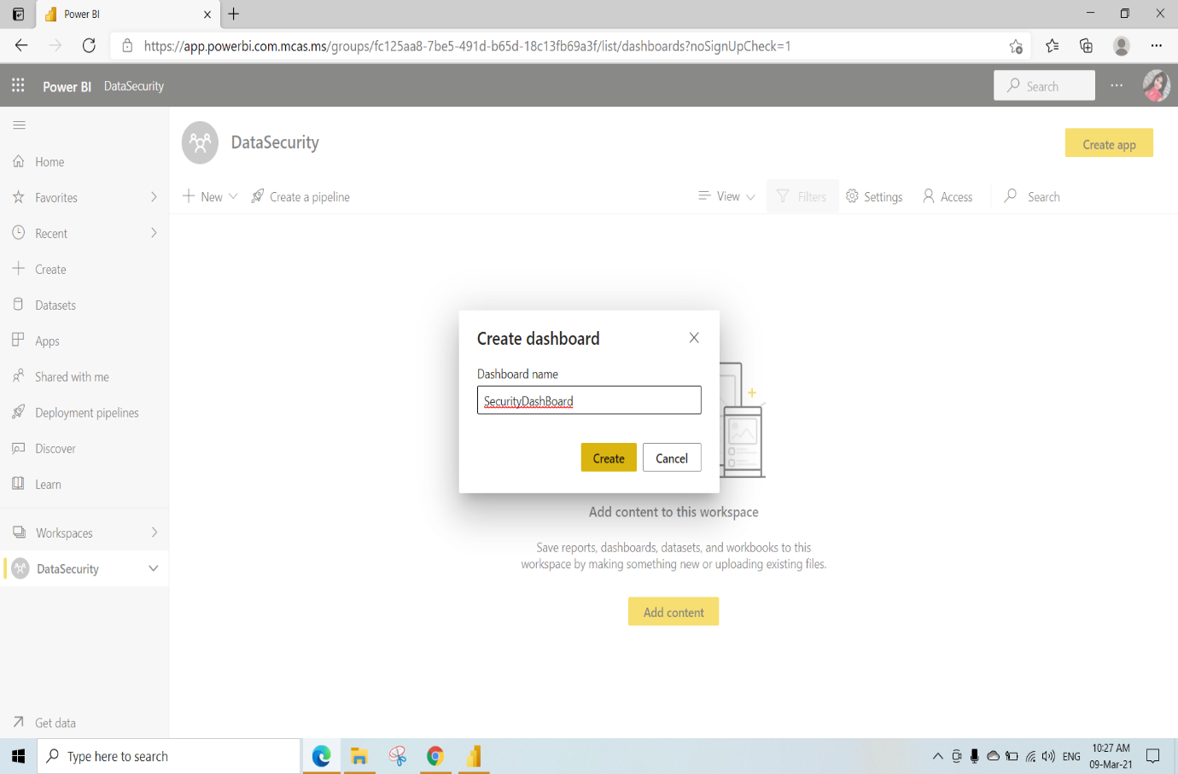

After this need to publish this Simple_Row_Level_Security_Example.pbix File to DataSecurity Workspace

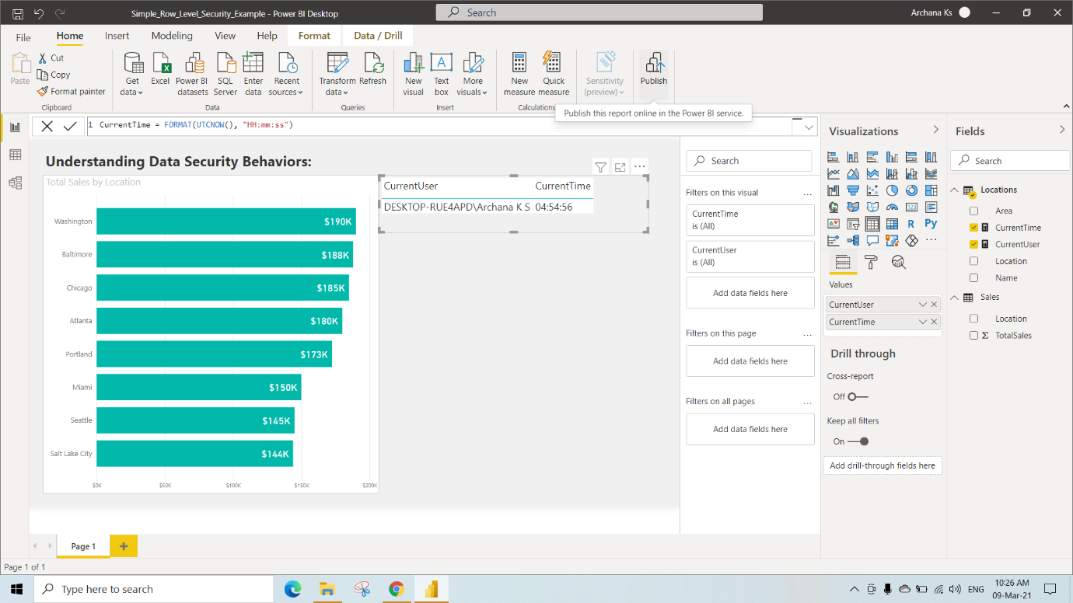

After Publishing click on “Open‘Simple_Row_Level_Security_Example.pbix’ in Power BI”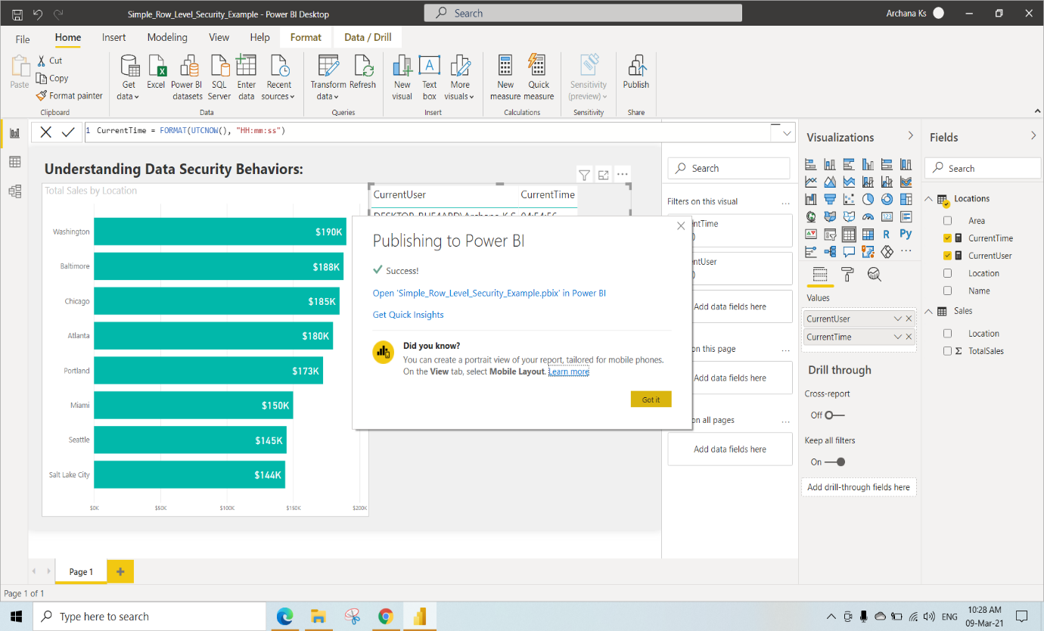

In the dataSecurityWorkspace click on Simple_Row_Level_Security_Example report

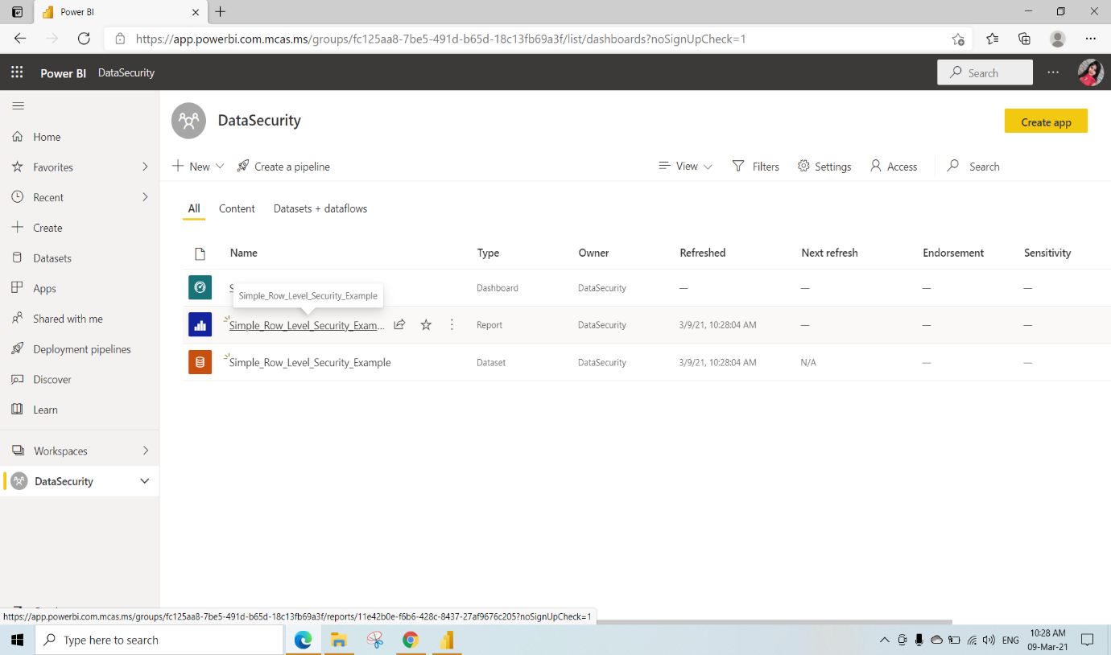

Pin both the visuals to the SecurityDashboards

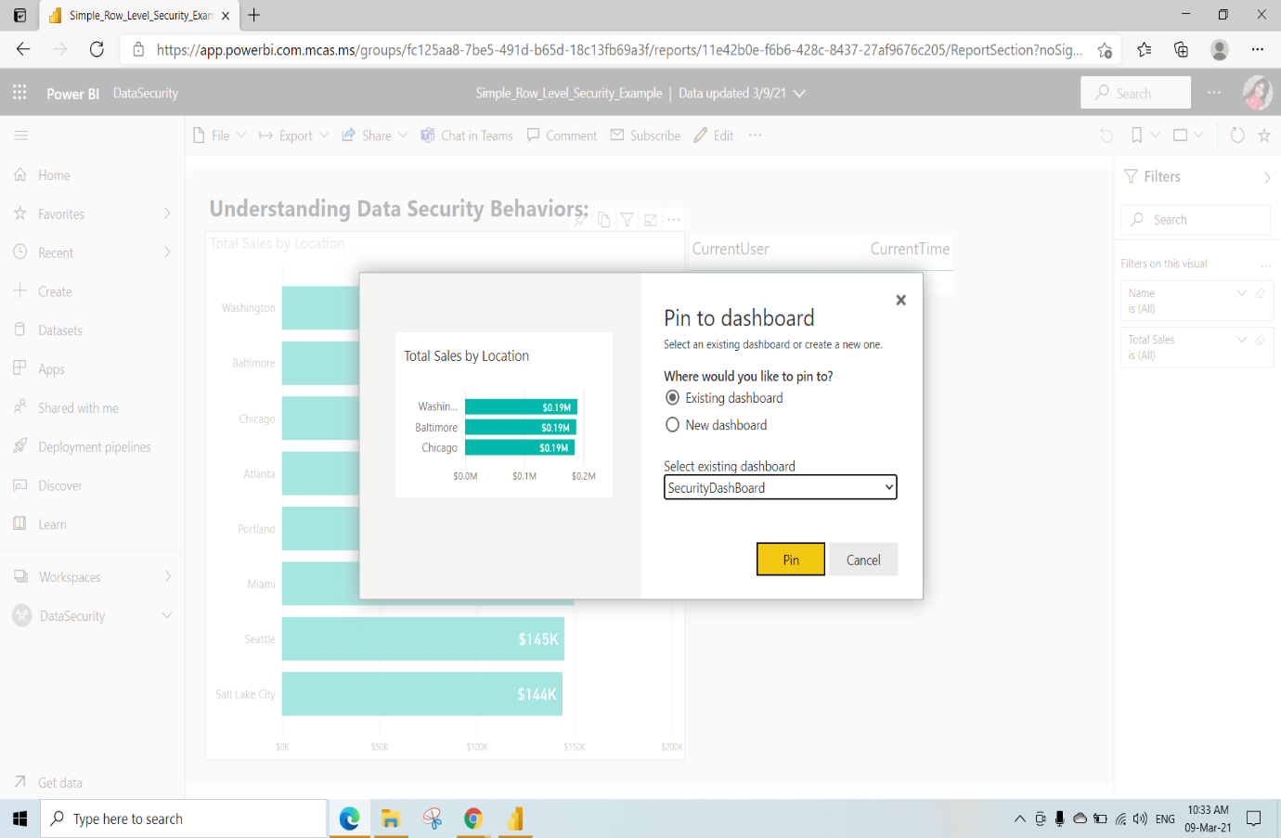

This is the SecurityDashboard View

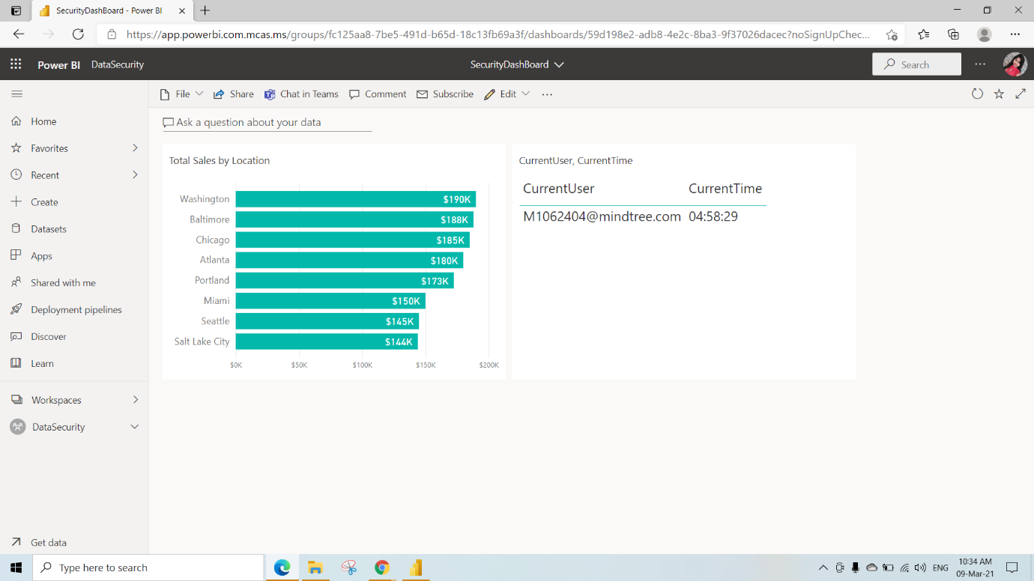

If we click on Refresh button on the top right side in the SecurityDashboard The current time will be displayed

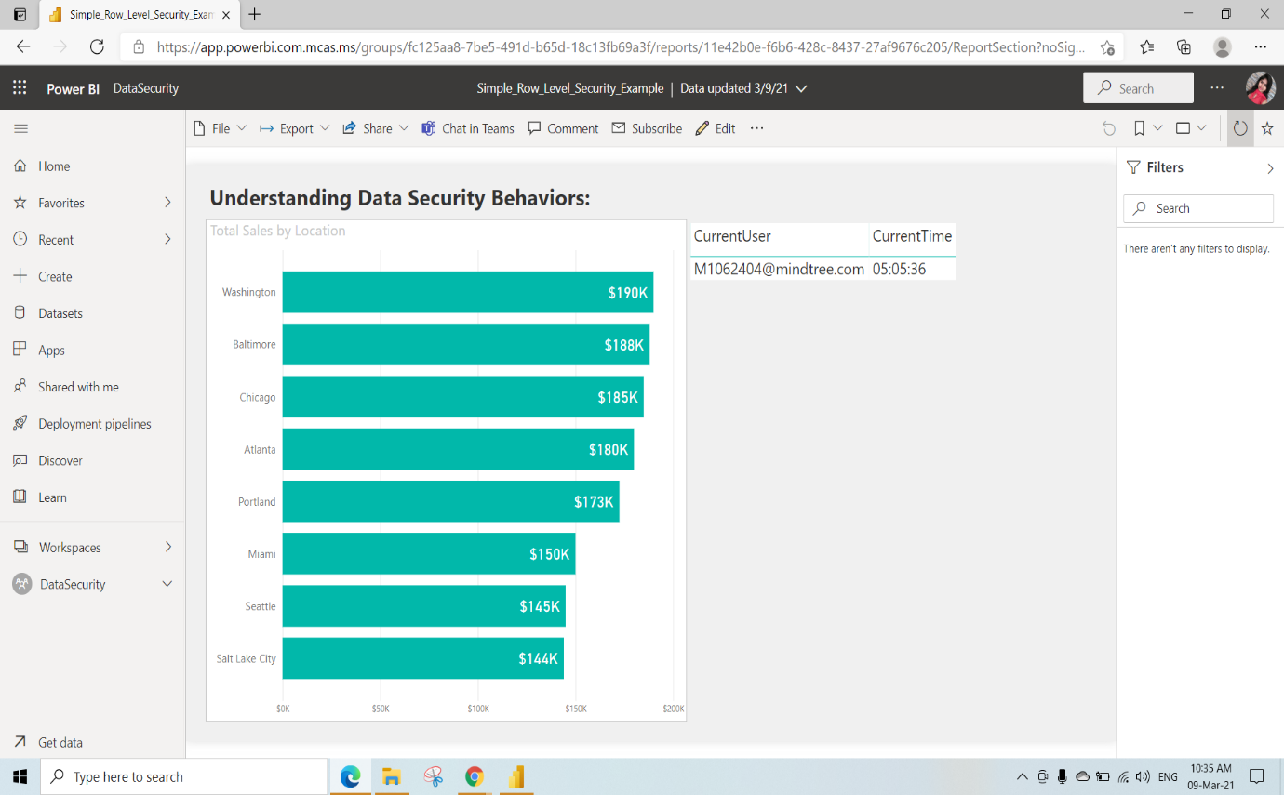

Here click on 3dots near Simple_Row_Level_Security_Example Dataset and select “Security”

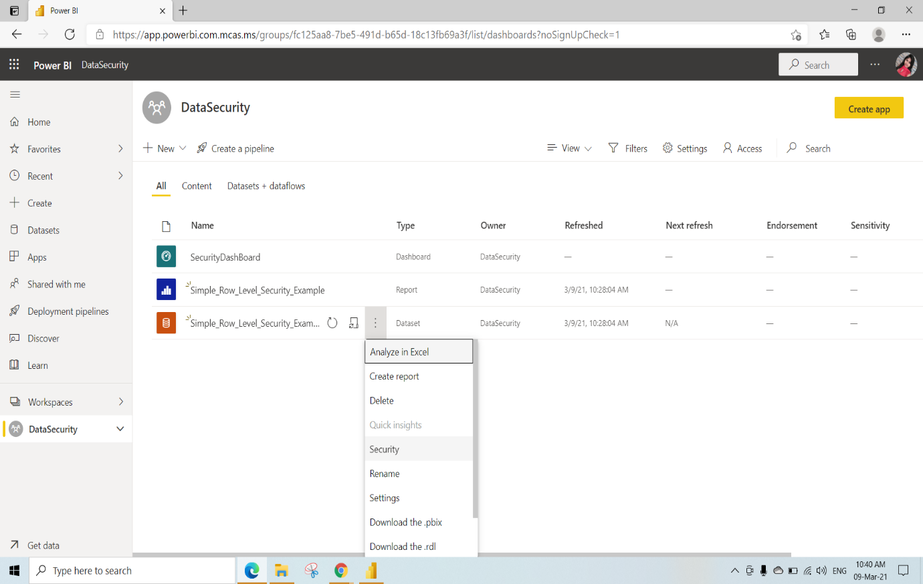

Select North and add the people or group who belongs to this role and click on save

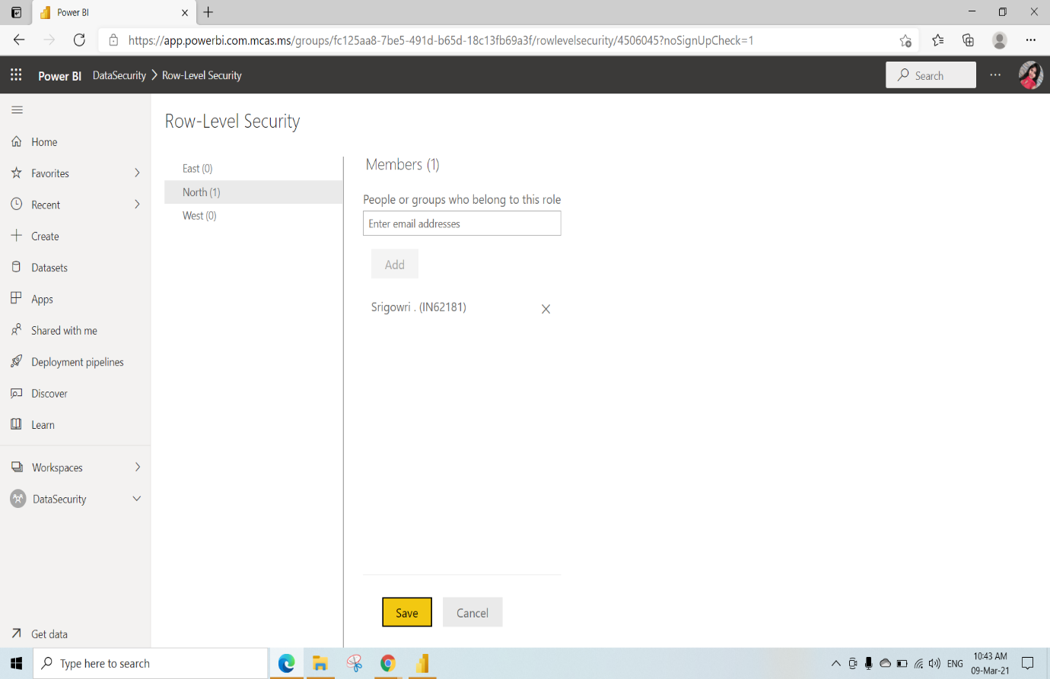

In the DataSecurityWorkspace click on 3dots and select Workspace access

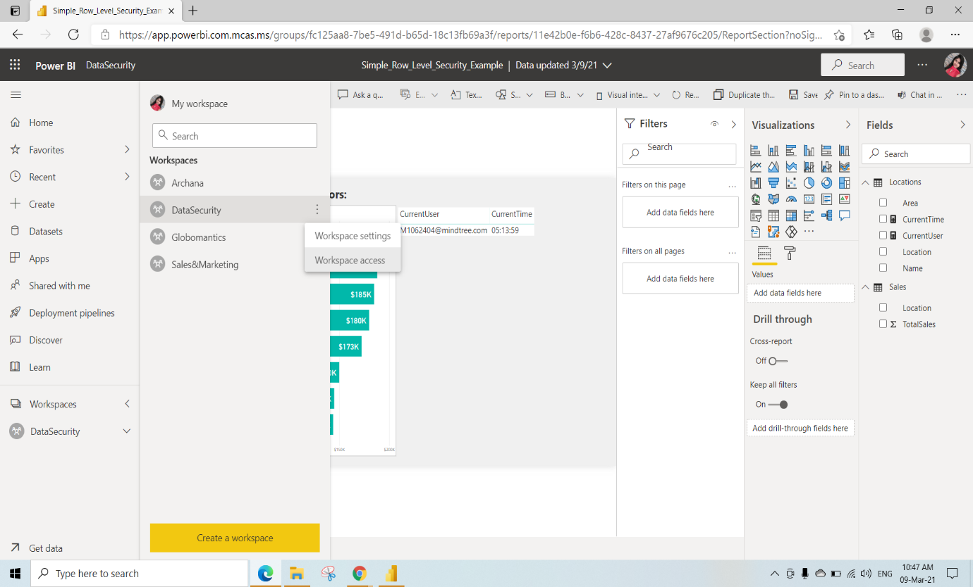

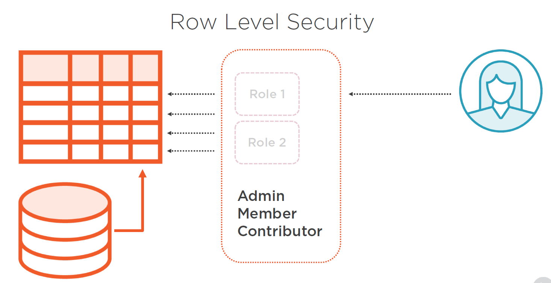

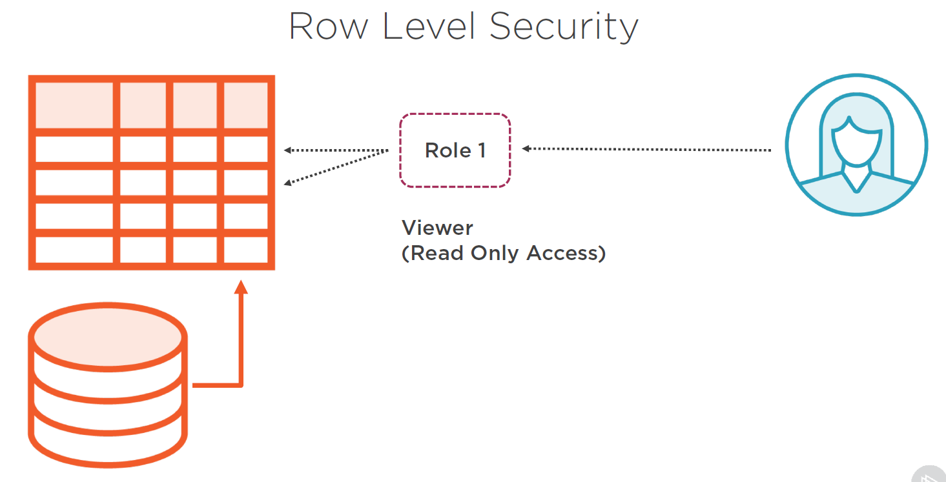

And give Access to added Members or contributors and click on close

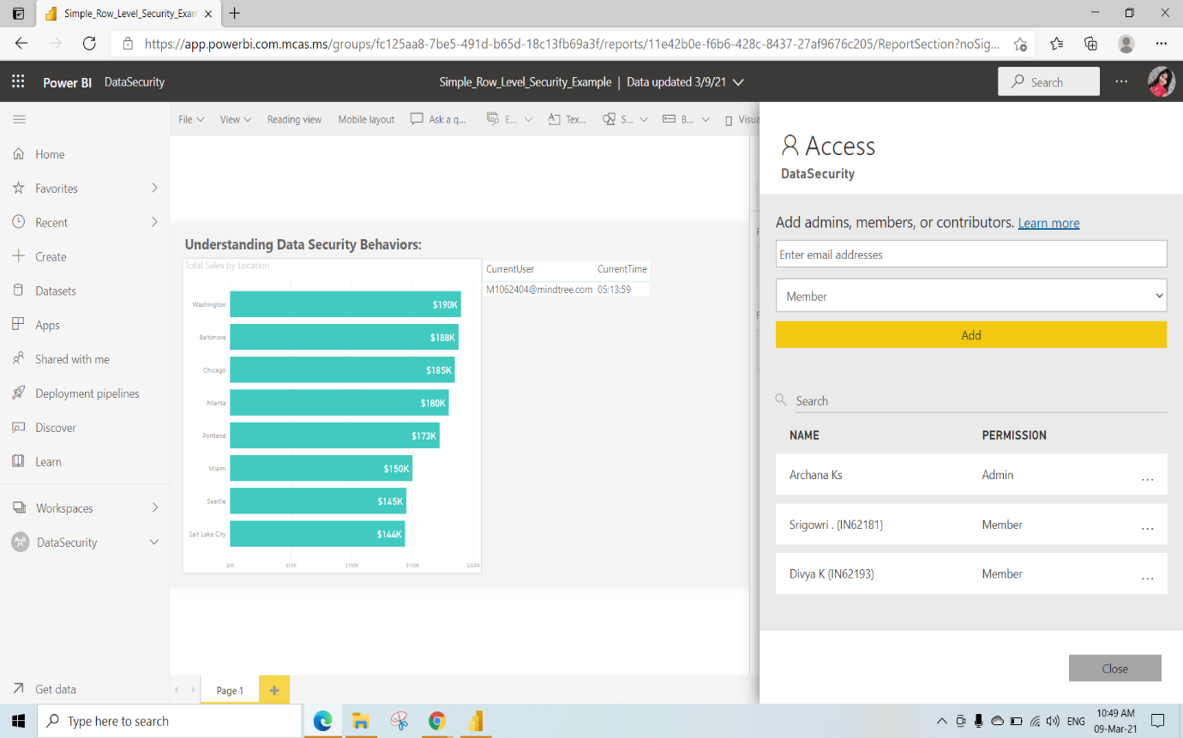

We can share the Dashboards by granting access to any members

If we checked the Allow recipients to share your dashboard: They can share your dashboard to any one

If we checked the Allow recipients to build new content using the underlying datasets: they can make any changes to our Dashboard by having access to our datasets

If we checked the Send an email Notification to recepients : The Member will get an email notification when we shared the dashboard

Later Click on Share

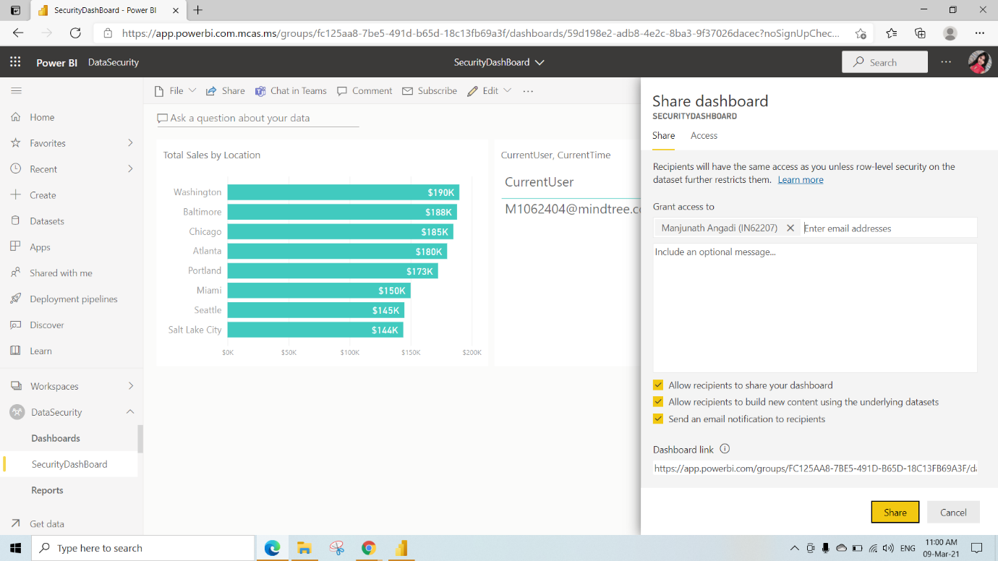

KO 5: Able to Share Reports and Dashboards, Embed Reports in Intranets and Extranets and custom applications

Sharing Reports and Dashboards

Here we are publishing 2018SU07 blog Demo.pbix file to DataSecurity Workspace

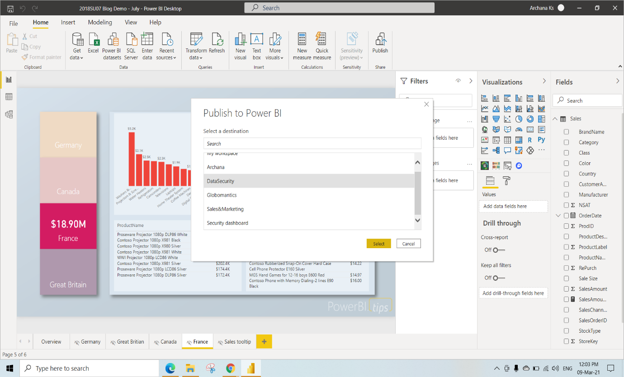

Click on the 2018SU07 blog Demo Report

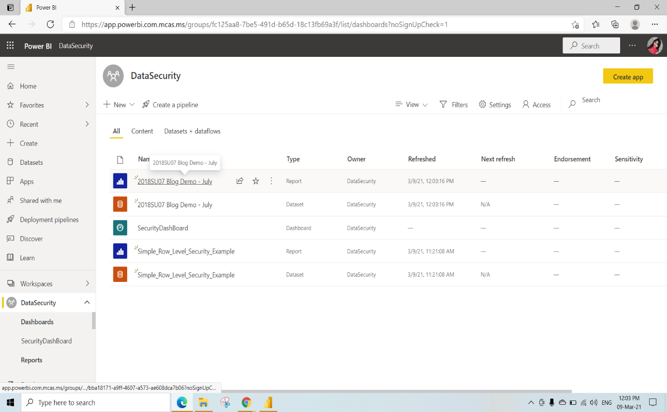

To share the Report with anyone click on Share🡪 select Report 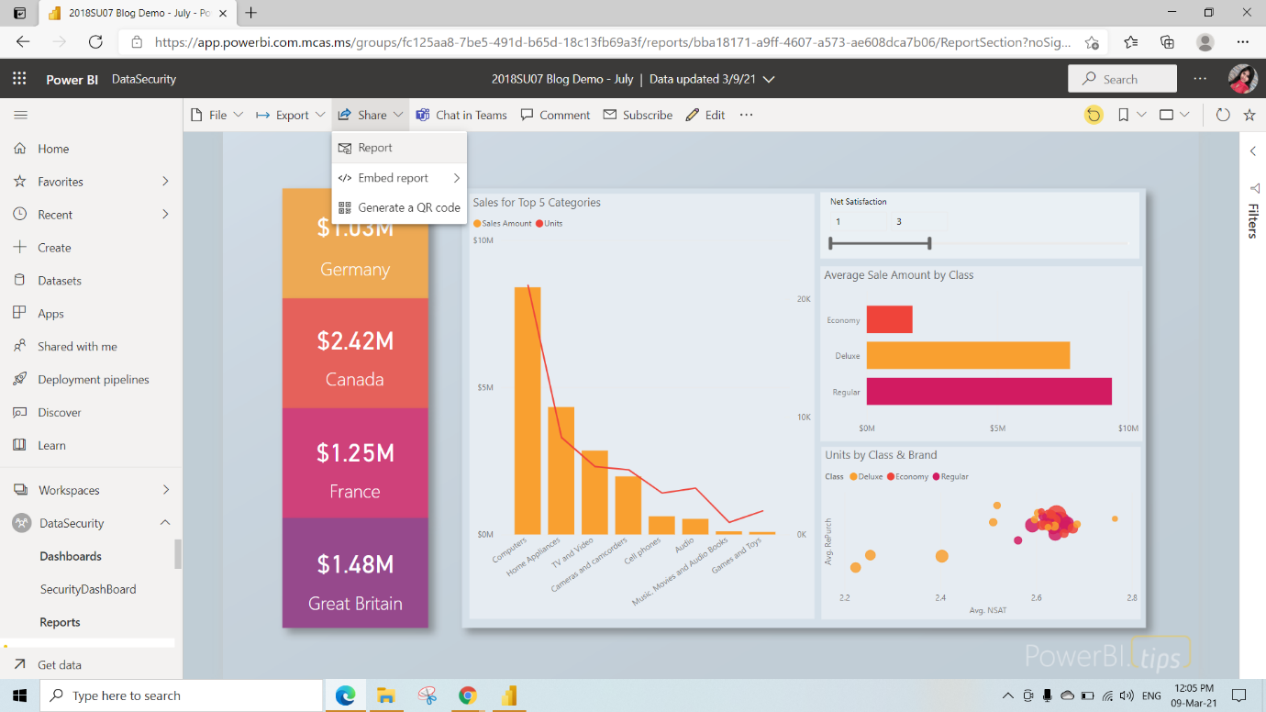

Give Access to any members by adding their email address and click on share

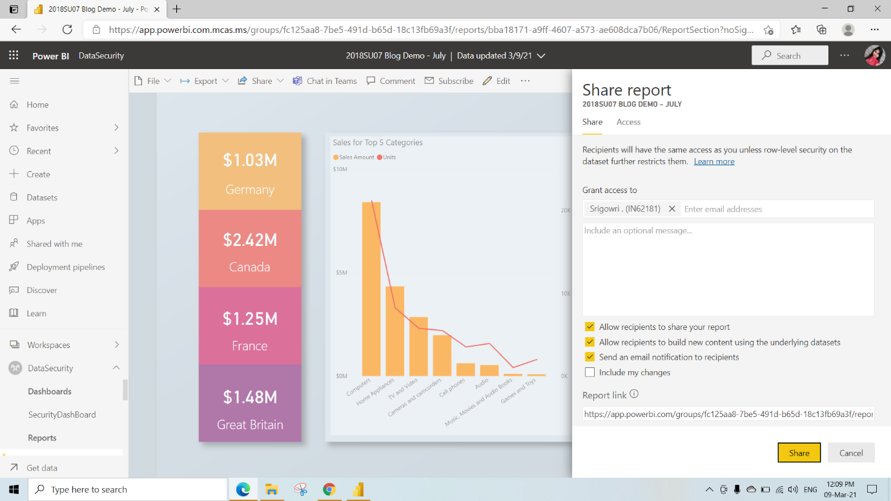

Shared Report Output in another account

We have not given permission to make changes and to share

Hence we can just view it

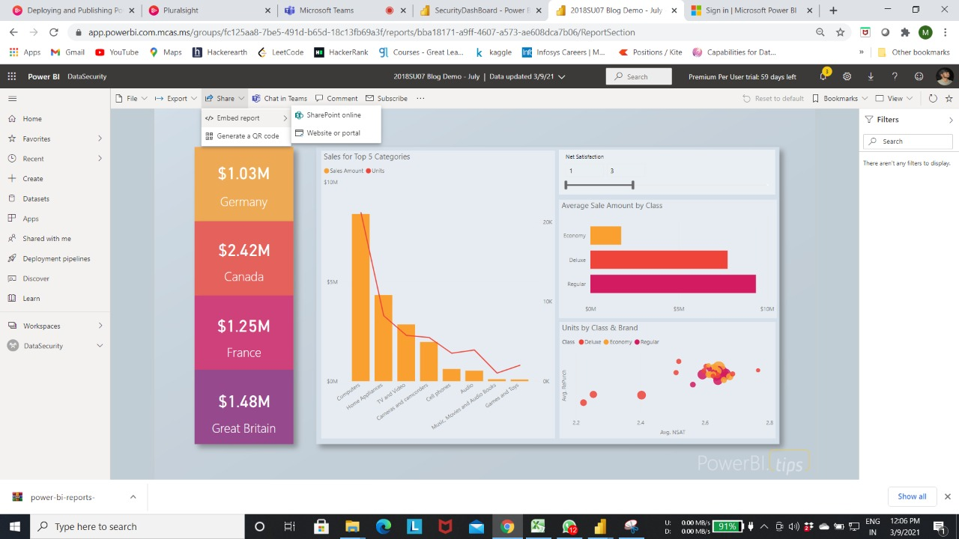

Click on Shared with me and select Report

So that the recipients will be able to check the shared report

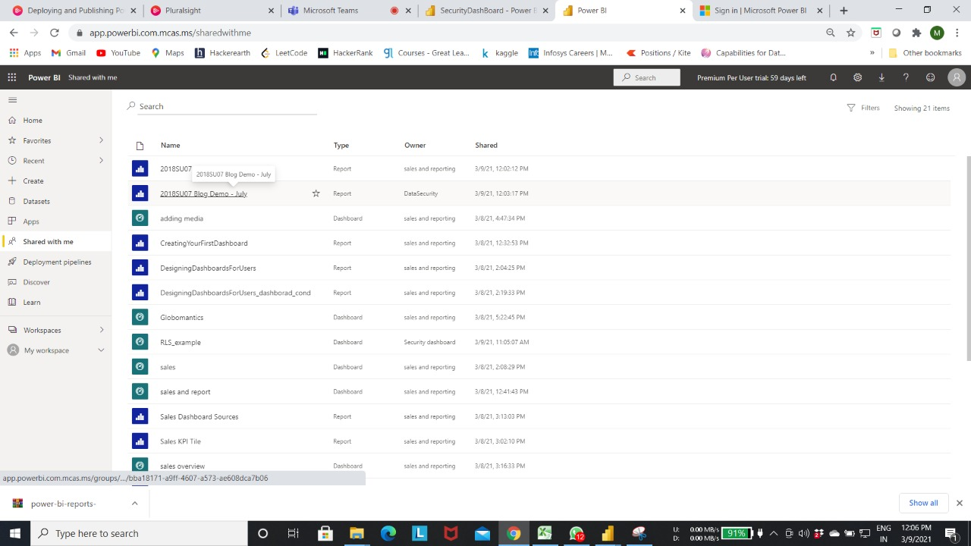

This is the shared Report view

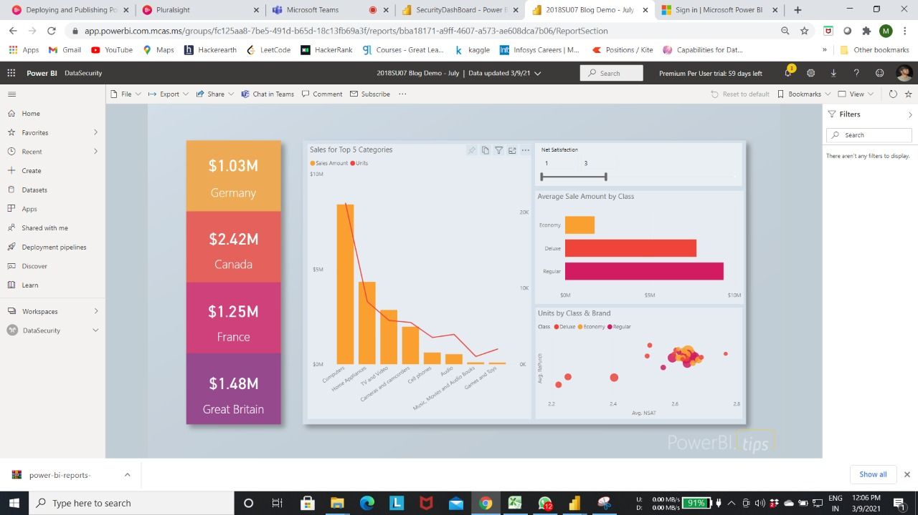

From the Blog Demo report Pin the Units by Class & brand and sales for Top 5 Categories to the Sharing Dashboard

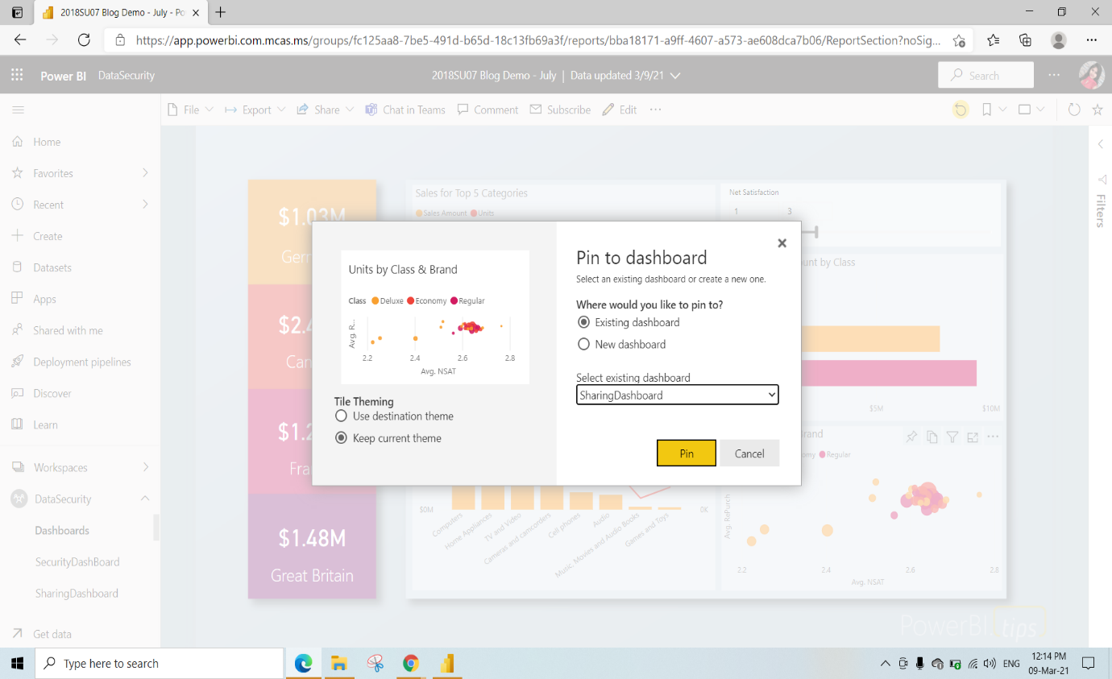

Click on Go to dashboard

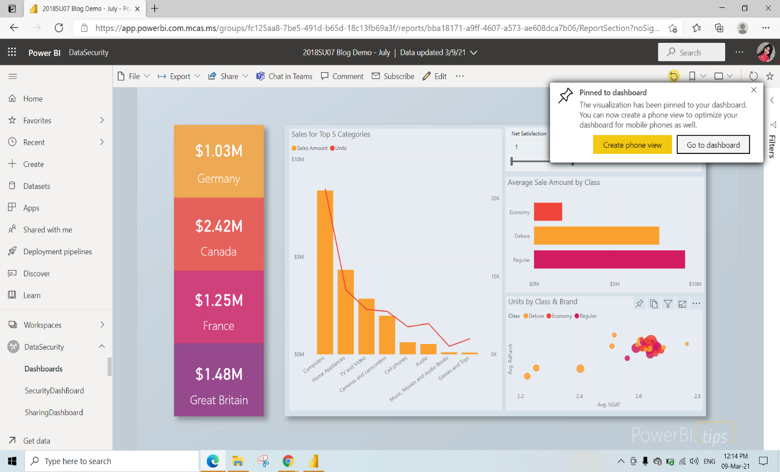

This is the SharingDashboard View and click on Share to share the Dashboard with anyone

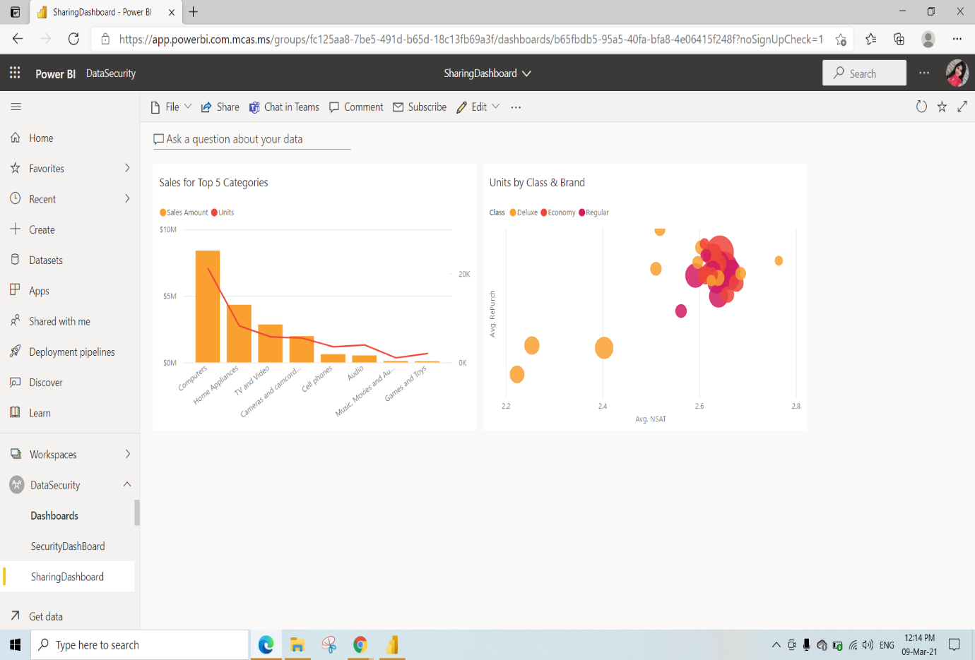

To share the dashboard enter the email adress of the recipient and click on share

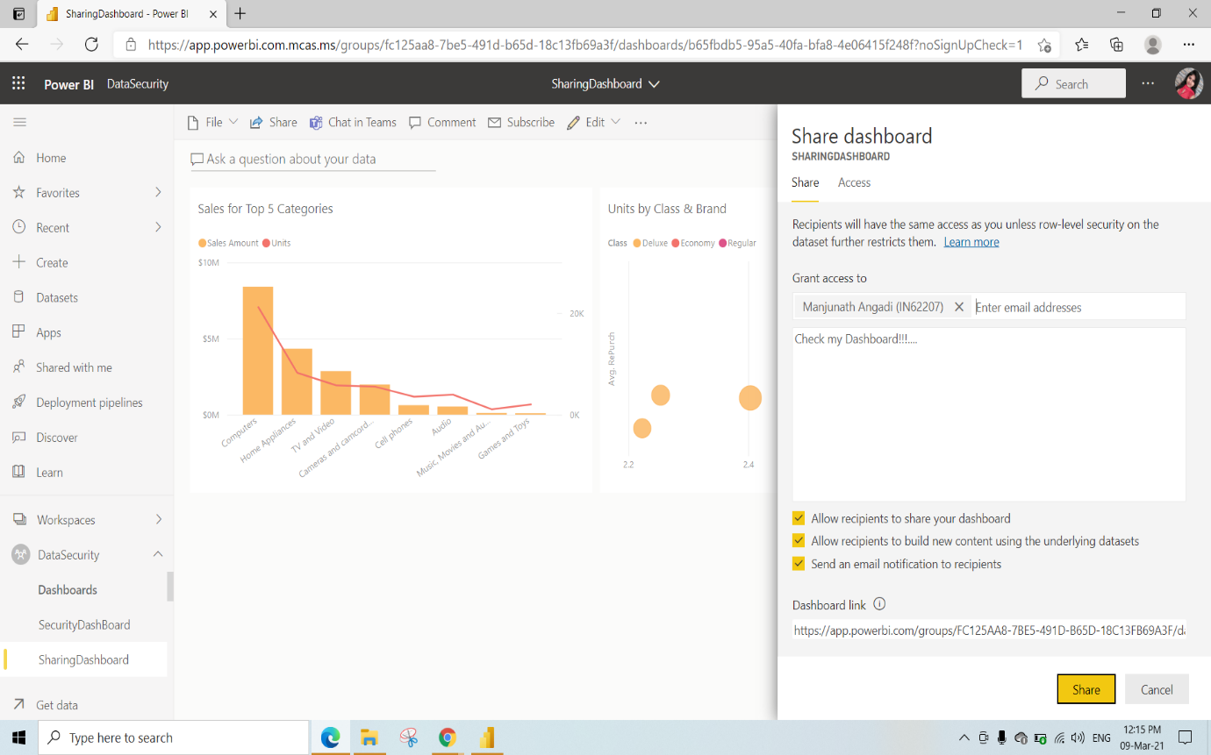

Click on Shared with me and select Sharing dashboard

So that the recipients will be able to check the shared dashboard

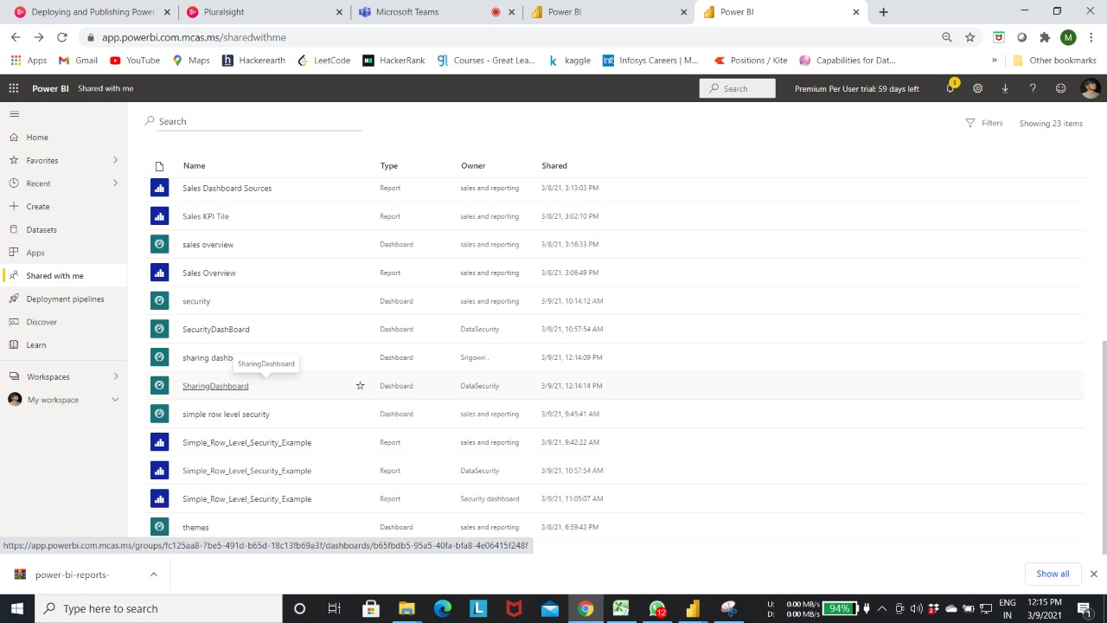

This is the shared dashboard view

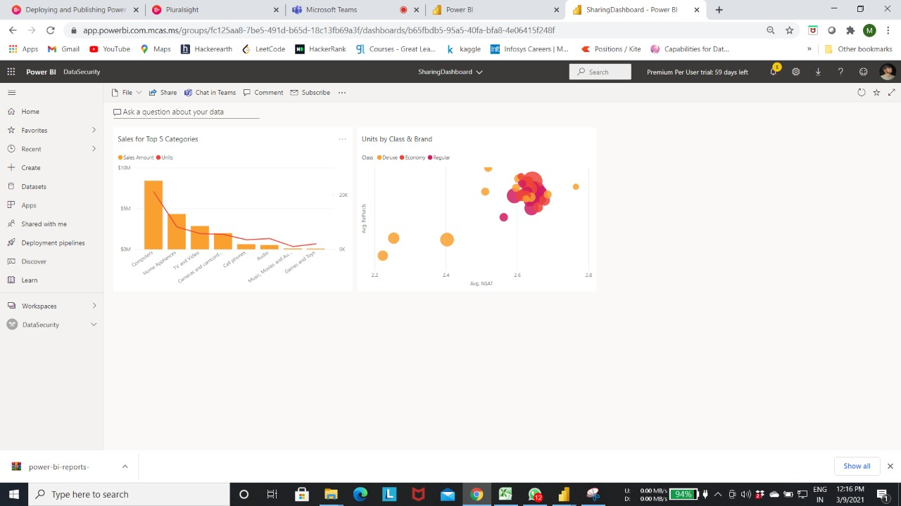

We had given access to change and share the dashboard to others

Hence the dashboard can be shared by the recipient

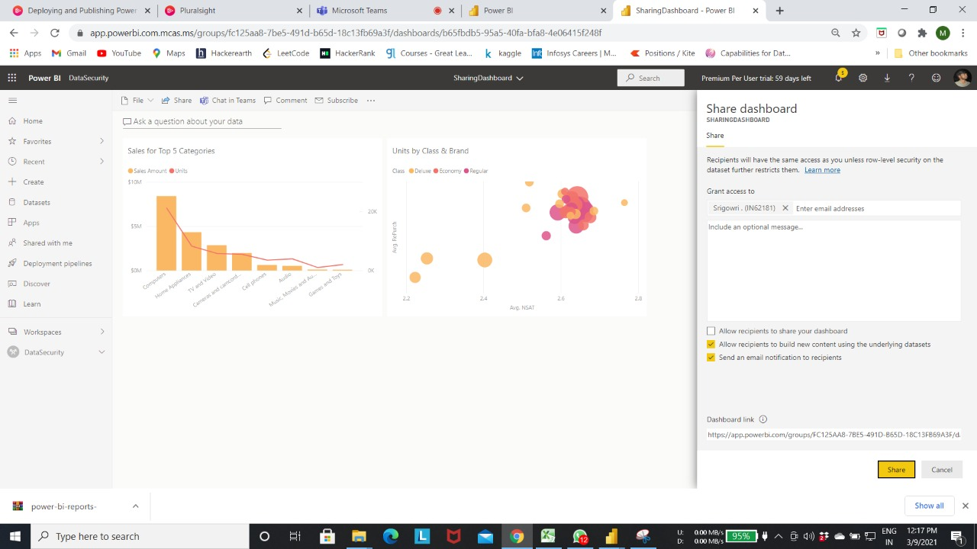

Go to DataSecurity Workspace click on 3dots and select workspace access

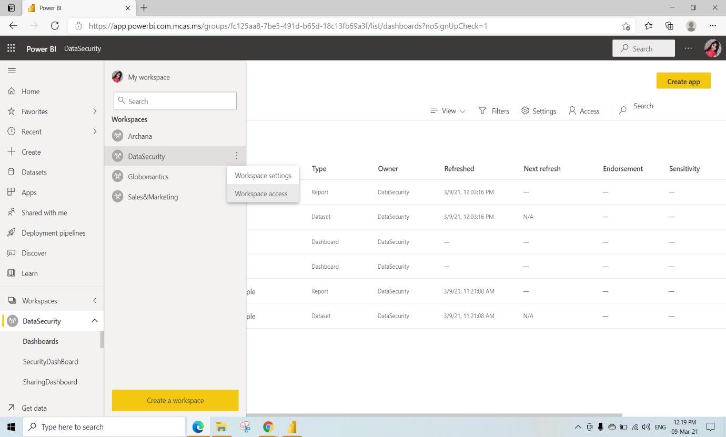

Here we have already given access

Here we are removing the the access of 1 viewer

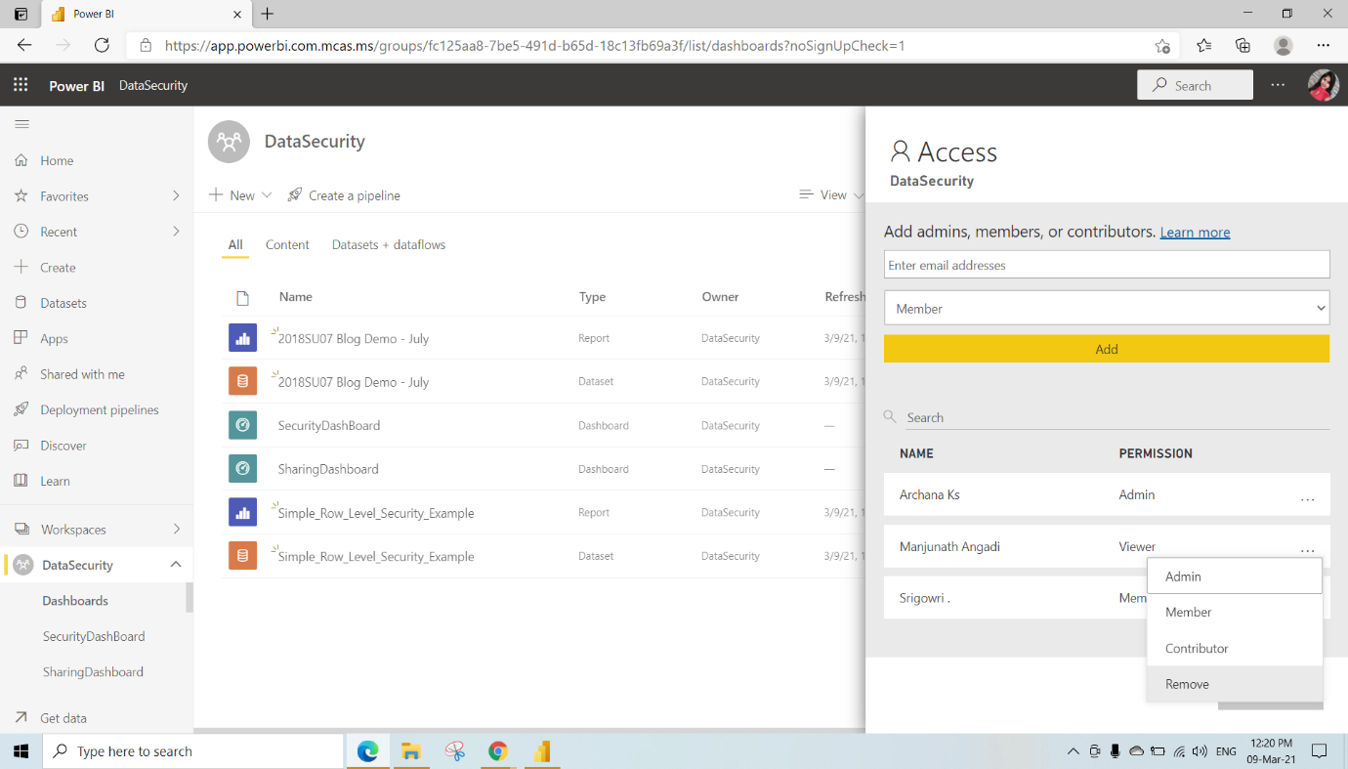

Here we have changes the permission from Member to Contributor

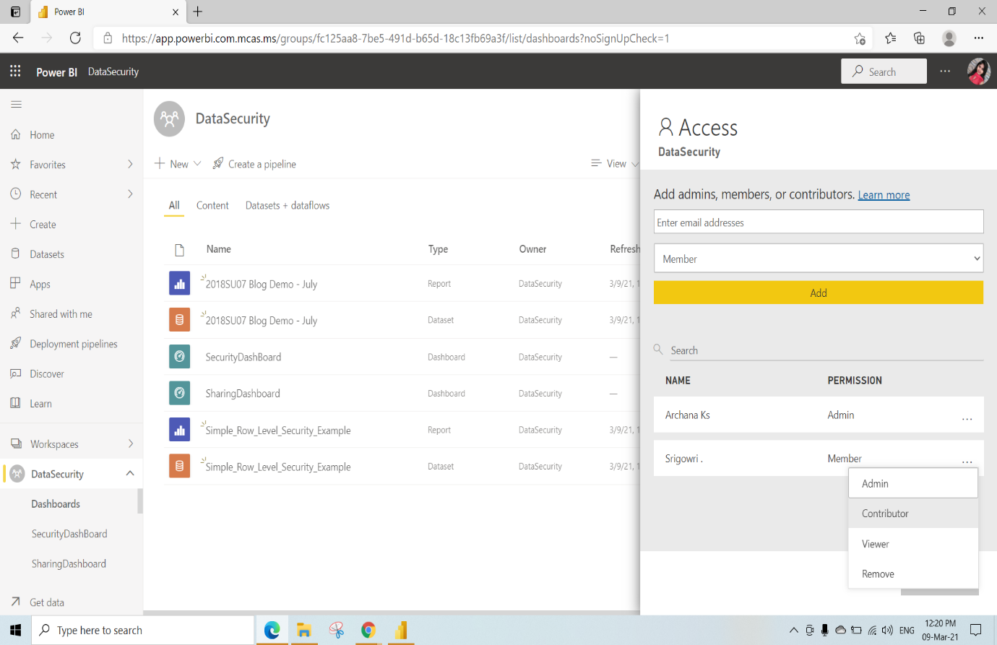

After changing the permissions

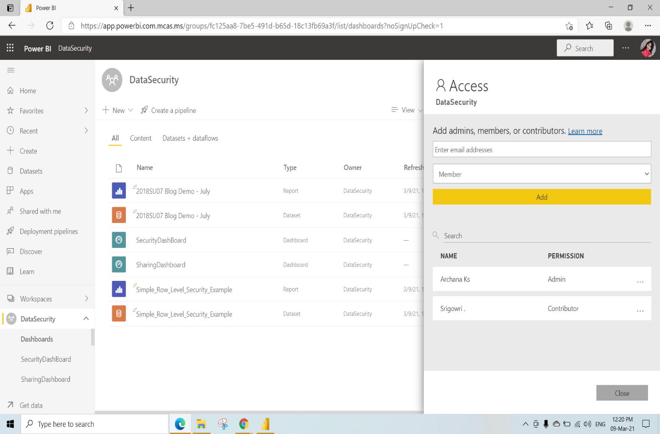

To check the access for dataset click on 3dots and select Manage permissions

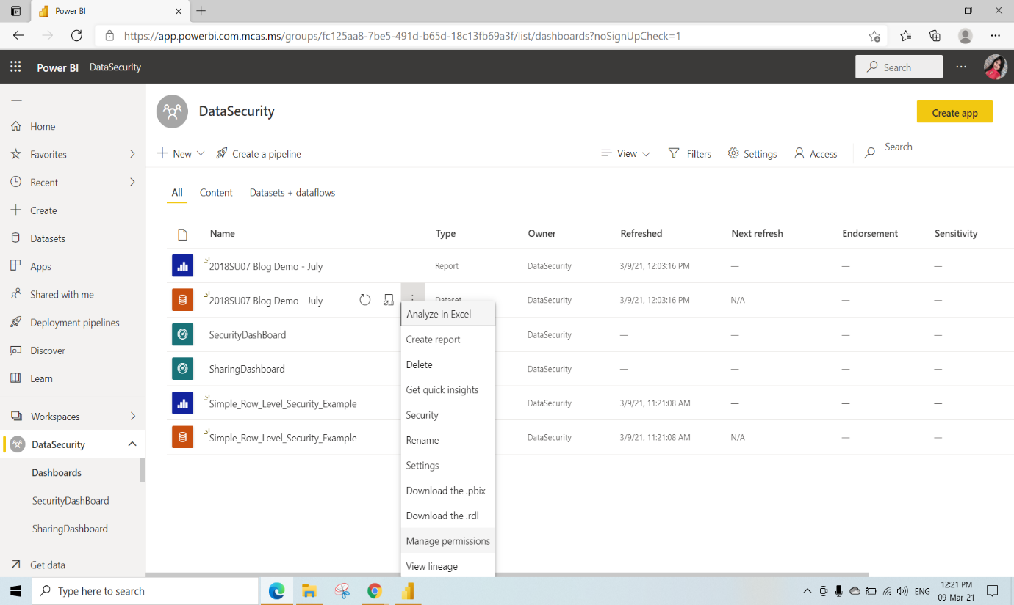

2recipients have access to view the Dataset

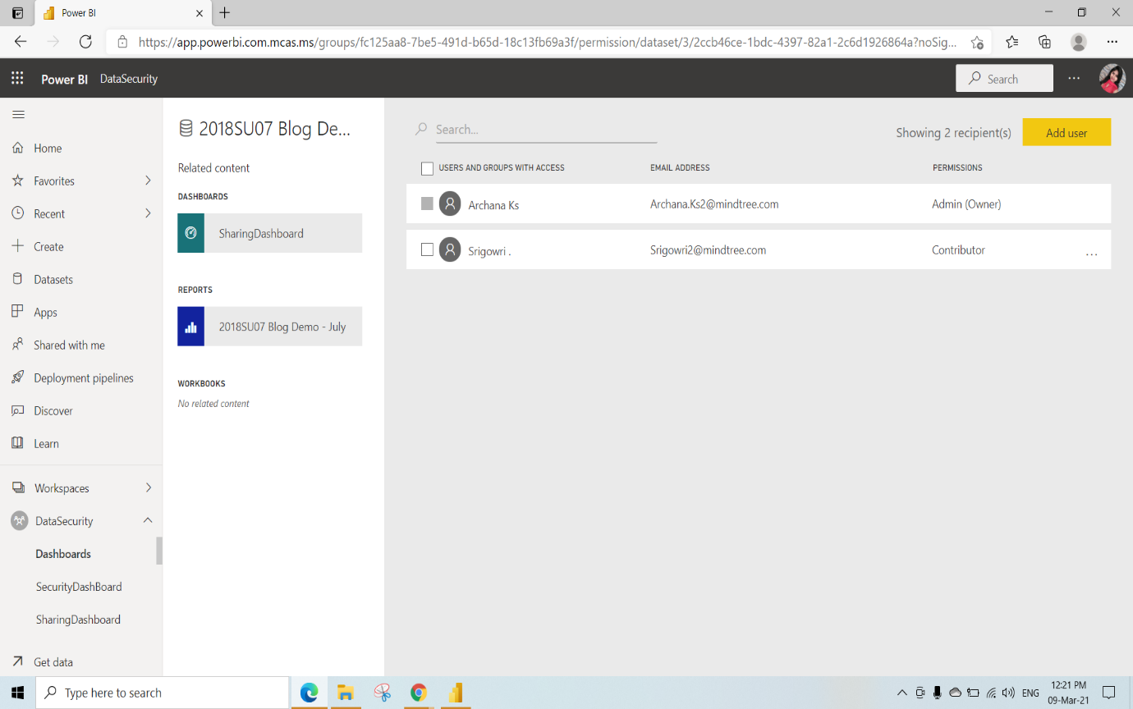

Sharing and Staging with App Workspace

Here we are creating new Woekspace named as new_app1 and we have given description as This workspace contains Sales details and click on save

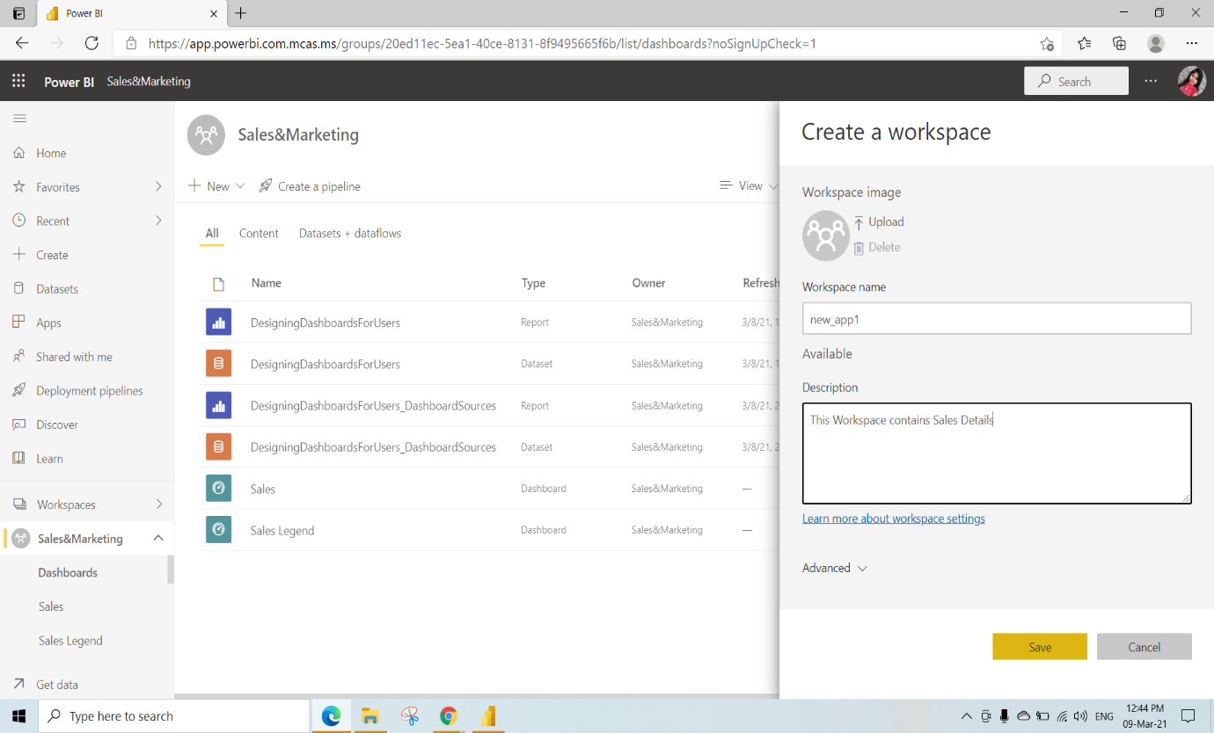

Publish the Blog Demo pbix file to the new_app1 workspace

Open this Blog Demo Report under the new_app1 workspace

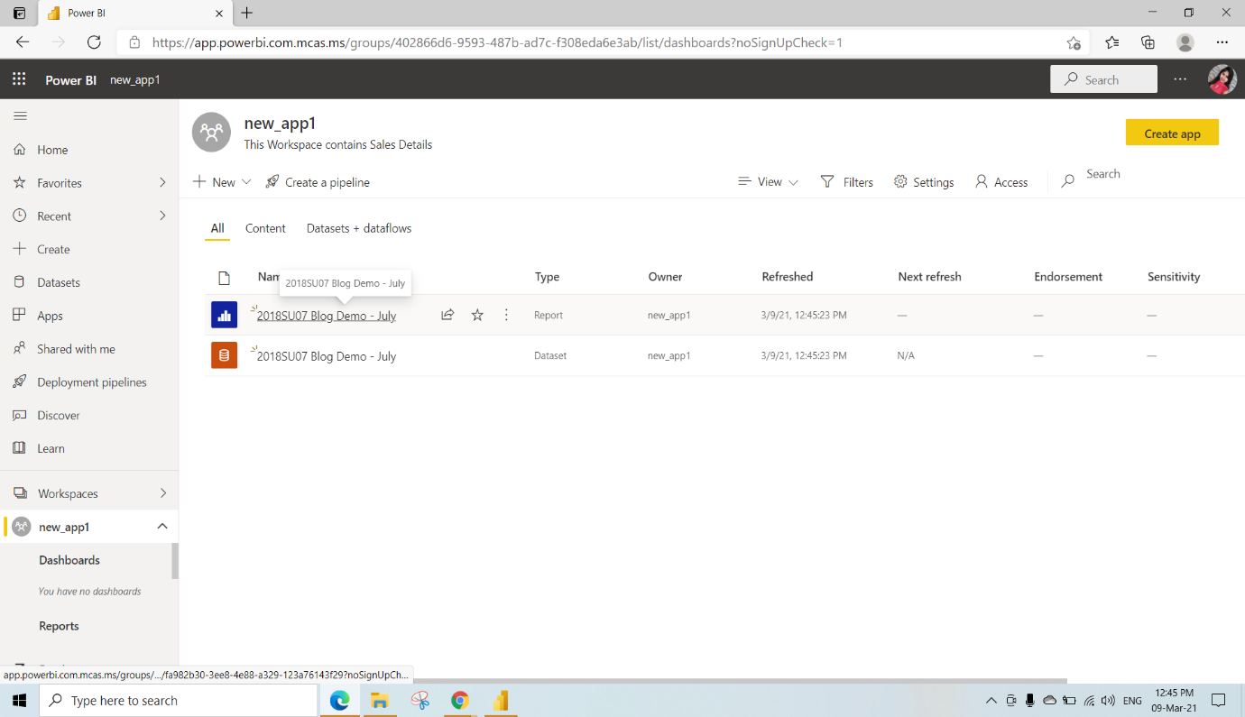

We need to pin Sales for top 5 categories and Units by class & brand to the new_app dashboard

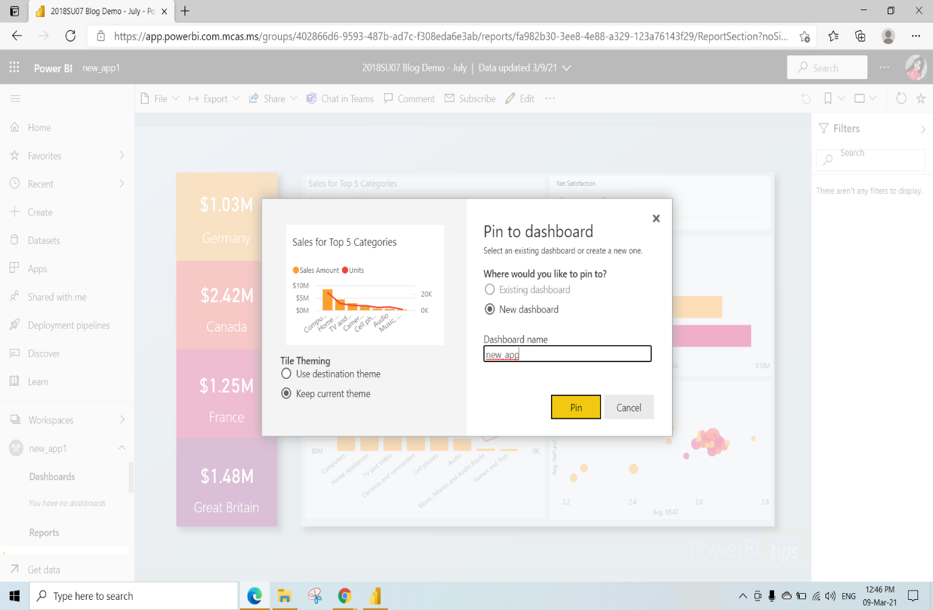

This is the new_app Dashboard view

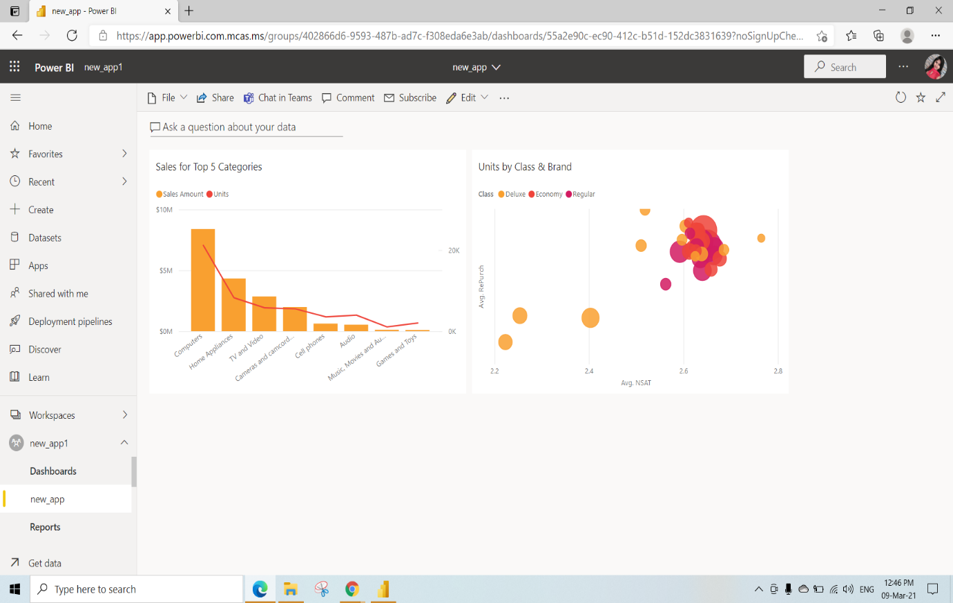

In the new_app1 workspace click on Create app

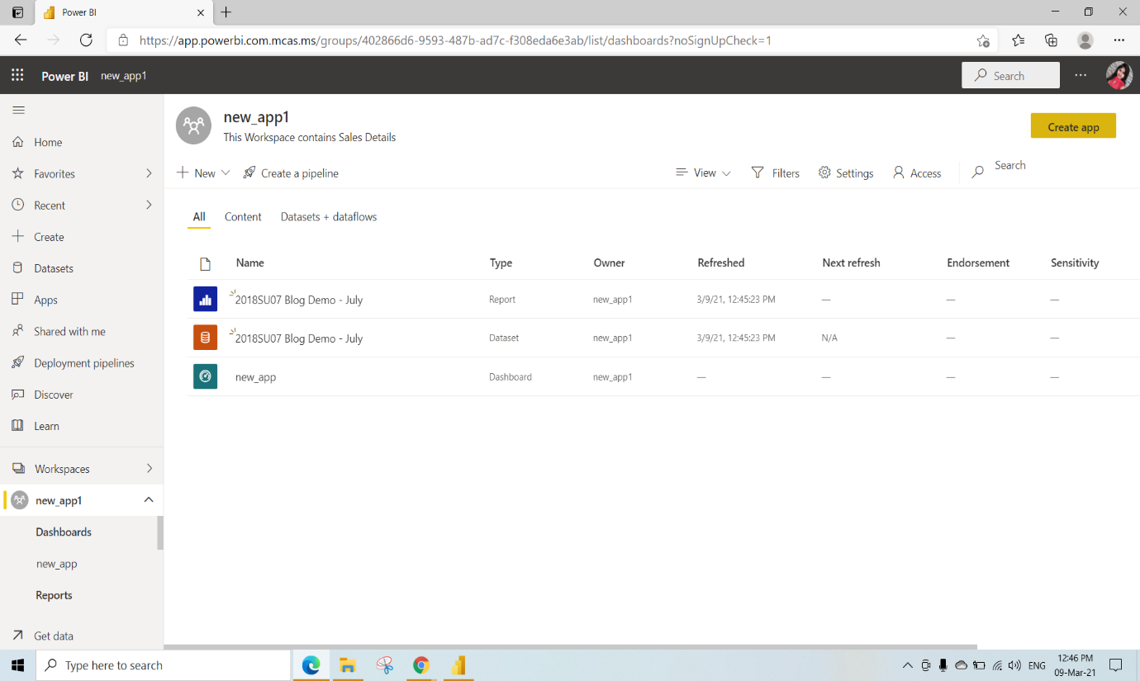

Under the setup We need to give the app name and Description of app (we have given description as “This is a sales overview Report “)

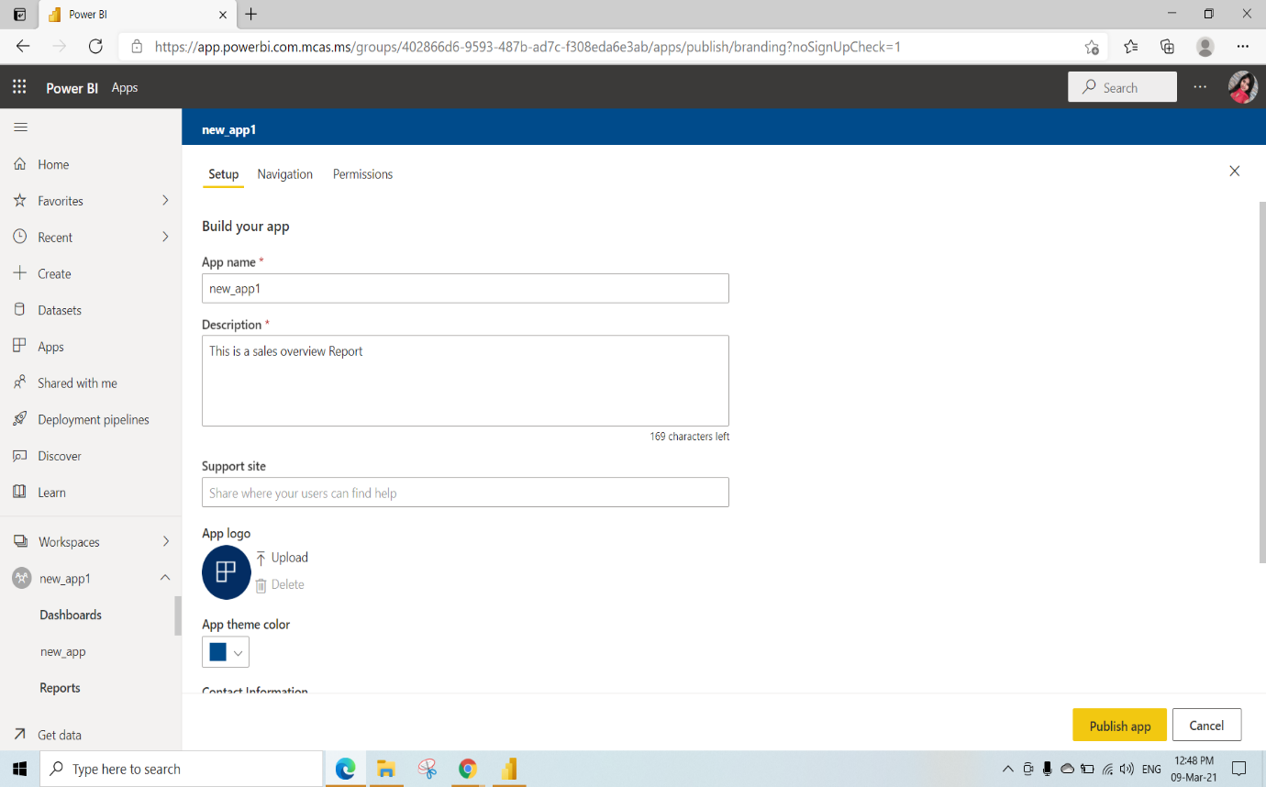

Under the navigation we can hide reports and dashboards to this app

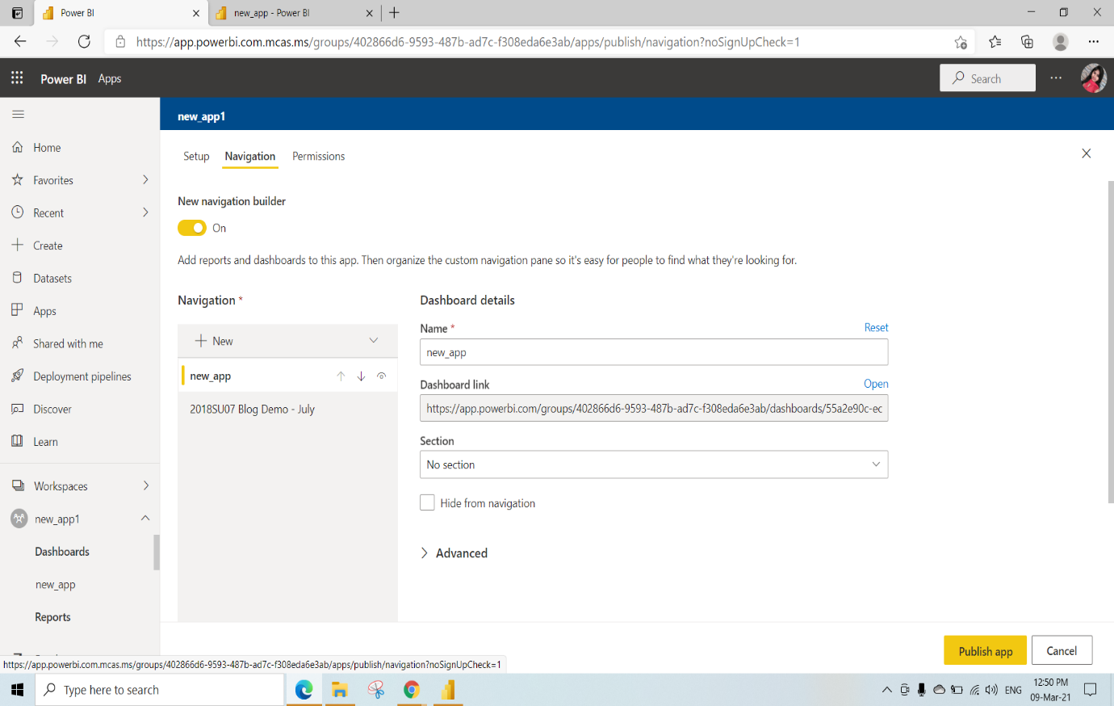

Under the permissions We can select entire organization or Specific individual or group and click on publish app

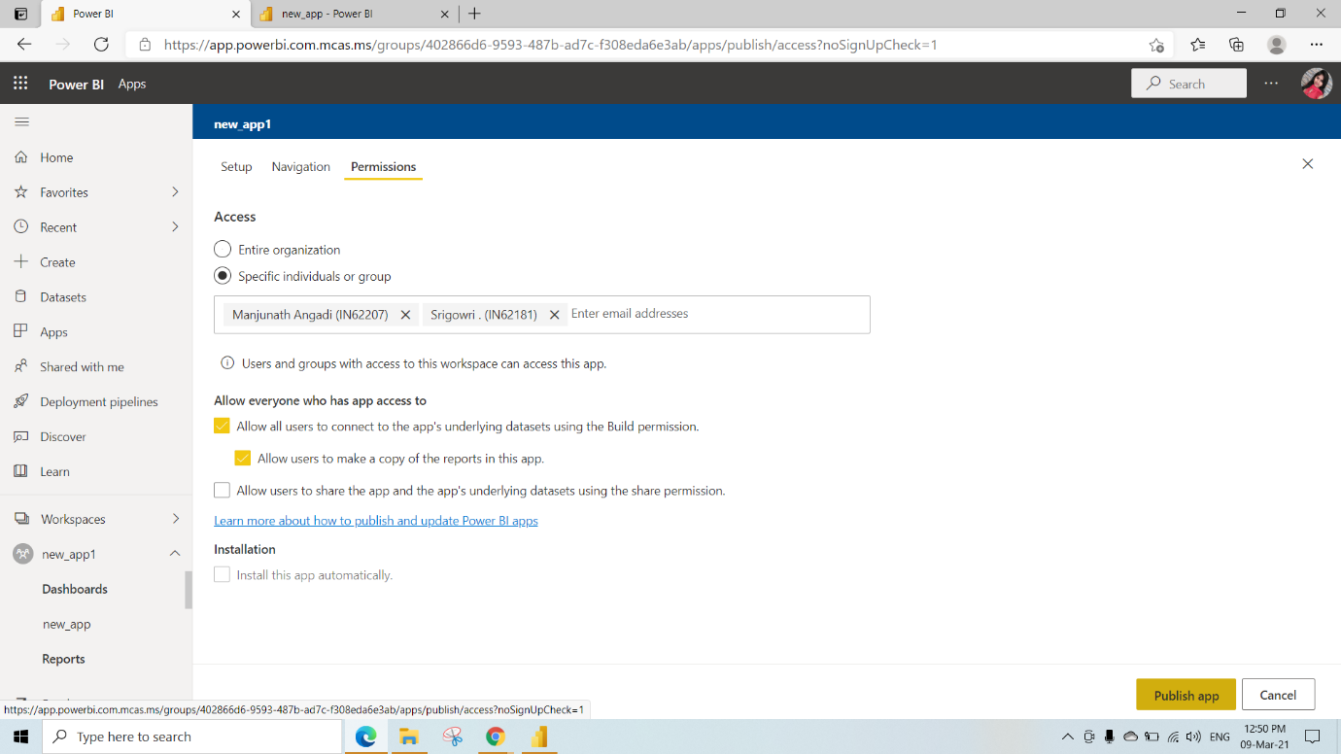

Click on publish

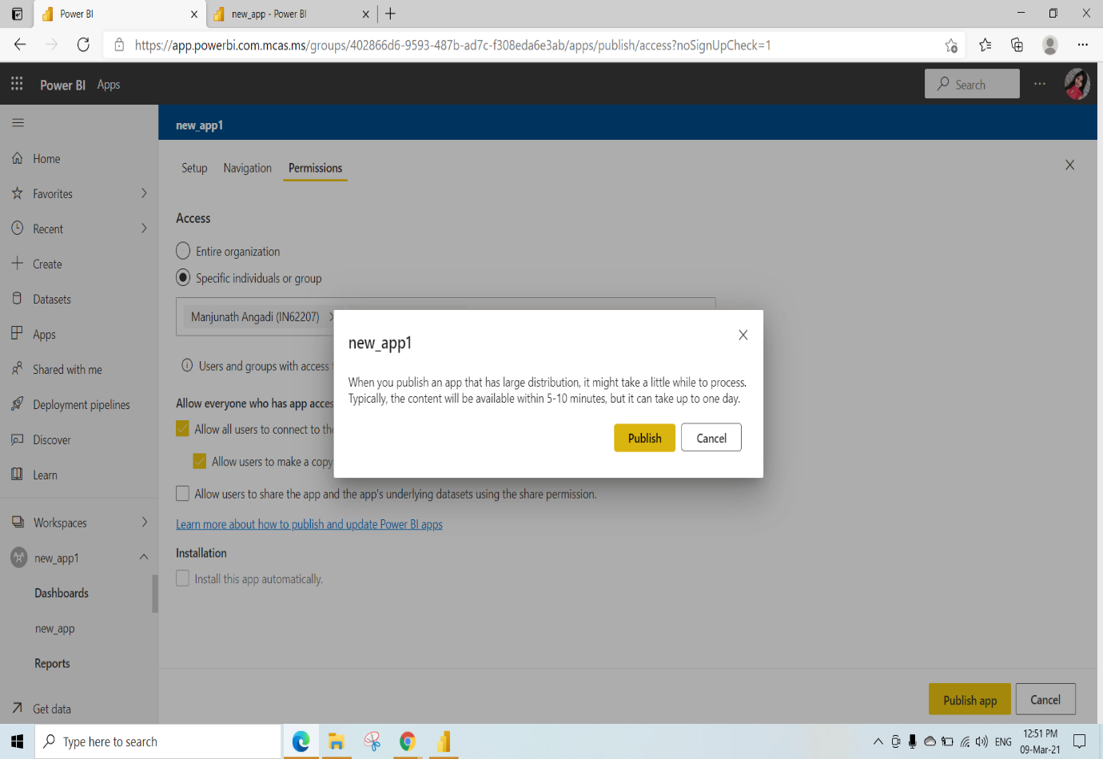

Click on Go to app

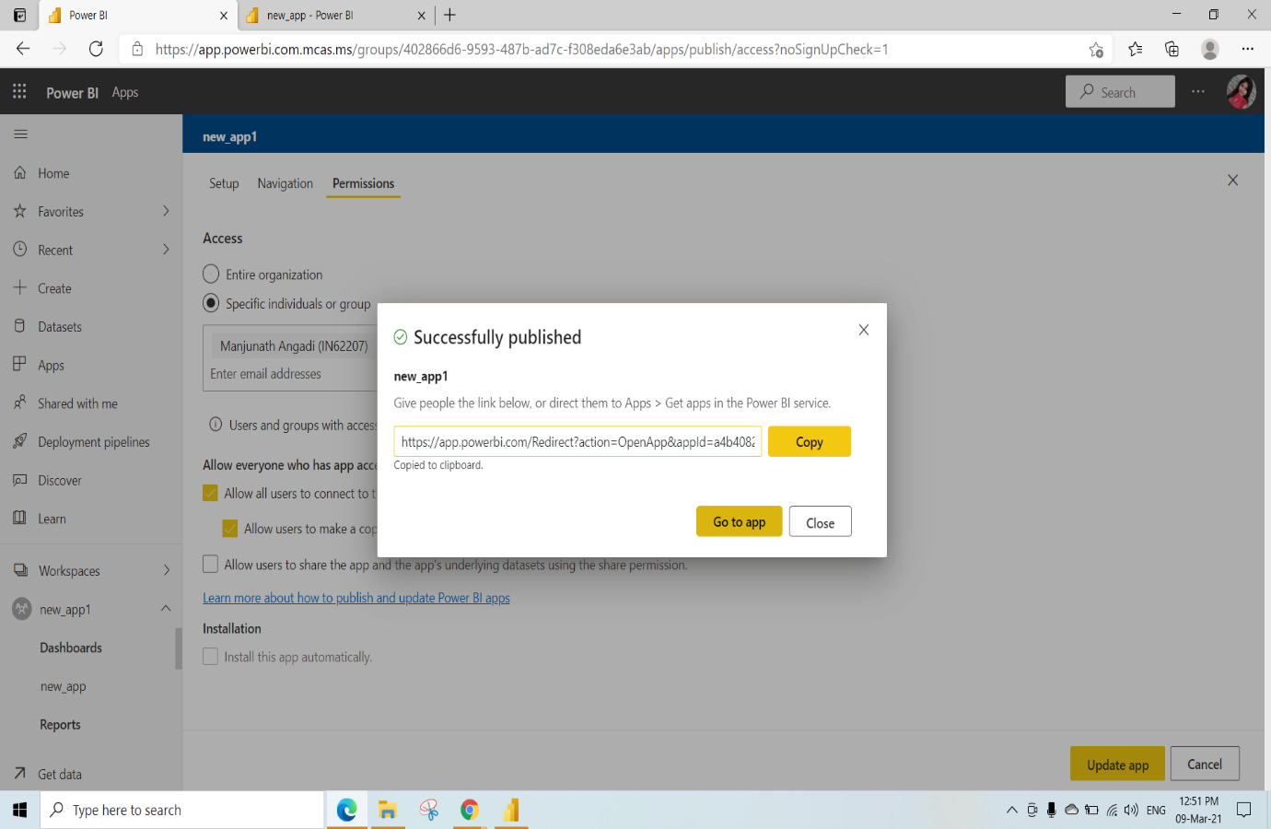

This is the new_app View

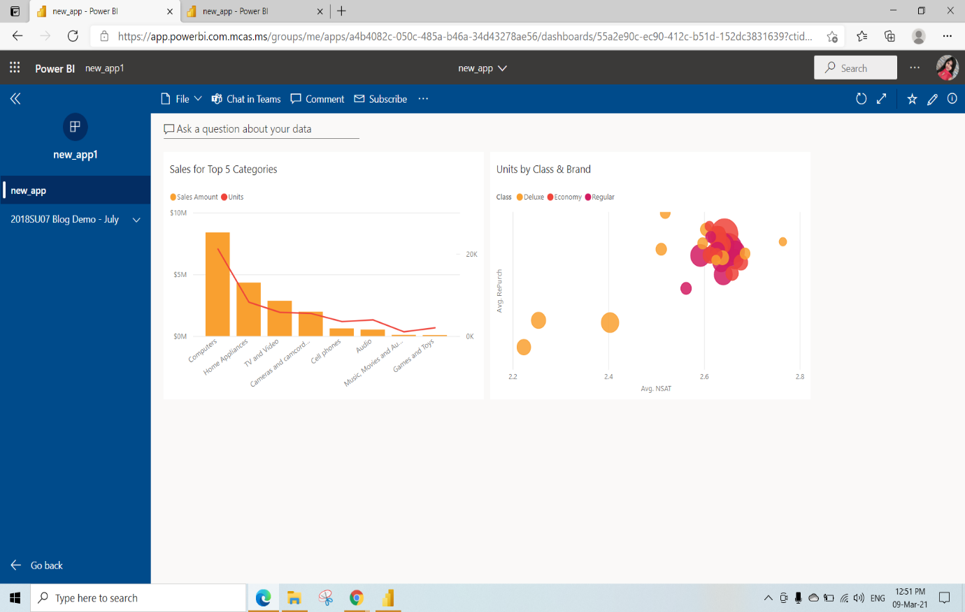

We can also delete the app by clicking on 3dots and select delete

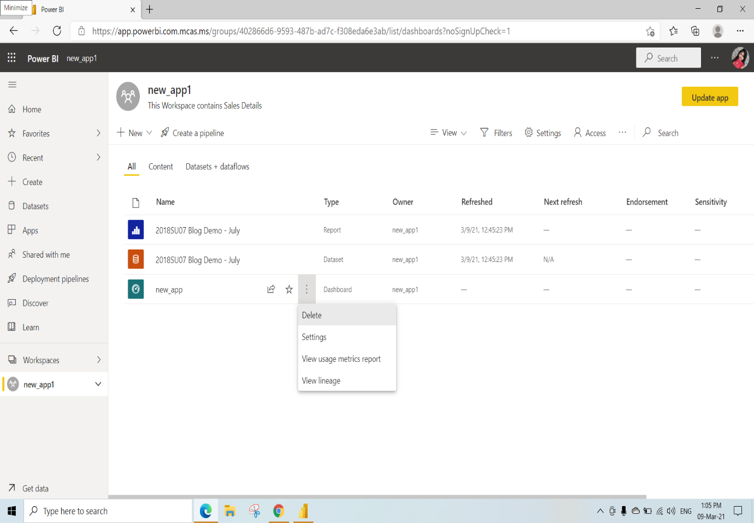

We can also update app by clicking on Update App on Top

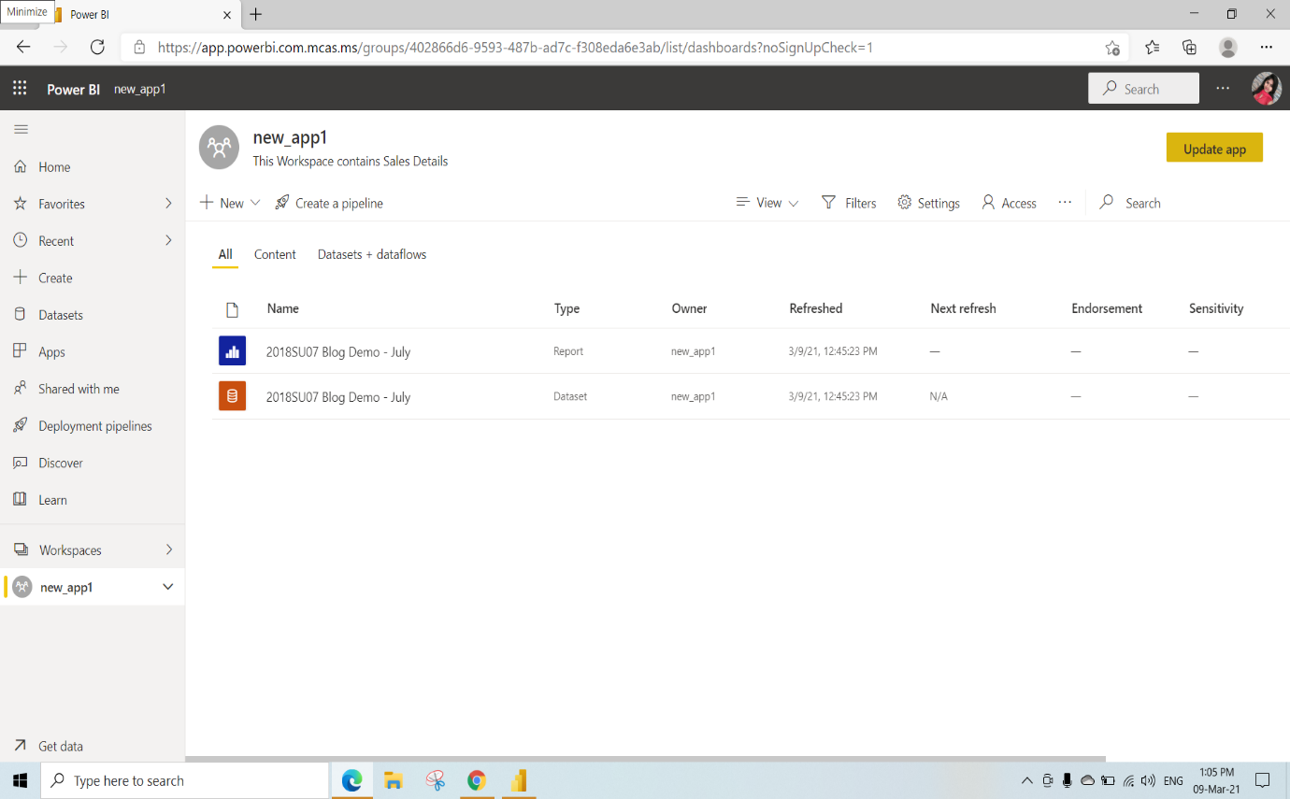

Under Navigation we have hided information and click on Update App

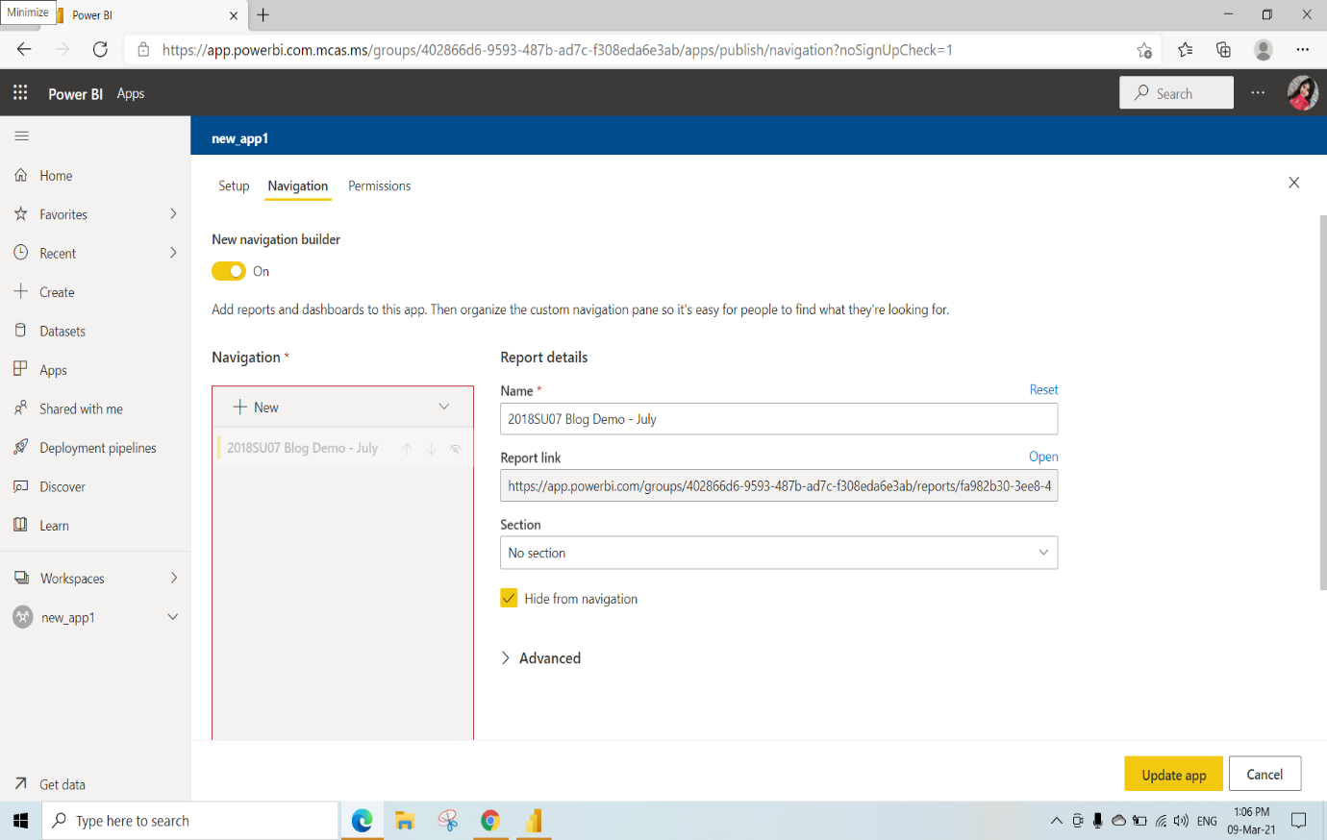

Click on Update

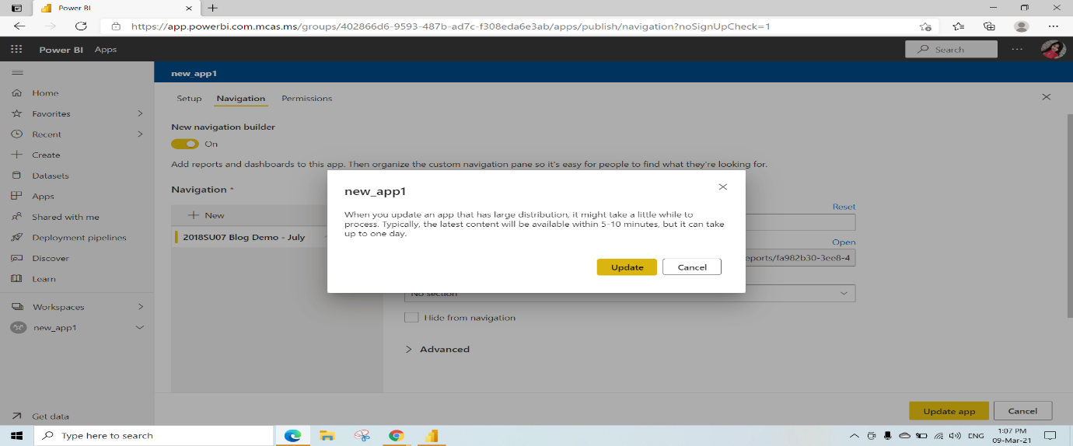Click on Go to App

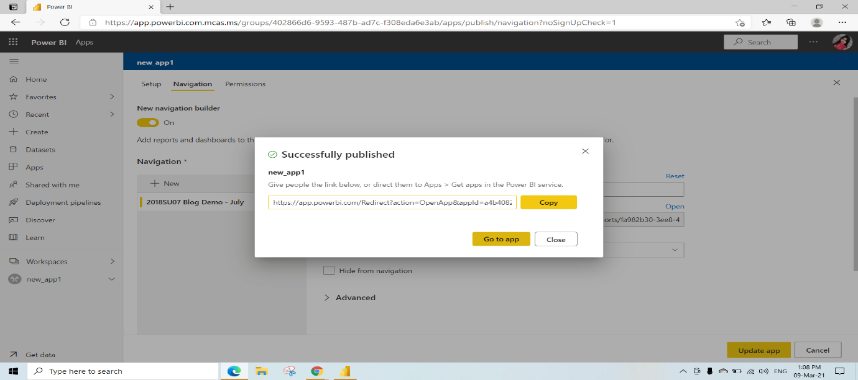

This is the Updated App Page

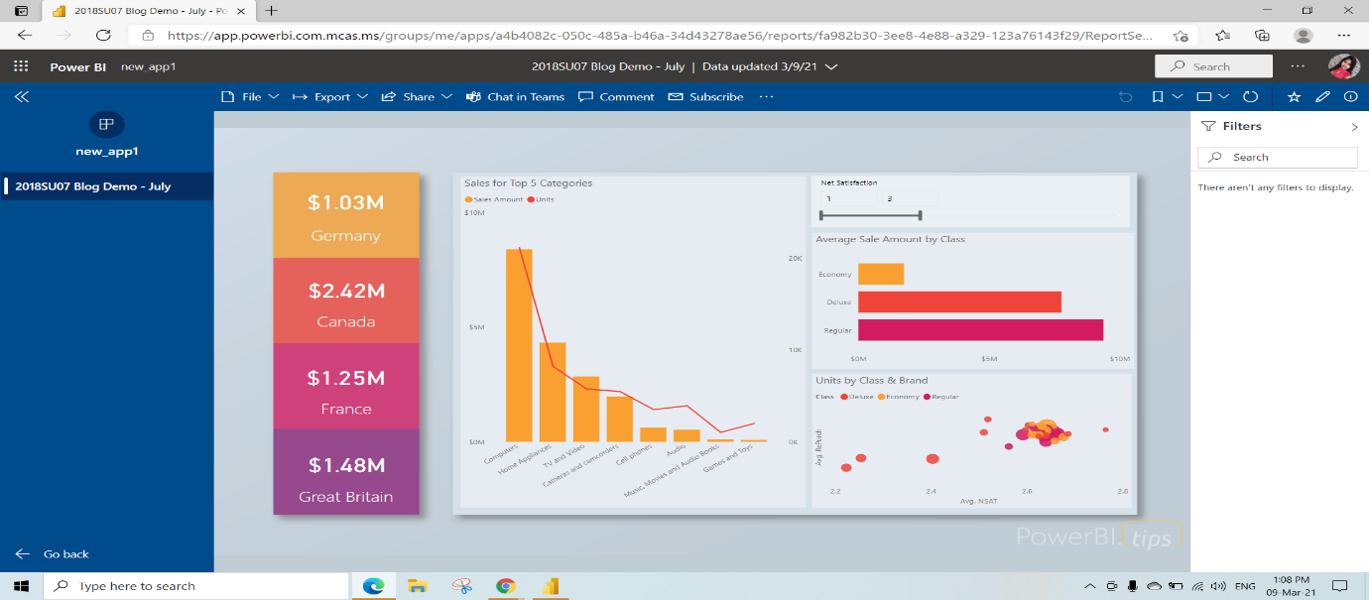

In the other Account We can see the app created by others by clicking on Get apps

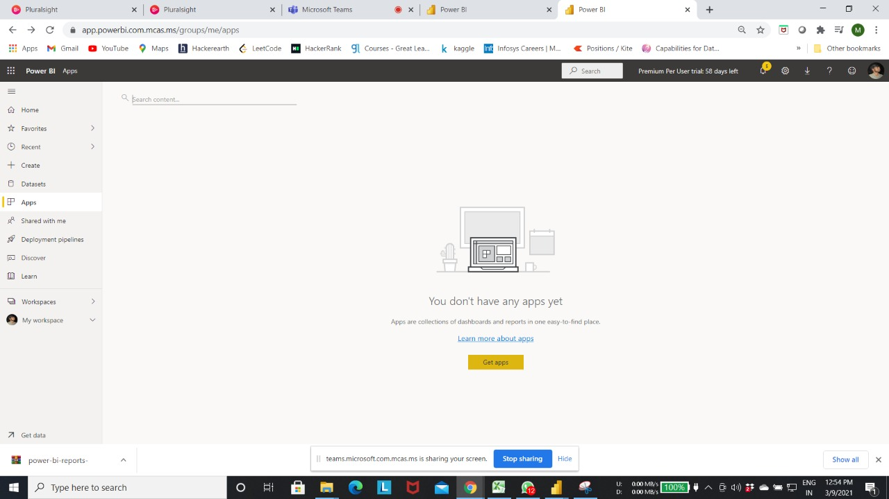

Click on new_app1 to view the published app

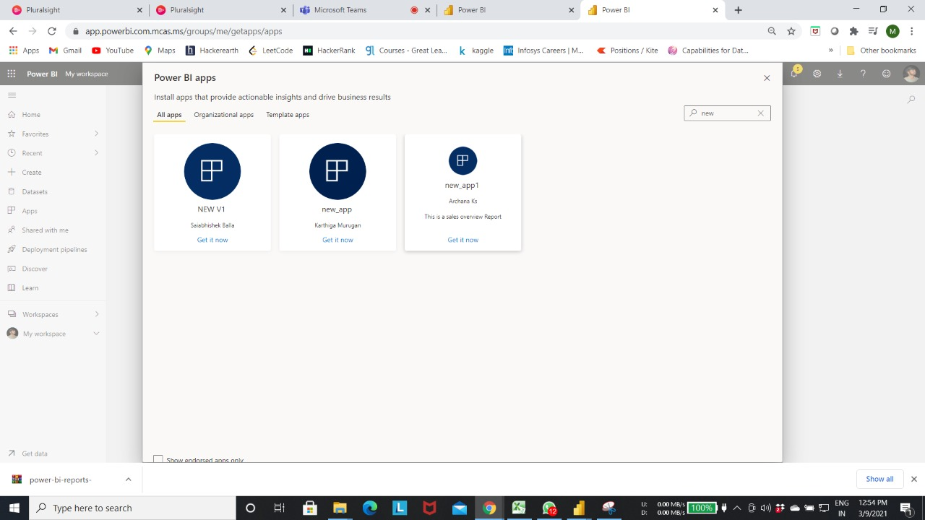

Published App View

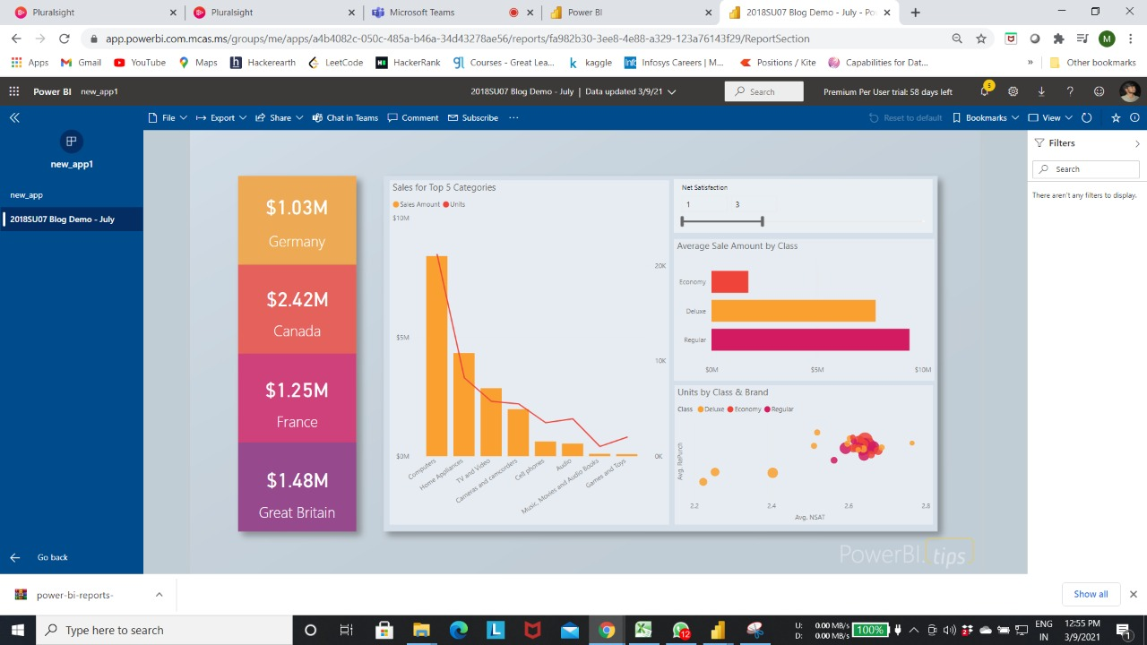

Dashboard view in that app

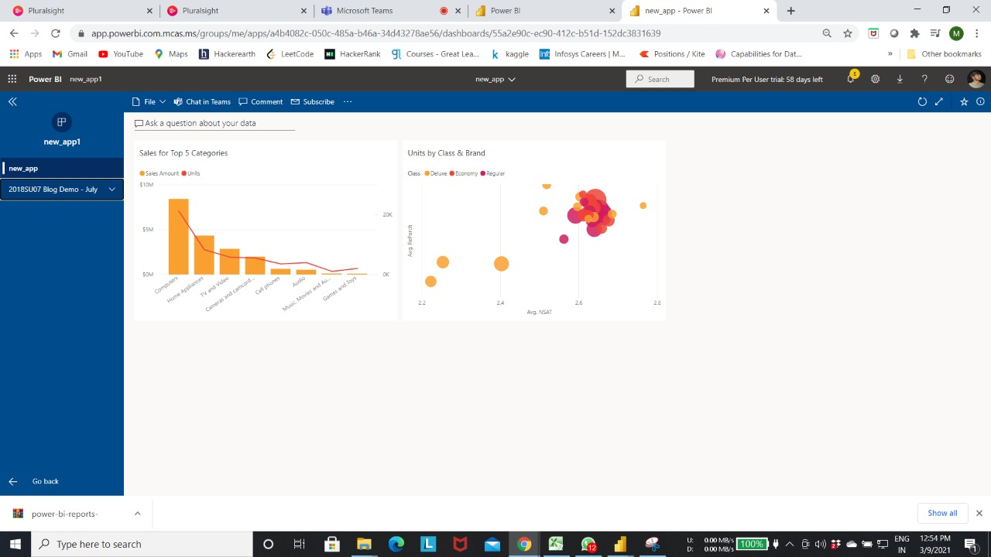

Embedded report in Intranet and Extranet

To share the app in the MS Teams We can add a tab in any chat or in any channel by clicking on + sign (here we have added a tab in the chat)

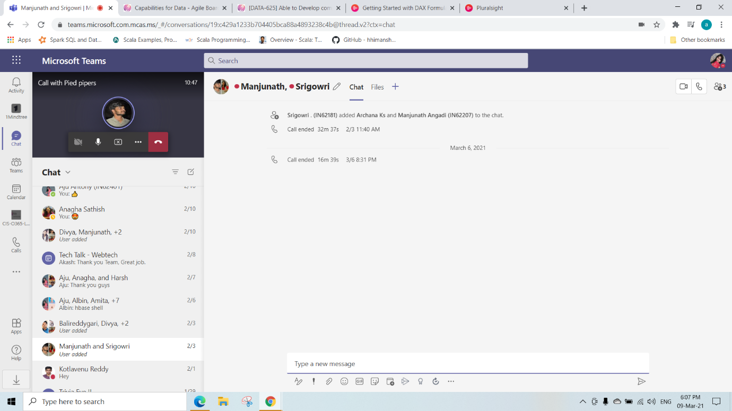

Click on PowerBI

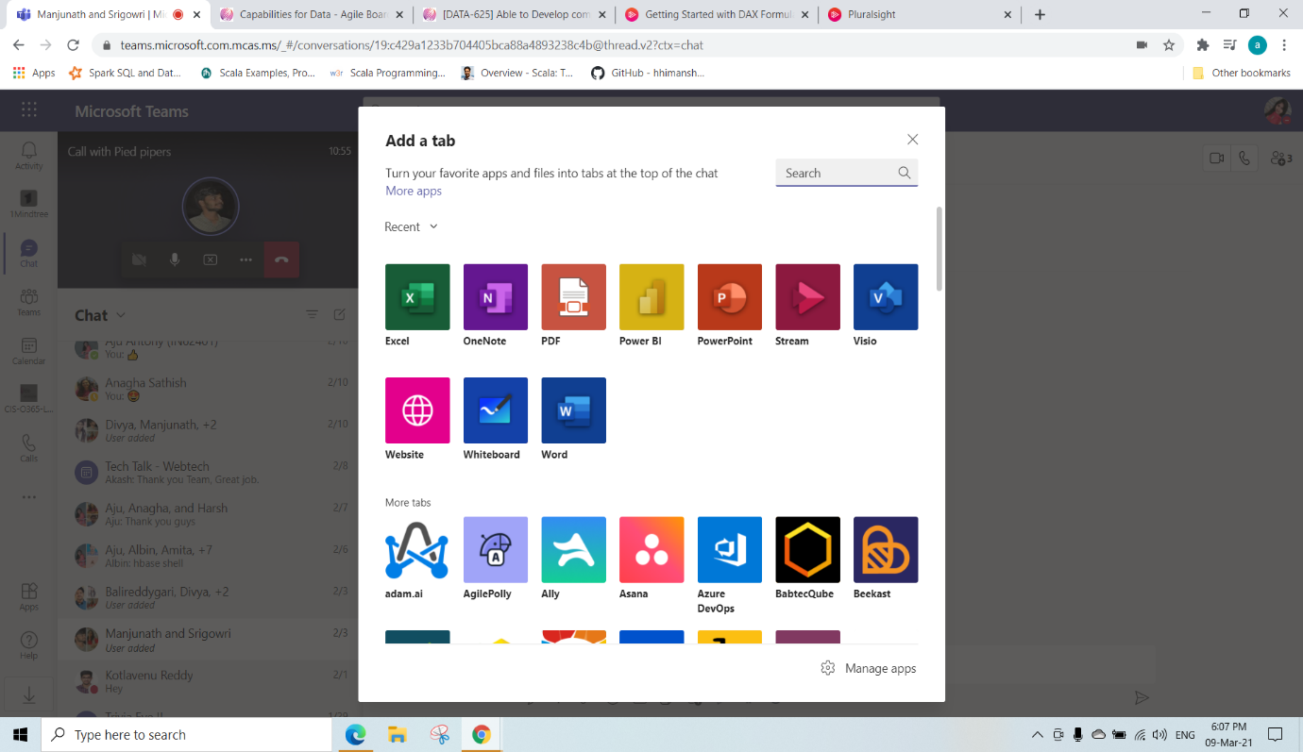

We can select any Reports or dashboards and click on save(here we have added blog demo report)

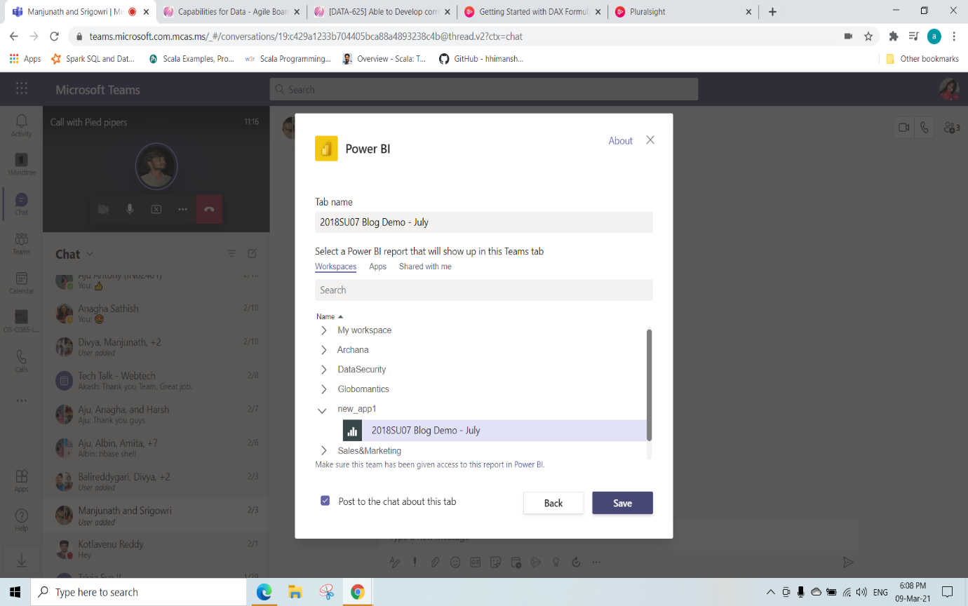

After adding a tab we can see this in the chat

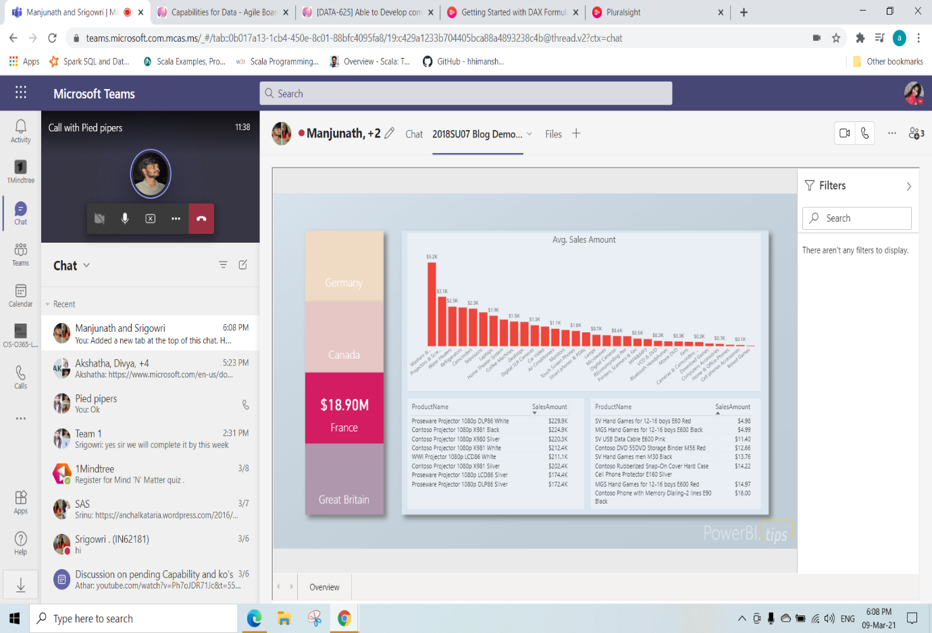

We can click on any tiles to see the information or visuals contained in that tiles

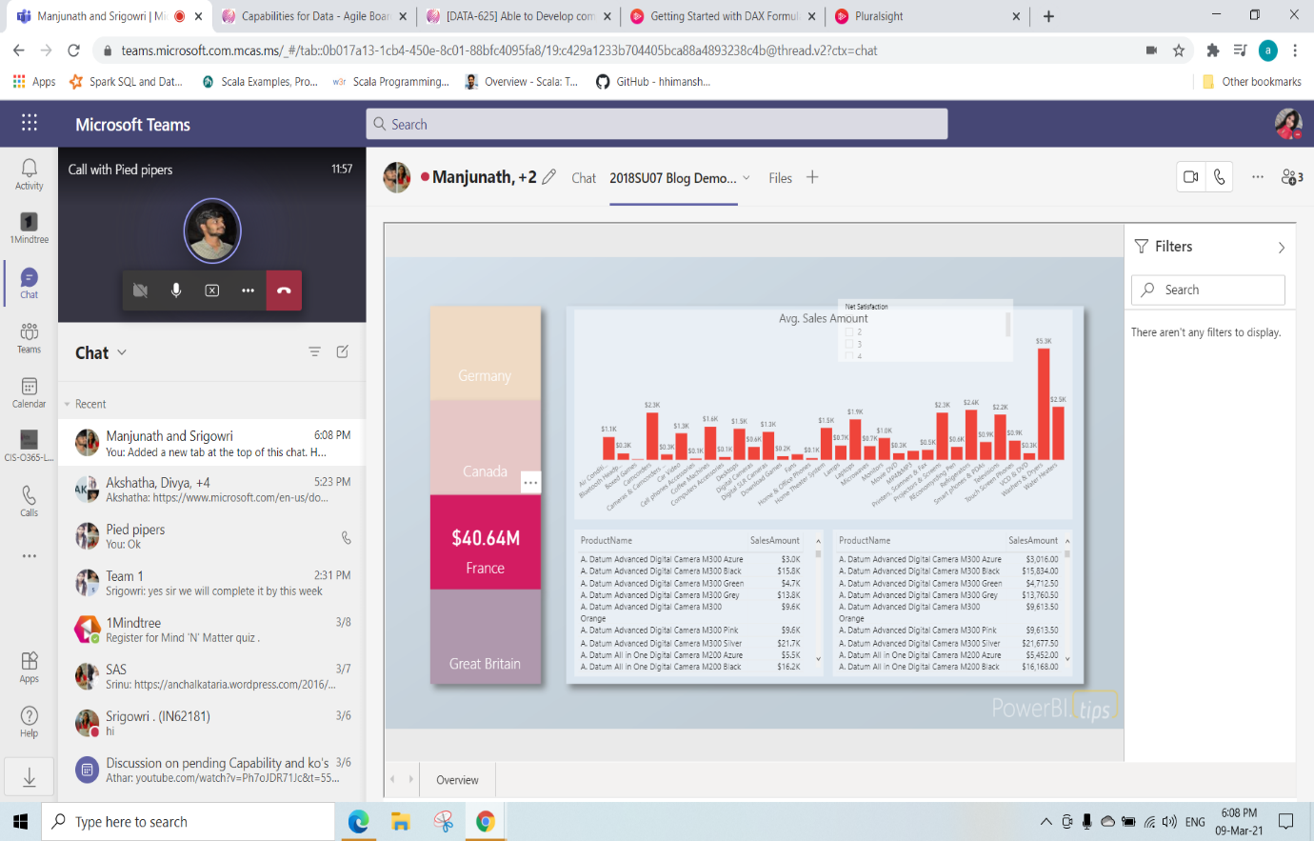

KO 6: Able to Deploy On-premises with Power BI Report Server

To Install Power BI Report Server follow the below Steps

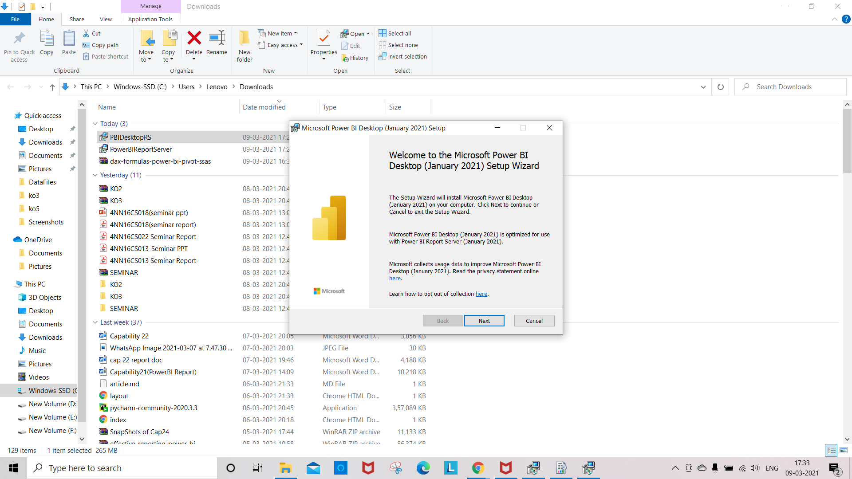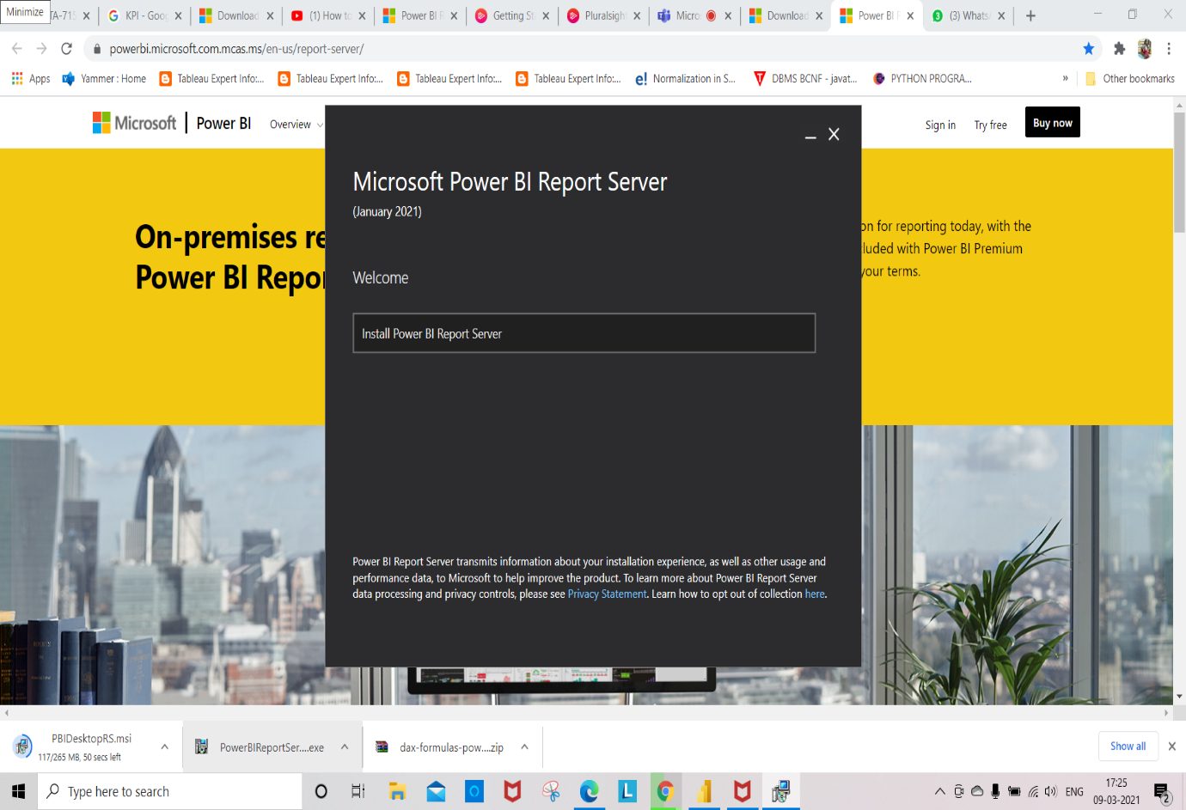

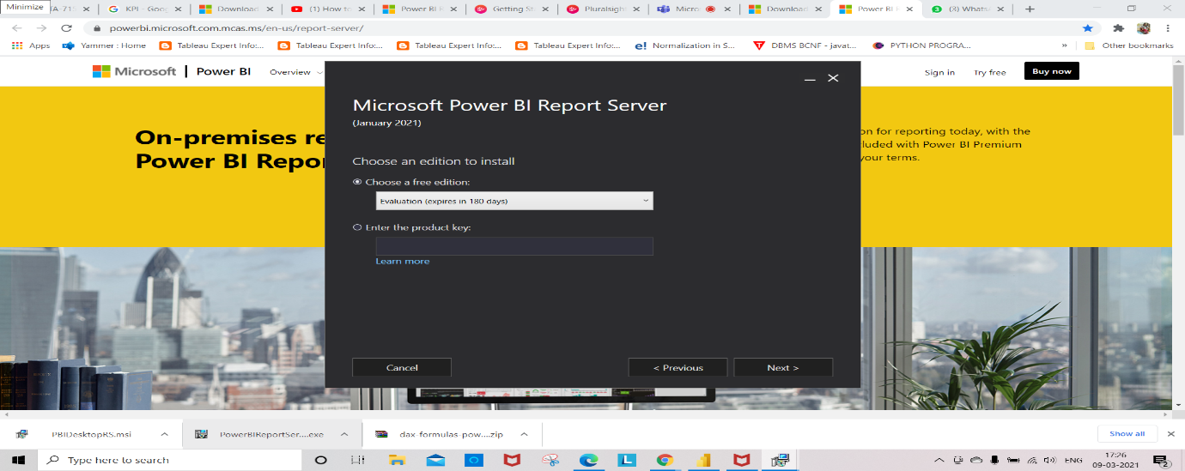

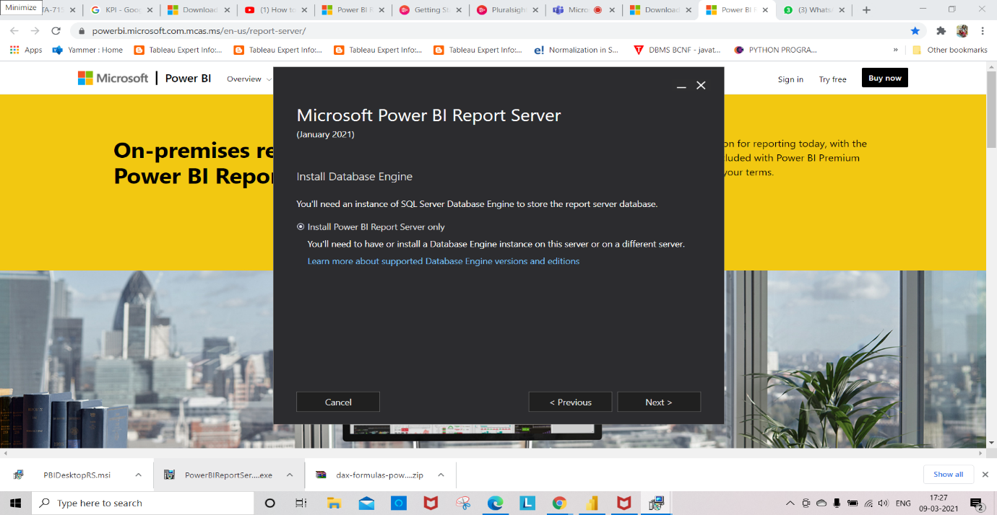

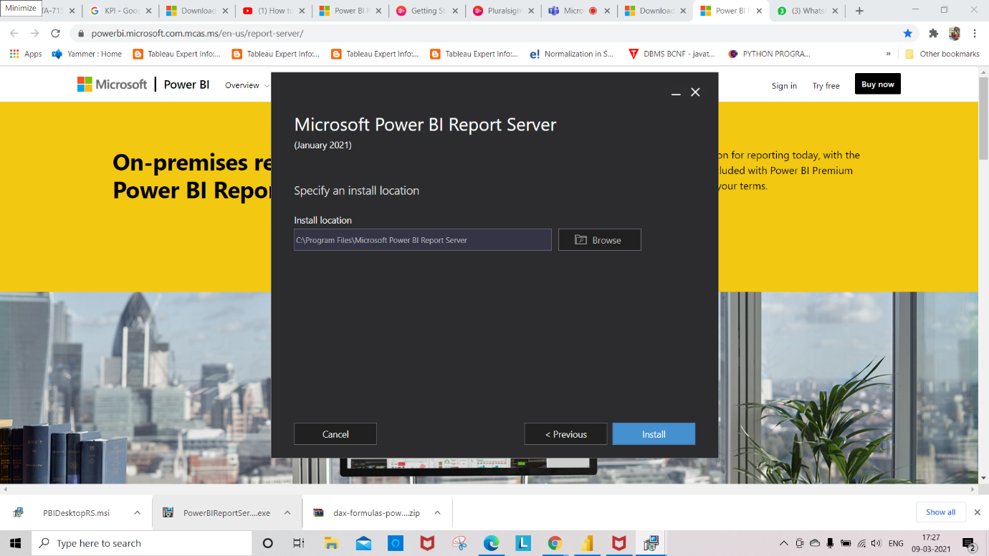

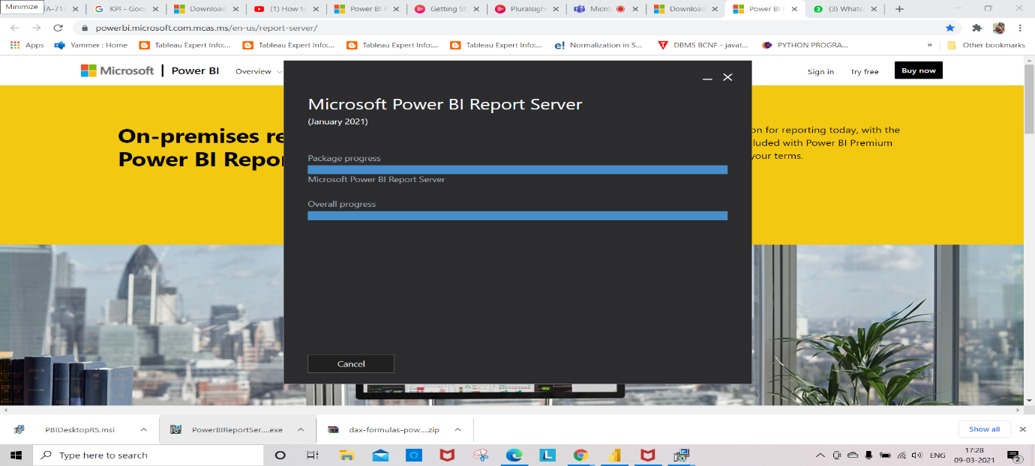

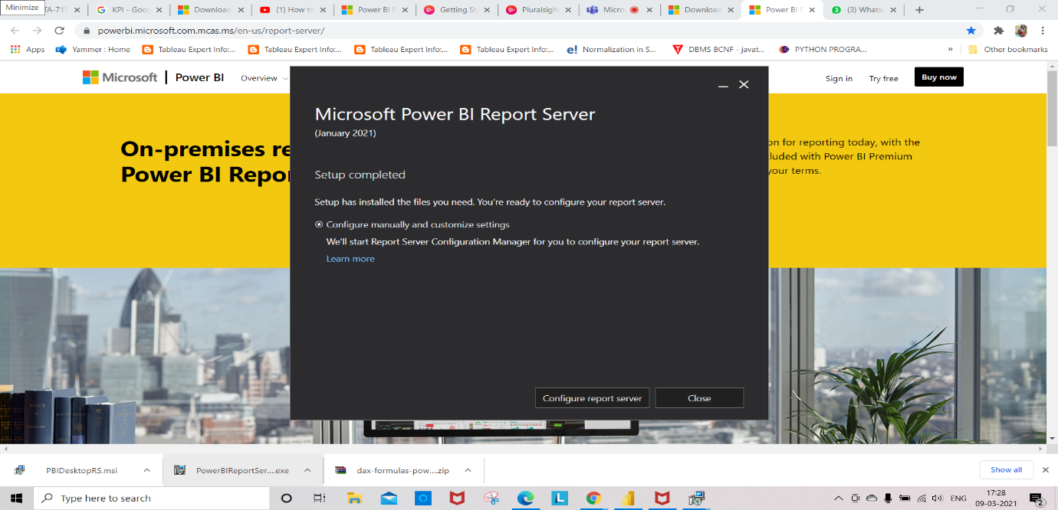

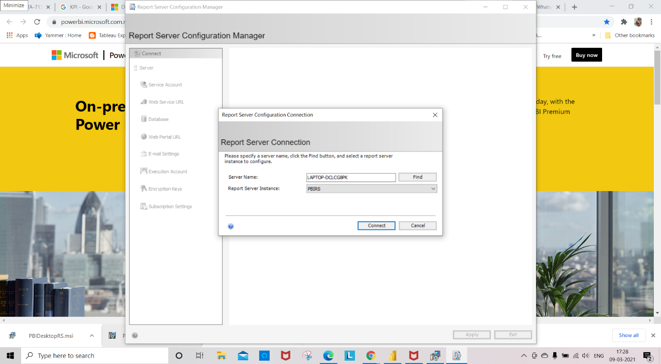

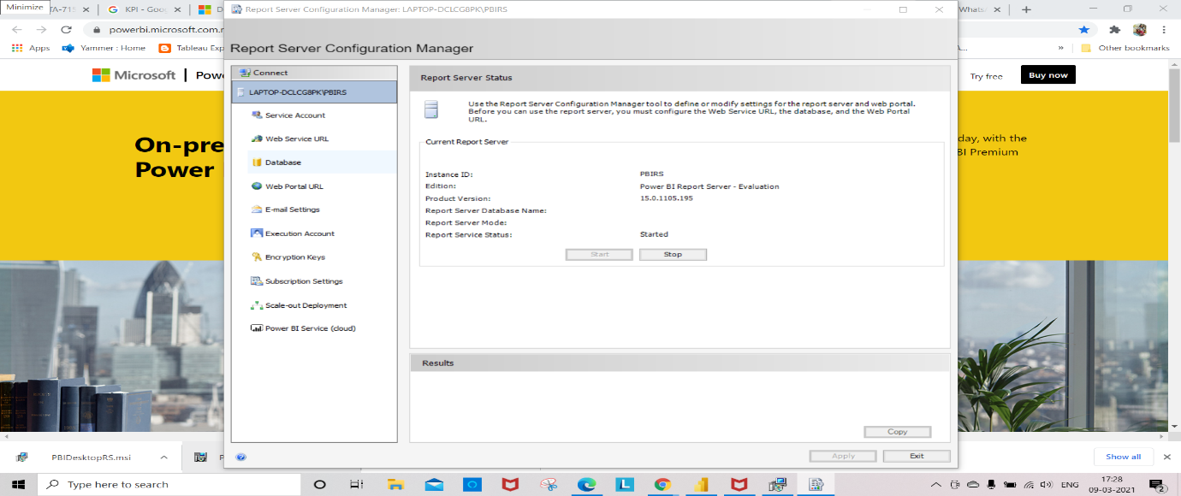

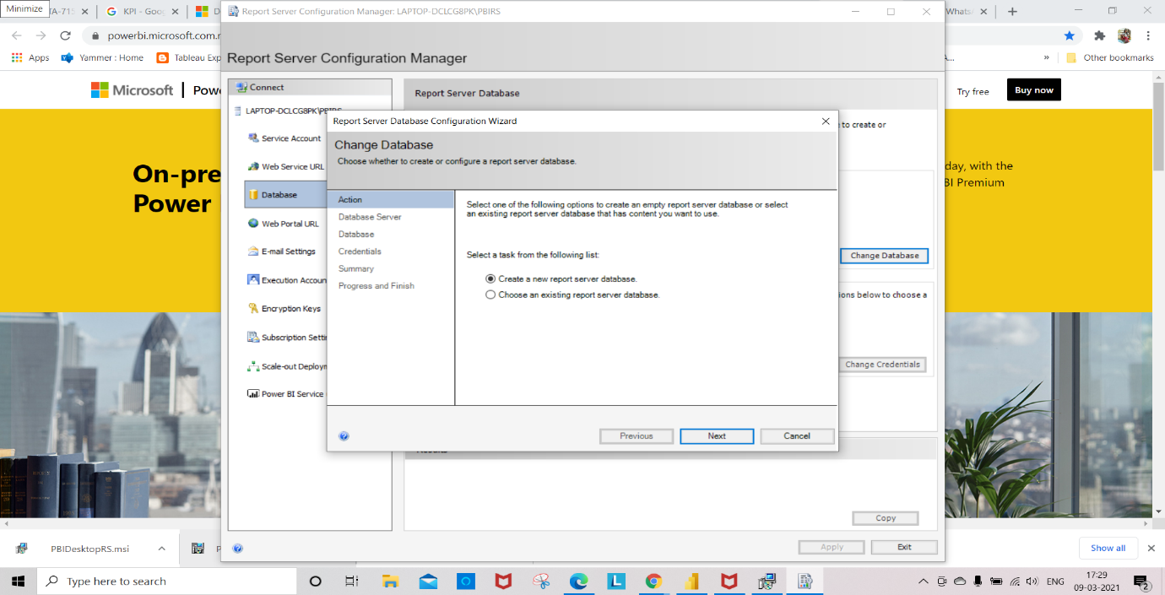

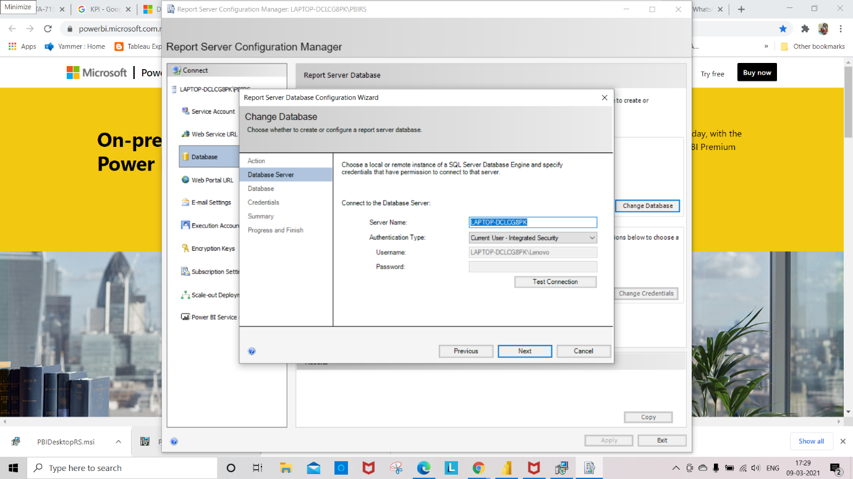

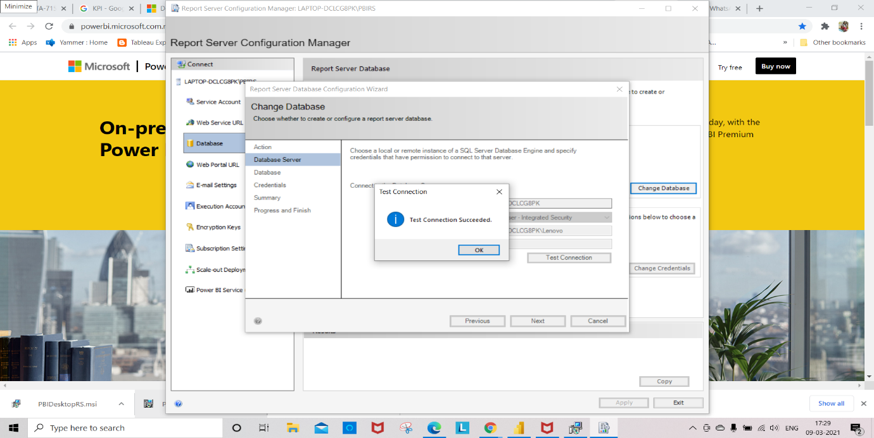

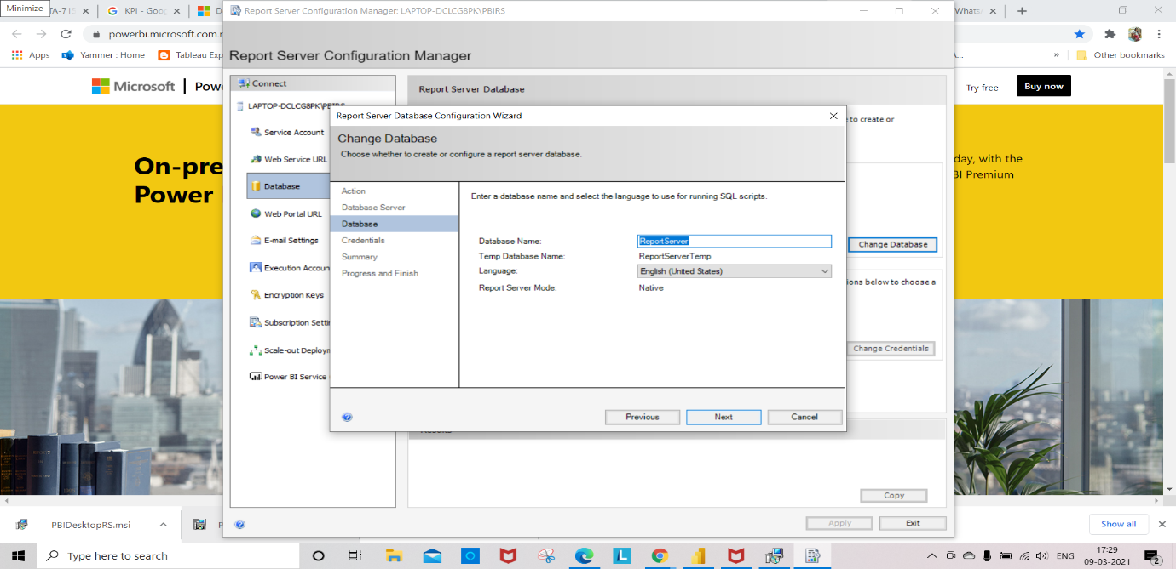

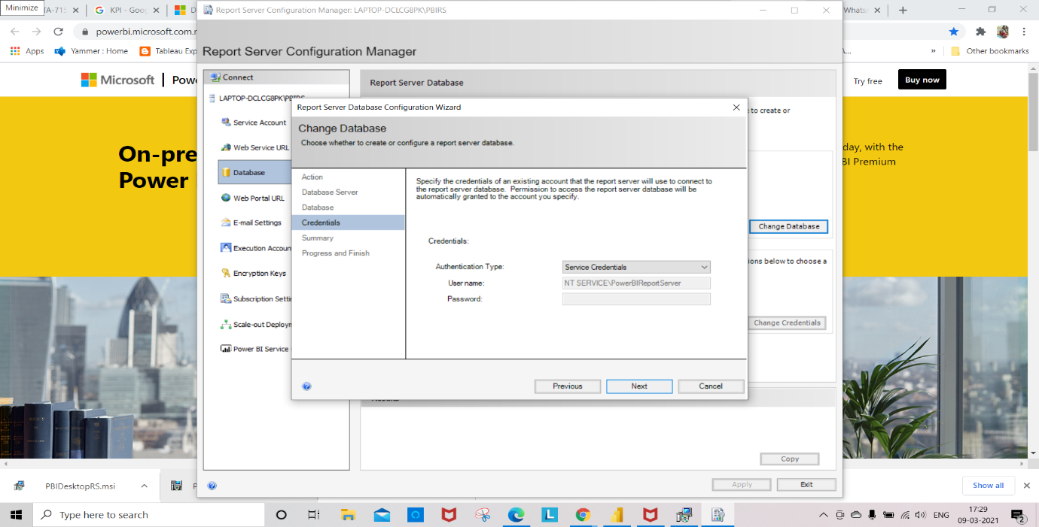

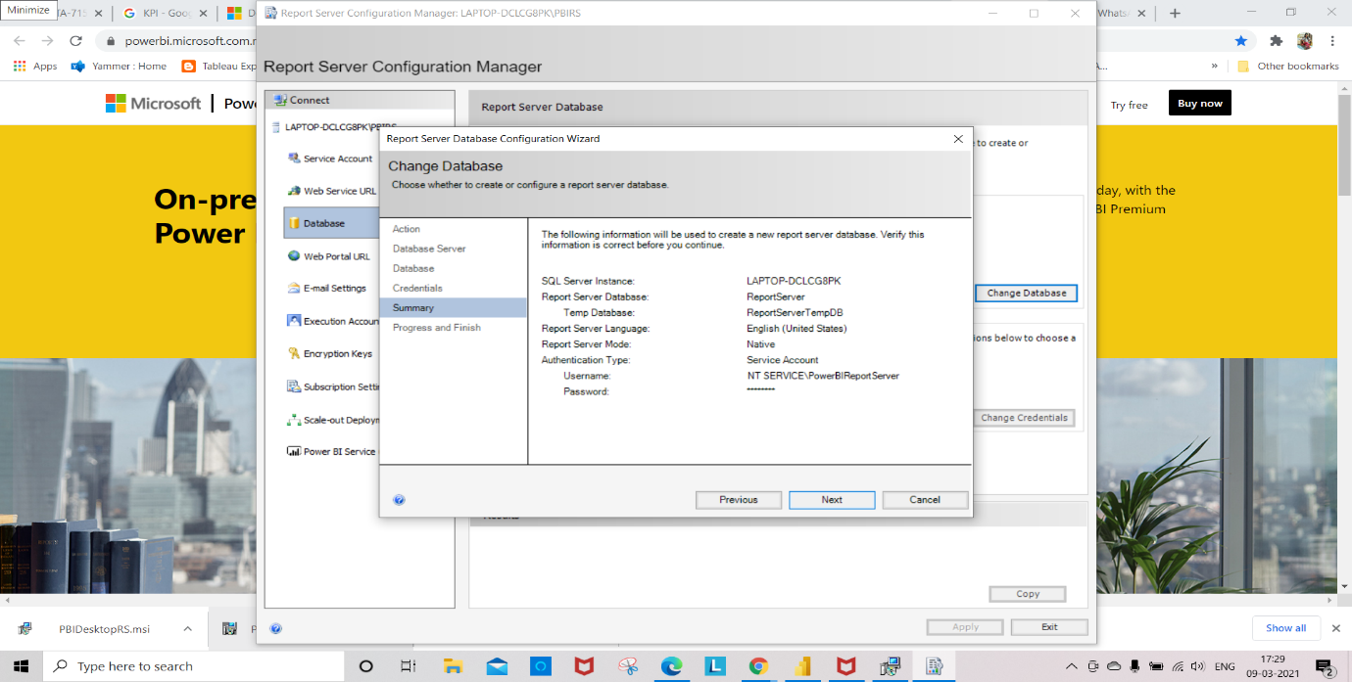

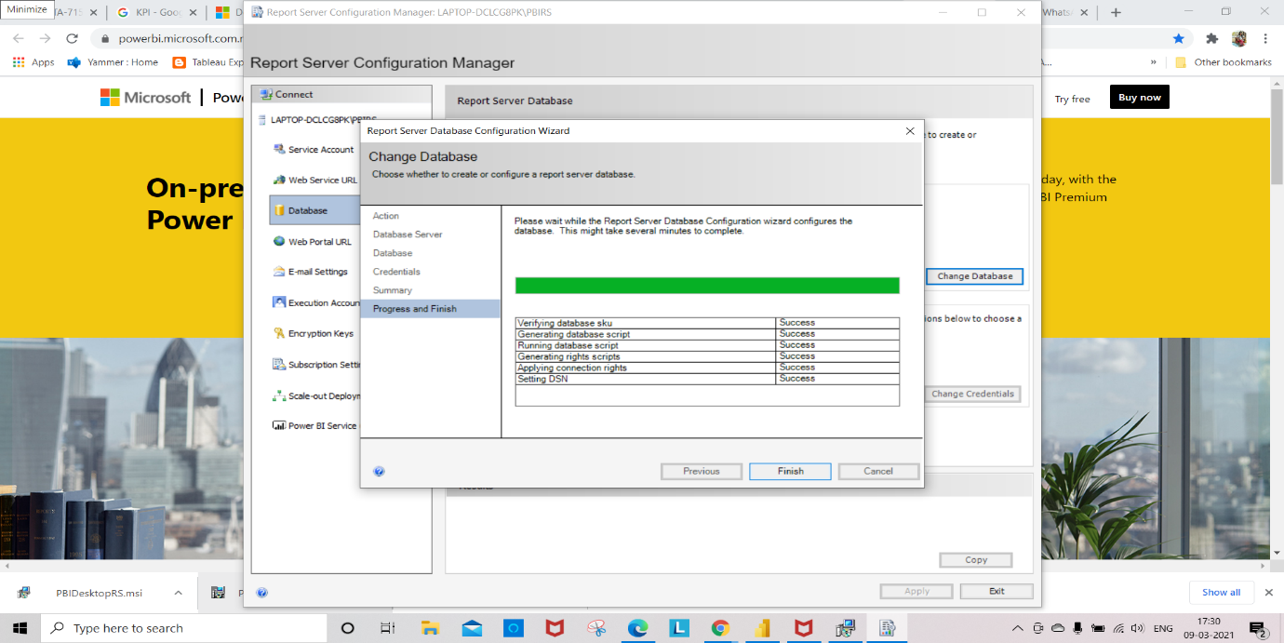

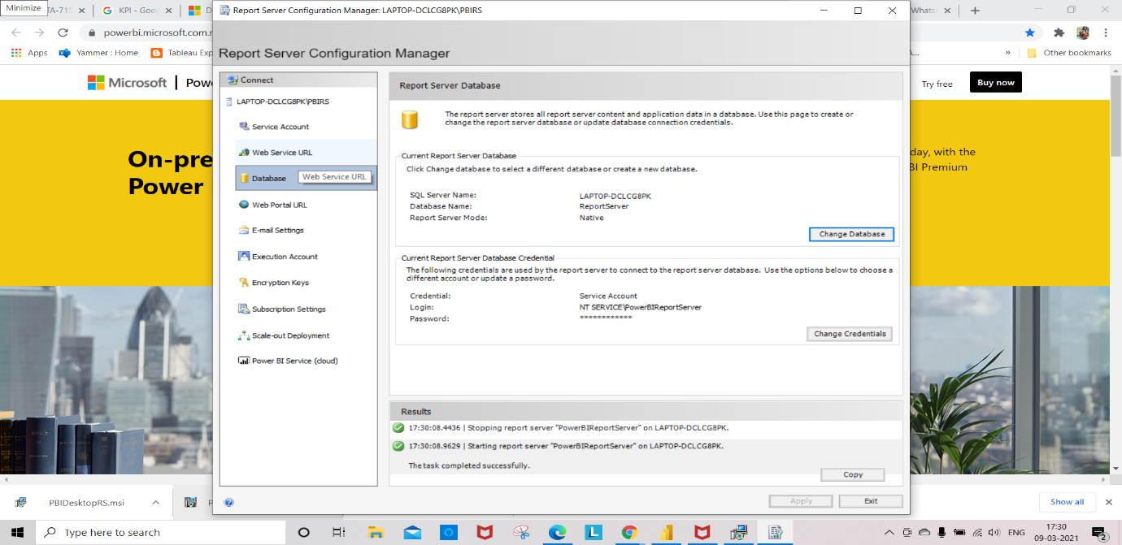

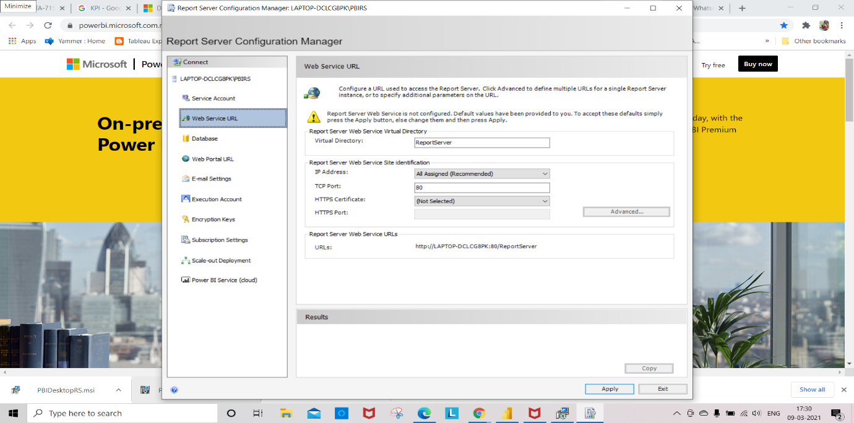

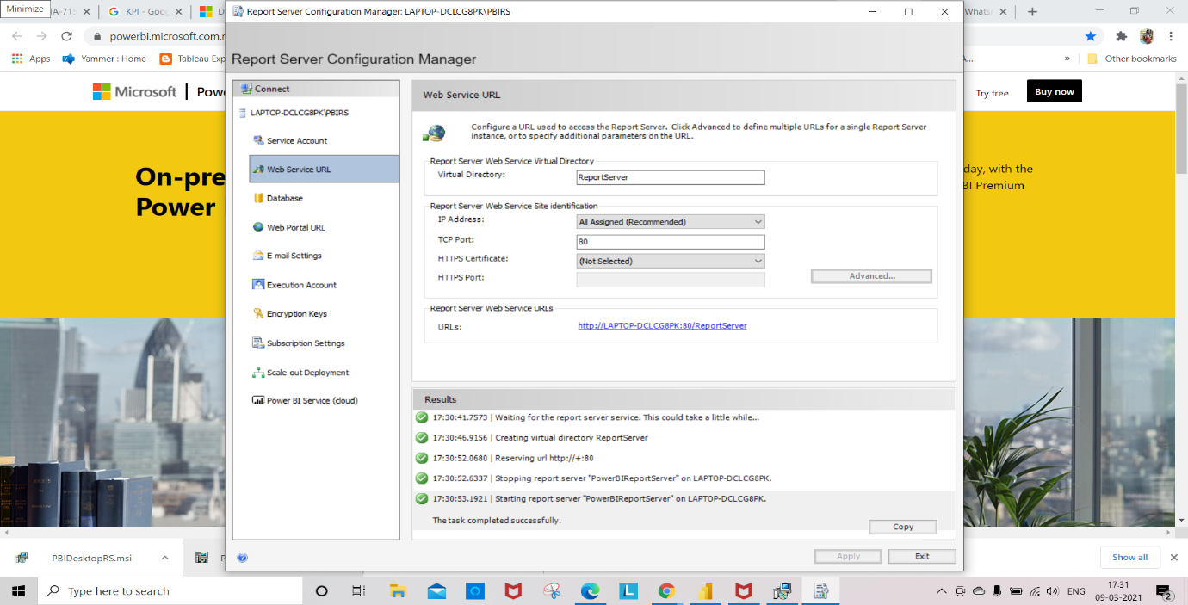

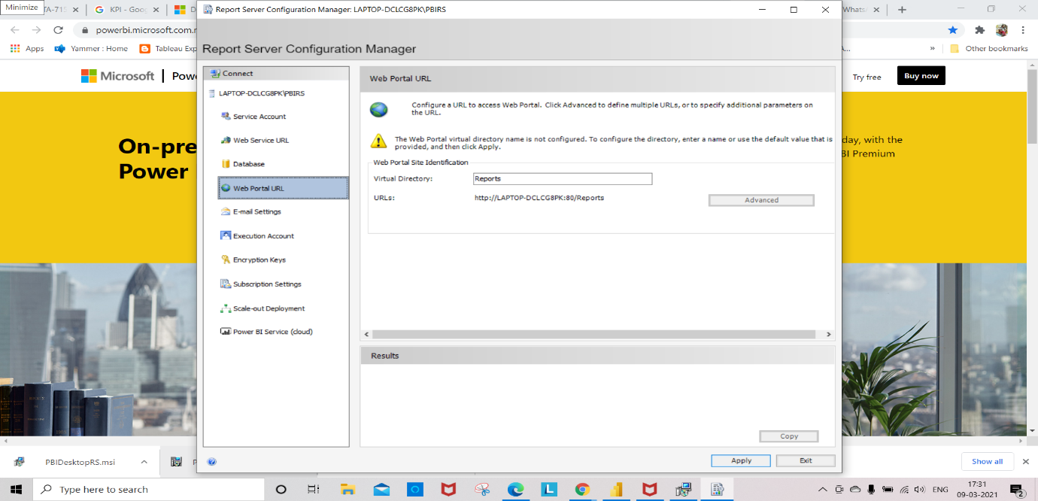

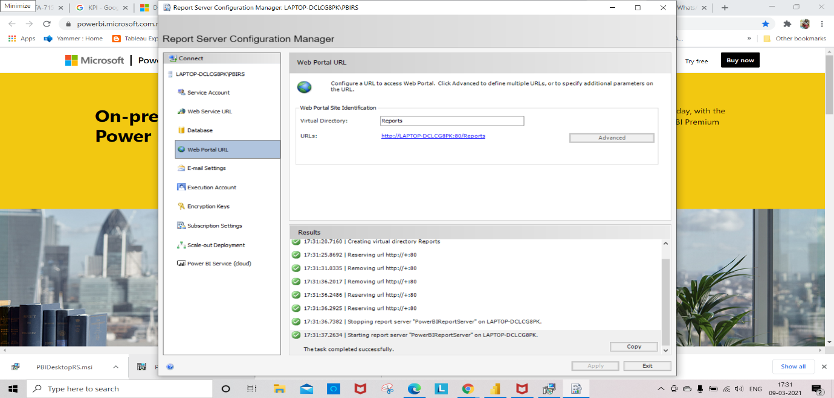

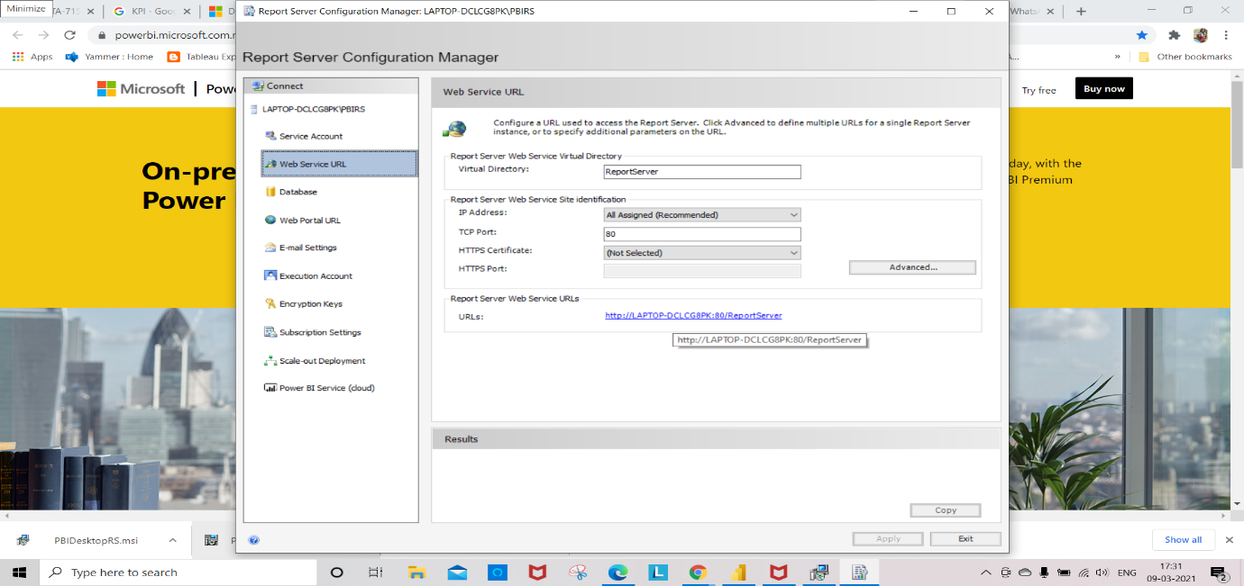

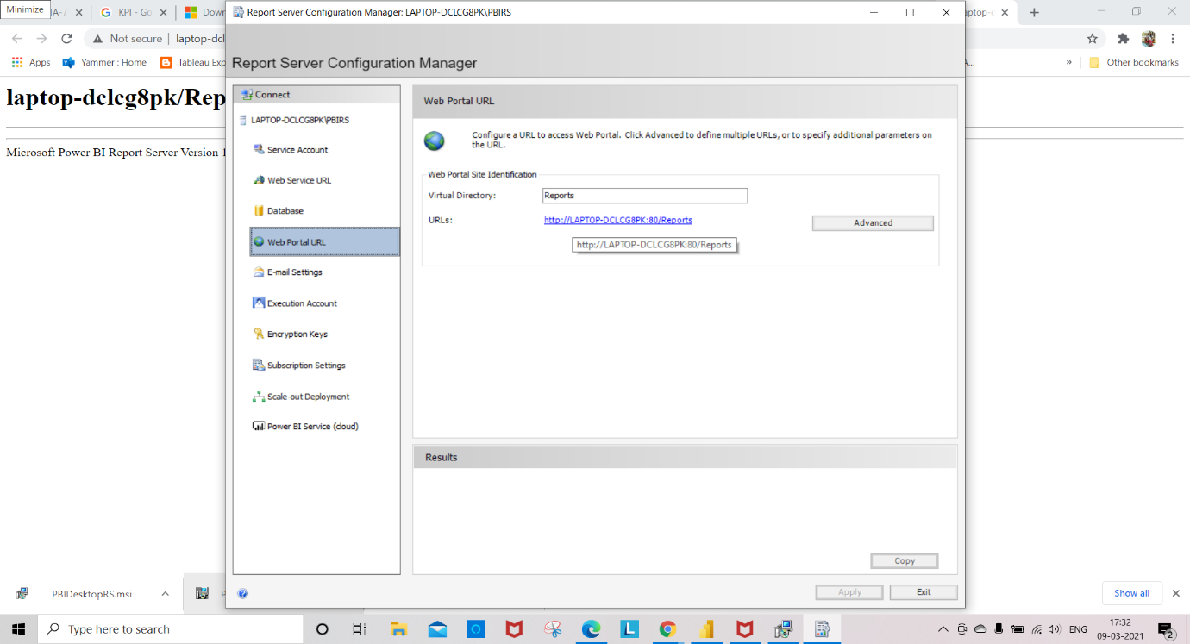

To install PowerBI Desktop Remote Server Follow the below Steps

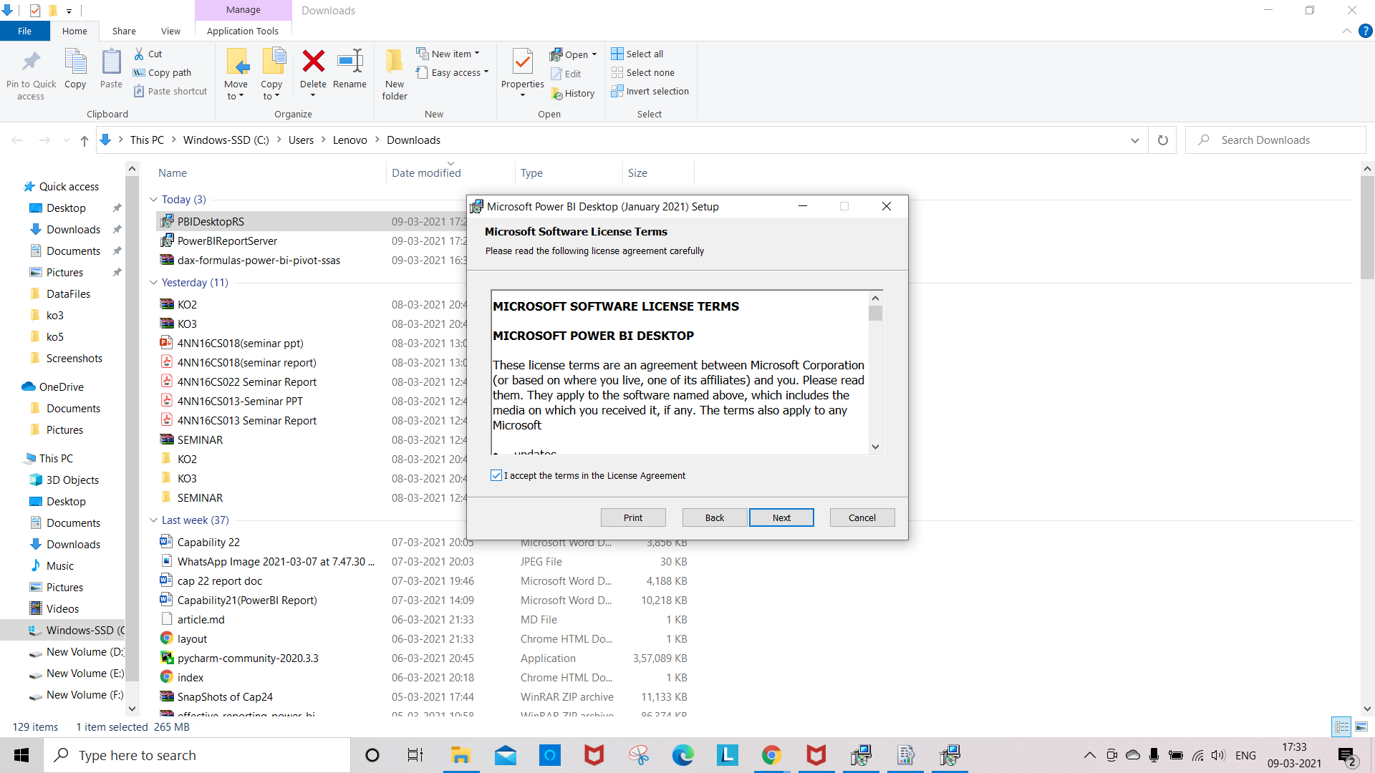

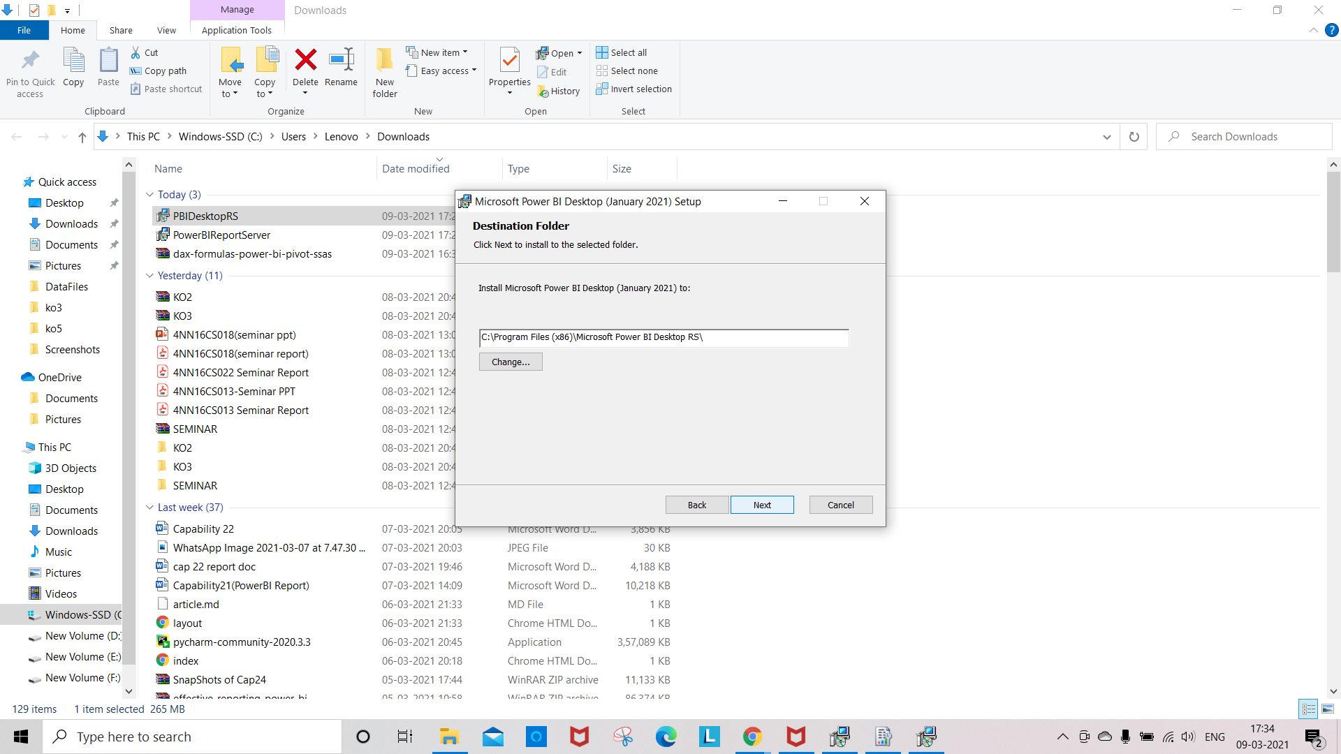

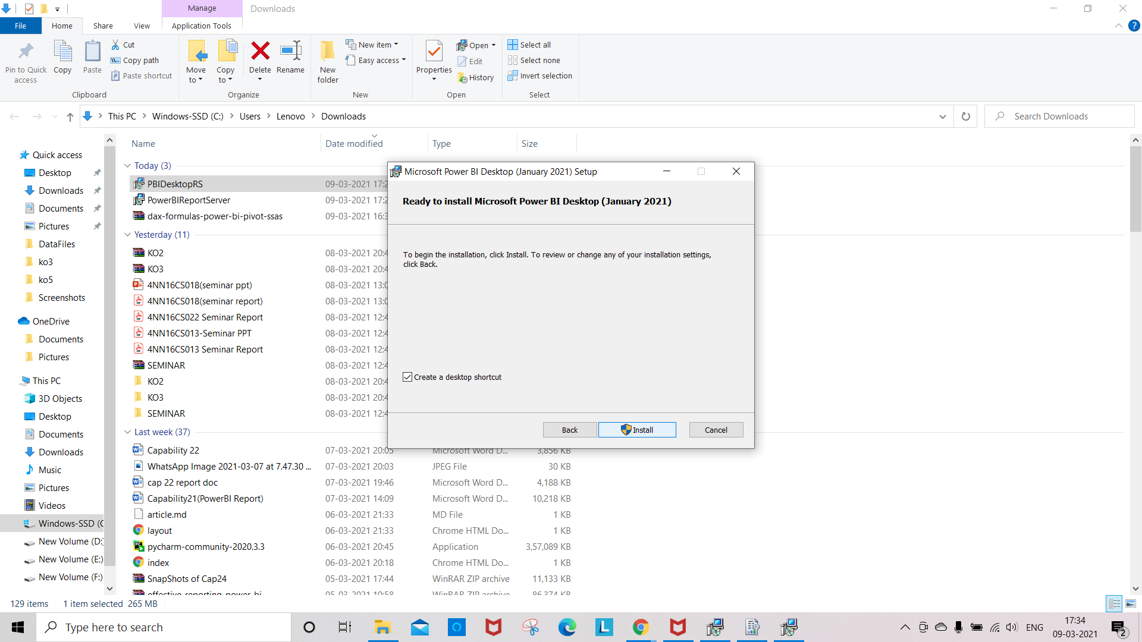

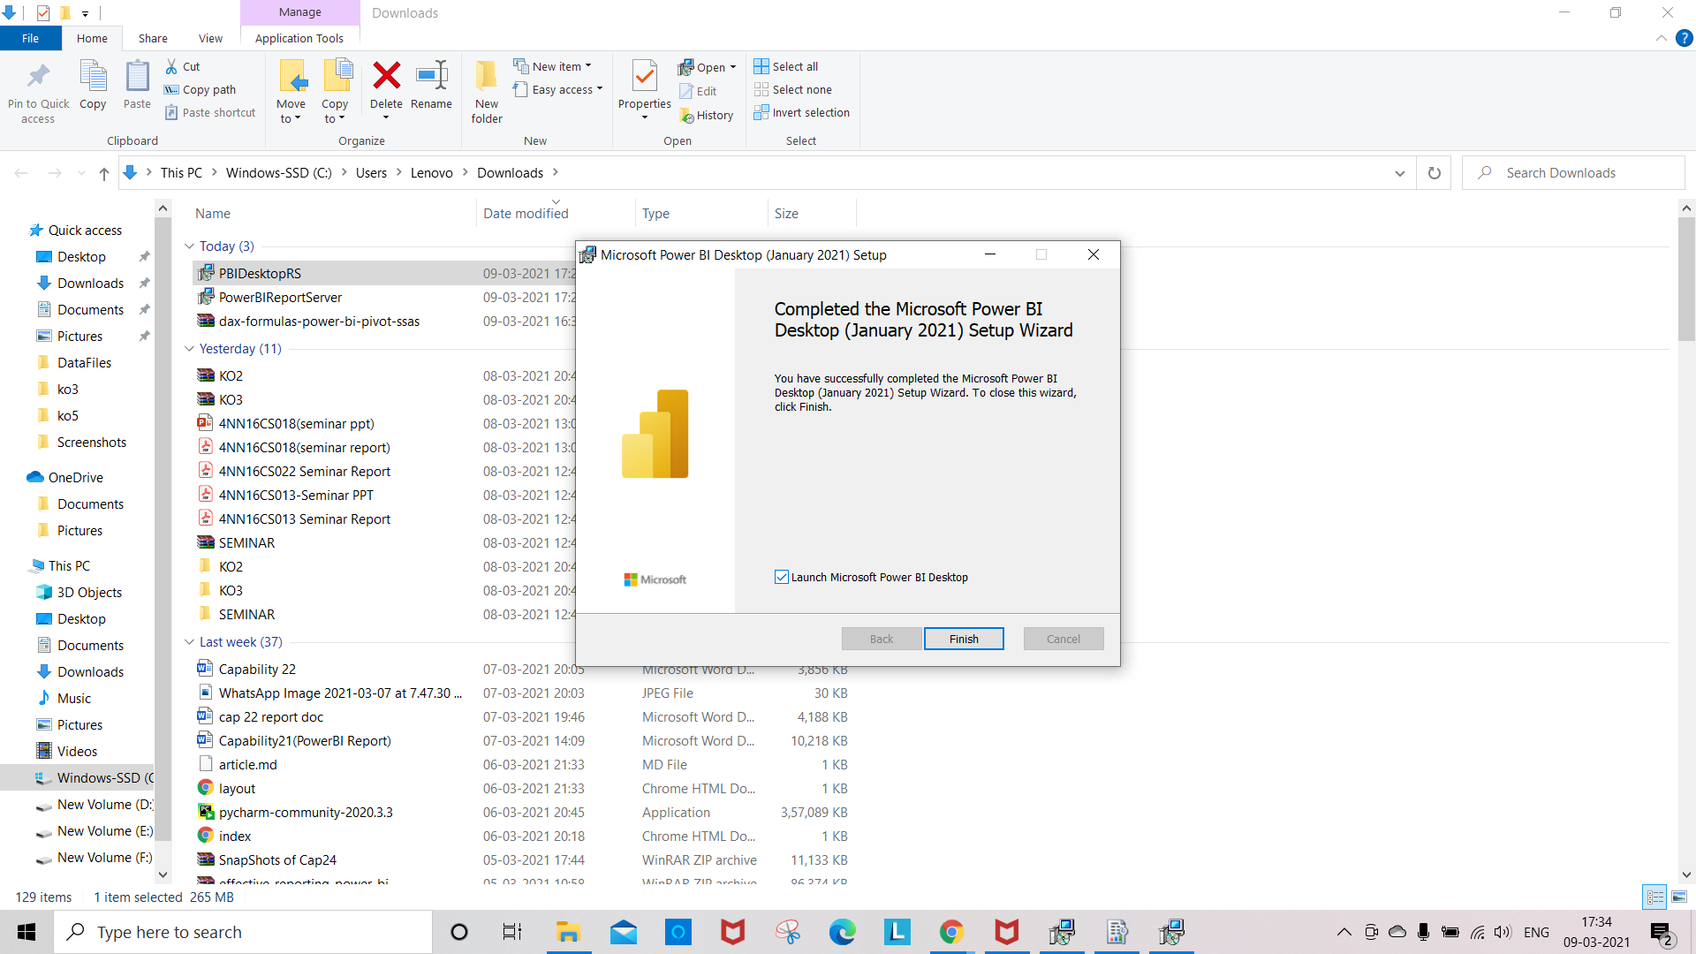

Adding new files to the powerBI Report Server

Click on New 🡪 Power BI Report on PowerBI Report Server

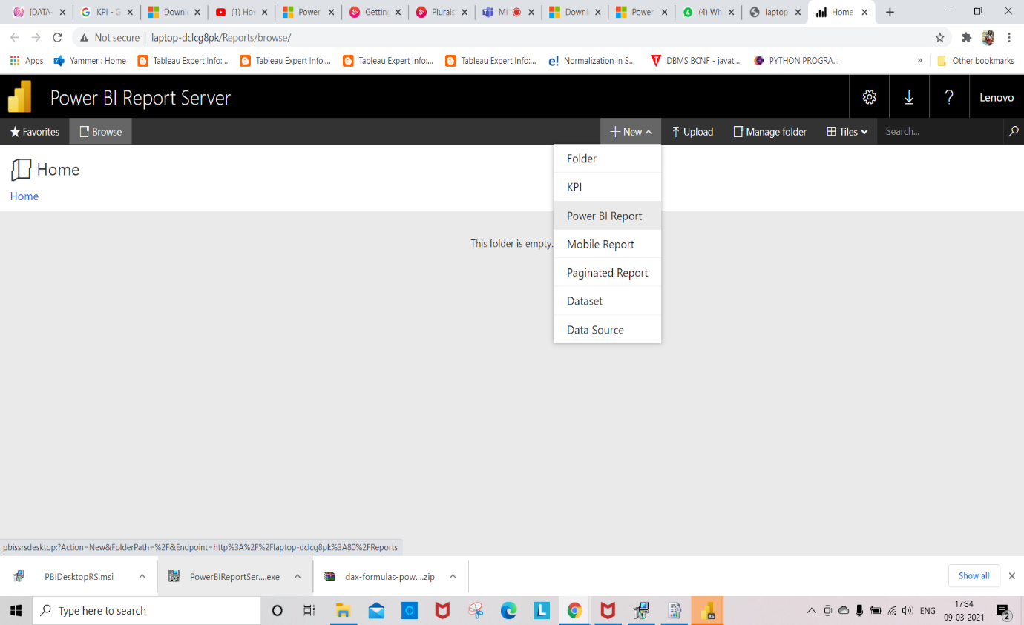

Click on Open Microsoft PowerBI Desktop in the pop up

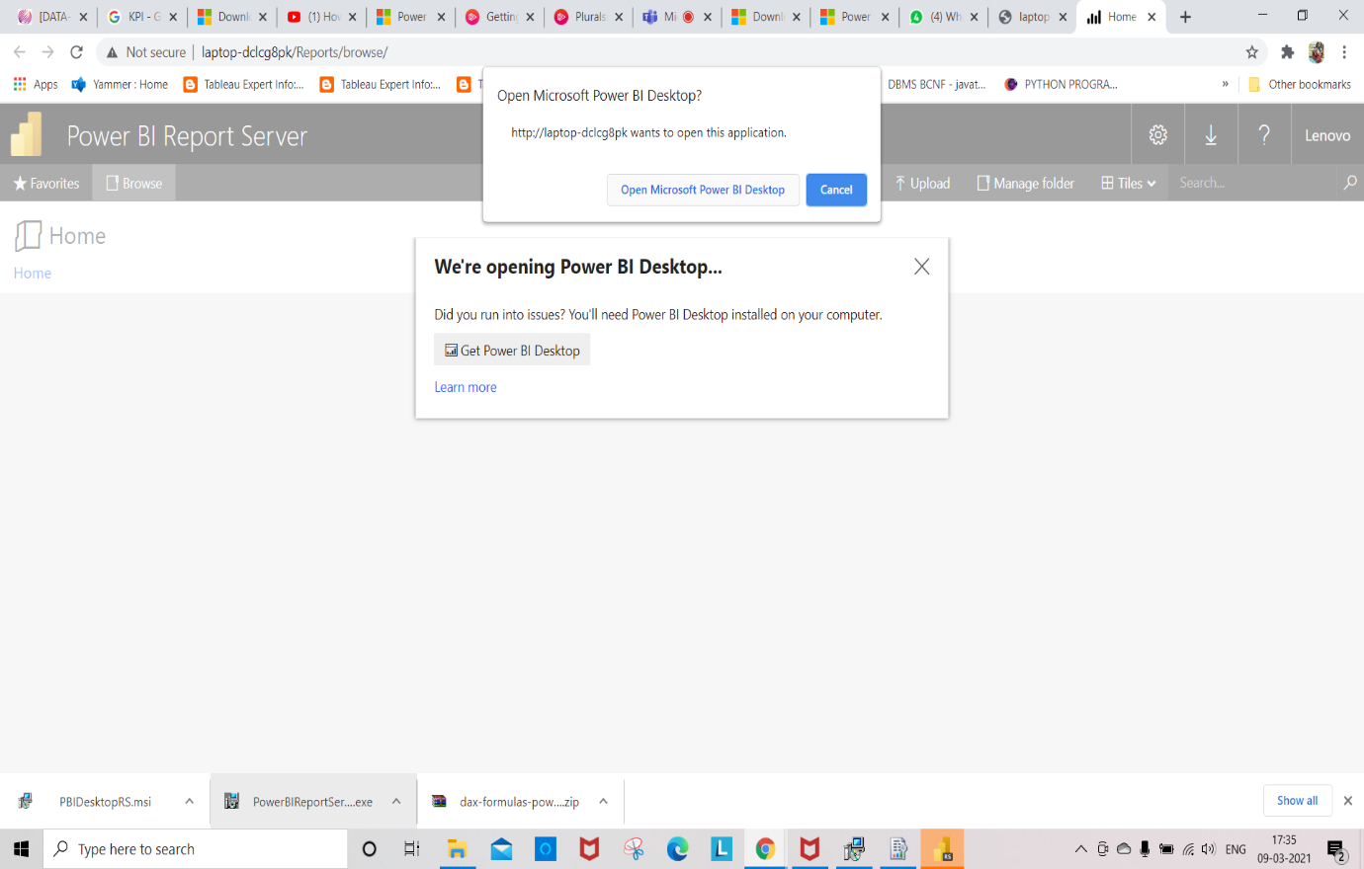

Take a Text Box under Home to add a text box to your report

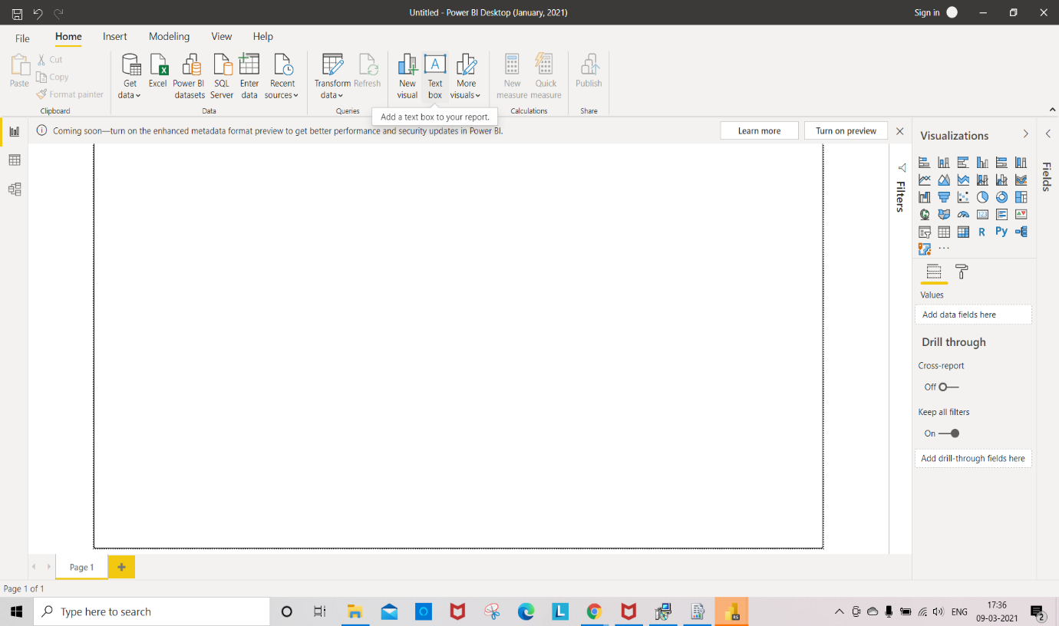

We can add any text in the text box(Here we have added Pied Pipers)

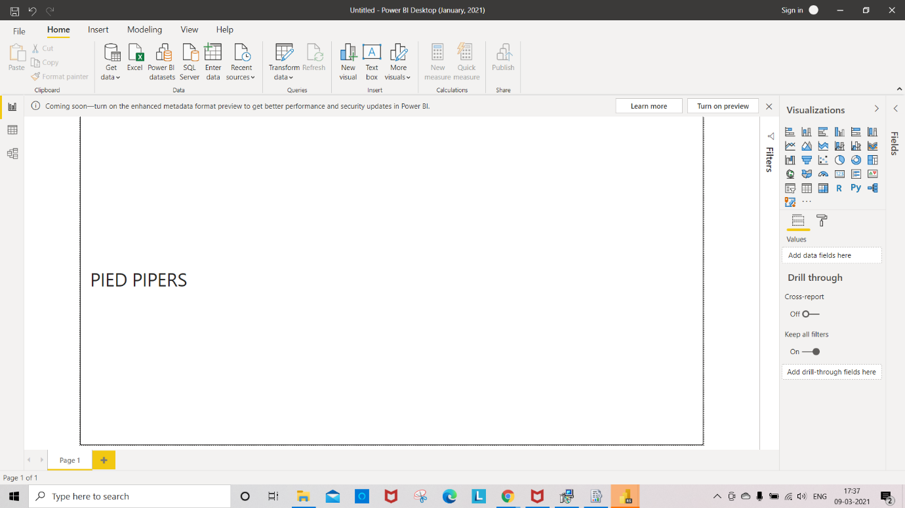

To save this file to Report Server click on File 🡪 Save as 🡪 Power BI Report Server

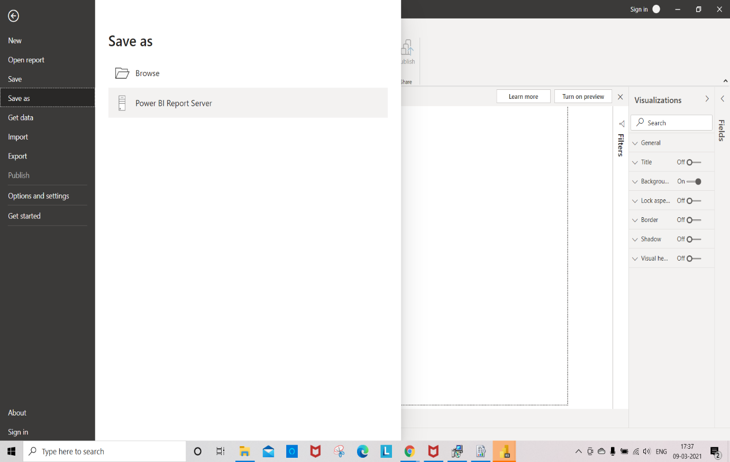

Give the location to save this Report and click on OK(here we have given https://localhost/Reports

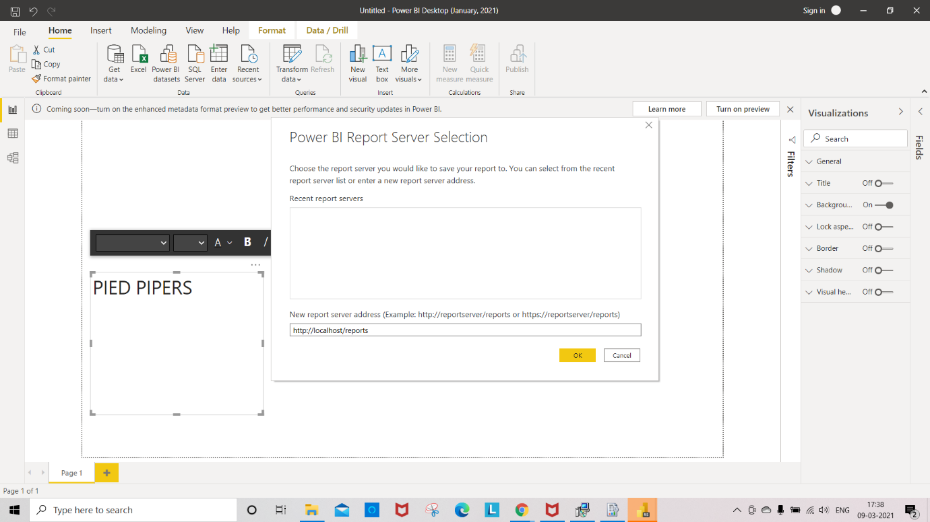

Give any file name to save and click on ok (we have given pp.pbix)

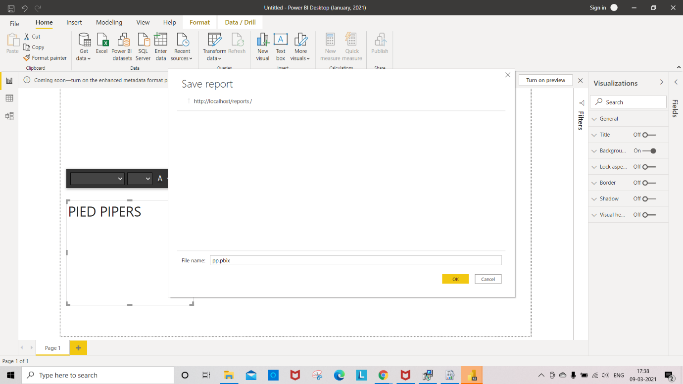

After saving pp.pbix file to the powerBI Report Server

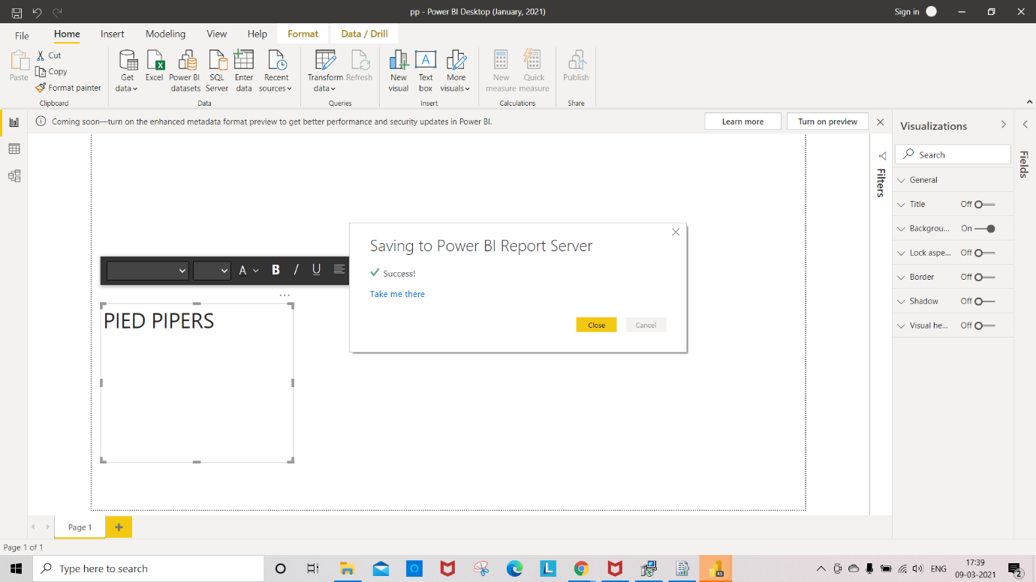

We can see the saved pbix file in the Report server

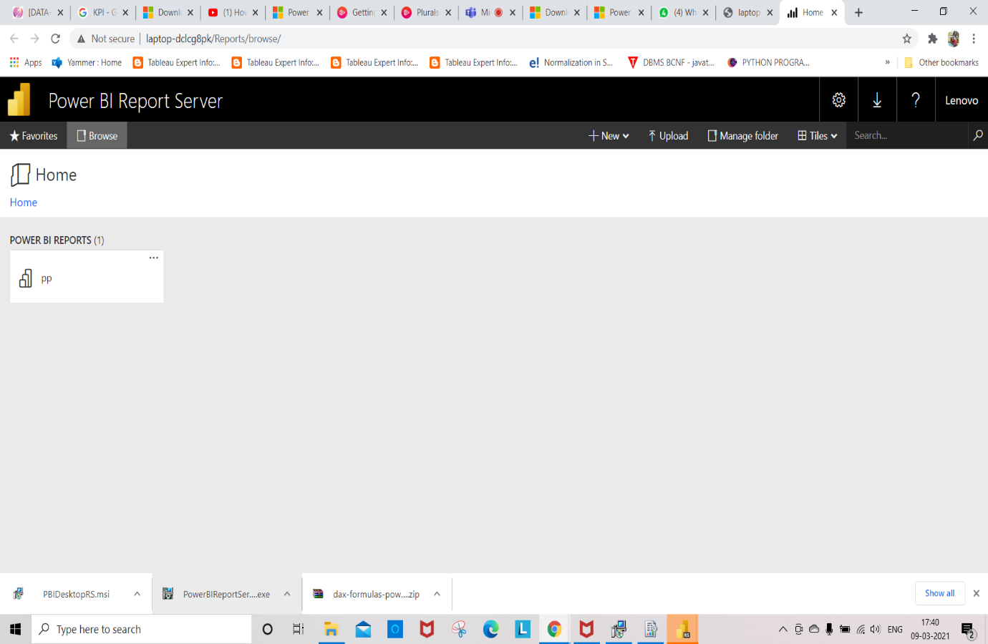

Click on PP to open that file

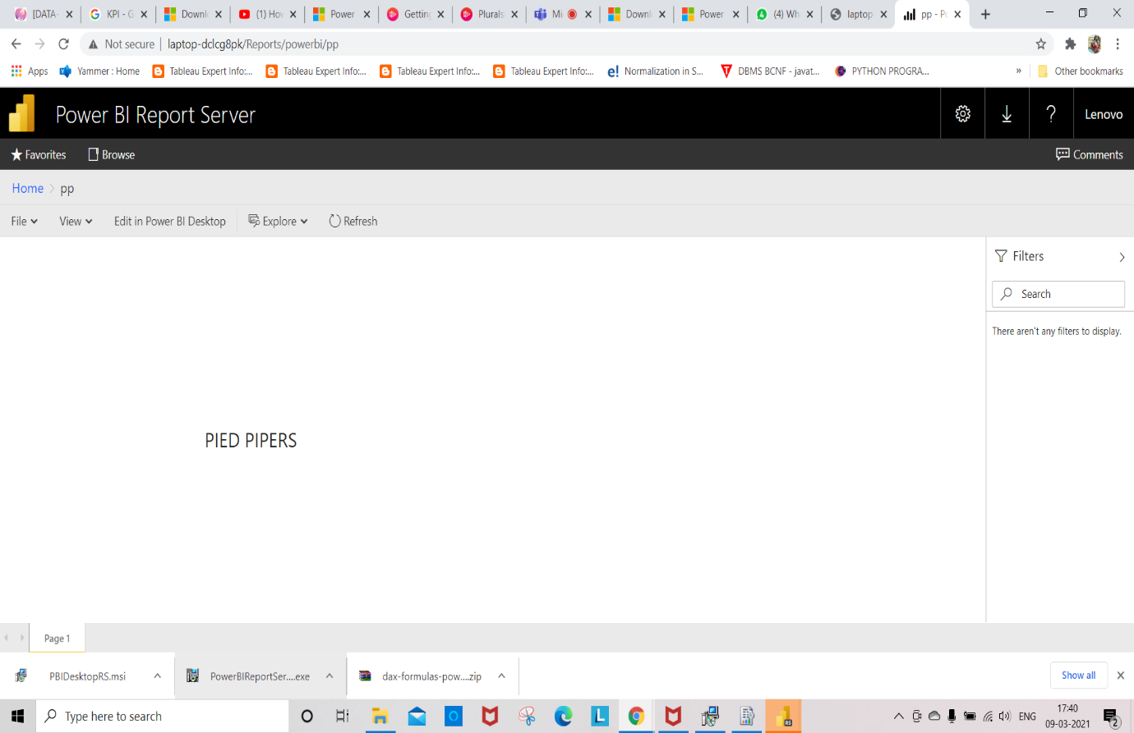

In the PowerBI Remote Server click on File🡪 Open Report 🡪Browse Reports

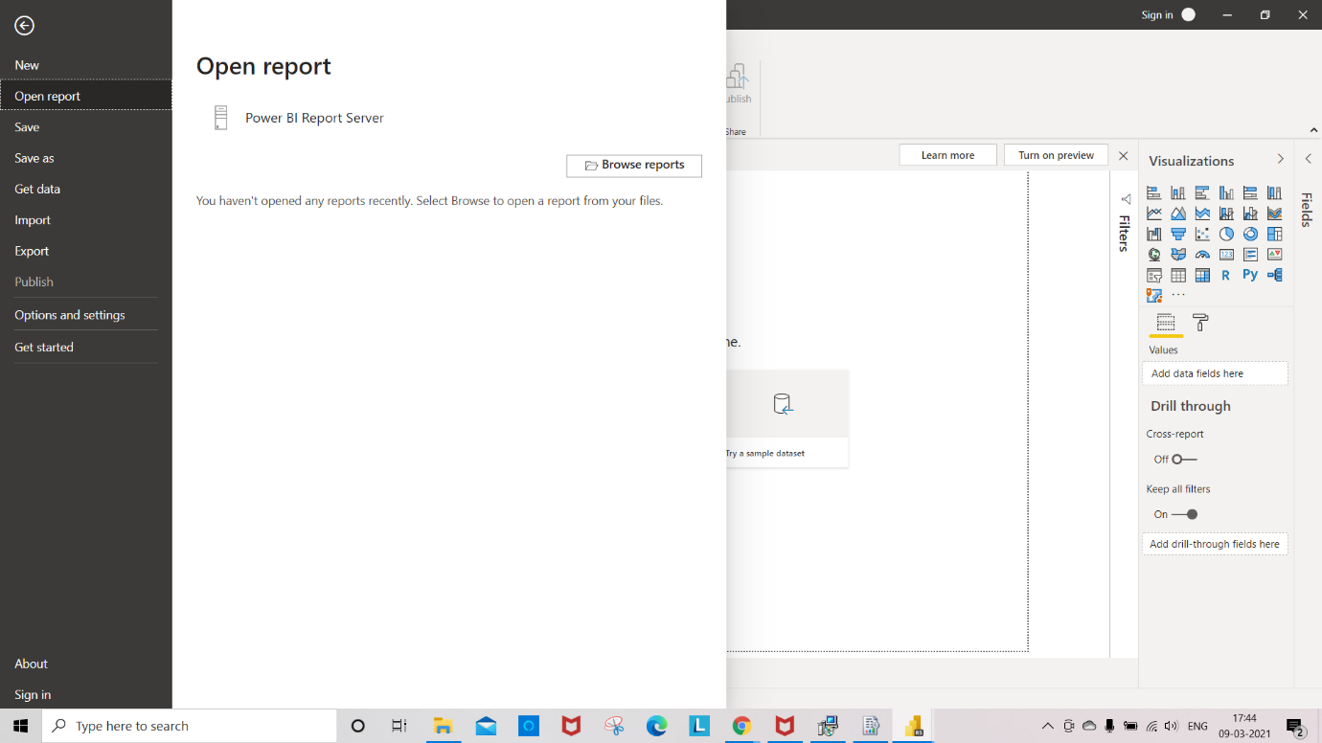

Select any pbix file and click on open

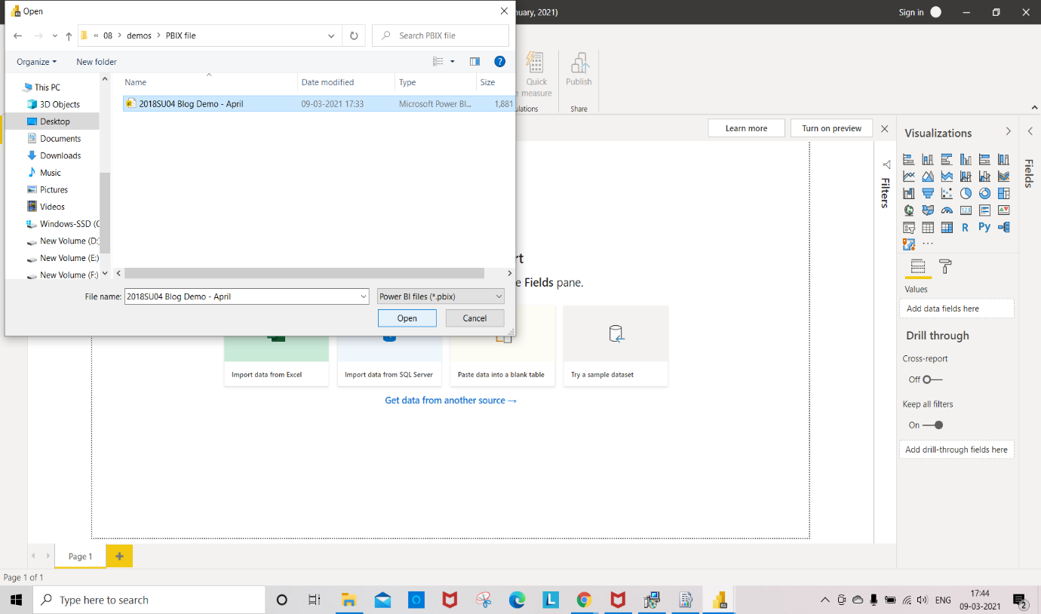

Blog Demo pbix file View

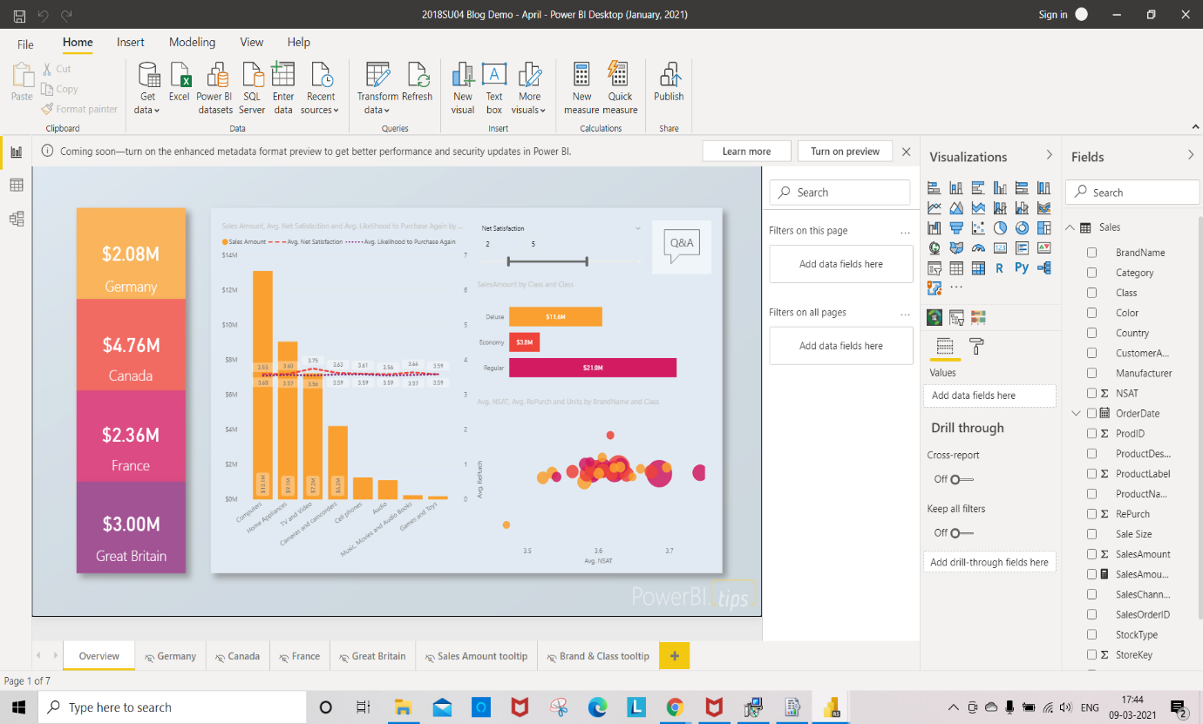

To save this in the Report server click on File 🡪 save as 🡪 Power BI Report Server

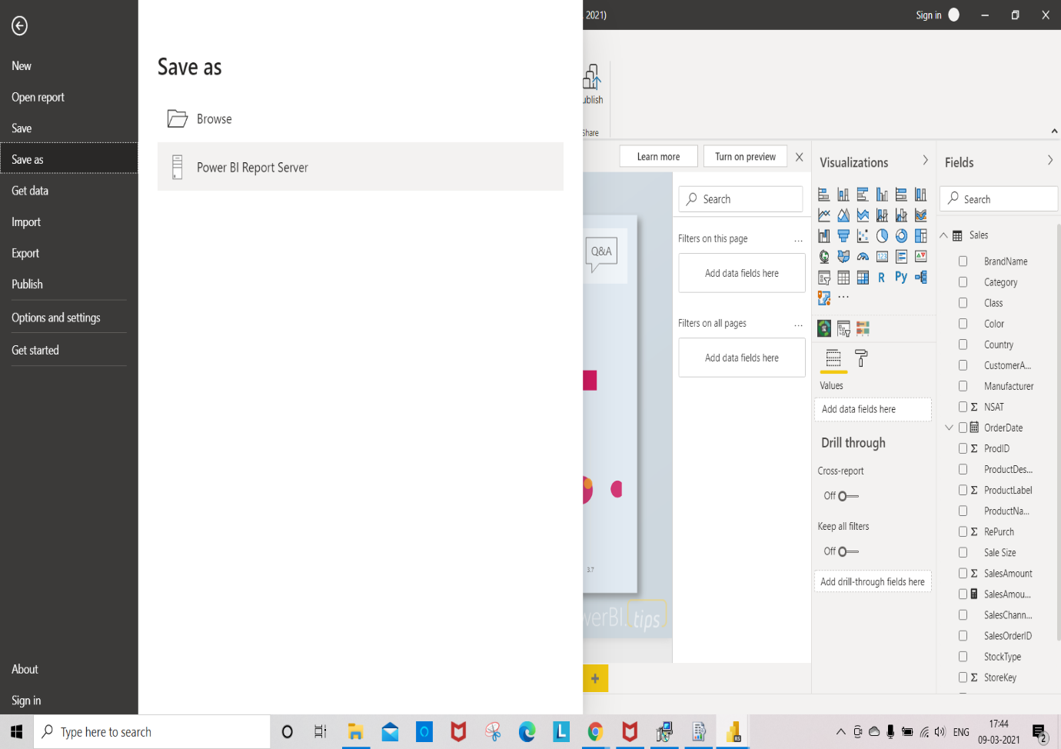

Give the location and click on OK

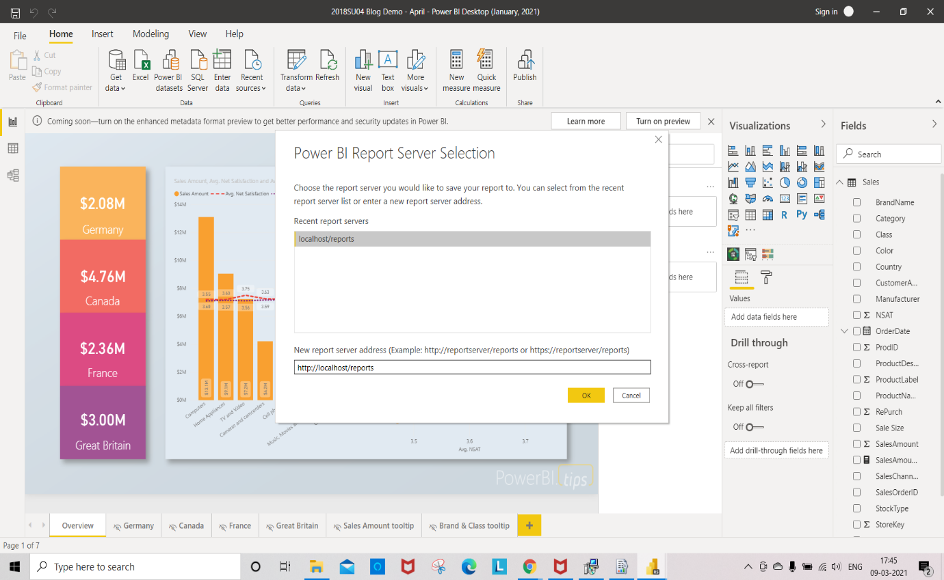

Give any file name and click on OK

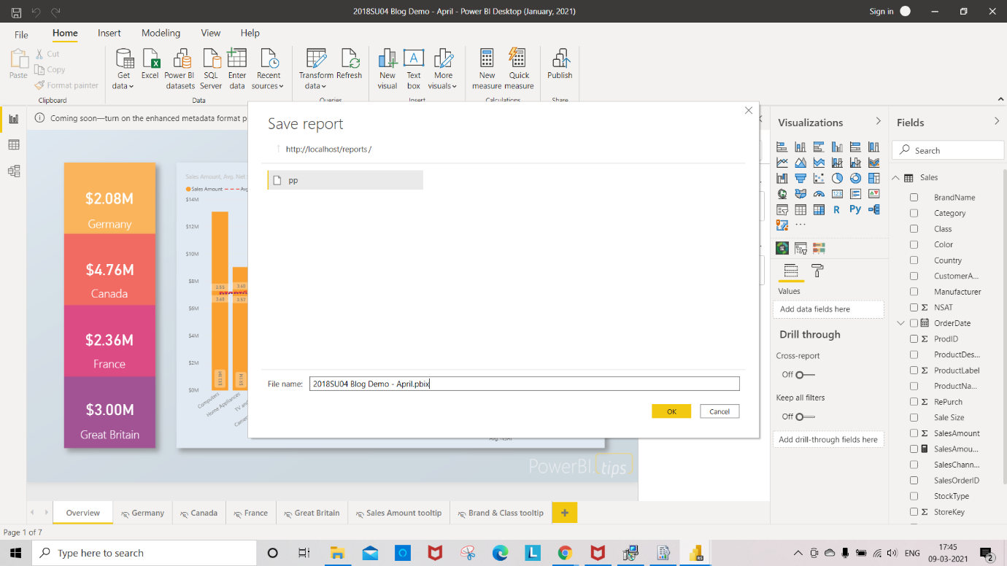

After saving the pbix file to Report Server

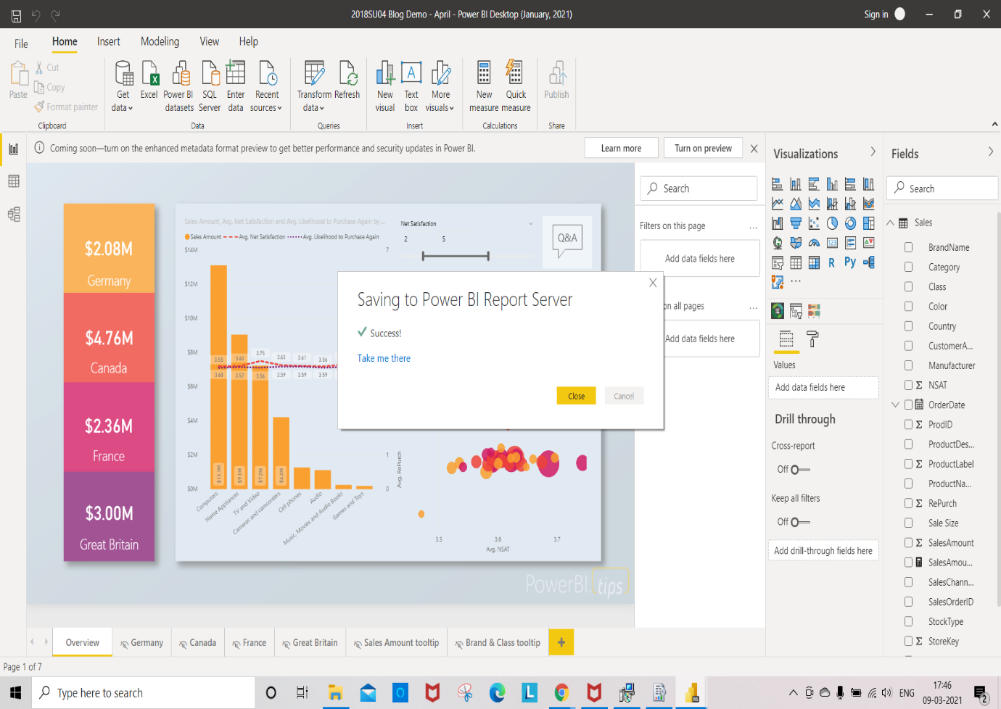

We can see that saved report in Report Server

